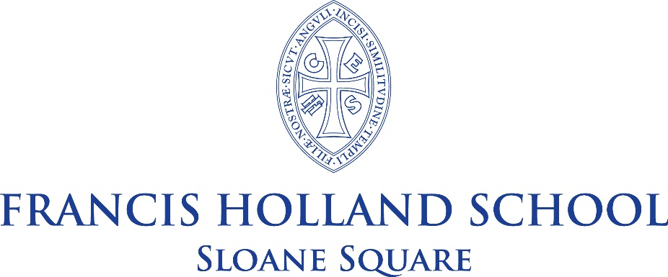

Individual Learning Support Assistant
Full Time
Required for September 2023
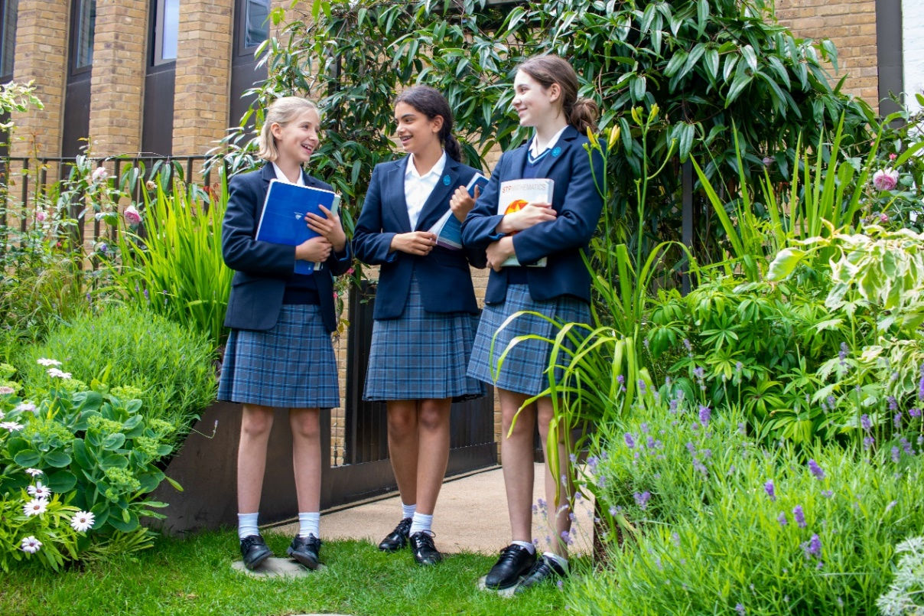

General Information
Francis Holland School Sloane Square is a highly sought-after, independent selective school for around 770 girls aged 4 to 18 (HMC and GSA). There are around 170 Juniors and 600 Seniors, including over 140 in a fast-growing Sixth Form. The School is located on a spacious site in a beautiful residential part of Belgravia, close to the Saatchi Gallery and many cultural institutions such as the Victoria and Albert Museum, the Science and Natural History Museums, the Royal Academy and the Tate Galleries. The proximity to Imperial College offers us unparalleled access to lectures and support.
The School has enjoyed some significant building developments in recent years to accommodate a dramatically increasing roll and our vision for creative learning for the real world. Most recently, the Sixth Form has moved into a spacious and inspirational building called The Old School House, which forms a bridge with the local community and provides an exciting environment for young people to develop their entrepreneurial talents.

Pupils come from all parts of London with many of the Junior School pupils choosing to stay for the Senior School. Ours is a vibrant international community, and families from major cities abroad often seek places for their children here as a priority. Each member of staff is involved in the pastoral life of the School, normally as a Form Tutor, and the care of the children is renowned and exceptional. A team of counsellors provide constant support to the pupils and staff, reflecting our emphasis on supporting wellbeing.
A very wide range of co-curricular opportunities is offered to the pupils, and all staff contribute to this vibrant dimension of the School. Over sixty clubs and societies, outstanding music and drama opportunities and renowned art department are complemented by an exceptional sporting reputation which benefits from the superb facilities of nearby Battersea Park. Overseas trips and annual expeditions for all pupils build resilience and independence. The School has a distinctive emphasis on creativity and innovation, and all pupils learn to use their ‘time, talent and treasure’ in the service of the local and wider community. Volunteering and fundraising are strong, and all girls develop an understanding of social enterprise, with many setting up their own business ventures. The School has several energetic partnerships, including a link school in Tanzania.
Academic standards are consistently high throughout the School, placing it amongst the most successful schools in the UK. On leaving, after A Levels, girls proceed to a wide range of prestigious higher education courses, sometimes after a gap year.
The staffing ratio is generous and the School has its own attractive salary scale. Interest free travel loans are available for new appointments.

Individual Learning Support Assistant

Francis Holland Senior School is seeking to appoint a highly motivated and proactive professional to work as an Individual Learning Support Assistant in Key Stage Three. This opportunity would suit someone who wants to work as part of a small, dedicated learning support team integrated a busy, dynamic secondary school. The main part of this role will be to enable and advocate for a Year 7 pupil on a daily basis to engage in school life in the fullest way possible. This will include managing her timetable, coordinating with staff and liaising with various healthcare professionals. We fully expect the candidate to be a fully participating member of our department and our school.
Key responsibilities:
- To work closely alongside the Heads of Learning Support in order to understand the physical, social, emotional and educational needs of the individual pupil.
- Provide specific support for the individual pupil in their learning and co-curricular activities.
- Provide some physical assistance where needed.
- To be aware of, and contribute to, health and safety procedures to ensure the wellbeing of the individual pupil.
- To liaise with other members of the school team, and wider healthcare professionals, to create and manage an individual timetable for the pupil.
- To be part of, and contribute to, regular meetings with the parents of the pupil.

In relation to the individual pupil:
- To develop an understanding of the special educational needs of the pupil concerned.
- To take into account the pupils needs and ensure their access to the lesson and its content through appropriate clarification, explanations, equipment, and materials.
- To build and maintain successful relationships with the pupil, treat them consistently, with respect and consideration.
- To help promote independent learning.
- To develop good habits of study and organisational skills.
- To help build the pupil’s confidence and enhance self-esteem.
- To carry out informal observation and feedback outcomes.
- To assist the pupil with physical needs in order to move around the site safely.
- To be and flexible and able to adapt according to the changing needs of the individual pupil.
- To be proactive and adaptable to manage last-minute changes to school routines.

Support for the School and General Duties:
- Consistently model the FHS Code of Conduct
- Follow school’s policies on safe-guarding
- Attend school events as required
- Attend weekly whole school staff meetings
Person Specification:
- Is comfortable working within a dynamic environment
- Is enthusiastic and enjoys working with young people
- Works effectively as part of a team
- Willing to learn new skills and attend staff INSET training
- Has high expectations of pupils’ attainment, progress and behaviour
- Has strong ability to support literacy and numeracy
- Has excellent organisational skills
- Is creative and able to contribute to planning discussions
- Has the confidence to manage relationships and advocate for the pupil
- Is proactive and can problem-solve effectively
- Has a good sense of humour
Hours:

8.00am – 5.30pm Monday to include the weekly staff meeting
8.00am – 4.30pm Tuesday – Friday
Some additional hours will be required for school events or after school co-curricular activities.

Application
Completed application forms should be emailed to jobs@fhs-sw1.org.uk by Monday 5th June with interviews the following week. Early application is advised. Applications will be assessed in order of receipt, and interviews may occur at any stage after applications are received.
With effect from 1st January 2023, new members of teaching staff will automatically be enrolled in The Francis Holland Schools’ Trust Group Pension with Aviva (salary exchange scheme) to which members will contribute 10% (the ‘Employee’ Contribution) and Francis Holland Schools contributes 20% the ‘Employer’ Contribution).
The TPS is closed to new staff members from this date.

Several colleagues have already opted for the new Aviva (Salary Sacrifice) scheme due to the tax advantages it offers, the flexibility with the option to reduce one’s own contribution (without affecting the ‘Employer’ Contribution), and the ability to opt for a lower ‘Employer’ contribution in favour of a higher salary, as well as the added benefit of Income Protection; full details of the scheme, and self-management is available to members via the Aviva Pension Microsite upon joining Francis Holland Schools.

In addition, our benefits package includes:

- Wellbeing Scheme
- Cycle to Work Scheme
- Life Cover
- Free school lunch during term time
- Interest free travel and computer purchased loans
- The Francis Holland Schools Rewards Hub offering a vast range of retail and entertainment discounts
- Enhanced Maternity Pay
- 50% fee remission for own daughters
- Outstanding professional development opportunities
- Accredited ECT induction with reduced timetable and mentor support
- Approximately 20 fewer teaching days per year compared to the maintained sector
- Smaller class sizes compared to most maintained schools

Further information about the benefits package is available from hrpayroll@fhst.org.uk

The Trust is committed to safeguarding and promoting the welfare of children and young people and expects all staff to share this commitment. Statutory checks including a satisfactory DBS certificate and references will be a requirement for this role. This role is classed as regulated activity with children as it involves teaching, training or supervising children on a day-to-day basis and is exempt from the Rehabilitation of Offenders Act, 1974.

