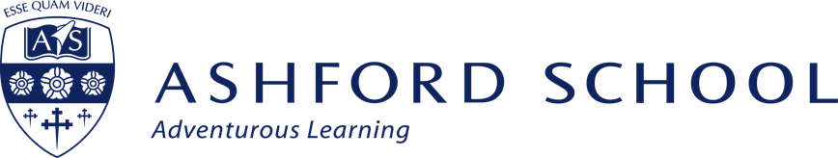

TEACHER of RELIGIOUS STUDIES & PHILOSOPHY
(Part-Time)

Required from September 2017
Fixed term contract, initially for one year

An able and inspiring teacher is required to teach part-time in this successful subject within the Humanities faculty. RS is a compulsory subject for pupils in Years 7-9 and an option at GCSE and A Level. This is a temporary post for the academic year 2016/17 in the first instance, and the successful applicant must be able to teach across Key Stages 3-5.

Students in Years 7-9 enjoy learning a range of topics including creation stories, animal rights, modern morality, medical ethics, alongside studying Christianity, Islam and Buddhism in detail. At GCSE students currently follow the Edexcel Religion and Life and Religion and Society specification and at A-Level students follow the OCR Philosophy of Religion and Ethics specifications. Once the new specifications are accredited, final decision will be made on which exam boards will be offered at GCSE and A Level in 2016/2017. Typically, there are two sets in each of the GCSE years and a good number of candidates for A Level. The department enjoys some of the highest value added scores in the school with 100% A*-B grades at GCSE. Enthusiasm and interest is at an all-time high and it is an exciting time to help take the department forward onto the next stage in its development as the new specifications come into force. RS and Philosophy are popular and our approach is to explore all the major world religions and philosophical thinking from a critical viewpoint. The successful applicant will be expected to build on this approach and will have the scope to develop it.

The subject is taught in a well-resourced, dedicated classroom, well-stocked with a wide range of visual aids and an interactive whiteboard. Pupils’ learning opportunities are further enriched by departmental visits and the hosting of conferences from eminent speakers in the field. The department has its own area on the school’s VLE (Firefly) to allow distance learning through holidays and weekends, and a willingness to help develop further resources would be desirable. In 2016/2017, all students in years 7-11 now have their own school-provided iPad, and each member of teaching staff is provided with one to enhance the range of learning opportunities for pupils. Training opportunities on how to develop iPad use are available and help is at hand through our Director of E-Learning.

You should be academically well qualified with a degree in Philosophy, Theology or Religious Studies and, preferably, accustomed to guiding students of high ability. Ideally you should have a few years’ experience but ability and drive are key factors. You need the imagination, commitment and ambition to challenge students to enjoy the subject and the insight and enthusiasm to stretch pupil learning beyond the constraints of exam specifications. You should be familiar with IT and its use as a tool for learning, teaching and administration.

Teachers at Ashford enjoy a welcoming, comfortable and well-resourced environment and are provided with assistance from a range of support staff. All teachers are expected to contribute to the co-curricular life of the school and an understanding of the ethos of the school is essential.

Ashford School is one of the UK's leading coeducational, independent schools and was voted Independent School of the Year 2010/11 and again in 2014/15. The School was endorsed as outstandingly successful in every category during the most recent inspection in 2014. In September 2014, Ashford School became a Teaching School; only one of four Independent Schools in the UK to do so.

We are committed to safeguarding and promoting the welfare of children and expect all staff to share this commitment. An enhanced DBS check is required for all successful applicants.

