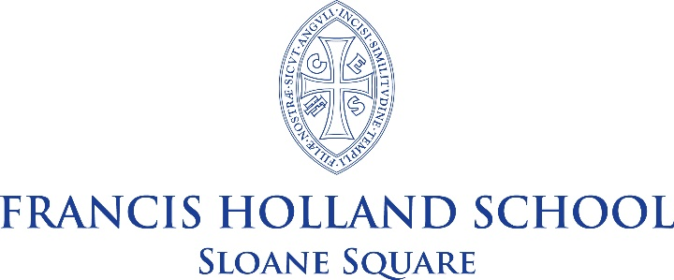

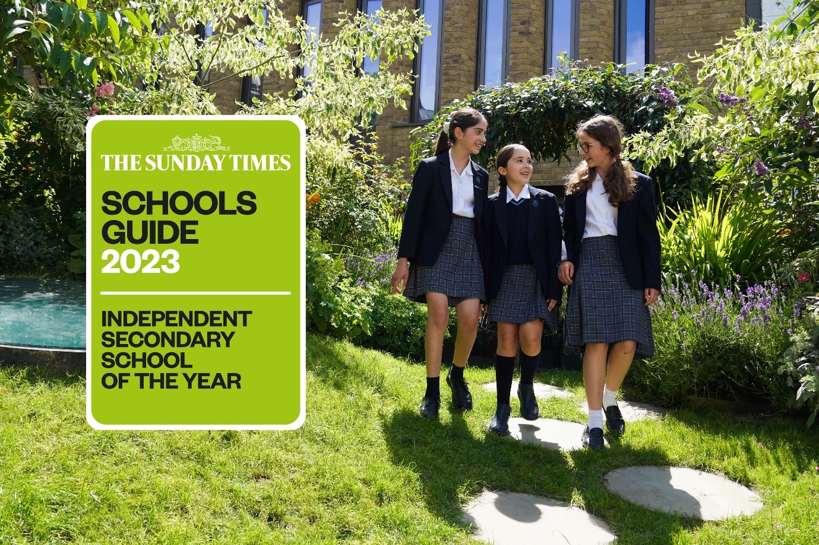

General Information

Francis Holland School Sloane Square is a highly sought-after, independent selective school for around 770 girls aged 4 to 18 (HMC and GSA). There are around 170 Juniors and 600 Seniors, including over 140 in a fast-growing Sixth Form. The School is located on a spacious site in a beautiful residential part of Belgravia, close to the Saatchi Gallery and many cultural institutions such as the Victoria and Albert Museum, the Science and Natural History Museums, the Royal Academy and the Tate Galleries. The proximity to Imperial College offers us unparalleled access to lectures and support.

The School has enjoyed some significant building developments in recent years to accommodate a dramatically increasing roll and our vision for creative learning for the real world. Most recently, the Sixth Form has moved into a spacious and inspirational building called The Old School House, which forms a bridge with the local community and provides an exciting environment for young people to develop their entrepreneurial talents.

Pupils come from all parts of London with many of the Junior School pupils choosing to stay for the Senior School. Ours is a vibrant international community, and families from major cities abroad often seek places for their children here as a priority. Each member of staff is involved in the pastoral life of the School, normally as a Form Tutor, and the care of the children is renowned and exceptional. A team of counsellors provide constant support to the pupils and staff, reflecting our emphasis on supporting wellbeing.

A very wide range of co-curricular opportunities is offered to the pupils, and all staff contribute to this vibrant dimension of the School. Over sixty clubs and societies, outstanding music and drama opportunities and renowned art department are complemented by an exceptional sporting reputation which benefits from the superb facilities of nearby Battersea Park. Overseas trips and annual expeditions for all pupils build resilience and independence. The School has a distinctive emphasis on creativity and innovation, and all pupils learn to use their ‘time, talent and treasure’ in the service of the local and wider community. Volunteering and fundraising are strong, and all girls develop an understanding of social enterprise, with many setting up their own business ventures. The School has several energetic partnerships, including a link school in Tanzania.

Academic standards are consistently high throughout the School, placing it amongst the most successful schools in the UK. On leaving, after A Levels, girls proceed to a wide range of prestigious higher education courses, sometimes after a gap year.

The staffing ratio is generous and the School has its own attractive salary scale. Interest free travel loans are available for new appointments.

The Department of Modern Foreign Languages is a leading department. It is the largest department in the school, consisting of five full time members of staff, five part- time staff and language assistants as well as visiting teachers to teach Italian. Being located in an area of central London close to embassies, the French Lycée and other cultural centres, as well as to the City, we benefit from a cosmopolitan intake, attracting many girls from a bilingual or multilingual background who are always very open to discovering new cultures and to learning new languages.

German Language Assistant

Francis Holland Senior School is seeking to appoint a highly engaging and motivated professional to work as a German Language Assistant. This role would involve supporting the improvement of pupils’ communication skills and helping them to develop their knowledge of a different society and culture. This post would suit someone who can support the work of the language department, under the supervision of the MFL teachers. The individual may do this in whole class situations with a teacher, or they may lead activities independently with small groups of pupils. This position is ideal for those who wish to embark on a teaching career as it offers first-hand experience of the MFL curriculum and the opportunity of working with experienced teachers.

Key responsibilities:
- Help students prepare for oral examinations at IGCSE and A Level and practise their speaking skills, especially pronunciation and intonation.
- In class support to work with a small group of pupils either in the class or separately.
- Deliver our bilingual curriculum. This involves teaching a small group of pupils who have a (near) native advantage.
- Support the department by creating resources, displays and ad hoc administrative tasks.

Language assistants can:
- Transform language teaching through conversation, songs, games, and activities with students.
- Introduce students to aspects of their culture and inspire an international outlook.
- Encourage students to be more ambitious and outgoing, as well as helping them develop the ability to communicate their ideas about the world.

Profile of language assistants
Essential:
- University educated, preferably in linguistics, or in languages.
- Native expertise in German.
- Fluent in English (minimum B2 level).
- Team player.
Desirable:
- A basic knowledge of the British educational system, including public examination.
- Be creative and take initiatives.
- Experience working in a multi-cultural setting.
- Some experience working with children or young adults.
Hours:
- Part-Time; flexible (Tuesday availability desirable)
- To be further discussed during interview

Application

Completed applications should be emailed to jobs@fhs-sw1.org.uk by 10.00 on Wednesday 14th June 2023. With interviews the following week. Early application is advised. Applications will be assessed in order of receipt, and interviews may occur at any stage after applications are received.

With effect from 1st January 2023, new members of teaching staff will automatically be enrolled in The Francis Holland Schools’ Trust Group Pension with Aviva (salary exchange scheme) to which members will contribute 10% (the ‘Employee’ Contribution) and Francis Holland Schools contributes 20% the ‘Employer’ Contribution).

The TPS is closed to new staff members from this date.

Several colleagues have already opted for the new Aviva (Salary Sacrifice) scheme due to the tax advantages it offers, the flexibility with the option to reduce one’s own contribution (without affecting the ‘Employer’ Contribution), and the ability to opt for a lower ‘Employer’ contribution in favour of a higher salary, as well as the added benefit of Income Protection; full details of the scheme, and self-management is available to members via the Aviva Pension Microsite upon joining Francis Holland Schools.

In addition, our benefits package includes:

- Wellbeing Scheme
- Cycle to Work Scheme
- Life Cover
- Free school lunch during term time
- Interest free travel and computer purchased loans
- The Francis Holland Schools Rewards Hub offering a vast range of retail and entertainment discounts
- Enhanced Maternity Pay
- 50% fee remission for own daughters
- Outstanding professional development opportunities
- Accredited ECT induction with reduced timetable and mentor support
- Approximately 20 fewer teaching days per year compared to the maintained sector
- Smaller class sizes compared to most maintained schools

Further information about the benefits package is available from hrpayroll@fhst.org.uk

The Trust is committed to safeguarding and promoting the welfare of children and young people and expects all staff to share this commitment. Statutory checks including a satisfactory DBS certificate and references will be a requirement for this role. This role is classed as regulated activity with children as it involves teaching, training or supervising children on a day-to-day basis and is exempt from the Rehabilitation of Offenders Act, 1974.

