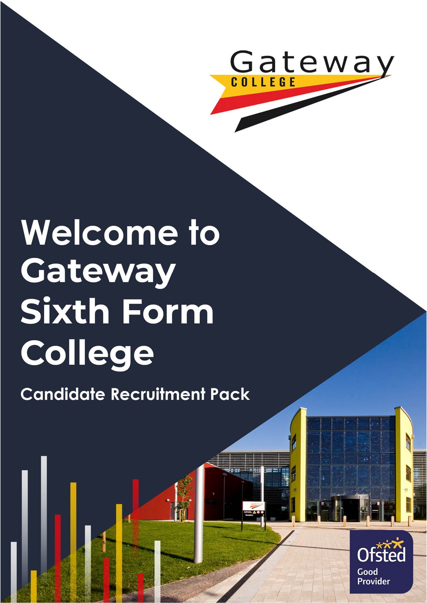
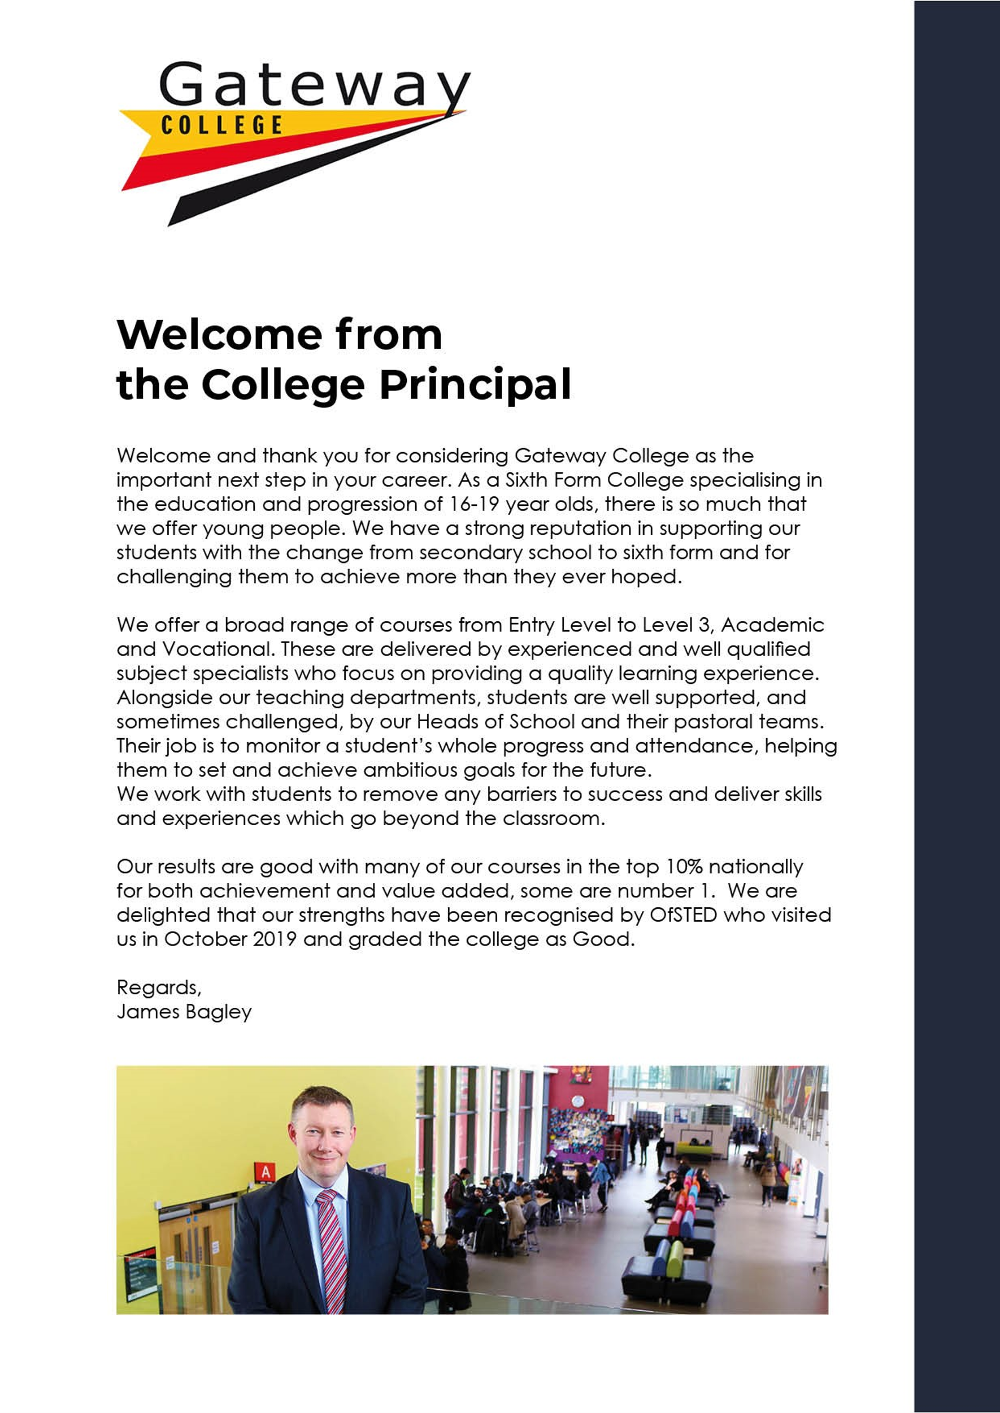
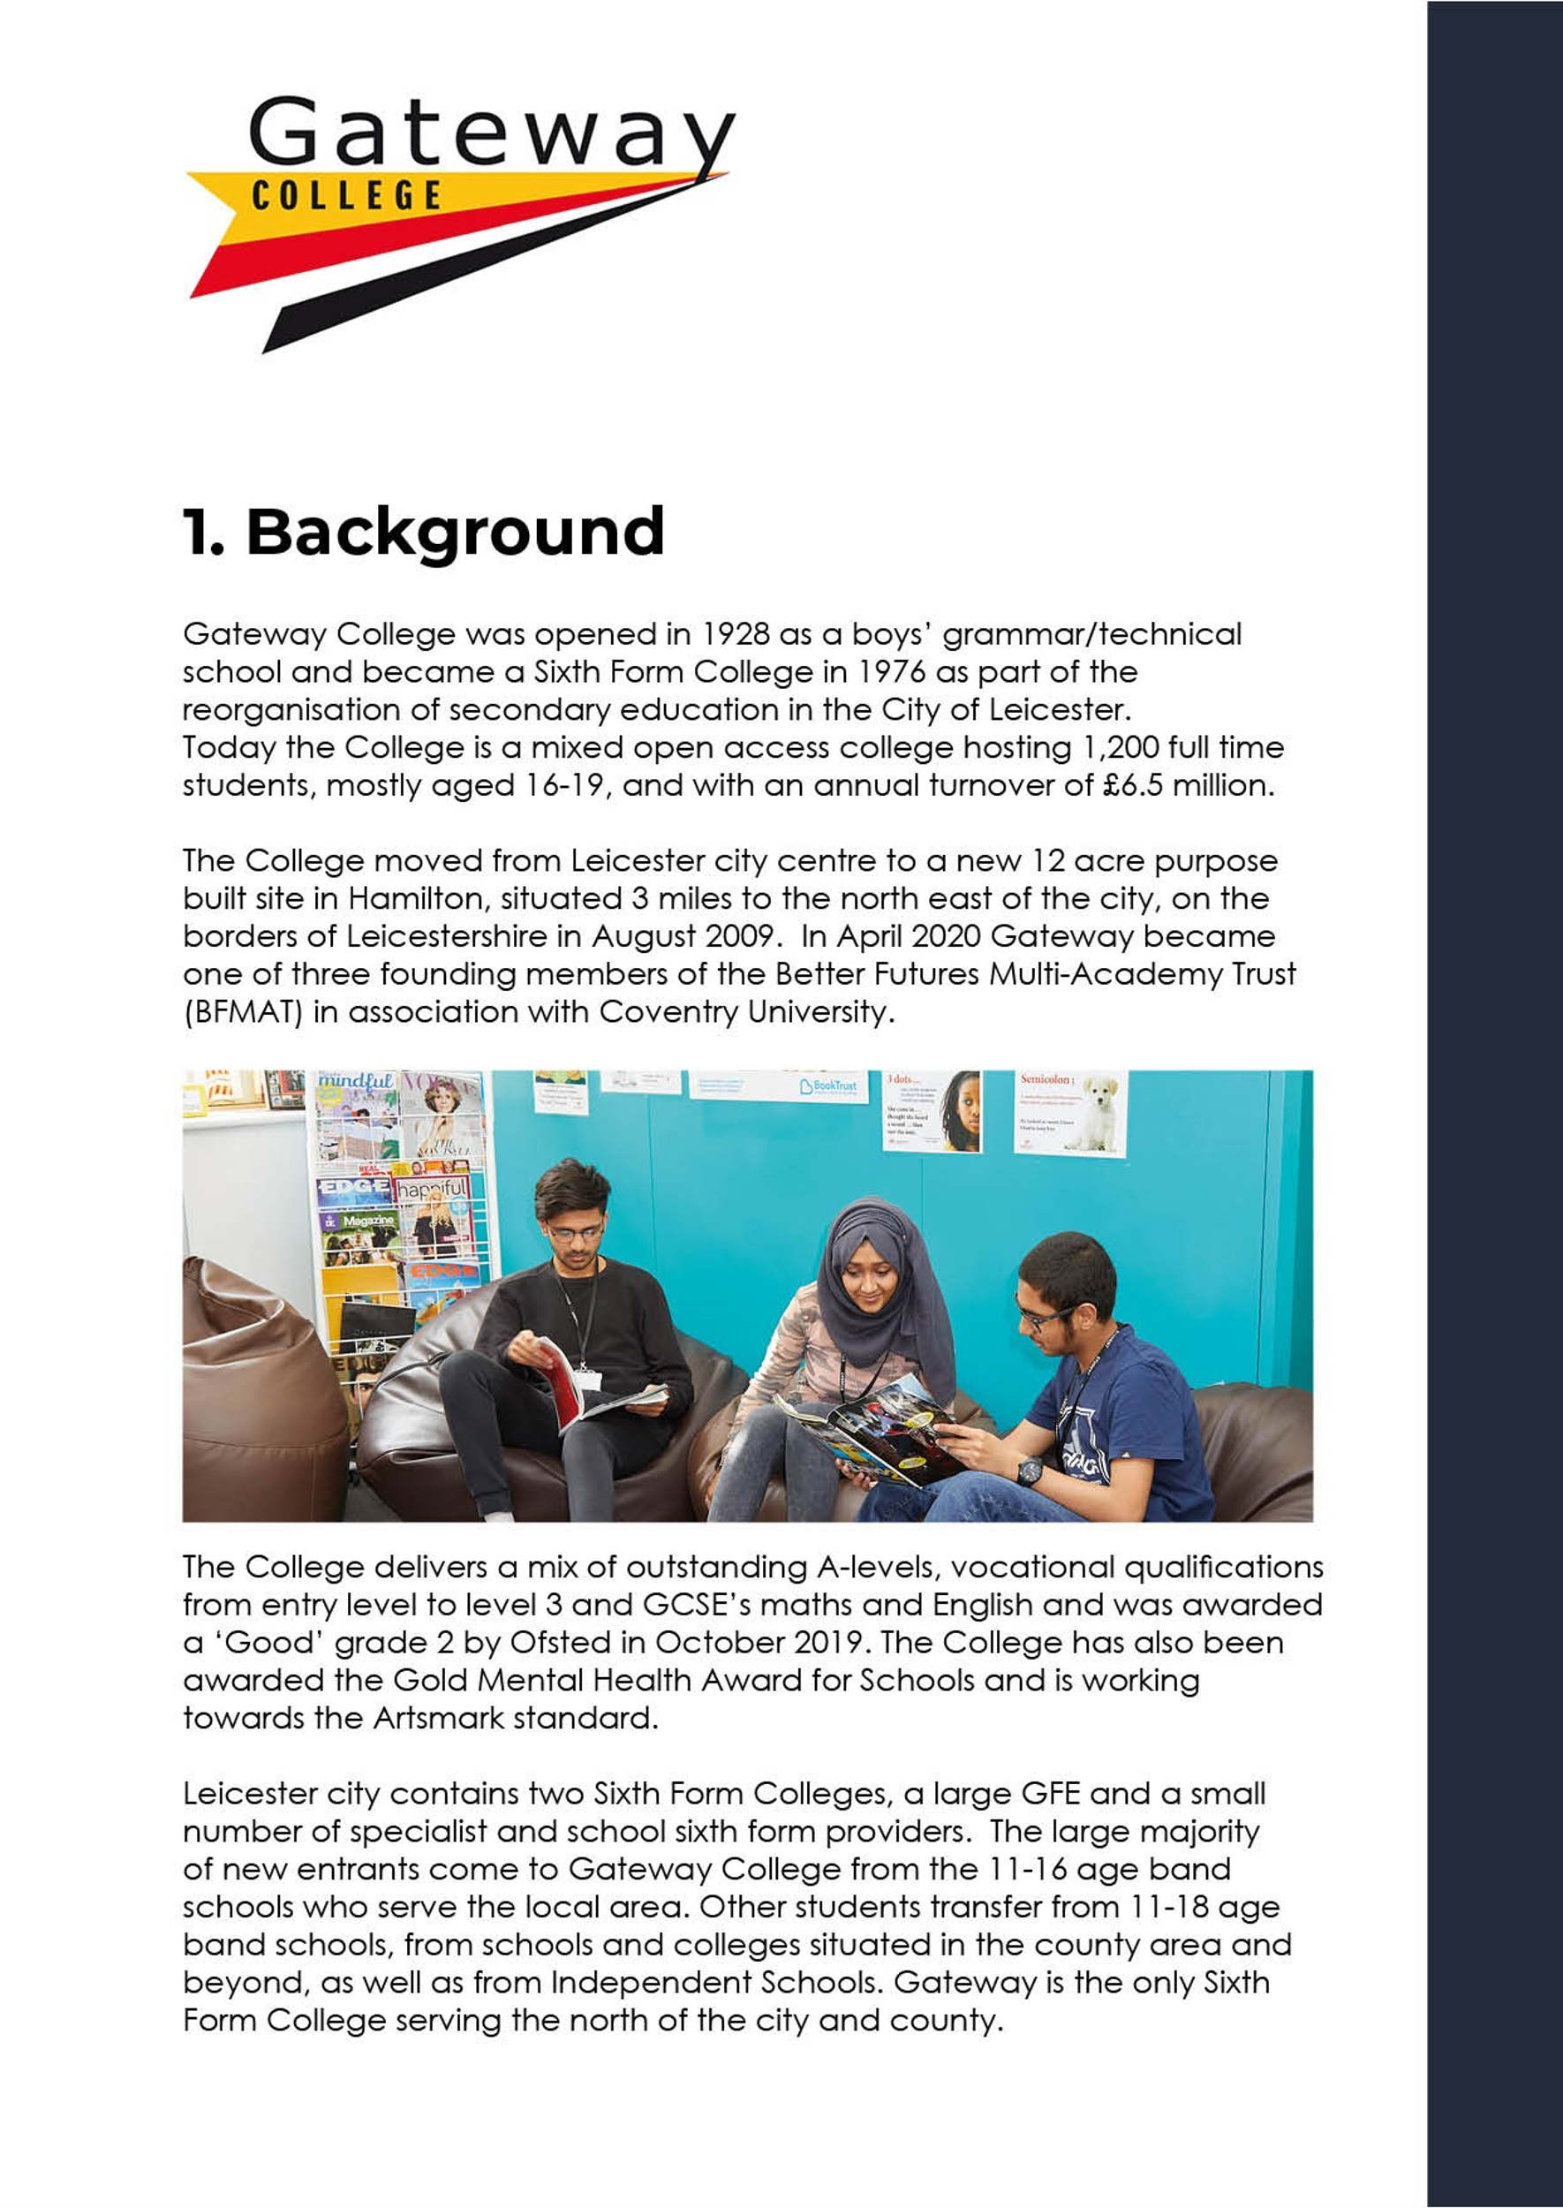
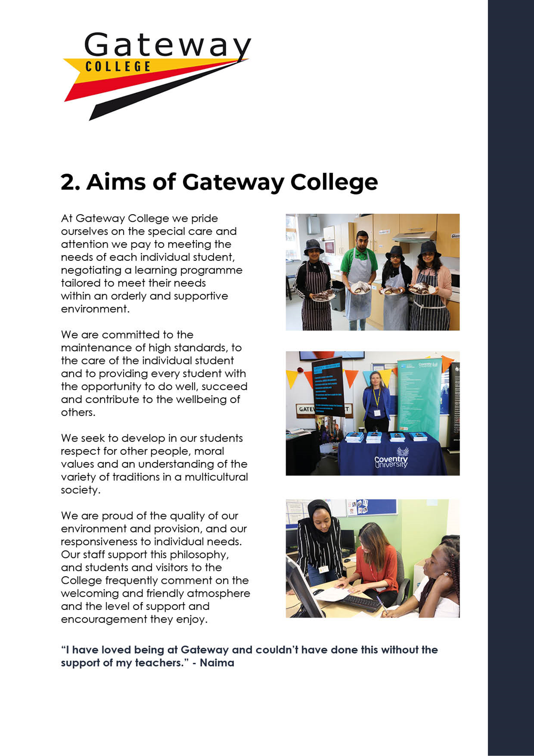
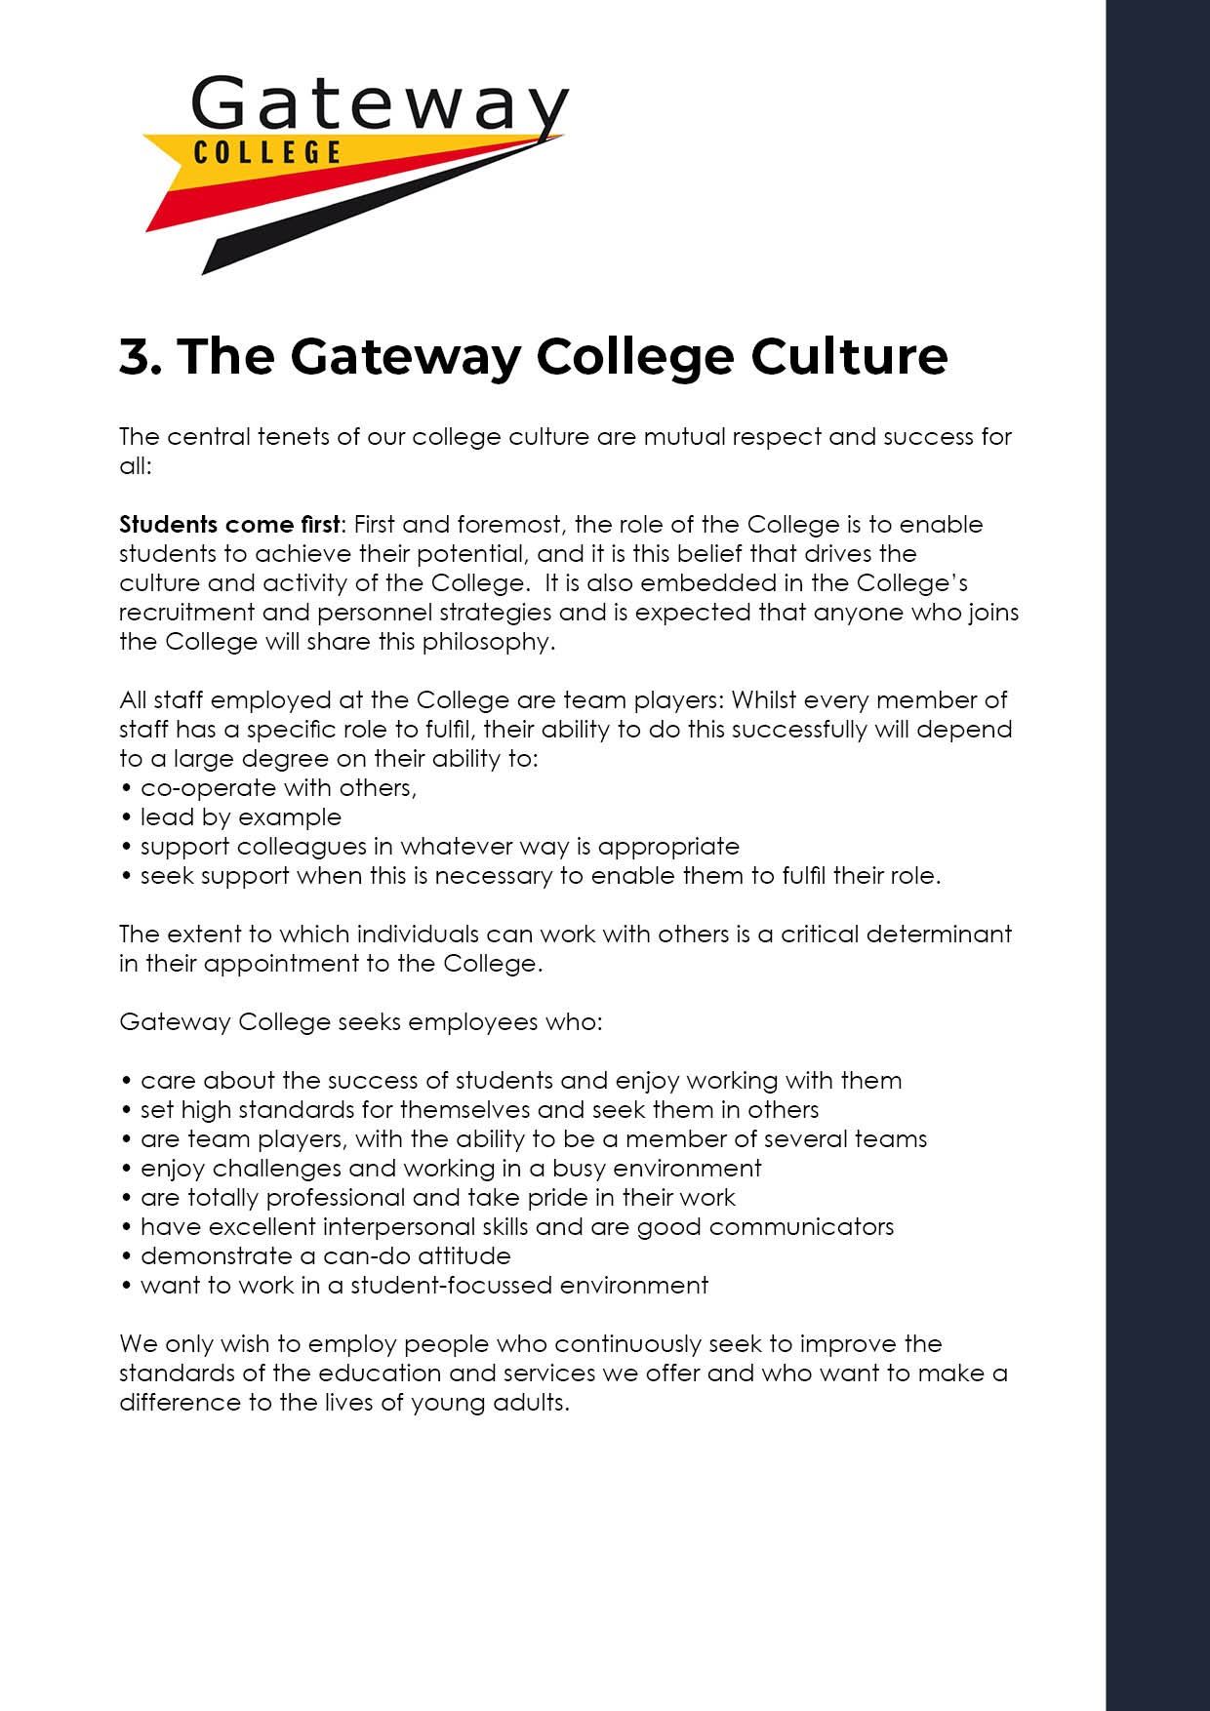
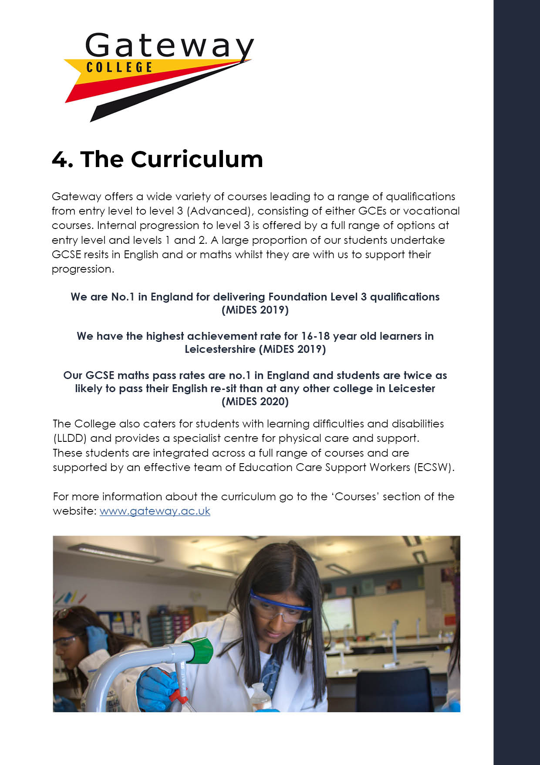
www.gateway.ac.uk

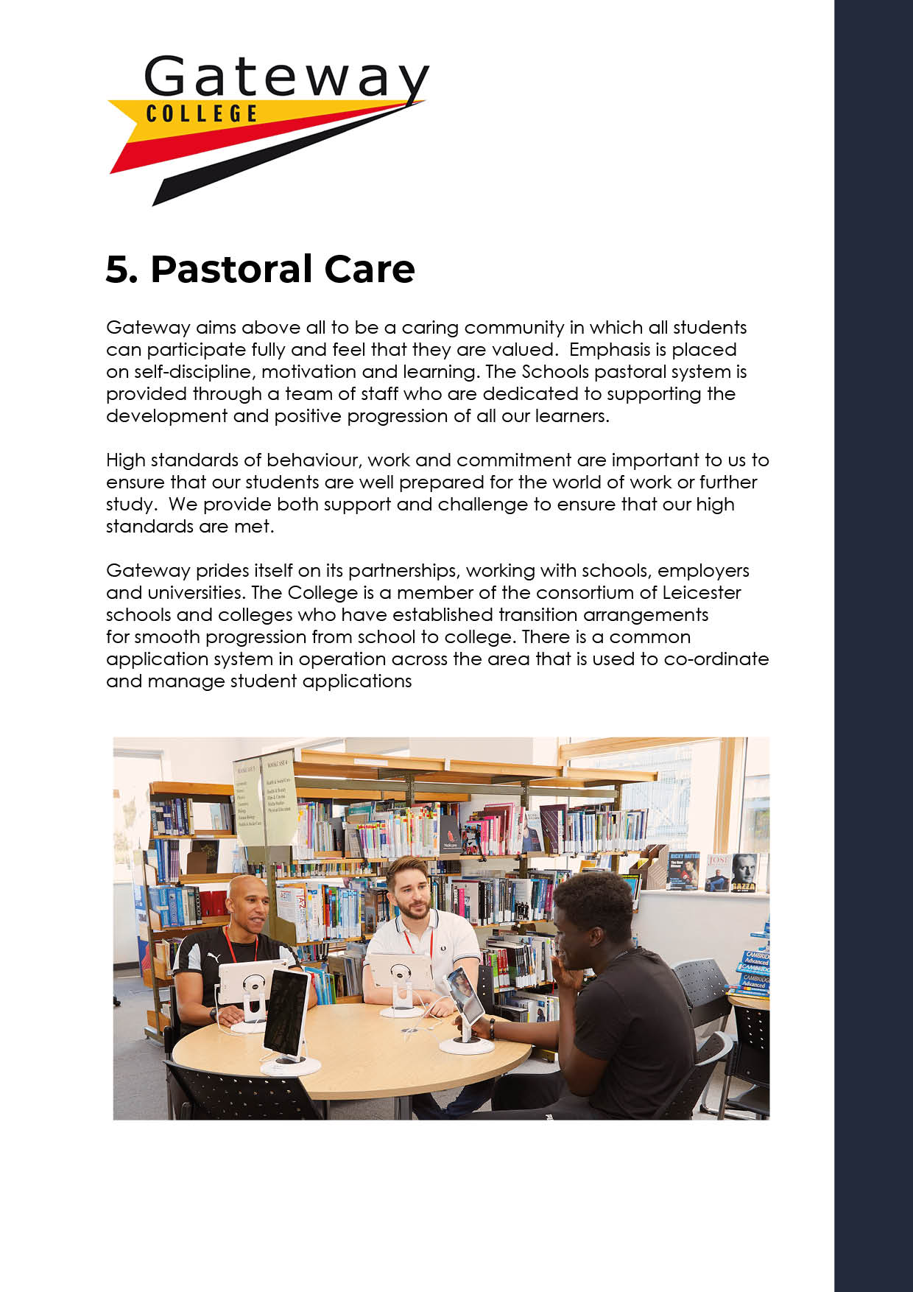
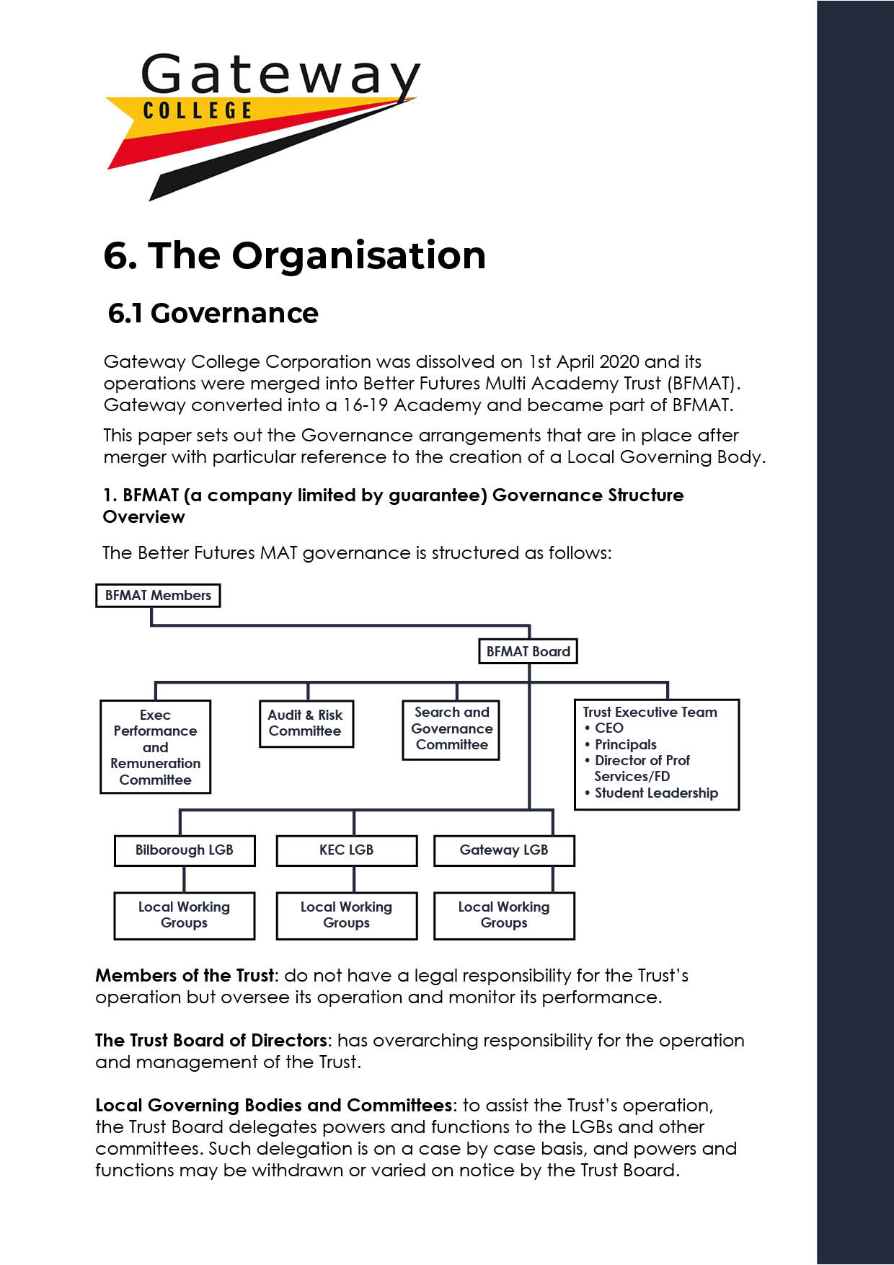
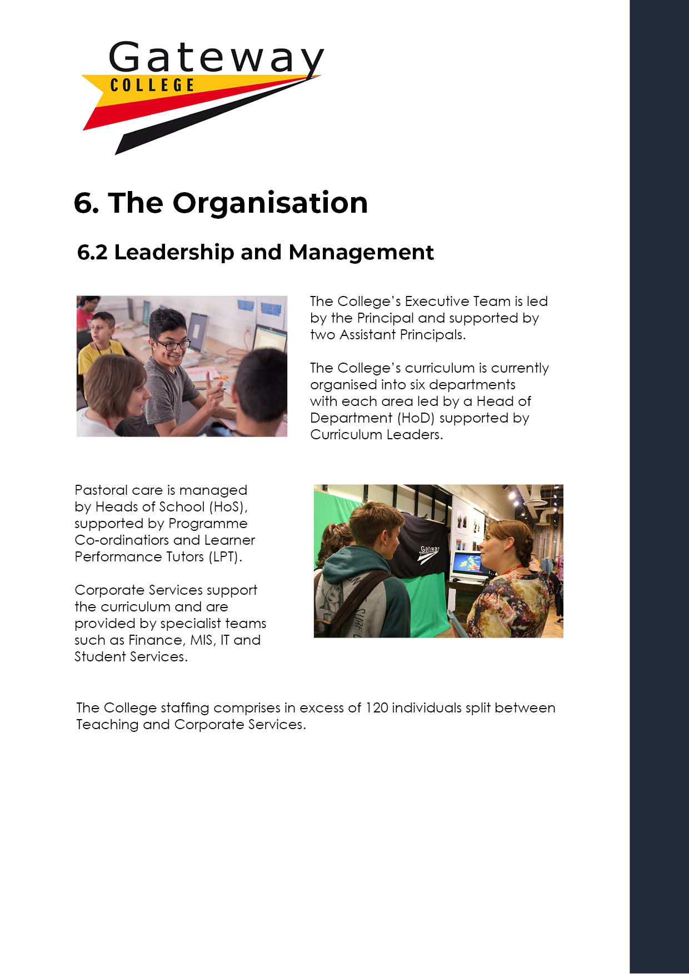
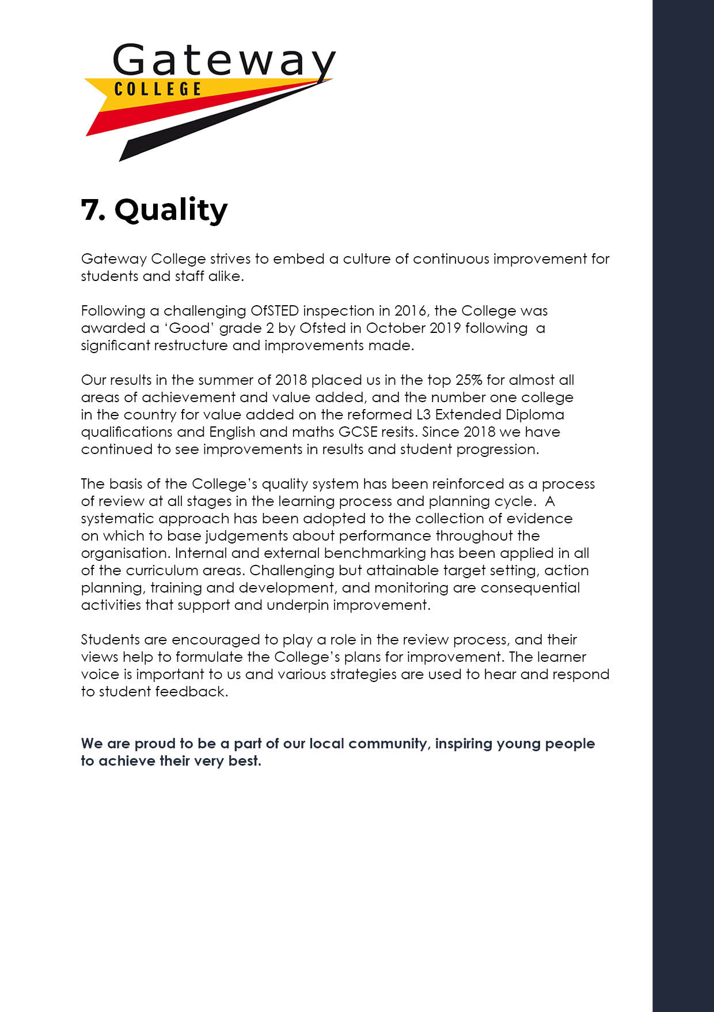
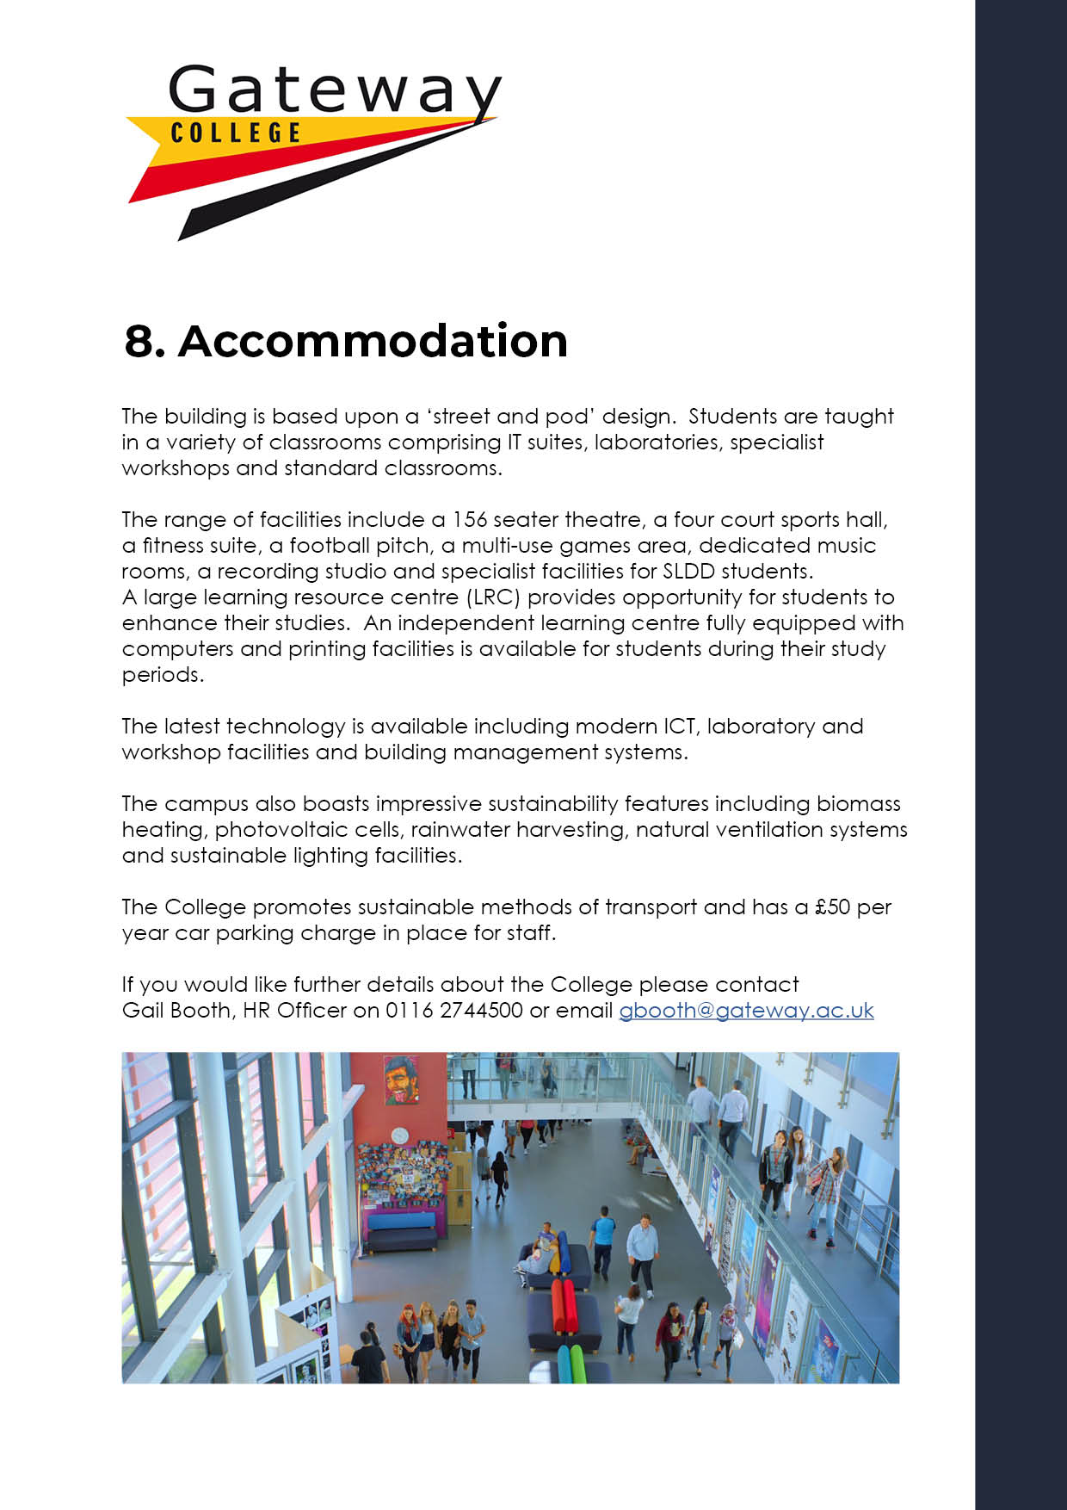


Gateway College is a vibrant, multicultural sixth form college catering
for around 1,300 students. In April 2020, Gateway joined the Better
Futures Multi Academy Trust (BFMAT). The following opportunity exists
to join a strong staff team based at our campus in Hamilton, Leicester.
Human Resources Assistant (Ref: 24/01)
30 hours per week, term time only (working pattern negotiable)
Actual salary: £16,162 - £17,628
An approachable and friendly person is required to provide a high standard of administrative support to the HR function.
The successful candidate should be well organised and have the skill to prioritise workload and meet tight deadlines. You should be sensitive and caring and understand the importance of confidentiality.
Duties will include processing Disclosure & Barring Service forms, inputting data, assisting with the recruitment and selection process and minuting meetings.
Closing date: Monday 22nd January 2024
Interview date: Monday 29th January 2024
Further details and an application pack can be obtained from www.gateway.ac.uk or Teaching and education jobs in LE5 1GA | Tes.
Further details and an application pack can be obtained from
www.gateway.ac.uk or Teaching and education jobs in LE5 1GA | Tes.



Responsible to: HR Manager
Tenure: 30 hours per week, term time only

Duties and Responsibilities:
Administration
- To undertake HR administrative functions as required by the HR Manager.
- To create and maintain employee records and update employment documentation as appropriate and ensuring all relevant changes are processed correctly and on time for the payroll deadlines.
- To support and maintain up to date information systems for monitoring Continuing Professional Development.
- To scan and archive all HR related documentation.
- To ensure staff qualifications are updated and maintained on a timely basis.
- To assist with the Equal Opportunities monitoring and recording of information with regard to recruitment of staff.
- To monitor and arrange staff probation, liaising with line managers, to ensure reports are received in a timely manner and take notes at review meetings.
- To act as minute taker within HR and other related groups.
- To undertake Reception duties during lunchtimes and other busy periods.
Absence management
- To support the HR Manager in sourcing cover for absence where necessary including liaison with employment agencies where required.
- To monitor and record staff absences via College systems, to include manual input of data and ensuring appropriate documents are completed by staff and line managers.
- To liaise with the HR Manager on matters relating to staff absence.

Recruitment & Selection
- To assist with pre-interview and new starter checks, including compiling offer letters, contracts, chasing up of all new appointment documentation in accordance with the appointment checklists (e.g. medical clearance, references, qualifications, DBS / Right to Work checks).
- To assist in the recruitment and selection procedure to ensure the efficient and effective running of interviews.
- To prepare shortlisting packs and notifying the HR Manager of any disclosures contained in application forms in line with the recruitment policy (e.g. adjustments required for interview);
- To assist in the preparation of correspondence relating to recruitment including interview, reference and reject letters to unsuccessful candidates.
- To provide administrative support in relation to the recruitment and induction of new staff.
- To process/record and monitor of all Disclosure & Barring Services (DBS) checks on all staff, external contractors, volunteers and other relevant personnel in line with appropriate guidance within the Safer Recruitment policy, ensuring the Single Central Record is kept up to date at all times.
- To liaise with the HR Manager on matters relating to DBS checks.

Other duties
- To support and maintain up to date information for monitoring Continuing Professional Development.
- To provide advice to the appropriate level on good HR practice and procedures.
Other
To undertake such other duties relevant to and connected with the smooth operation of the College as the Principal, or a designated alternative, may require.



Person Specification
ESSENTIAL | Method of Assessment | Short listing Column
- A good general level of education, likely to be beyond GCSE or equivalent. | A
- Excellent keyboard skills and the experience of using Microsoft packages and HR systems. | A/T
- Recent experience of working in an admin post and maintaining computerised records with minimal supervision. | A
- Excellent organisational skills with the ability to plan and deliver work to reasonable timescales and deadlines. | I
- A professional understanding of confidentiality, trust and discretion at all times. | I
- Recent experience of dealing with staff/customers/students. | I
- Tact, diplomacy, integrity and balanced judgement in day to day work. | I
- Ability to act independently using personal professional initiative, taking decisions and undertaking significant tasks in the absence of the HR Manager. | I
- High levels of literacy and numeracy skills, including drafting and proof reading. | A/T
- Skills and ability to draft confidential and sensitive correspondence on behalf of the HR Manager. | T
- Possess a high level of interpersonal skills to relate to and communicate effectively with colleagues verbally and in written form. | A
- Positive attitude, appropriate sense of humour, patience and professional cheerfulness. | I
- Awareness of own strengths and areas for development. | I

DESIRABLE
- An understanding of pre-employment checks and safer recruitment practices. | A
- An understanding of the role and practices of HR. | I
- An understanding of the Education Sector. | A/I
- Experience of dealing with problems under pressure. | I
- Recent experience of working in a HR department | A

A = Application form I = Interview T = Test

This post is subject to enhanced disclosure from the Disclosure & Barring Service.

Gateway College is subject to the Safeguarding Vulnerable Groups Act 2006 which requires that any candidate appointed must produce:

- A DBS clearance certificate
- Proof of identity
- Proof of qualifications
- Proof of the right to work in the UK.

The above documents MUST all be produced BEFORE commencement of employment.

Gateway College is an equal opportunities employer, committed to equality in employment and services.

