

Appointment of Part Time Rowing Coach
(January 2025)

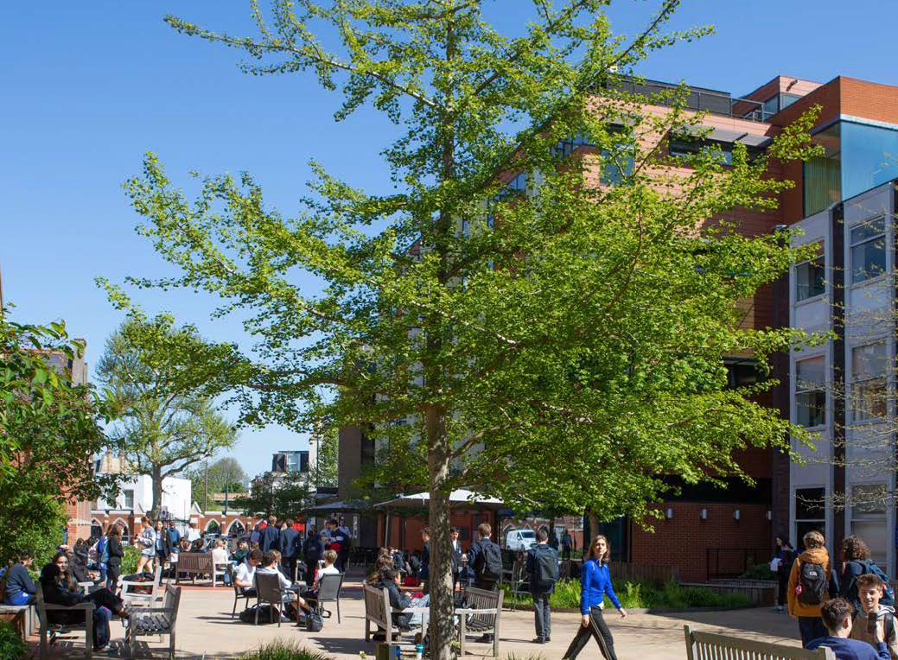

Contents

The Role 3
The Person 5
Additional Information 6
Application 7
Background Information 8
School Aims and Ethos 9
Team Biographies 10
Location 11

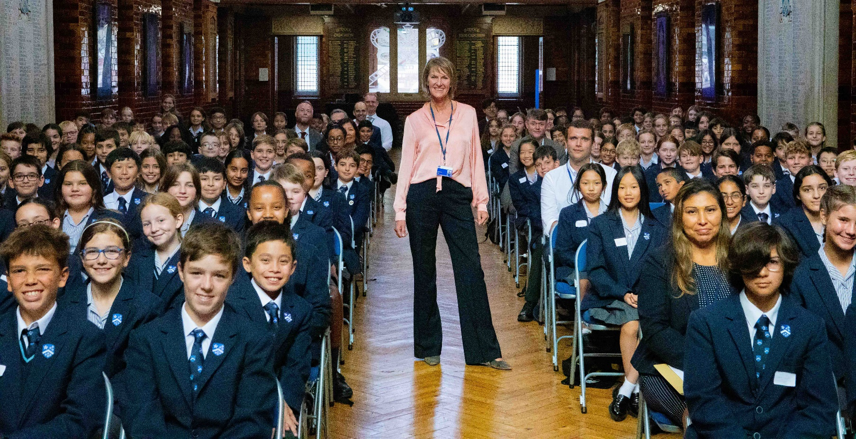

The Role
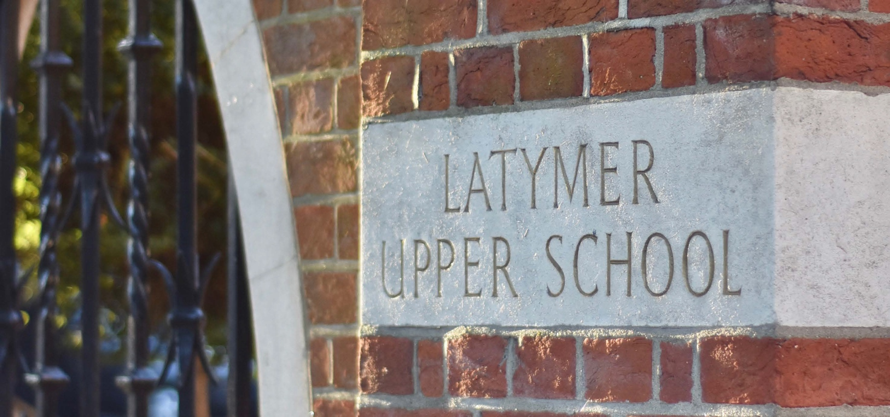

Overall purpose of the job:
As the leading, fully co-educational independent school in London, we have established a strong rowing programme across girls and boys’ events in both sculling and sweep disciplines, having achieved extensive success on the National stage.
We are now seeking to appoint a Part Time Rowing Coach to start in January 2025, coaching 20 hours per week. The successful candidate will be highly motivated, passionate and eager to build on the recent accomplishments of the school boat club that places pastoral support at the centre of its coaching. Experience of developing young athletes within a school programme progressing to Junior GB selection will be highly desirable.
The role will demand excellent planning, communication and administrative skills, with an ability to adapt coaching style to the individual, think ambitiously and work collaboratively and flexibly within a strong team environment.
Good judgement and sound Tideway knowledge will be essential, as will creativity in managing pupils of varying abilities in changeable conditions. A high level of responsibility will be given to implementing the programme and ensuring the consistent development of pupils from junior to senior level. Close communication will need to be established and maintained with sports, academic and the school pastoral team.
.

Reporting to:
Director of Sport
Head of Boats

Key responsibilities:
Coaching / Officiating

- To work with the Head of Boats to build an effective and dynamic rowing environment for pupils.
- To work with the Head of Boats to design and implement a technical framework on the water, land, and strength & conditioning sessions.
- Be confident in organizing equipment in advance for sessions
- To take a proactive role in ensuring rowing equipment is packed up at the end of each session, stored correctly and any repairs reported to the Boat House Manager.
- Attend coaches' meetings and any department meetings that have links to the boat club within the school.
- To assist the other coaches at regattas and head races, both rigging boats and boating pupils for races.
- To follow races and give relevant feedback to coaches and athletes as required.
- To demonstrate excellent knowledge of rowing and sculling techniques.
- To demonstrate knowledge of the principles of boat rigging.


- Be proactive in matters relating to health and safety, monitoring and identifying and dealing with hazards.
- Where necessary, to undergo on the job training and/or to attend INSED training where appropriate.
- safeguarding procedures, at all times.

The list above is not exhaustive and the rowing coaches are expected to be flexible and undertake any reasonable duties that the Head of Boats and/or Director of Sport deems applicable. There will be a significant commitment out of term time. LUSBC traditionally travels to train in October half-term, and again at Easter. All squads also train at other times during the school holidays and seniors attend GB trials and camps.

The Person
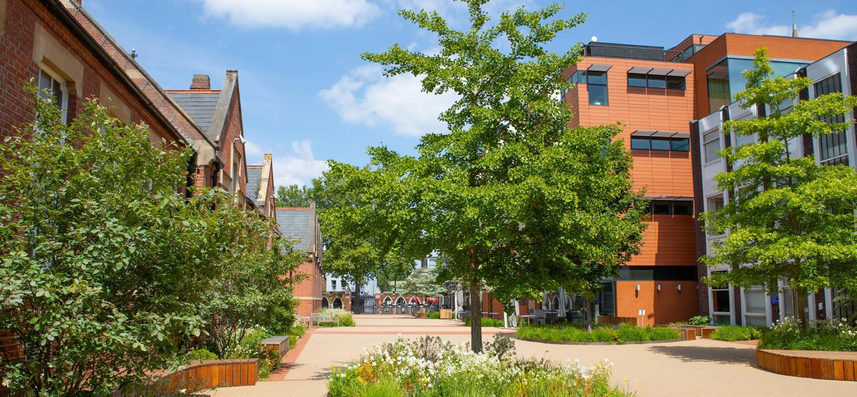

Person Specification

Essential:
- Excellent technical rowing knowledge supported by solid coaching experience
- A clear understanding of the administrative requirements of a Boat Club
- Strong written and verbal communication skills
- Strong interpersonal skills with the ability to inspire both pupils and colleagues alike
- Ability to work as part of a team
- Determination to get the best out of every pupil
- The vision to initiate new ideas and the skills to implement them
- Excellent organisational abilities
- Evident passion for the sport
- Passionate about developing rowers’ abilities from the early stages through to Senior level.
- An understanding of the place of rowing within the context of an academic school

Desirable

- Current or recent experience of coaching within a successful school program
- Current or recent experience of leading a large Squad to national level success
- Tideway knowledge and experience (preferably with steers accreditation)
- UKCC Level 2 (coaching qualification)
- RYA Level 2 Powerboat Licence
- Possession of the appropriate driving licence for towing and experience of towing would be a benefit (evidenced by a D1 or B + E category on licence documents)
- Proficiency in maintaining rowing equipment

Additional Information
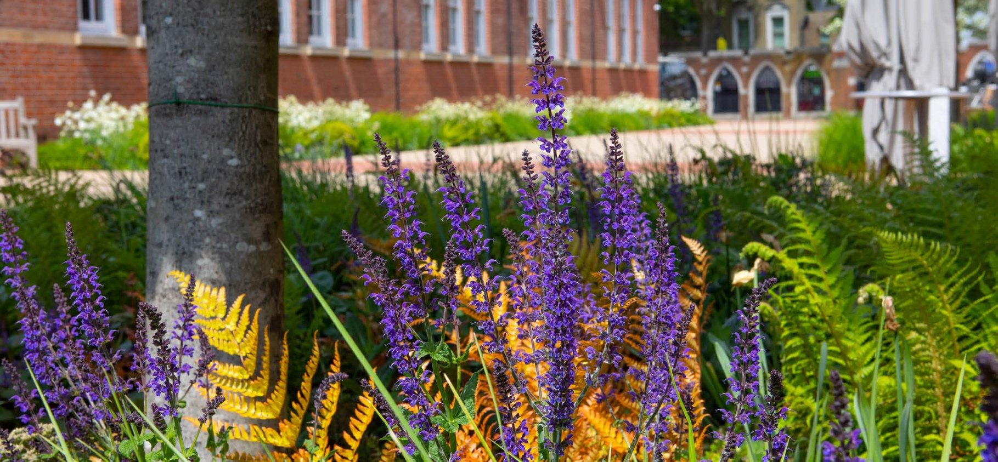

Salary
Up to £35,000 per annum FTE (pro rata based on 20-hour working week; actual salary circa. £17,500 p/a) dependent upon experience

Hours

Part time, 20 hours per week, to be agreed with the Head of Boats

Annual Leave
Annual leave of 33 days per year including bank holidays, rising to 38 days per year including bank holidays after five years of service. (please note that an element of leave is designated to be taken over the Christmas period and annual leave must be taken during the school holiday periods)

Dress Code
The School regularly receives visits from parents, potential parents and others, and naturally wishes to convey an impression of efficiency and organisation. Therefore, whilst not wishing to impose unreasonable obligations on staff, you are required to look smart in appearance

Application


To apply, please visit our dedicated recruitment website
Latymer.ciphr-irecruit.com
Further information on Latymer Upper School is available via the school website.
The closing date for applications: 9am on Thursday 5th December 2024

Interviews.

We will review applications as they are submitted, therefore suitable candidates may be interviewed before the closing date. We reserve the right to withdraw these positions if early appointments are made, therefore early applications are encouraged.

Diversity

The School is fully committed to the principles of equal opportunity, diversity and inclusion. We have an established and representative staff Equality and Diversity Board to help drive forward positive change. A further Equality and Diversity Committee has recently been formed from our student population.

We are committed to attracting and retaining the very best staff, ensuring that our staff body reflects the diversity of our students and local community. Acknowledging a lack of ethnic diversity within our staff community, we particularly encourage applications from Black, Asian and Minority Ethnic candidates for this role. All appointments will be made on merit, following a fair and transparent process. In line with the Equality Act 2010, however, the School may employ positive action where diverse candidates can demonstrate their ability to perform the role equally well.

Safeguarding
The School is committed to safeguarding and promoting the welfare of children and young people. The post is subject to an enhanced DBS check, online checks and two satisfactory references.

Background Information

Latymer Upper School was created by a generous act of charity. Writing his will in 1624, a wealthy lawyer named Edward Latymer left part of his wealth for the clothing and education of “eight poore boyes” from Hammersmith. Since its inception, the School has changed markedly although its founding aims and values have remained the same.
Established on its current site in Hammersmith in 1895, the Latymer Upper School of today consists of a vibrant, fully co-educational pupil body of approximately 1,220 girls and boys from all over West London and beyond, and a further 169 pupils at Latymer Prep. The School admits an equal spread of entrants from the state and independent sector and has one of the most ambitious bursary programmes in the country, delivered through The Latymer Foundation, which underpins the whole ethos of the School.
The School is proud of its unpretentious, cosmopolitan and caring community and visitors regularly comment on the Latymer ‘buzz’ and energy that permeates the whole school; it’s innovative and forward-thinking and pupils are academically questioning and curious.
Latymer Upper is unashamedly one of the most academically successful schools in the country and pupils excel across a wide range of subjects. Generally, pupils achieve over 30% A* and over 80% A*/A at A level and at GCSE over 90% A*/A grades.
Latymer Upper takes great pride in preparing its pupils to go on to study at a broad range of universities. Generally, between 15 and 20% of pupils win places at Oxbridge; increasing numbers win places at prestigious North American and European universities and the vast majority of UK university entrants go to Russell Group universities and several to leading specialist Drama, Music and Art Foundation Colleges.
You cannot pigeonhole a Latymerian: they are individual, highly academic but also rounded and grounded.

THE LATYMER FOUNDATION
In keeping with the inclusive vision of its founder, Latymer Upper School continues to offer such opportunities to London children by giving a number of means-tested bursaries to bright pupils every year based on the twin criteria of academic merit and family financial circumstances.
The Latymer Foundation exists to provide an academic education of the highest quality to pupils of ability, regardless of background. The Foundation is a separate charitable trust and, through the work of the Foundation, the School has had considerable success in recent years in raising funds for additional means tested bursaries.
In September 2017, The Latymer Foundation launched an ambitious new fundraising campaign – Inspiring Minds – ahead of the 400th anniversary of the School in 2024. The target - to raise £40m to build the School’s endowment and enable Latymer Upper to double its bursary provision to be able to offer 1 in 4 pupils a fee-assisted place. This would be a lasting and significant step towards the School’s ultimate ambition to ensure that any child is able to access a Latymer education regardless of their financial circumstances and make Latymer Upper School an engine of social mobility. It is an ambition that is supported by the talents, enthusiasm and generosity of all of the stakeholders in the School: pupils, parents, staff, alumni and former parents.

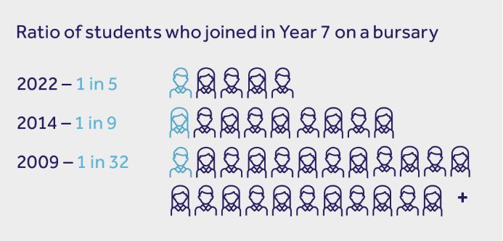

Please click to find out more about our Bursary programme

BURSARY PROGRAMME
www.latymerfoundation.org/bursaries/bursaries

PARTNERSHIPS
www.latymerfoundation.org/core-programmes/core-programmes

School Aims and Ethos

Edward Latymer’s vision was to offer his wards a life-changing education that would equip them to flourish in the wider world. This vision remains firmly at the heart of the School today.
Latymer Upper is first and foremost a ‘learning school’, vibrant, global in perspective, innovative in its teaching and learning and combining the best of the traditional and the modern. A high value is placed on scholarship in both pupils and staff and the School prides itself on the excellence of its teaching and pastoral care, its academic achievements and its exciting and innovative curriculum.

The aims of Latymer school


To provide an opportunity for academically able students from all walks of life to develop their talents to the full

To provide a choice of academic courses taught to the highest level in a broad, imaginative and developing curriculum, supported by a wide range of extracurricular activities, thereby giving all children the opportunity to excel in both their academic studies and their extra-curricular activities

To encourage independence of thought and approach in the pursuit of excellence in all activities

To educate our children into a recognition of their wider social responsibilities, particularly through educational activities including community links and partnership schools, to prepare them to become active citizens within their community

To maintain a focused environment within which an awareness of the needs of others and respect for all members of the community – children, teachers, support staff and parents – is paramount

To recognise and celebrate the richness and diversity of the range of cultural, religious and social backgrounds within our school community

To encourage in all Latymerians a pride in their school and the wish to exemplify to the world our values of tolerance, respect and intellectual curiosity

To inspire a love of learning and of life. Through support, guidance and encouragement we seek to nurture self- confidence and resilience in our pupils to enable them to achieve to the highest academic standards, to find self-fulfilment and to be happy

Team Biographies

 | Michelle – Payroll & Purchasing Manager  I carry out many roles in Finance but my most important is to make sure we all get paid. I really enjoy helping people get their pensions sorted out.  I worked in finance when I left school but did A levels at night school, followed by a degree in Ecology and Populations Genetics then a Phd at the Zoological Society in Conservation Genetics. I love Science!  Natalie – Director of Sport  I am a former England International hockey player and played hockey in the National Premier league for over 20 years. What I love about Latymer is how forward thinking and independent it is in every aspect - staff and students are given the freedom to express themselves and so, they are encouraged to take responsibility and think out of the box. I am currently also studying for a Postgraduate Diploma in Educational Leadership with a view to convert it into an MSc in the next two years.

Location

Address
237 King Street Hammersmith
London
W6 9LR
England
W www.latymer-upper.org
T 0208 629 2024

Nearest Underground Station
Hammersmith (District, Piccadilly and Hammersmith and City Lines) Ravenscourt Park (District Line)

Bus Routes
To Hammersmith Broadway: 9,10,27,33,72,190,209,2 11,220,266,283,295,391,419

Driving
There is no parking on site and we therefore recommend using public transport when travelling to the School

On Arrival
Please report to security at the main entrance on King Street

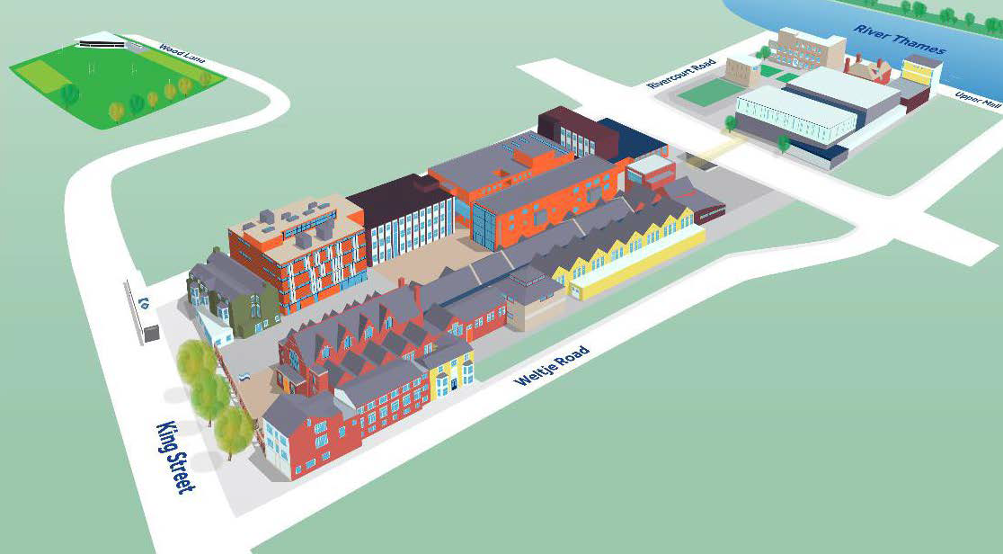


Latymer Upper School, King Street, Hammersmith, London W6 9LR latymer-upper.org

