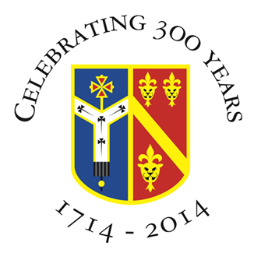

Archbishop Tenison’s CE High School
Selborne Road, Croydon CR0 5JQ
Tel: 020 8688 4014
www.archten.croydon.sch.uk

Assistant Head of Science

Location: Croydon, Surrey
Subject: Assistant Head of Science
(Physics or Chemistry would be an advantage but not essential)
Contract Type: Permanent – full time
Salary: MPS/UPS + TLR 2b (£5,352.00)
Required for: Thursday, 29th August 2024
Closing date: Monday, 25th March 2024
Interviews: Friday, 19th April 2024

- Teach KS3 to A Level Science
(Physics or Chemistry would be an advantage but not essential)

- Contribute to a committed and developing departmental team

- Communicate your enthusiasm for Science to the next generation of scientists in London’s largest Borough

- It would be suitable a more experienced teacher wishing to extend their expertise

- Be part of a school with strong traditions and wide-ranging extra-curricular activities

- Develop professionally and personally in a secure, but lively atmosphere

- Contribute to our pastoral care and our Christian ethos

Total number of pupils - 767 pupils (Sixth Form 75)

Exam Results can be viewed via - https://www.archten.croydon.sch.uk/academicresults

Archbishop Tenison's is an equal opportunities employer and committed to safeguarding and promoting the welfare of children. Successful candidates will be required to undertake an enhanced Disclosure check by the Criminal Records Bureau; online checks will be carried out.

Application Process: Please submit your application and covering letter to Mr Parrish, Headteacher detailing your suitability for the role by 25th March 2024. Please visit the staff recruitment page via the school website https://www.archten.croydon.sch.uk/staffrecruitment
An initial phone call or visit to explore possibilities and express interest is much encouraged. Please email Mrs Andrew, Headteacher's PA via patoheadteacher@archten.croydon.sch.uk or call 020 8688 4014.

