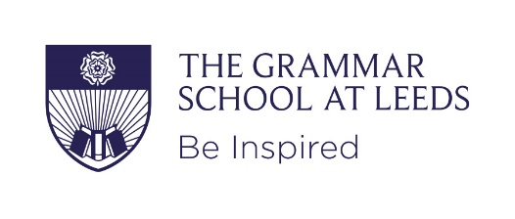
Job description
The Grammar School at Leeds
Job title: Modern foreign languages assistant
Responsible to: The Head of Department and through/him/her to the Head of the Modern Languages Faculty

Main purpose of job:
The role of the Language Assistant is to:
- improve students’ confidence and oral communication skills
- motivate students to learn languages
- teach students about the culture of Francophone countries

Main responsibilities:
The main function of the language assistant is to support the language teacher, either working alongside them in the classroom (team teaching) or on their own with small groups of students. Assistants can help to:
- practice students’ reading, comprehension, pronunciation, oral skills
- plan activities and games, using authentic materials
- introduce and contribute to group discussions and role plays
- prepare for oral exams
- teach younger students and / or special cases (including bilinguals) to facilitate differentiation.
- contribute to other areas of the curriculum where they may have a special interest or expertise (music, drama, sport, history)
- To provide language teaching within a cultural context by establishing a link with the target language speaking countries
- To prepare relevant, up-to-date and authentic materials for use in teaching which engage and challenge students
- produce displays using authentic materials
- assist with administration / clerical loads within the Faculty (depending on teaching commitments)
- run film clubs/news clubs at lunch times or after school
General:
- Any other assistance as may be reasonably required from time to time by the Principal or other senior manager in order to facilitate the efficient running of the school.
- This job description does not define in detail all responsibilities and the responsibilities and activities in the job description may be varied to meet the changing demands of the school at the reasonable direction of the Principal.
- All staff employed by The Grammar School at Leeds are expected to take responsibility for promoting and safeguarding the welfare of children and young persons for whom they are responsible or with whom they come into contact.
- All staff should be aware of the school’s health and safety policy and implement it as appropriate.

Person specification

Job title: Modern foreign languages assistant

Main purpose of job:

The role of the Language Assistant is to:
- improve students’ confidence and oral communication skills
- motivate students to learn languages
- teach students about the culture of Francophone countries

Qualifications & attainments
- Minimum of GCSEs in Maths and English, grade C/4 or above or equivalent.
- Successful completion of a foreign language course/degree level French, if not a fluent speaker.

Experience & knowledge
- Experience of working in an educational setting may be advantageous, but not essential.
- Knowledge and understanding of the issues, concerns and needs of pupils.

Skills & qualities
- Ability to communicate effectively orally and in writing to a range of audiences
- Enthusiastic, with a passion for the subject and the ability to motivate students
- Friendly, approachable and patient with the ability to relate well to students and colleagues.
- A strong team player, who actively helps and supports others.
- An interest in the cultures of Francophone countries

Values & ethos
- Commitment to child protection and the promotion of a safe environment for learning.
- Commitment to the school’s support and promotion of equity, diversity and inclusion.
- Commitment to continuous self-development and a willingness to learn.
- Understand and support the ethos of independent education.

Work circumstances
- Ability to work flexibly to meet the demands of the job, including attendance at school events, occasionally on evenings and weekends.

