
Job Title: Head of Physics

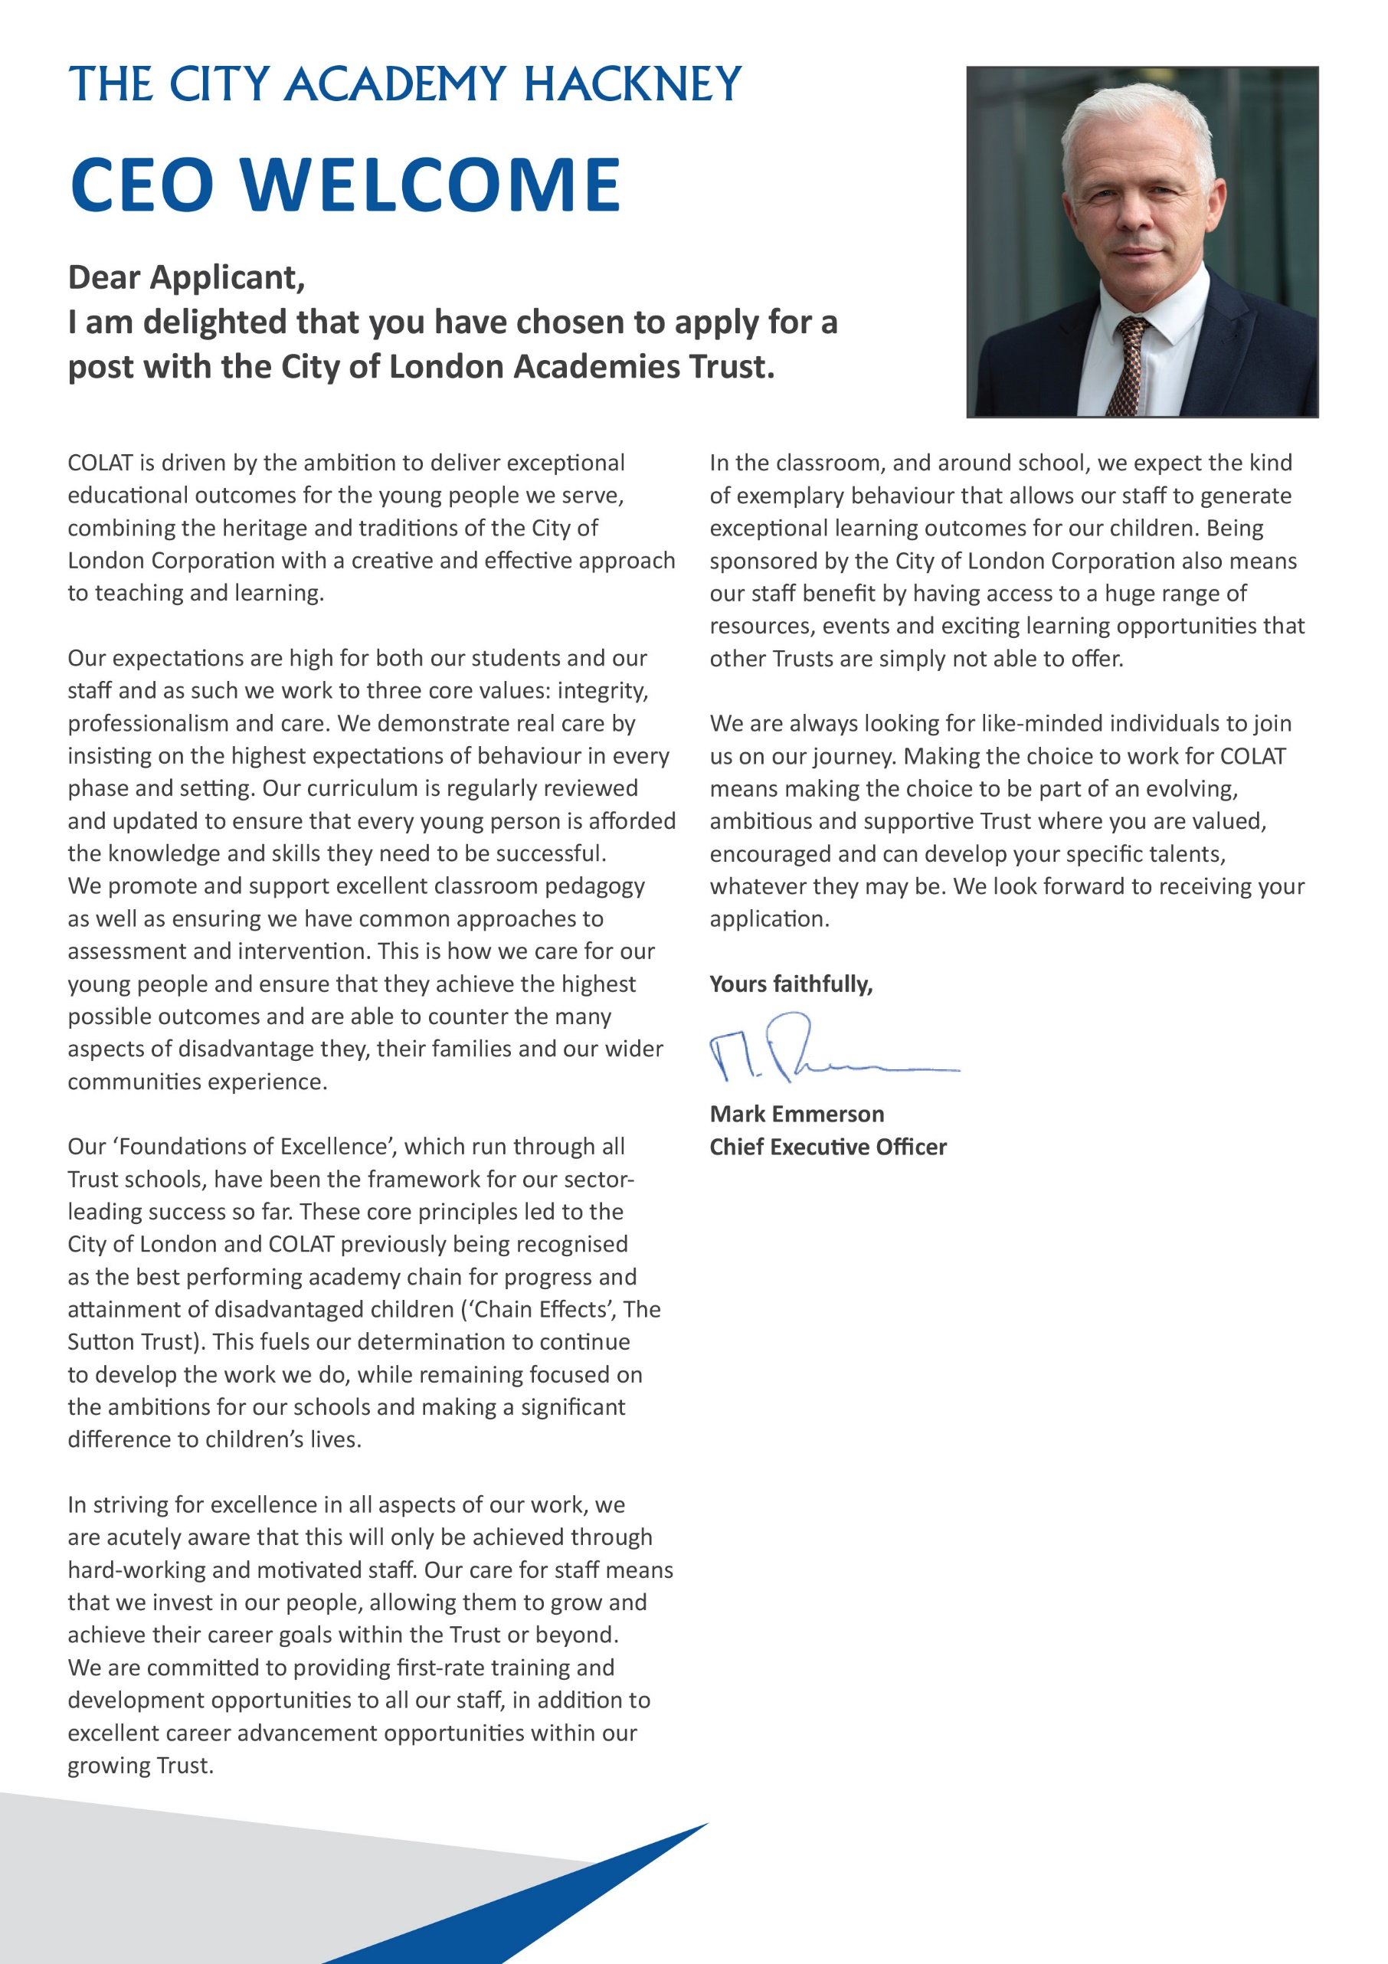

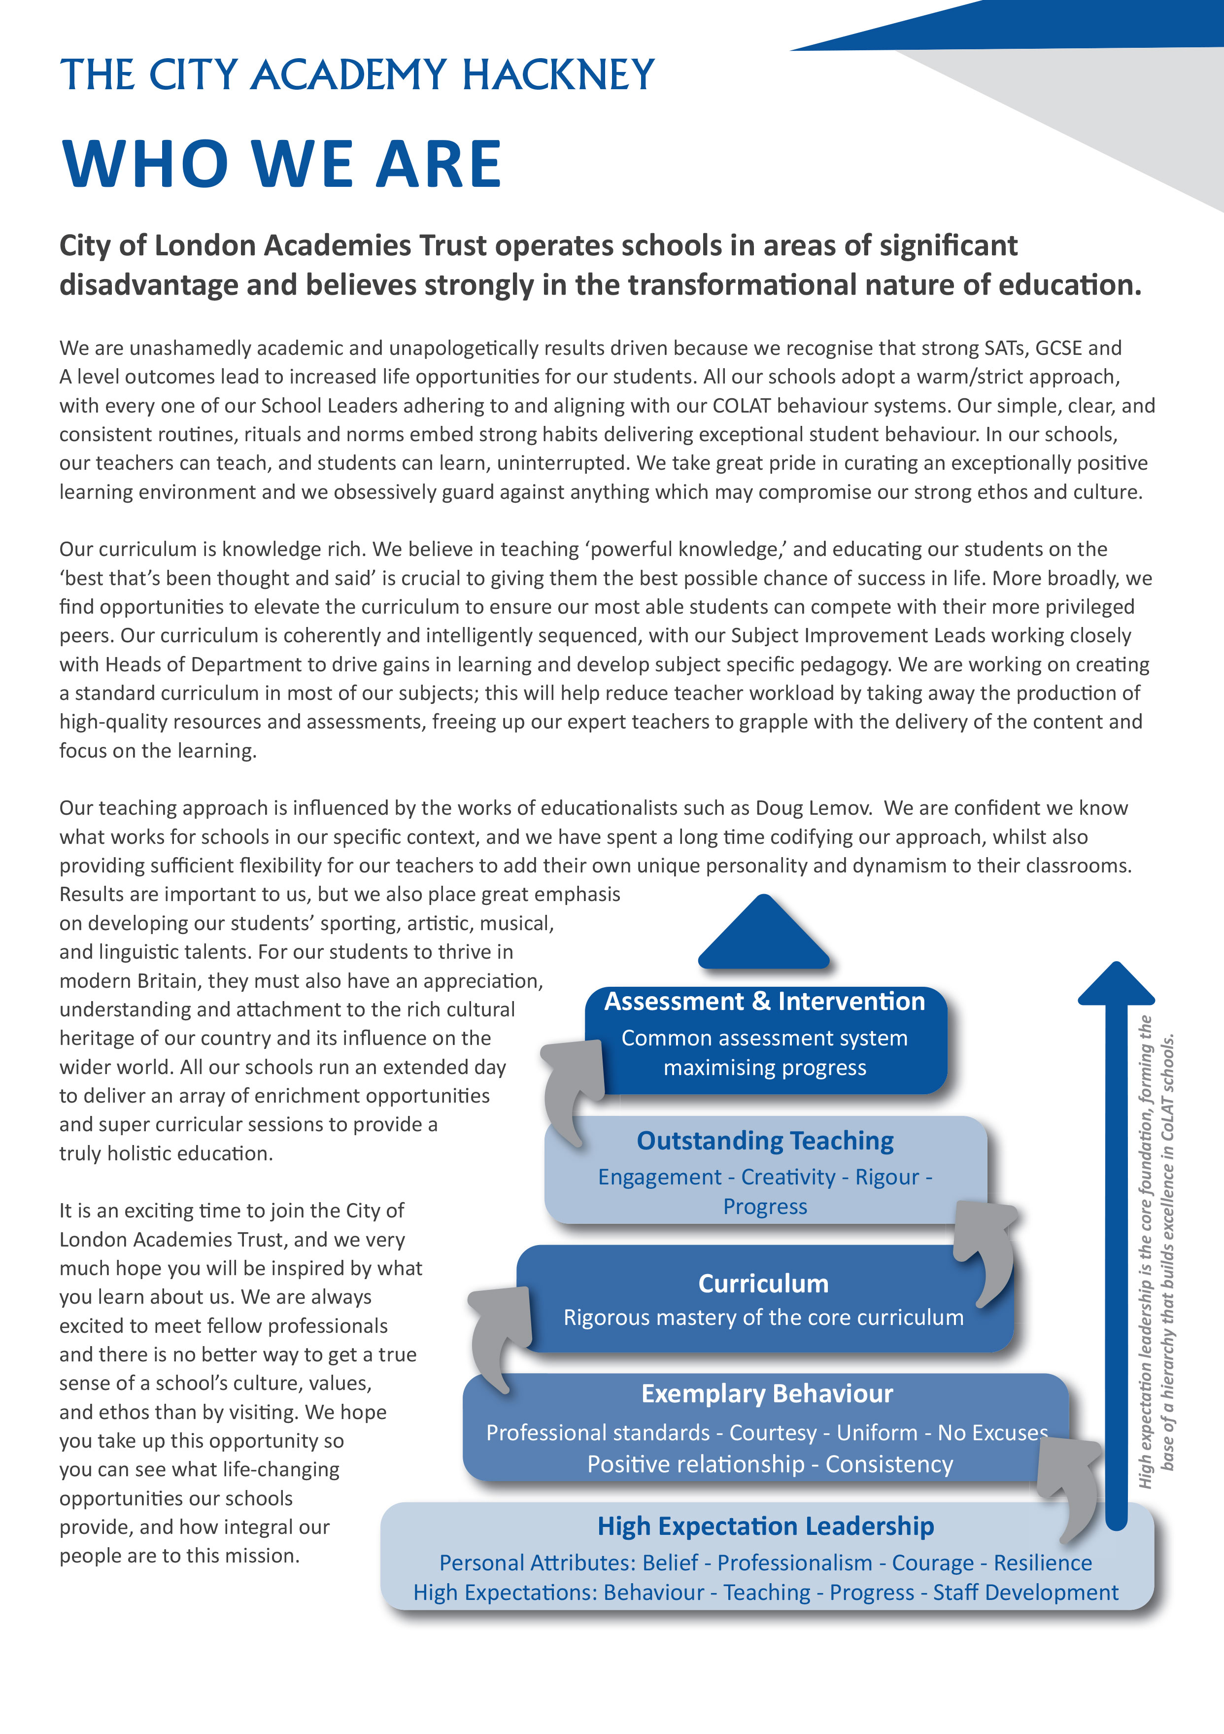


Headteachers Welcome

Dear Candidate,

Thank you for expressing an interest in the post of HEAD OF OHYICS at The City Academy, Hackney.

At The City Academy, Hackney, we are dedicated to providing all the students in our community with the best possible educational opportunities. We believe excellence is achieved through three key ingredients: clear structures, high expectations and strong relationships. Our outstanding curriculum is built around 'The City Experience' which places equal value on academic, creative, sporting, linguistic and personal development.
We pride ourselves on being a school which offers young people a warm and supportive environment, enabling them to meet our very high expectations. Our inspirational staff are skilled and committed and we are generously supported by The City of London Academies Trust. As a result of this, our students make exceptional progress.
We are looking for staff who are committed to working with students of all abilities, who constantly seek to learn and improve and who are ambitious for themselves as well as for their students. We expect hard work, skill and dedication, and in return will provide a supportive, flexible working environment, first class training opportunities and a comprehensive benefits package.

If you have the experience and passion to join our team and inspire the next generation, we look forward to hearing from you. Please apply via our website: https://www.thecityacademyhackney.org/

If you have any questions or would like to arrange a visit to the academy please contact our HR team at hr@thecityacademy.org. I look forward to reading your application.

Yours sincerely,



Anna Sarchet
Principal

Head of Physics - Job Description

Post: HEAD OF PHYSICS

Accountable to: Subject Leader Science

Grade Scale Point Range: M1 up to UPS3 (Inner London) plus TLR2b

Salary Range: £38,766 - £60,092 plus £5,835 (2024/25)

Working Pattern: Permanent, Full Time

Location: Hackney

Disclosure level: Enhanced

Responsible for: Supporting the leadership of the Science faculty

Main Purpose:
- Work with the Subject Leader to further develop and implement the curriculum in Physics
- Provide high quality leadership of staff in the Science faculty
- Contribute to the leadership capacity of Science across the academy.

Key Accountabilities
- Teaching and Learning
- Teach Science across all key stages
- Be a form tutor and/or Personal Adviser
- Ensure students’ progression is adequately monitored and achievements maximised
- Efficiently address gaps in attainment of underachieving students
- Fulfil the requirements of academy policies.

- Leadership and Management Responsibility
- Be responsible for one key stage, raising the level of attainment in Science in accordance with academy targets and expectations
- Line manage staff within the faculty
- Monitor the quality of teaching and learning
- Monitor and identify underachieving students from performance data
- Address underachievement by helping formulate and deliver strategies and approaches
- Deputising for the Subject Leader as required as part of the academy’s middle leadership group.

- Standards/Quality Assurance and Additional Responsibilities
- Support extended day activities to enhance students’ learning experiences
- Adhere at all times to professional business standards of dress, courtesy and efficiency in line with the ethos and specialism of the academy
- Attend team and staff meetings
- Attend and participate in open evenings and student performances
- Uphold the academy’s behaviour code and uniform regulations
- Participate in staff training and development
- Develop links with governors, LEAs and neighbouring schools/academies.

Key Organisational Objectives

The postholder will contribute to the academy’s objectives in service delivery by:
- Following Health and Safety requirements and initiatives as directed
- The academy is committed to safeguarding and promoting the welfare of children and young people and we expect all staff to share this commitment
- Ensuring compliance with Data Protection legislation
- At all times operating within the school’s Equalities policies, demonstrating commitment and contribution to improving standards of attainment
- Adopting Customer Care and Quality initiatives
- Fulfilling the role of Student Personal Adviser and/or mentor if required
- Contributing to the maintenance of a caring and stimulating environment for young people.

Conditions of Service
Governed by the National Agreement on Pay and Conditions of Service, supplemented by local conditions as agreed by the Trust.

Special Conditions of Service
Because of the nature of the post, candidates are not entitled to withhold information regarding convictions by virtue of the Rehabilitation of Offenders Act 1974 (Exemptions) Order 1975 as amended. Candidates are required to give details of any convictions and are expected to disclose such information at the appointment interview.

Because this post allows substantial access to children, candidates are required to comply with departmental procedures in relation to Police checks. If candidates are successful in their application, prior to taking up post they will be required to give written permission to the Department to ascertain details from the Metropolitan Police regarding any convictions against them and, as appropriate the nature of such convictions.

Safeguarding Children
COLAT is committed to safeguarding and promoting the welfare of children and young people. We expect all staff to share this commitment and to undergo appropriate checks, including enhanced DBS checks.

The above responsibilities are subject to the general duties and responsibilities contained in the Statement of Conditions of Employment. The duties of this post may vary from time to time without changing the general character of the post or level of responsibility entailed.

The person undertaking this role is expected to work within the policies, ethos and aims of the Trust and to carry out such other duties as may reasonably be assigned. The post holder will be expected to have an agreed flexible working pattern to ensure that all relevant functions are fulfilled through direct dialogue with employees, contractors and community members.

English Duty
This role is covered under part 7 of the Immigration Act 2016 and therefore the ability to speak fluent spoken English is an essential requirement for this role.

Head of Physics – Person Specification

Our Values and Vision
The City of London Academies Trust, sponsored by the City of London Corporation, aims to provide high-quality education for students and pioneer educational innovation. We are driven by the ambition to provide world-class experiences and deliver exceptional educational outcomes for the young people we serve.

All City of London academies draw upon the traditions, institutions, heritage and historical successes of London to furnish each of their diverse communities with life-transforming learning experiences. In doing so, we believe that the young people we serve develop into successful, compassionate young adults, who make a positive contribution to their local, national and global communities.

Our schools are characterised by a common understanding of what makes outstanding schools, based on five key principles which are known as our 'Foundations of Excellence'​.

Our Staff
Our staff have high expectations, are consistent and driven to provide the best teaching and opportunities for our students. Teachers work in a well-disciplined environment where they are able to teach creative and engaging lessons, and all staff are given exciting opportunities to develop and learn from exceptional practitioners.

Equal Opportunities
The postholder will be expected to carry out all duties in the context of and in compliance with the COLAT Equalities policies.

 | Essential | Desirable
Qualifications
Educated to degree level or equivalent
Qualified teacher status
Experience, Skills and Knowledge
Ability to organise whole school/year-based activities
Ability to think and plan strategically and manage change
Ability to use collaborative teaching methods and work with colleagues in the preparation, assessment and monitoring of work
Ability to provide high quality outcomes
Ability to provide high quality teaching to students of all abilities
Experience as a form tutor and/ or pastoral work
Demonstrable experience of improving student outcomes
Leadership experience including managing staff and students
Experience developing differentiated schemes of work
Knowledge of developments in the National Curriculum
Knowledge and understanding of the Academy’s strategic plan and the role to be played by this role and the faculty
Knowledge of effective strategies for supporting staff to improve teaching and learning
A record of continuous professional and career development
Personal Qualities
Excellent communication skills and organisational skills
Good interpersonal skills and the ability to work collaboratively, leading to professional development of staff, achievement of departmental aims and to the efficient running of the faculty
Excellent creative teaching ability
Commitment to personal career development
Ability to work under pressure while maintaining a positive, professional attitude
Ability to organise and prioritise workload and work on own initiative
Ability to use ICT effectively
Ability to use ICT to raise achievement and as a management tool.
Other
Understanding of different social backgrounds of students
Understanding the needs of students and the appropriate strategies to support them
Understanding the needs of bilingual students

