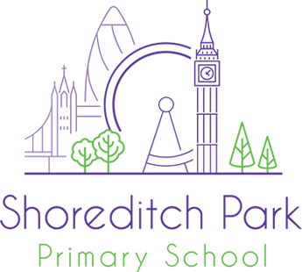

Autism Resource Provision Manager
Hackney

Employer | Shoreditch Park Primary School
Location | Hackney
Salary | Competitive and based on experience  (Please note this position is not suitable for ECTs)
Contract type | Full Time
Contract term | Permanent – (Open to flexible working)
Job dates
Posted | 6th January 2023
Closing date | 19th April 2023
Job starts | 1st September 2023
Welcome to Shoreditch Park Primary School

Are you a passionate teacher, SEN teacher or SENCo with an interest in autism education? Do you want to develop your skills and expertise in a specialist area? We are looking to recruit an experienced teacher to manage the school’s outstanding autism resource provision.

Shoreditch Park is a thriving and high performing school in Hackney with a dedicated autism resource provision (ARP) for 10 pupils. Our well-established and forward thinking ARP caters for pupils with a diagnosis of autism and an EHCP.

You will be joining us on an exciting part of our journey to excellence. We are a Flagship School for Excellence for Inclusion (IQM). At the heart of our achievement is the belief that every child can flourish in a calm, structured and stimulating environment. As a result pupil behaviour is exemplary and outcomes are high. We have wonderful children and dedicated staff that go that extra mile every day.

We are looking for an ARP manager who can:
- Oversee the teaching, learning and assessment of two learning groups.
- Manage a team of dedicated and experienced support staff.
- Communicate effectively with parents, including leading annual review meetings.
- Liaise with specialist staff and external professionals to coordinate their input.
- Demonstrate optimism about children and expect the highest possible standards.
- Be part of the wider SMT or SLT (depending on experience)

We offer:
· A passionate, driven and successful school where you will feel well supported in your role.
· A well-established autism resource provision with high aspirations for its pupils.
· Opportunities for training and development in the field of autism education.
· A robust induction process supported by a strong inclusion team.
· A comprehensive Wellbeing Policy which includes benefits such as free membership to Employee Assistance Program.

Visits are highly recommended.
Contact Nicola Cavanna at vacancies@shoreditchpark.hackney.sch.uk to arrange a school tour with the Assistant Head for Inclusion on the following day:

Tuesday 18th April 2023
9am or 4.30pm

Please visit our website, www.shoreditchpark.hackney.sch.uk, for further information about Shoreditch Park Primary School and to download an application pack.

Closing date for applications: 19th April 2023
Interviews: W/c 24th April 2023

(We reserve the right to interview exceptional candidates prior to the closing date and references will be requested for shortlisted candidates).
Shoreditch Park Primary School is committed to safeguarding all children. Successful candidates will require a DBS clearance and suitable references before commencing employment. We are committed to diversity, equality and inclusion and welcome applications from all section of the community, regardless of gender, race, religion, disability, sexual orientation or age. We actively welcome applicants from ethnic minority backgrounds and under-represented groups in primary settings.

