TEACH WORLDWISE.

Dulwich College International is One Family of Schools focused on every student achieving his or her very best in school and life beyond, which is why all our students Graduate Worldwide, ensuring they are confidently prepare for the uncertainties of the future. To guarantee this experience for all our students, we look to recruit the very best practitioners in international education so that, with us, they continue to develop as Worldwise Teachers. Our teaching and learning is grounded in the Dulwich Learning principles.

Our vision of Teachers

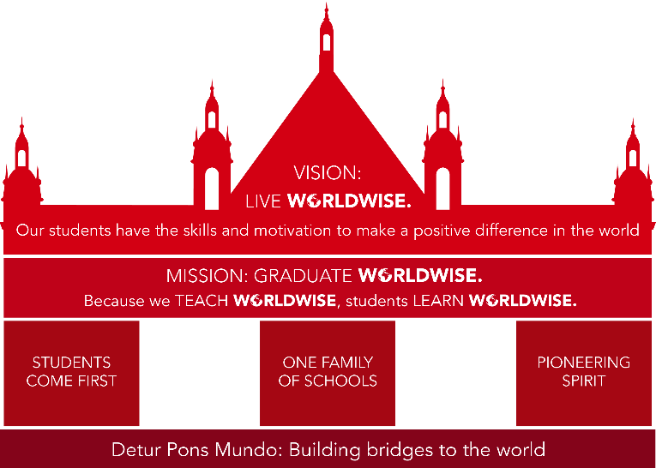

Worldwide Teachers:

- Display self-control and flexibility and nurture these skills in learners
- Promote a love of learning and student wellbeing
- Show professional initiative and perseverance
- Get on with others and have highly developed communication skills
- Are committed to internationalism and equity
- Are committed to sustainability and global citizenship
- Promote academic rigour and holistic learning

A Worldwide Teacher values: A Worldwide Teacher’s practice:

- Evidence-based pedagogy and personalised student learning
- A compassionate approach to complex problem-solving
- High levels of student motivation and engagement
- Professional collaboration and collective efficacy
- Lifelong learning and reflective practice
- Reveals the complex and inter-disciplinary nature of learning content
- Nurtures supportive and dynamic learning environments
- Maximises every student’s opportunity to learn
- Activates hard thinking processes and skill

