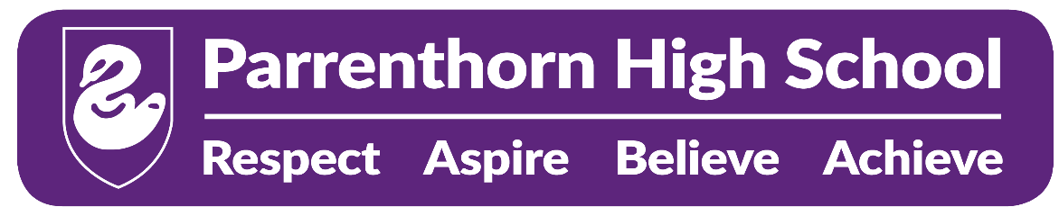

Parrenthorn High School, Heywood Road, Prestwich

Inclusion Manager

Grade 10 pro-rata £27,435 to £29,836 ( pay award pending)

Required to start as soon as possible, 37 hours per week term time plus five Professional Development Days.

An experienced individual is required to assist in the management of the Behaviour Support area (REFLECT) within school. The role requires a high level of emotional intelligence to remove barriers to pupil learning with a focus on social and emotional well-being. The post holder will work with individual pupils as well as small groups.

You must have excellent organisational and time management skills; be able to work independently using your own initiative as well as part of a team. Effective communication skills and an awareness of Health and Safety issues are essential.

Experience of working within a school either on a paid or voluntary basis is essential.

Employees of the school have a responsibility for, and must be committed to, safeguarding and promoting the welfare of children and young people and for ensuring that they are protected from harm.

Appointment to this post is subject to a satisfactory enhanced disclosure from the Disclosure and Barring Service.

Application forms and further details obtainable from this website and returnable to Parrenthorn High School, Heywood Road, Prestwich M25 2BW A.Morley@bury.gov.uk by 12 noon on Monday 13th November 2023.

