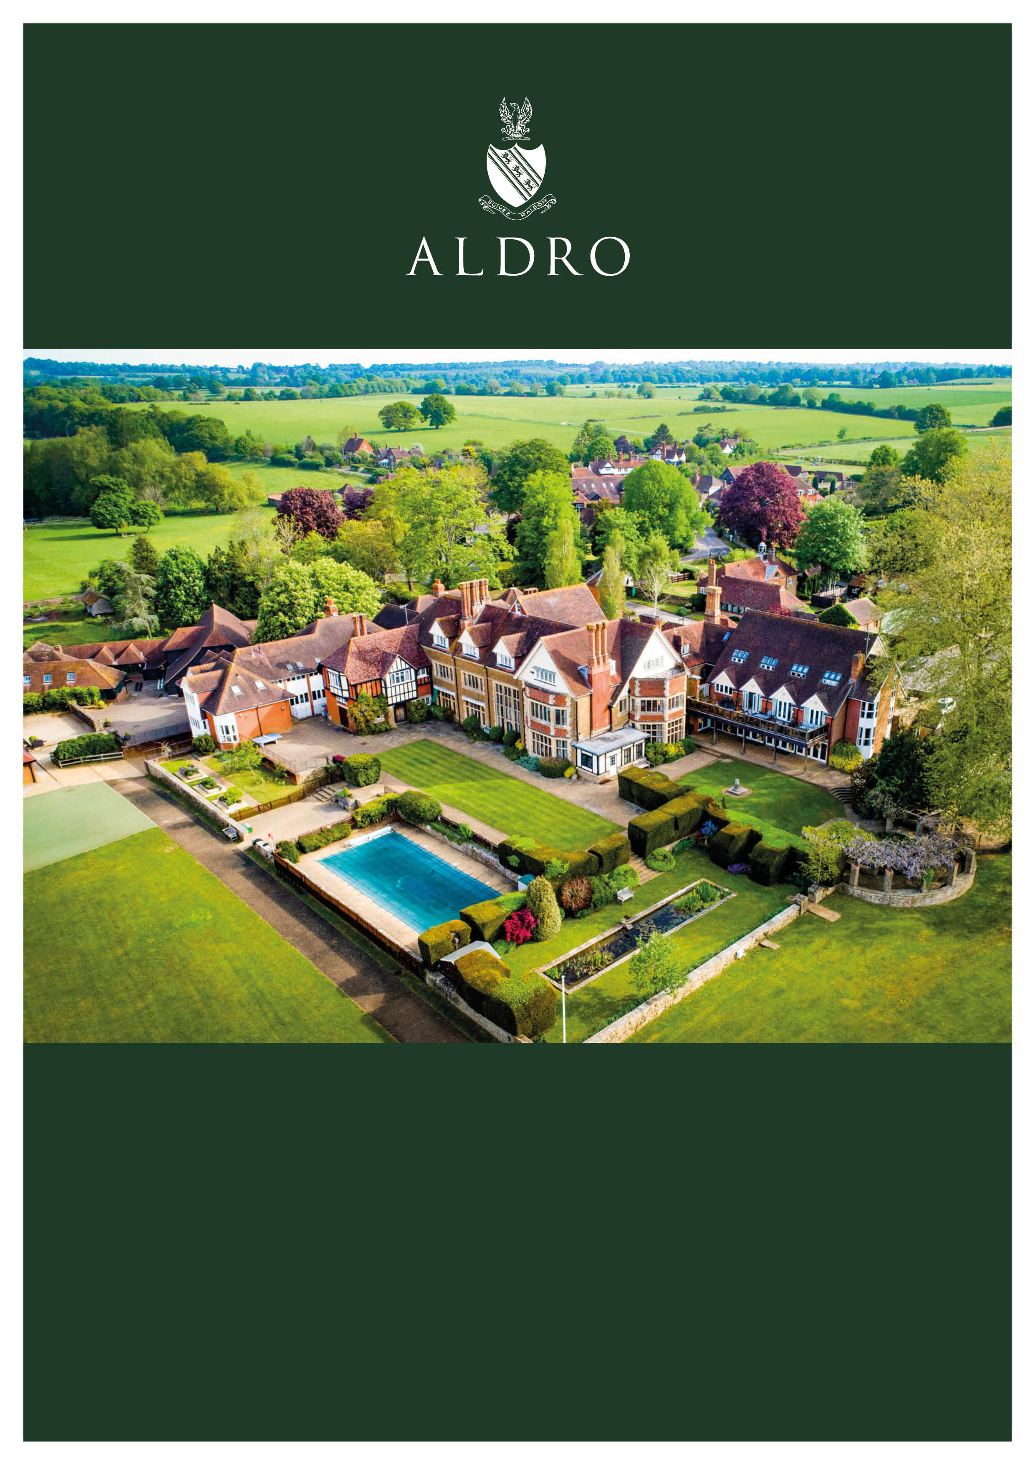

**Acting Head of Girls’ Games**

**Part-time (c.0.4 FTE)**

**Fixed-term, until 6th July 2024**

**Required immediately**

**ABOUT ALDRO**

Aldro is an outstanding coeducational boarding and day preparatory school located in the idyllic village setting of Shackleford near Godalming in Surrey.

The school is at a very exciting stage in its history. Numbers on roll have risen by 50% in the last few years and the school is currently more full than ever before. The most recent ISI Inspection Report (June 2023) rated the school ‘Excellent’ in both areas of qualitative judgement (pupil achievement and pupil personal development) and the school was deemed fully compliant. The school successfully introduced co-education in 2021; girl numbers represent over 30% of the pupil population and are expected to rise further next year. The school has a flourishing Senior School (Years 7 and 8) including up to four sets in the core subjects and a discrete scholarship stream.

There are over 230 pupils in the school aged 7-13; approximately 70 of them board full-time, weekly or part-time. Pupils sit Common Entrance or Scholarships at 13+ in Year 8, and the school has an outstanding record of academic excellence. The school has averaged 15 Scholarships and Exhibitions per year over the last 5 years, and specifically 19 last academic year. In the last couple of years, Aldro pupils have left to attend such schools as: Abingdon, Bradfield, Canford, Charterhouse, Eastbourne, Eton, Guildford High School, Harrow, King Edward’s, Lancing, Lord Wandsworth, Marlborough, Merchiston Castle, Oundle, RGS Guildford, Sevenoaks, Sherborne, Tonbridge, Uppingham, Wellington and Winchester.

Aldro is committed to a breadth of education for its pupils and excellent results are achieved in sport, music, drama, art, design and chess. The school runs an extensive activity programme ranging from pistol shooting to Lego robotics, and debating to pétanque!  The curriculum is taught over six days, including lessons on Saturday mornings and inter-school fixtures on Saturday afternoons. The school has a weekend leave at least every third weekend and benefits from generous holidays. All staff are expected to make an active contribution to the wider life of the school.

Aldro’s Christian foundation underpins the ethos and values of the school and all staff are expected to be supportive of the school’s Christian character. An attractive Chapel is amongst the excellent facilities available which also include a multi-purpose sports hall and a large theatre. Further details about the school can be found on our website: [www.aldro.org](http://www.aldro.org)

Aldro operates its own salary scale. Placement on the scale will be subject to the candidate’s qualifications and experience.  Appropriate certification and identification should be brought to the interview.

**Please email the completed Application Form and covering letter (no CVs please)**   
**to the Headmaster, Mr Chris Carlier.**Acting Head of Girls’ Games**

Part-time (c.0.4FTE, 20 hours per week across six afternoons, Monday-Saturday).

**Reporting to: Director of Sport**

**The Role**

The opportunity arises in response to the planned, long-term absence of the current post-holder. The role is ‘Acting Head of Girls’ Games’ whilst the current post-holder is away from school, and ‘Assistant Head of Girls’ Games’ on their return, herein referred to as: ‘Head of Girls’ Games (Acting/Assistant)’.

Sport is at the heart of the school’s co-curricular provision and we are delighted to have had pupils play representative sport in football, rugby, hockey, cricket, athletics, cross-country, swimming, tennis, golf and shooting in the recent past. Aldro runs a range of mainstream sports accompanied by an array of minor sports. Last academic year, the School played over 400 sports fixtures and fielded 100 teams across 4 major sports and 6 minor sports.

All pupils at Aldro are expected to participate in a wide range of sports. The school hosts both competitive inter-school fixtures and inter-house competitions providing opportunities not only for the most talented performers to develop and flourish but also for the many others who are keen to practise and compete at an appropriate level. Match days are on Wednesdays, Thursdays (Juniors only), and Saturdays (except on Weekend Leaves). Mondays, Tuesdays and Fridays are training afternoons for all pupils. The school also competes in external competitions of all kinds at times dictated by the providers.

**Job Specification**

The Head of Girls’ Games (Acting/Assistant) will report to the Director of Sport and be responsible for overseeing all aspects of girls’ sport. The post is designed for an experienced and ambitious professional who can lead the development specifically of girl’s sport from 7+ onwards and help to promote excellence in all areas of sporting provision at Aldro for both boys and girls. The successful applicant will work closely with the Director of Sport and the PE team. The post holder will be responsible, through the Director of Sport and Deputy Headmaster, to the Headmaster.

The Head of Girls’ Games (Acting/Assistant) will coach across all major sports and possess the ability, appropriate qualifications and specialism to lead in at least two of the School’s core sports for girls – hockey, netball, cricket, football, athletics and tennis.

**Specific responsibilities**

* To have the overview of girls’ sports provision.
* In conjunction with the Director of Sports, help to coordinate and oversee the provision of inter-school fixtures, ensuring that the programme is balanced and appropriate.
* To advise on staffing, training and budgetary needs, with particular oversight of the girls’ core sports each term.
* In conjunction with the Director of Sport, to have oversight and management of the coaching of both competitive and non-competitive girls’ sports.
* To offer direct line management to staff assisting with the delivery of girls’ core games, meeting with them regularly to review and preview provision.
* To offer direct line management to selected coaching staff of other sports where girls participate.
* Oversee structuring, planning and delivery of girls’ internal school competitions.
* In conjunction with Director of Sport ensure that an effective termly review is carried out and advise on annual development plans.
* To assist with the provision of the boys’ sports programme where appropriate.
* In conjunction with the Director of Sport oversee the planning of girls’ sports tours or joint sports tours, including pre-season training and holiday activities.
* Maintain excellent working relationships with other departments within the School such as Grounds and the School’s medical provision (School Nurse and Matrons team).
* To uphold the school’s core values and ensure these are observed and encouraged through sport.

**External Relations**

* To work with the Director of Sport and the Admissions and Marketing Departments to promote sport at Aldro via Open Days and in the wider community, and to help recruit talented pupils to the School.
* Host girl-focused Aldro sports tournaments & events, overseeing and managing sports-based taster day events for local primary schools and the wider community.
* To act as an ambassador for Aldro by visiting feeder schools and to promote the name and brand of Aldro through the medium of sport.
* In conjunction with the Director of Sport, to liaise with local, regional and national sports bodies, establishing close and beneficial relationships.
* To oversee communication regarding girls’ sport with parents.

**Supervisory and Managerial Responsibilities**

* To be responsible for managing kit (equipment and clothing) within a budget, pre-authorised by the Director of Sport.
* To ensure that staff, pupils and visitors comply with all aspects of health and safety as required under the provisions within the Health and Safety at Work Act 1974 and the School’s Health and Safety Policy.
* To conduct and review regularly a thorough assessment of risk for all areas of personal responsibility.

**General**

* To work with Admissions and Marketing to promote the school to prospective parents.
* To attend Open days and other events organised to promote the school.
* Leading or helping with assemblies.

**Safeguarding**

* To promote and safeguard the welfare of all pupils.
* To promote, insist on and help instil the school’s core values.
* To protect children from harm and to prevent impairment of their health and development.
* Be aware of, and comply with, all the school’s policies, and especially the Safeguarding, Whistleblowing, Behaviour, Anti-bullying, Health and Safety, Staff Code of Conduct and Pupil Equality and Diversity policies.
* To establish a positive, supportive and secure culture which promotes in all pupils a sense of being valued, listened to and respected.

*No job description can fully cover all aspects of the role and consequently the responsibilities are likely to evolve and change over time. This description does, however, give an overall view of the position.*Shape, square
**

**Person Specification**

|  |  |  |
| --- | --- | --- |
| **Qualifications and experience** | **Essential** | **Desirable** |
| A minimum level 2 coaching award in chosen sports |  | √ |
| An accomplished sportsperson, able to inspire through example. |  | √ |
| Experience of coaching at a high level |  | √ |
| QTS, Teaching Degree or equivalent (BA, BEd, PGCE etc) |  | √ |
| Qualified Teacher Status |  | √ |
| Degree or equivalent qualification/experience |  | √ |
| Previous experience of teaching or coaching in an independent prep school |  | √ |
| Strong ICT skills, particularly Microsoft Excel and Word |  | √ |
| First Aid trained |  | √ |
| **Professional Attributes** | | |
| An outstanding coach. | √ |  |
| Calm under pressure | √ |  |
| Excellent written and oral communication skills, able to communicate with a range of audiences. | √ |  |
| Well organised, and with good time-management skills. | √ |  |
| An ability to work alongside individuals within the Sports Department and provide support for coaches across the school. | √ |  |
| Possessing a strong track record of leading a team to achieve particular goals. | √ |  |
| Experience of undertaking a wide range of complex tasks. | √ |  |
| **Personal Attributes** | | |
| Excellent inter-personal skills; empathetic, caring, kind and compassionate. | √ |  |
| A deep sense of compassion for young people and a sensitivity to their needs. | √ |  |
| A natural and confident leadership style; able to inspire confidence. | √ |  |
| Strong organisational and administrative skills; attention to detail. | √ |  |
| Reliability, integrity, loyalty. | √ |  |
| Positivity, energy and enthusiasm. | √ |  |
| Able to inspire and motivate others. | √ |  |
| A sense of humility and a desire to serve others. | √ |  |
| A willingness to go the extra-mile. | √ |  |
| Excellent record of health, punctuality and attendance. | √ |  |
| Ability to nurture pupils’ welfare with well-developed pastoral instincts. | √ |  |
| A proven track record of ‘making a positive difference’ to young people’s lives. | √ |  |
| A sense of humour | √ |  |
| Clean driver’s licence and ability to drive a minibus |  | √ |
| **School Ethos, Values and Aims** | | |
| Fully supportive of the ethos and aims of the school. | √ |  |
| Sympathetic to the Christian teaching that underpins the school’s values. | √ |  |
| Commitment to the safeguarding and protection of children. | √ |  |
| A commitment to promoting equality, diversity and inclusion. | √ |  |
| Promotion of Health and Safety in line with the school’s policy. | √ |  |

**Applications**

**Deadline: No deadline – applications processed upon receipt.**

**Please email the completed Application Form and covering letter (no CVs please)**   
**addressed to the Headmaster, Mr Chris Carlier.  Email: HR@aldro.org**

Interested candidates should complete a copy of the [Aldro Application Form](https://resources.finalsite.net/images/v1666112883/aldroorg/o6jimcvdp8l2pr7uikto/AldroJobApplicationForm2022.pdf) available on the ‘[Vacancies](https://www.aldro.org/about/vacancies)’ section of the Aldro website and send, with a letter of application addressed to the Headmaster, to [HR@aldro.org](mailto:HR@aldro.org). CVs are not required. Early applications are encouraged and will be processed on receipt.

The school is an equal opportunities employer and complies with its duties under the Equality Act 2010. Aldro is committed to safeguarding and promoting the welfare of the children and young people here, and all staff are expected to share this commitment. As part of the recruitment process, applicants should expect scrutiny of their online profile. All staff are expected to adhere to and ensure compliance with the school’s Safeguarding / Child Protection Policy at all times. If, in the course of carrying out the duties of the post, the post holder becomes aware of any actual or potential risks to the safety or welfare of children in the school, he/she must report any concerns to the school’s designated Safeguarding Lead.

In line with the School’s Safeguarding / Child Protection Policy, the successful candidate will be subject to checks by the Disclosure and Barring Service. As part of this process, Aldro additionally carries out its own online and social media checks. Applicants’ references are typically sought before interview, unless the applicant specifically requests otherwise.

The post is exempt from the Rehabilitation of Offenders Act 1974 and Aldro is therefore permitted to ask job applicants to declare all convictions and cautions (including those which are ‘spent’ unless they are ‘protected’ under the DBS filtering rules) in order to assess their suitability to work with children.

Aldro recognises the benefits of a diverse workforce and is committed to equality of opportunity for staff, volunteers and applicants. Building upon legislative requirements, Aldro seeks to ensure proper access of opportunity in matters relating to recruitment/selection, support for staff development and promotion. All HR policies are underpinned by this commitment to inclusivity and discriminatory behaviour by staff, pupils, contractors and external contactors will be taken very seriously, fully investigated and appropriate action taken where necessary****.

