Cedar Mount Academy
Gorton Education Village, 50 Wembley Road,
Gorton, Manchester, M18 7DT
VACANCY: Curriculum Lead
Maths and Numeracy
CEDAR MOUNT ACADEMY
INFORMATION PACK

CONTENTS

HOW TO APPLY | Page 3
ABOUT BRIGHT FUTURES EDUCATIONAL TRUST | Page 4
BRIGHT FUTURES EDUCATIONAL TRUST’S STRATEGY | Page 5
CEDAR MOUNT ACADEMY – HISTORY & CONTEXT | Page 6
CEDAR MOUNT ACADEMY – PUPIL INFORMATION | Page 8
JOB DESCRIPTION | Page 10
PERSON SPECIFICATION | Page 12

HOW TO APPLY
This information pack is designed to provide you with further information on Bright Futures Educational Trust, Cedar Mount Academy and the role of Curriculum Lead for Maths and Numeracy at this academy. If having read the information and you want to apply, please:

Complete the application form, with a covering letter (no more than two sides of A4 please)

Email the application form and letter to vacancies@cma.bfet.uk, or post it to be received by Monday 19th April 2021

Closing Date: Monday 19th April 2021
Selection process, we expect this to be week commencing 26th April 2021

Bright Futures Educational Trust
ABOUT BRIGHT FUTURES EDUCATIONAL TRUST
The best for everyone, the best from everyone

Bright Futures Educational Trust (BFET) was established in 2011 and comprises 7 schools in the Great Manchester and Blackpool areas, a teaching school (Alliance for Learning), Maths Hub and School Centred Initial Teacher Training and the central head office team.
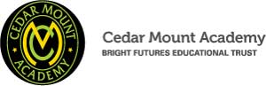

Our schools are their own entities and form one organisation and one employer, BFET. The BFET Board of Trustees maintains strategic oversight of the Trust and delegates some of its responsibilities to the Executive team, Principals and local governing bodies. We place a high value on integrity and probity and take seriously our accountabilities for making the best use of public money. How decisions are made is described in our delegation framework. You can find out more about the Trustees and the Executive Board on our website: http://bfet.co.uk/about-us/

Collaboration and strong relationships form one of the ‘commitments’ in our Strategy and all components of the BFET family work closely together. Our Strategy was developed collaboratively and is contained in this pack for your reference. We are in the process of engaging with all staff across the trust in reviewing this work.

The Alliance for Learning is our Teaching School and partners with many schools across the North West, including our own. The Teaching School includes a maths hub, a SCITT, a broad range of professional learning and wider network opportunities. Please see the website for more details http://allianceforlearning.co.uk/about-us/welcome-director-of-teaching-school-and-partnerships/

The head office team, comprises the Executive team: John Stephens, CEO; Edward Vitalis, Finance Director; Gary Handforth, Director of Education; Lisa Fathers, Director of Teaching School and Partnerships and Lynette Beckett, Director of HR & Strategy. The focus of all of these roles is to work with schools, providing high quality and timely guidance, challenge and support to our schools. The finance operations of all our schools are centralised in two hubs, reporting to the Finance Director. Similarly, HR support is overseen by our HR Director. There is an HR Adviser based at Cedar Mount, reporting directly to the HR Director.
BRIGHT FUTURES EDUCATIONAL TRUST STRATEGY
Vision
The best for everyone, the best from everyone

TTo provide high quality educational opportunities that nurture the best in everyone, enabling every student to develop the values, qualities, knowledge and skills to live happy and fulfilling lives and to help others to do the sameo provide high quality educational opportunities that nurture the best in everyone, enabling every student to develop the values, qualities, knowledge and skills to live happy and fulfilling lives and to help others to do the same.

Aims 2017-2020
Outcomes
Values
Community: We work together for a common purpose acknowledging our diversity as strength
Integrity: We do the right things for the right reasons
Passion: We take responsibility, work hard and have high aspirations
Mission
Our family of schools places young people, families and communities at the heart of everything we do. We are a true community with shared responsibility and common core values which create a culture of collaboration, opportunity, respect and innovation. We inspire excellence and believe in nurturing the abilities of all within our schools and communities. We empower our young people to build purposeful lives and have the courage and confidence to make a positive contribution to society. Through excellence in education all of our young people will have a bright future.

Commitments
Collaboration and strong relationships Strong Governance and Accountability
Professional learning Value for money
Supportive, challenging and fair United behind decisions
Effective communication

All schools to be improving at pace and have the capacity for sustainable continuous improvement in all aspects.
Excellent progress and achievement for all pupils
Long term sustainable viability, managed within a robust financial control environment that is effective and efficient.

Ensure financial viability
People are listened to, held to account, supported and challenged.
An environment where our people
are valued

Any growth adds value to the rest of the trust. Roles, responsibilities and organisational systems are fit to deliver the strategy.
The Trust’s direction is clear and well defined

Governance
Board of Trustees: Provides strategic leadership, monitors school improvement and compliance and oversees effective controls for financial viability
Executive team: Provides strategic and operational leadership.
Local governing bodies: Provide scrutiny of school development plans, monitor that schools are working within agreed finances and policies

CEDAR MOUNT ACADEMY – HISTORY & CONTEXT
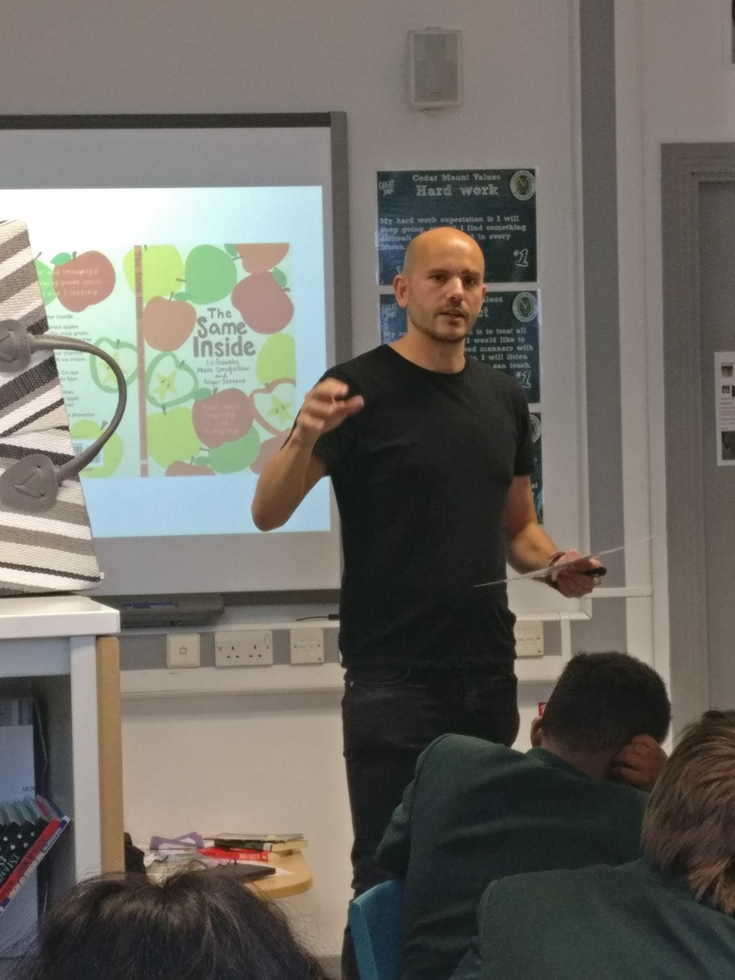
Cedar Mount opened in 2000 as a replacement for Spurley Hey High School and moved to the current site (a new building as part of the Gorton Education Village) in 2008. It is co-located and works well with Melland High School, an outstanding special school also within the Bright Futures Educational Trust.

Cedar Mount has a Published Admission Number of 180 per year group and therefore should have 900 on roll. When the new building opened the school was full but there was a decline across a number of years due to poor exam results and Ofsted outcomes, and the school had 620 on roll in 2016. The school was placed in Special Measures in April 2015 but, after a change of leadership in 2016, standards and pupil numbers began to rise and the school was judged RI in July 2017. Our latest Ofsted inspection was January 2020 and was judged RI overall but good for both personal development and leadership and management, saying, “Cedar Mount Academy is improving strongly. Leaders have a clear and ambitious strategy which has pupils’ best interests at its heart” and “some of the improvements that leaders have put in place have made a real difference to the quality of pupils’ education.”

Exam results and progress have improved and are expected to do so again in 2019. The number on roll currently stands at 862 and we expect it to reach 900 for the first time in 10 years in 2020.

Cedar Mount is situated in South Gorton, the 5th most deprived ward in the country according to the latest set of figures. The Pupil Premium percentage stands at 38% currently but this does not reflect the actual situation, due to high numbers of international new arrivals and families not registering for FSM. 64% of the school population speaks English as an additional language with 46 different home languages being spoken. There has been a significant shift in the school population in recent years with EAL numbers rising by over 20 percentage points since 2014.

The last 2 years have seen real progress at Cedar Mount and it now needs to be built on and sustained for the students to get the education that they deserve. Students now have much more success in sports (we are City Champions in a range of events), public speaking (we were the top ranked school in the country for Debate Mate in 2018-19), drama (students have taken part in a range of performances within Manchester) and much more. Students are also able to take part in far more trips, visits and residentials than previously, which is enabling them to improve their knowledge and confidence in a range of areas. Attendance has improved by nearly 2% since 2016 but is still below the national expectation at 93.9%. Behaviour has also shown great progress with fixed term and permanent exclusions reducing significantly; the school is a cohesive community.

CEDAR MOUNT ACADEMY – PUPIL INFORMATION

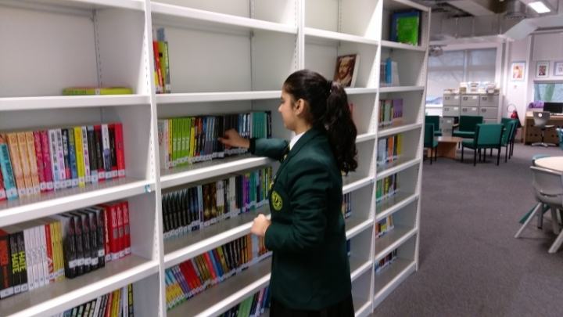

Mainstream School
Phase: Secondary
Funding status: Public - Academy
Gender: Mixed
Religion: Mixed
Age Range: 11 - 16 years
No of students on roll: 862
PAN: 900
SEN Students: 14.6%
EAL Students: 64%
Address: Gorton Education Village,
50 Wembley Road,
Gorton,
Greater Manchester.
M18 7DT
Telephone: +44 161 248 7009
http://www.cedarmount.manchester.sch.uk

Cedar Mount Academy is located within Gorton Educational Village in Gorton, East Manchester and shares the campus with two of our partner schools in the Trust; Melland High School, a Special Educational Needs school for 11-19 years and Rushbrook Primary Academy.

Bright Futures and Cedar Mount Academy is committed to providing equal opportunity in recruitment and employment to all individuals. We will consider candidates without regard to race, ethnicity, gender, religion, sexual orientation and identity, national origin, age, military or veteran status, disability or any other legally protected status; and without discrimination based on socioeconomic, marital, parental or caregiving status, or any of the previously listed characteristics or statuses.

We value the diversity of our staff and reject any form of harassment, discrimination or victimisation. The Bright Futures Educational Trust vision is: ‘the best for everyone, the best from everyone’. To achieve this, we create and maintain a work environment and culture where people from different backgrounds, and with varying lifestyles, interests, opinions and responsibilities, treat each other with dignity and respect. It is a climate in which our staff feel safe and are inspired and motivated to be their best.

Our schools are dedicated to sustaining and promoting diversity with respect to recruitment, promotion, training and general treatment during employment. We are actively seeking to extend the diversity of our staff. We aim to ensure that our recruitment processes set up all candidates for success. At interview our aim is to provide a positive experience. We don’t want to catch anyone out, but rather to provide the opportunity for all candidates to be themselves and show us what they are capable of.

CEDAR MOUNT ACADEMY

Curriculum Lead (Mathematics and Numeracy)
MPS + TLR – 2b

(Conditions of service as defined in the current Schoolteachers’ Pay and Conditions Document)

The role of Curriculum Lead (Mathematics and Numeracy) is responsible for the development, organisation and delivery of a highly relevant and stimulating knowledge-rich Mathematics curriculum. Reporting to the Senior Leader of Mathematics and working alongside the Assessment Lead (Mathematics), the post holder will support the mathematics department to ensure high standards and quality outcomes in the subject area.

The post holder will also lead the development of innovative practice within the delivery of numeracy and maths as a cross-curricular skill. This area of whole school responsibility will include inspiring and coaching staff to deliver numeracy skills, playing a key role in raising standards of numeracy across all subjects.

The Curriculum Lead (Mathematics and Numeracy) will be a successful and experienced teacher of Mathematics, who is able to enthuse, motivate and inspire children, generating a love for learning and the subject. The successful candidate will have demonstrated good teamwork, high standards and a capacity for hard work will have been at the core of his/her success. S/he will be a creative thinker with an ability and determination to secure high-quality outcomes for all students.

Cedar Mount Academy is a member of Bright Futures Educational Trust

Key Responsibilities which will form the basis of specific responsibilities

Curriculum - Mathematics
- Lead on the development and implementation of an appropriate curriculum that supports the academy and departmental vision.
- Ensure appropriate schemes of work are in place for all curriculum pathways.
- Support and monitor the production of resources for all qualifications / pathways.
- Ensure suitable extra-curricular enrichment opportunities, including careers related activities, are embedded in the curriculum.
- Support the Senior Leader (Maths) in the development of a robust staff CPD programme to improve Subject Knowledge and Subject Pedagogy, linking to curriculum developments.
- Leadership of the appraisal process for teachers within the maths department
- Induction, monitoring and support of new staff, including NQTs and ITT.
- Contribution to the subject improvement plans, policy and practice for areas of accountability.

Curriculum – Numeracy
- Support the Senior Leader (Maths) to improve the numeracy of all students and their fluency, confidence and enjoyment of reading.
- Lead on, and be involved in creating, academy strategies to improve the numeracy of all students.
- Train teaching and associate staff on numeracy strategies
- Actively promote numeracy in the school
- Provide staff development as requested by the SLT
- Model/team teach and observe across departments to develop numeracy throughout the curriculum
- Ensure there are displays that promote numeracy around the school

Other Expectations of all Academy Staff
- To work professionally and effectively as part of a specific and wider Academy staff team.
- To be a positive professional role model for all students.
- Treat all students with dignity, building relationships rooted in mutual respect, and at all times observing proper boundaries appropriate to staff’s professional position.
- Have regard for, and promote the need to, safeguard students’ well-being, in accordance with statutory provisions and Academy policy.
- To be a form tutor to an assigned group of students and carry out that role in line with Academy policy.
- To carry out supervision duties as directed in the Academy duty rota.
- To contribute to regular reports to parents on the progress, attainment and development of students taught.
- Communicate effectively with parents and carers.
- Engage actively in the Academy performance management process.
- Engage actively in the Academy CPD program to develop skills and improve practice.
- Be familiar with, and follow, all Academy policy and practice to ensure a consistent high standard approach to all aspects of the Academy.
- Play a full part in the life of the Academy, to support its distinctive mission and ethos.
- Attend Academy events and activities as directed by the Principal.
- Any other reasonable request as directed by the Principal.

The duties of this post may vary from time to time without changing the
general character of the post or level of responsibility entailed depending on the developmental requirements of the department or academy.

Person specification

Category | Essential | Desirable | Means of identification
Qualifications, Education, training | - Degree level qualification  - Qualified teacher status or equivalent | - Post graduate qualification or professional qualification e.g. NPQML | Application form/Certificates
Relevant Experience | - Demonstrable track record of successful teaching of maths across KS3 and KS4  - Experience of planning and/or delivering interventions for maths and numeracy skills at KS3 or KS4  - Contribution to the work of departmental improvements, including involvement in curriculum planning, development and evaluation. | - Evidence of successful teaching at KS5  - Experience of responsibility within the subject or other relevant area.  - Knowledge and understanding of recent developments and initiatives in secondary mathematics, including Teaching for Mastery. | Application  Interview  Tasks  References
Our Values | - Community: Evidence of working together for a common purpose and encouraging diversity |  | Interview  Tasks
 | - Integrity: Evidence of doing the right things for the right reason |  | Interview  Tasks
 | - Passion: Evidence of taking personal responsibility, working hard and having high aspirations |  | Interview  Tasks
Pre-employment screening | - Enhanced DBS check  - 2 satisfactory employment references, from the last two employers  - Evidence of the right to work in the UK |  | On-line DBS check  References deemed suitable by BFET  Passport or other evidence allowed by UK Home Office

