Guide For
Applicants:

Pastoral Support Assistant with Midday Supervisory duties

A PERSONAL MESSAGE FROM THE HEADTEACHER

Thank you for your interest in the post of: Pastoral Support Assistant with MSA

I am delighted that you are interested in joining “Team Sherburn” as a member of our Team.
Teaching is at the heart of what we do and it is essential that all applicants share our passion for teaching and learning. For us, school improvement takes place through every interaction and the very best place to implement and embed positive change is in the classroom.
We strive to be open, honest and up for the challenge! We don’t claim to know all the answers or to always get it right, but we do claim to try our very best to support and care about every single young person in our school as summed up by our school motto “Achievement for All.”
With under a 1000 students, we believe that Sherburn High is an 11-18 school, which is big enough to deliver, but small enough to care. We are extremely proud of the open and welcoming nature of the school from both the staff and students; the sheer variety of activities offered both within the curriculum and after school hours. We are proud of our student outcomes, our strong reputation for looking after our students and where high standards of conduct are non-negotiable. We believe that it is a combination of these factors that means that our student numbers are growing and that places for September 2021 are oversubscribed.
We are fortunate to have an established and cohesive team of outstanding practitioners within a successful and vibrant school. At Sherburn we do not limit our definition of achievement simply to academic pursuits. We believe in developing well-rounded individuals and, as such, we make a significant investment in sports and the arts.
Over the last four years, the school has taken huge steps forward. The platform we have for continual improvement is secure. The students here are fantastic to work with and they come to school eager to learn. The staff is professional, supportive, and collaborative; there is a positive, aspirational atmosphere and an impressive level of commitment from everyone to continue moving the school forward.
We have excellent relationships with a wide number of schools and academies through our partnership work and of course membership of the STAR Multi-Academy Trust.
If you would like to know more about the school and its activities, please look at our website www.sherburnhigh.co.uk. and get in touch. Thank you for your interest in this post.

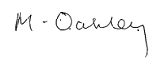
Miriam Oakley
Headteacher

Reasons to work at Sherburn High School:

- We have great students! Excellent student behaviour for learning means that you will be able to deliver outstanding lessons
- A career development coach to enable you to become ready for middle / senior leadership in three years with the opportunity to gain the National Professional Qualification for Middle Leadership (NPQML) or equivalent
- Access to professional development through the Yorkshire Teaching School Alliance
- A weekly CPD induction plan to establish you in school
- Leaders who walk the talk
- Senior leaders who teach and understand the demands of the role
- Leadership with moral purpose
- Passionate staff who always want the best for our students
- An exciting and fast paced school that is going from strength to strength

A VISION FOR SHERBURN HIGH SCHOOL

To develop a genuine learning community where:

- Achievement is at the heart of school culture. It is not just for some students it is for them all.

- Where students learn better because staff are learning all the time and improving what they do.

- All adults are valued and feel that they can make a difference to the achievement of students.

- We involve more people in playing a part in developing the school strategically, particularly middle leaders.

- We are outward looking and collaborate effectively with others to improve our provision and outcomes.

- Students and parents are listened to and involved in decision making

- We are creative, take risks, have good ideas and do not worry if things do not work the first time.

- We work together to solve problems, not simply identify them and we aim to develop a ‘no blame culture’.

Inclusion and Support

Sherburn High School is a fully inclusive school, which prides itself on its support for students who may require additional learning, emotional or behavioural support. Our Inclusion Team runs two centres, Here 2 Learn (H2L) which supports students with learning needs and Support 2 Learn (S2L), which supports students with emotional and behavioural needs. We believe our approach is part of the reason that our attendance is consistently above national average and our fixed term and permanent exclusion figures are significantly below national average.

S2L is a small centre, within our mainstream school currently employing 2 dedicated staff. The centre has an isolation unit, where up to 6 students work on individual work, supervised by S2L staff and other senior staff. Work is provided by subject staff and the S2L Manager works closely with subject teachers across the curriculum to ensure that students remain engaged and ready to return to mainstream.

There is also a small office space for the S2L Manager and a room for intervention. A range of intervention programmes including Anger Management and Mindfulness, Gardening and more run through S2L. Intervention runs in small groups and S2L staff also provide some one-to-one mentoring.

The S2L Manager will also be responsible for liaising with outside agencies to design, deliver and evaluate intervention and support. They will also be responsible for engaging with parents and carers, updating them on their child’s progress.

We are keen to build links between our two centres as well as links with Tadcaster Grammar School’s Inclusion Team as we become part of STAR MAT.
Assessment, recording and reporting

Whilst at Sherburn High School, students receive regular data rich reports to show how they are progressing in all their subject areas. This is communicated to parents and students each term at Key Stage 3 and in Year 10, whilst students in Year groups 11, 12 and 13 receive a regular update on their progress approximately every seven weeks. This allows staff and parents to use effective intervention and support and ensures students remain focussed and on course to achieve their potential. Students discuss their reports with their tutor at each data collection point and specific improvement targets are agreed.

Care, Support and Guidance

In order to care, guide and support students we promote good behaviour for learning and have constructive consistently implemented sanctions. We ensure that all students have a range of adults / peers within and beyond school to support them. Our vertical tutoring system, where students are in small, mixed age groups of Years 7 – 11, provides opportunities for high quality coaching and mentoring by staff and students within the tutorial programme.

Parents are ensured continuity of care, with children from the same family remaining in the one House for the duration of their time with us. The vertical system also promotes student leadership with increased roles and responsibilities for students and will develop relationships with the community via a structured system of links, competition and rewards to promote a sense of identity for all students within and outside of school. The work of the student council is also fundamental, with a strategic plan for consultation on key issues and subsequent feedback.

Curriculum

Our curriculum provides planned and structured progression for students from joining us in Year 7 through to when they move onto higher or further education, or the world of apprenticeships and employment at 16 or 18.

We have balanced subject content at Key Stage 3, providing a broad base of skills and knowledge that meets the requirements of the National Curriculum. Groupings enable students to work at a pace best suited to their individual rate of progress and provide appropriate challenge as they progress through school. There is a strong emphasis and time allocation towards English and Maths ensuring students have the skills to complement other areas of the curriculum and build the foundations for lifelong learning.

In Year 9 students begin their GCSE studies, following a three year route, which provides challenge and depth of study. All students follow Mathematics, English Language and Literature and Science. Students opt for three further subjects from a pool of subjects, including the Creative subjects.

At both KS3 and KS4, we ensure that there are progressive programmes of study for personal, religious, enterprise and health education along with citizenship and career planning. All students follow a comprehensive PE programme combining both the traditional sports with the opportunity to experience some of the less familiar sports.

Provision for students with Special Educational Needs

All students are taught in mainstream classes and are supported by teaching assistants in class: one to one, class support or small groups. We have expertise in providing personalised programmes to meet the needs of vulnerable children, particularly those with Dyslexia and those on the Autism spectrum, as well all in many other areas. Because of the relatively small size of the school, we know our students very well.

We have two discrete areas for learning support and behaviour support where specialist intervention programmes are delivered or, if needed, provide a quiet space to work.

Teaching Assistants are based in these areas and students with Special Educational Needs have access to computers, homework club, friendship club and Multi Skills club during break and lunch time when required. All Teaching Assistants are trained and experienced in a variety of areas.

Sixth Form

In the Sixth Form, we have over thirty subjects available for students to follow. Our collaborative Sixth Form with Tadcaster Grammar School facilitates students’ option choices allowing access to the curriculum at both centres, for both sets of students.

Sherburn High School is fortunate to have a Sixth Form, which enables students who wish to stay on (approximately 60% of each year group) and provides valuable continuity in their learning.

Post 16 Education at Sherburn High School offers a varied range of courses. Our curriculum leads to nationally recognised Advanced level (Level 3) and ‘Improvers’ (Level 2) qualifications. Where possible, we aim to tailor our timetable to the demands of individual students. The range and combination of courses on offer to students extends through our Post 16 collaboration with Tadcaster Grammar School (Law, Economics, Drama and Theatre Studies, Sociology and Philosophy and Ethics).

All Sixth Form students have their own personal tutor, who provides them with guidance and support to University, apprenticeships, or employment. Tutors will strategically monitor student progress and deliver a comprehensive tutorial programme.

We aim to develop independent, responsive and creative students who have transferable skills beyond the school environment. Our success is built on a three-way partnership, with the individual student at the centre supported in their studies by home and school. Time is invested in tutor support and personal guidance.

Facilities

The school is fortunate to have eight fully equipped ICT rooms, used extensively by all curriculum areas. All teaching rooms are equipped with LCD projectors for interactive white boards.
In addition, there is an Information Centre (which includes the library and Internet access), student social areas, a main hall with stage, drama studio and a multimedia lecture theatre. A Post-16 Centre incorporating teaching rooms, social spaces and offices is also available.
Extensive playing fields with grass and all weather surfaces allow a wide range of sports to be played, including football, hockey, netball, rugby and tennis.

Extra Curricular Activities

Extra-curricular activities are many and varied; they include numerous performing arts productions, sport and art. The school encourages residential and field trips. Foreign visits and student exchanges occur annually including a visit to Lille, a “Language Immersion” trip near Paris, watersports in the Ardeche, Skiing and visits to the Christmas Markets in France and Germany, as well as cultural trips to Barcelona.

Professional Support and Development

We believe that the school’s greatest asset is the quality of our staff. Consequently, we place particular emphasis on continuing professional development. New teachers joining the school can expect to receive considerable support from their curriculum leaders and members of the school leadership team. In addition, all teachers are part of a ‘Teacher Learning Community’ of colleagues who meet regularly, share good practice and engage in peer coaching.

Administration Team

The finance and admin team support all aspects of school life and are a vital service to the smooth running of the school. The school has a general office and visitor reception, student reception, finance office and personnel office. Responsibilities covered are reception duties, general admin, supply cover for teachers, student attendance monitoring, Parentpay, school finance, HR and payroll.

Friends of Sherburn High School
The “Friends of Sherburn High School” is an active group and provides strong social links and financial assistance to the school.

Safeguarding Children

The school is committed to safeguarding and promoting the welfare of all its students.

We have a robust Safeguarding Policy and all staff will receive training relevant to their role at induction and throughout employment at the school, a copy is on our website at www.sherburnhigh.co.uk.

In relation to this appointment process, you should be aware that your referees will be asked the following question – “Are you aware of any child protection allegations or issues of a similar nature in relation to this person? If so please provide details”.

At interview all candidates will be asked if there have been any allegations or issues raised against them by children and, if so, the outcome of them.

All employees must have enhanced DBS checks prior to starting work.

Examination Results
We are very proud of our students’ achievements at the end of Key Stage 4 and Key Stage 5. Full details of public examination results can be viewed on www.dcsf.gov.uk/performance tables as well as on our website.

The Area

Sherburn–in-Elmet is an ideal commuter village situated close to the A1 and A64 and therefore within easy travelling distance of Castleford (6 miles), Leeds (14 miles), Selby (8 miles) and York (15 miles). The new M1/A1 link road has made the whole West Yorkshire conurbation more accessible.

The school crest depicts the history of the area. The crimson discs on each of the five petals recall the Wars of the Roses, which reached a climax in the Battle of Towton nearby, in 1461. The other two discs bear the Archbishop’s Mitre (the Archbishops of York once held the lands and power in Elmete) and the hound taken from the coat of arms of the Hungate family, the founders of the original grammar school in Sherburn-in-Elmet.

Sherburn-in-Elmet has a thriving industrial estate on the outskirts of the village, which is good for local employment. Children attend the school from villages in the locality extending from Saxton in the north to Kellington in the south.

In addition to a good academic record, there is also a well-developed community spirit within the school and many links have been forged with the local community.

There is a wide selection of housing in the neighbourhood.

The following estate agents can supply housing information if you request it:

Mike Dobson Estate Agents  01977 684258 | Halifax Property Services  01757 697313 | Park Row Properties  01977 681122

Map of the Area

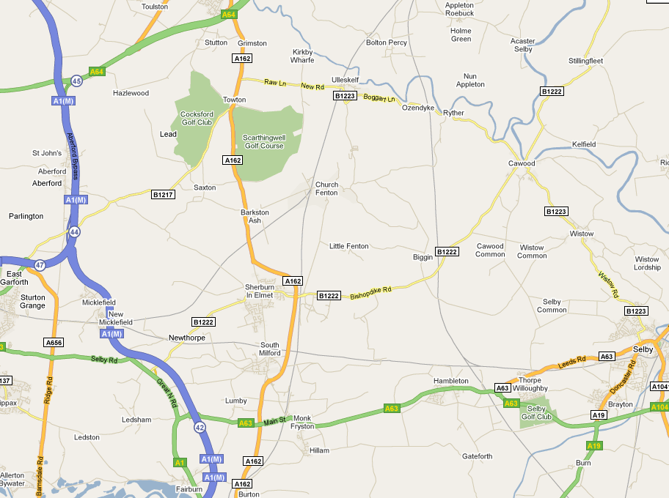
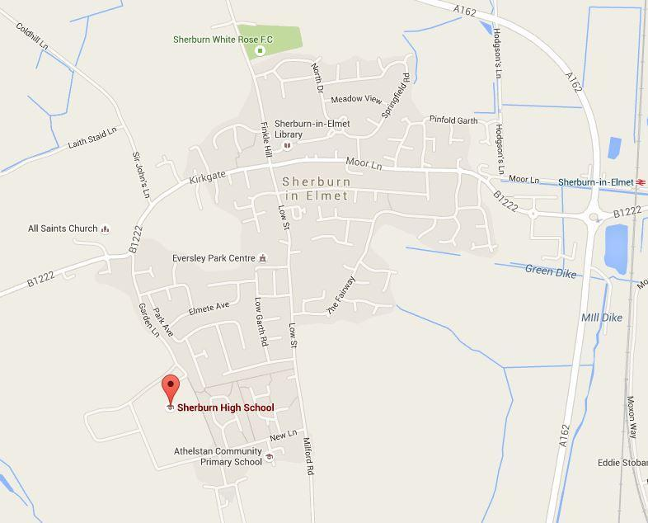

Your Application

Job descriptions, person specifications and application packs can be downloaded from our website
at: www.sherburnhigh.co.uk

Completed applications should be emailed to: recruitment@shs.starmat.uk

All emails will automatically be acknowledged. If you do not receive an email acknowledgement please contact Danielle Elliott on 01977 687969

Closing date is 9am Monday 20th September 2021 with Interviews being held on Tuesday 21st September 2021. Please do not send CV’s.

Candidates who have not been notified a week after applying are asked to assume their application has not been successful in this instance. Unfortunately, we are unable to provide feedback to applicants who are not shortlisted.

Where applicable please bring with you to the interview your original qualification certificates including QTS status if applying for a teaching post.

It will be necessary for the successful applicant to complete an enhanced DBS form and provide relevant documents proving identity and proof of address prior to starting work.

There is a no smoking policy for all staff and anyone for whom this might present a problem should consider their position seriously before making their application.

If you would like to discuss any of the above before making an application please do not hesitate to contact the Headteacher.

We welcome applications from all sectors of the community; we appoint on merit.

Thank you again for your interest in the post.

Published by Sherburn High School

