Bosworth Independent School

Job Application Pack



I am delighted that you are considering working with us at Bosworth Independent School. Bosworth is a special place, and I hope that some of the ‘Bosworth magic’ shines out through these pages. They certainly contain lots of information, which I hope will be useful as you consider submitting an application to work with us.

All members of staff here, irrespective of their role in the organisation, are committed to ensuring that Bosworth is a place where every student

flourishes and achieves their very best. We take student wellbeing seriously and safeguarding is our overarching priority. All employees understand that and those who wish to work with us will accept this too.

Bosworth is a dynamic, vibrant place to work. We are proudly global in outlook and makeup; our staff and students are drawn from many countries, speak a staggering number of languages and are proud of the cultures which shape them. Our task is to allow students to flourish while they’re with us, and to set them up for success in their lives beyond Bosworth. Our students are bright, engaging and a delight to spend time with; they have a positive attitude to learning, are well behaved, ambitious, kind and fun.

Teachers here at Bosworth are subject specialists and passionately committed to supporting students to attain their very best. They know their pupils well, which is possible because of our small class sizes but - more importantly - because they care deeply about the students and consistently tailor their teaching to a student’s individual needs and strengths. We offer exceptional pastoral care to our students and are on-hand to celebrate their achievements and to walk alongside them when times are hard.

Candidates who feel that a visit to the school would help them decide whether to submit an application are very welcome to come for a tour of the school and see the school in action on a typical day. Please email [info@bosworthschool.co.uk](mailto:info@bosworthschool.co.uk) to arrange that.

We look forward to receiving your application.

**A Message**

**from the Headmaster**

**Tony Oulton, Headmaster**

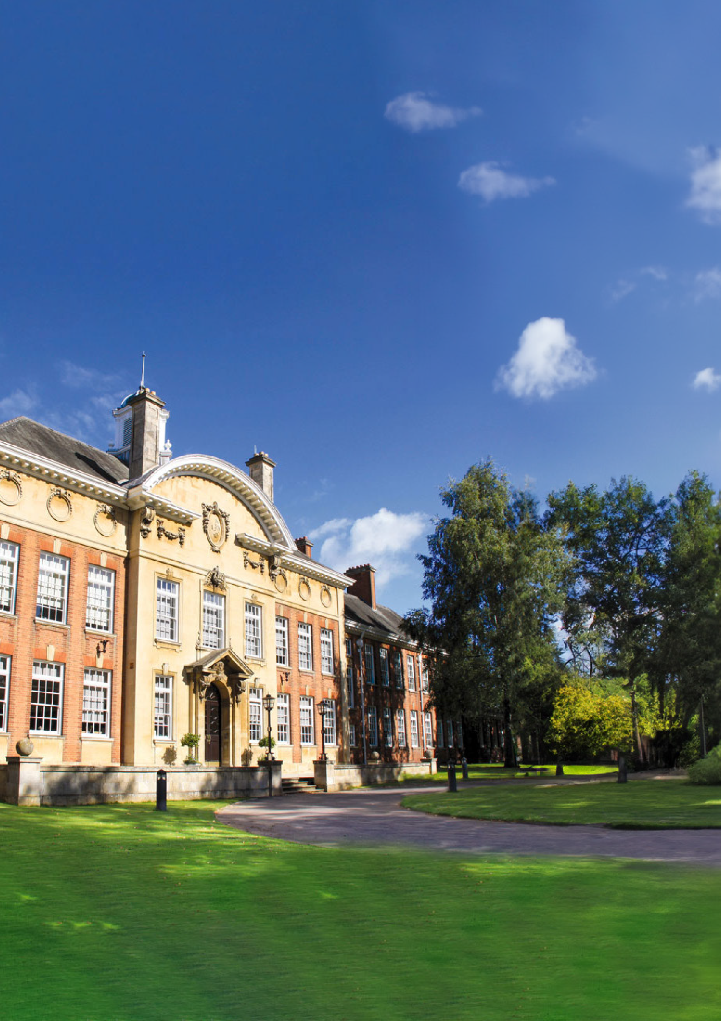

**About Bosworth**

*Established in 1977 as a small tutorial college, today Bosworth is a leading independent school in the UK catering for boarding and day students from Year 7 upwards.*

Bosworth is a relatively small school of approximately 200 students, the majority of whom are boarders from overseas, though the school has a small cohort of day students who benefit from being at a school that is proudly international in character. We pride ourselves on the individualised support we give to our students across all Key Stages. Staff know students well, care deeply, and are committed to doing their utmost to ensure every student thrives and attains their very best.

Our high-quality teaching, excellent academic results, established university links, and caring and supportive environment are just some of the stand-out features of the school, as well as our diverse student body and central location in Northampton, at the crossroads of the United Kingdom. We pride ourselves on being a non-selective school with a proven track- record of getting students great outcomes and putting them on a trajectory to success.

Taught by highly qualified academics, students are well prepared for the rigorous examinations ahead as well as for entrance to top universities, competitive courses and subsequent career opportunities. Our students

start their GCSEs with strong research, presentation and communication skills developed through guided and independent learning activities.

Our aim is to develop confident, independent learners with strong personal values and self-belief, who realise their full potential.

Beyond academic learning, students are encouraged to engage in learning that builds a well-rounded set of skills. Within weekly Drama lessons, students are prepared for the LAMDA exams, which develop their confidence in communication and public speaking. Weekly PE lessons offer opportunities to learn rugby, tennis and many more sports. In addition, there are a

range of sports and exercise clubs to join. Students have daily personal tutor sessions as well as weekly PSHE lessons to support their wellbeing and underpin their social and emotional learning.

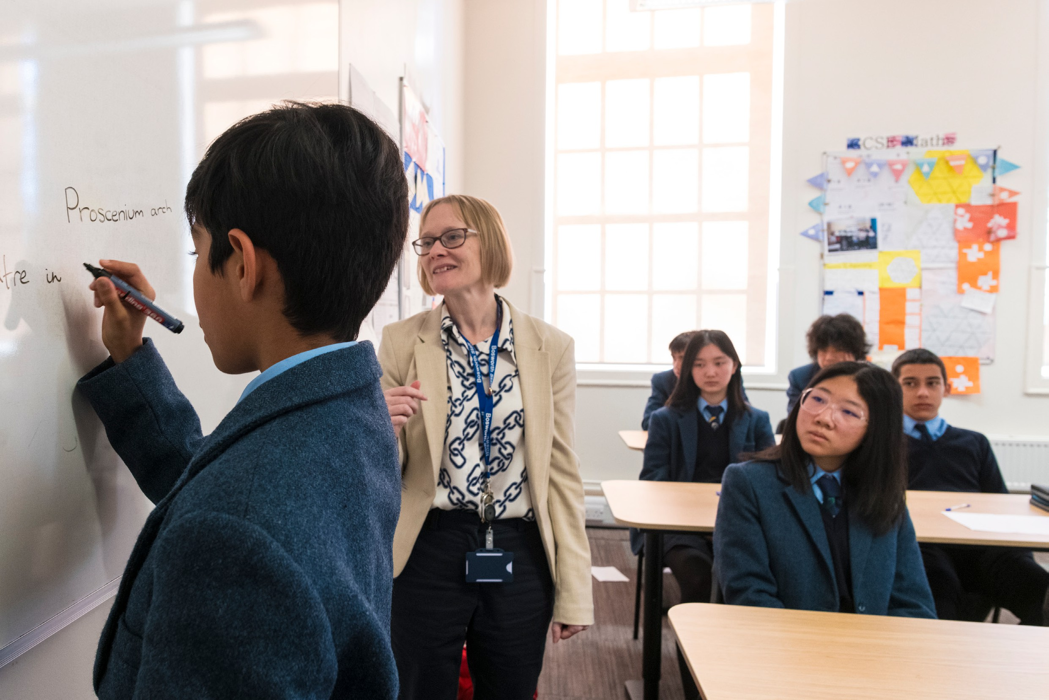

**Our curriculum and courses of study**

Our curriculum is deliberately broad and balanced and supplemented with a range of co-curricular activities, academic enrichment as well as a programme of educational trips and visits.

Providing academic programmes for ages 11-19, Bosworth ensures a customised timetable is in place for every student. There are very few restrictions on subject combinations at GCSE and A Level and, with average class sizes of eight, each student gets the individual attention they require to reach their academic potential.

At Key Stage 3, students enjoy an innovative and challenging curriculum designed to build every student’s comprehensive knowledge and develop their character. Students are motivated and supported to employ their learning creatively and flexibly as they strive for academic excellence. Our broad curriculum creates a strong academic foundation, instils academic skills and sparks their curiosity in preparation for future specialisations in Year 10 and Year 11. At Year 9, Business Studies and Social Sciences are introduced to expand students’ knowledge and increase their options at GCSE and beyond.

“This is an ideal environment to grow as an educator, whether you are starting your career or changing from an existing one”.

Dan Mattock

Teacher of Science & Head of Year



**Our students**

Our students are drawn from across the world and, together, they speak over 30 languages. We value each of them for the individual heritage, experience and history they bring to our diverse, global, multicultural community. While it’s impossible to accurately summarise a group of young people, there are some traits that characterise a Bosworth student. They are hard-working, motivated, and interested in their learning, which makes them a delight to teach. They are curious to know more and will want to speak to their teachers about the subject beyond the curriculum. They are polite and respectful to staff and to each other; their care and kindness is striking. They value the opportunities that a Bosworth education gives them, not least the chance to make friends

from around the world and learn more about the culture and countries their friends have been shaped by. They are interesting, fun and – frankly – along

with our staff are our best and most brilliant asset.

**Beyond the classroom**

Providing opportunities for learning beyond the classroom is key to our educational philosophy. Students can select from a wide variety of activities in and out of school, which encourages them to nurture their talents, deepen their academic knowledge and broaden their horizons, hone important qualities like resilience and teamwork, as well as having fun. Clubs currently include Med Soc, Oxbridge, EPQ, Red Cross and Model United Nations, the Duke of Edinburgh’s Award Scheme, Drone Club, Astronomy and Chess Club.

“Students are polite and hardworking. The diversity of the background of the students makes it a really interesting place to work”.

Lisa Punter

Head of Higher Education & Careers

**Our staff**

Staff who work at Bosworth are committed to the wellbeing and welfare of all students. Each of them does everything they can to ensure that students fulfil their potential. A strong sense of collegiality exists in the staff body and a genuinely friendly, supportive atmosphere is something that staff frequently comment on. This exists within and across departments; anyone who needs anything knows they can ask colleagues for help and get it. The school is a safe and pleasant working environment. Free lunches are available for all staff

and the quality of food is excellent as well as varied. There are a variety of social events for staff organised throughout the year, which include Christmas and Summer socials and ‘Cake Fridays’ in the staff room help to mark the end of the working week and provide an opportunity for colleagues to gather as we prepare for the weekend. Staff show deep respect to one another and know that they are highly respected for the qualified professionals they are. There is an enormous sense of professional pride that comes from knowing each day that young lives are being made better because of their effort and skill.



“Teachers have great subject knowledge and a desire to pass it on. We are committed to helping students be the best they can be. We’re supportive of each other and fun - there is a lot of laughter in the staffroom, but also a lot of support when people have problems, whether in or outside of work”.

Alison Barnes  
Examinations Officer

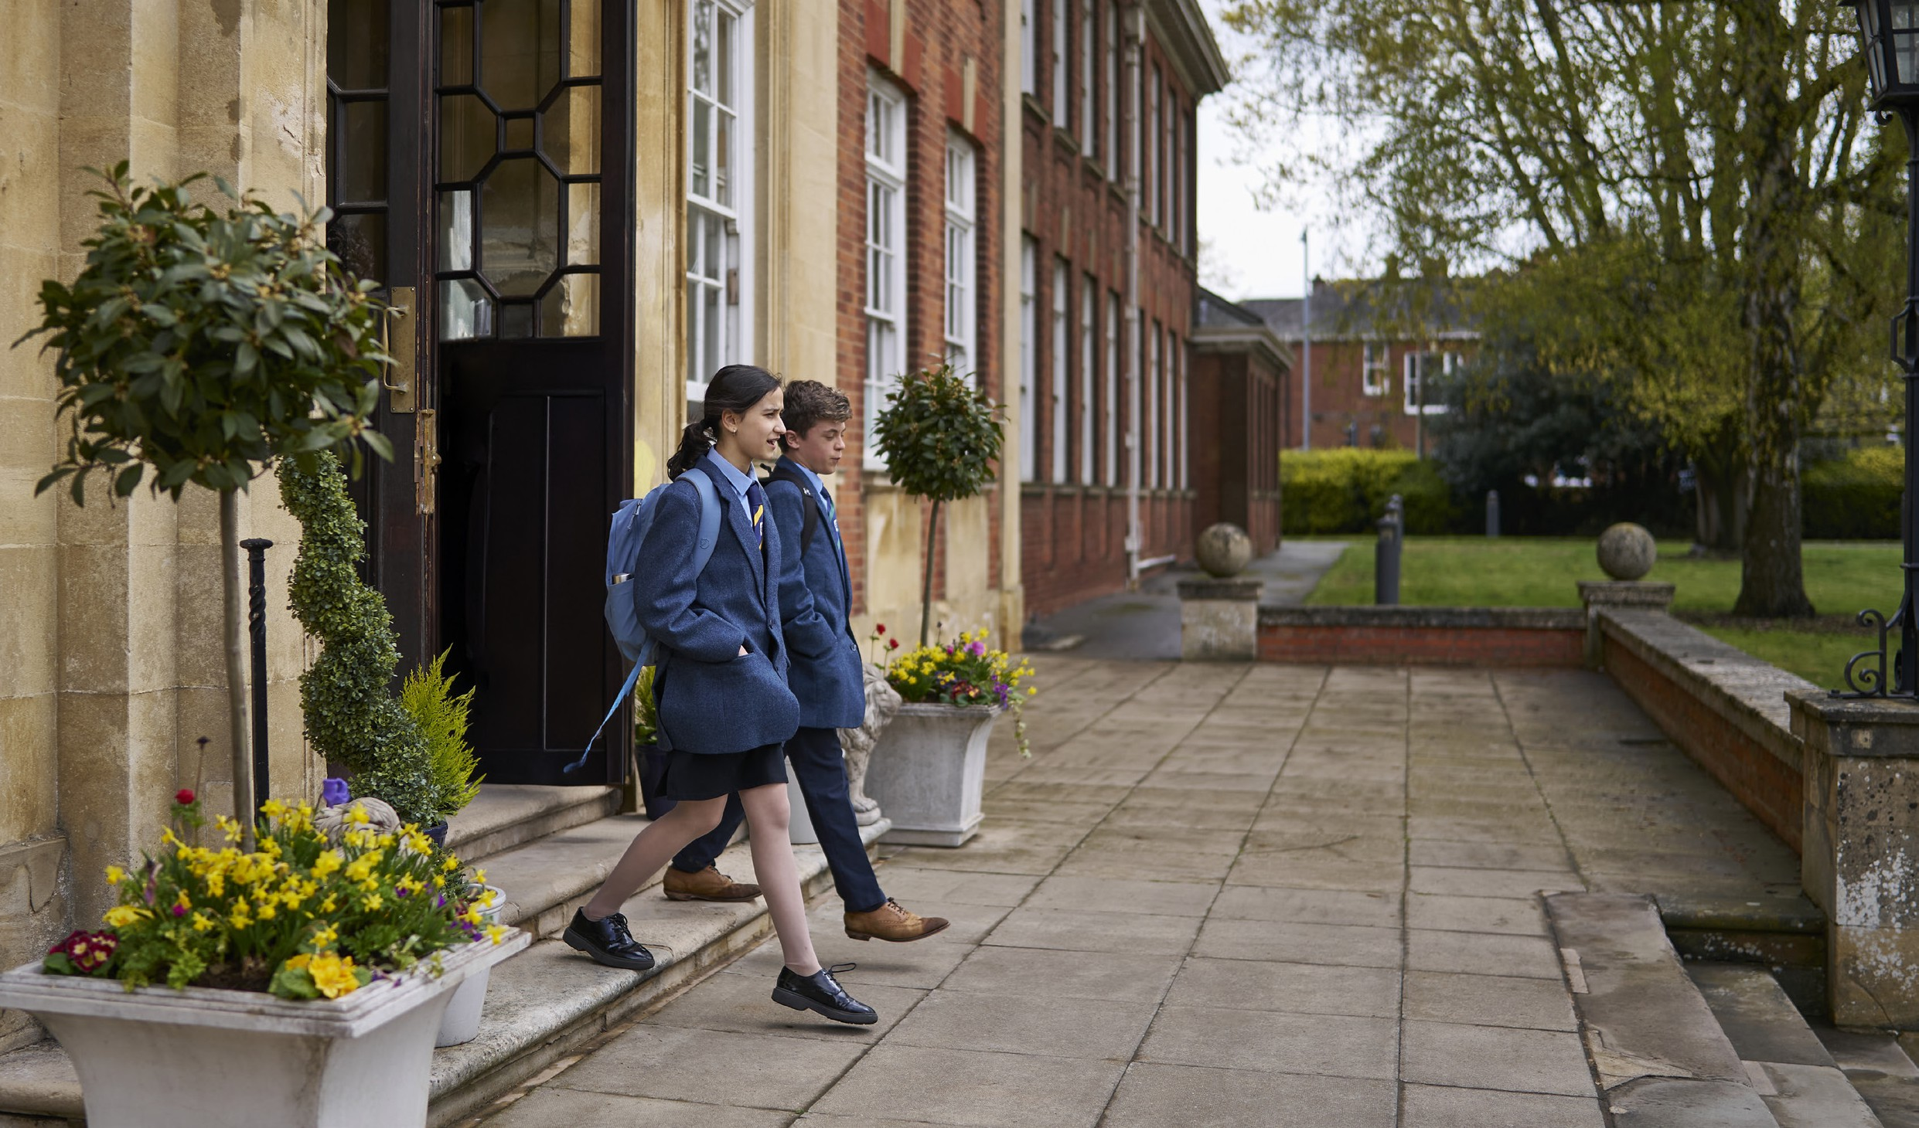

“Boarding allows students the opportunity to learn to live more independently, managing their own work schedule and learning self-discipline. As a result, they are more fully prepared for university… Learning to co-operate with others with respect and tolerance and having the ability to resolve conflict when it occurs are key skills that students will need when they enter the working world”.

Jeff Shipway  
Head of Boarding

**The School Site**

The school is spread over a wide range of buildings within easy walking distance of each other. The Newton Building is beautiful and houses the school’s administrative function, the Grand Hall (used for assemblies, concerts and special events) and the majority of teaching rooms. The nearby Bosworth Hall building houses the school’s dining room, the student gym, and recreational space for students to relax and spend down-time with friends. The first floor houses a suite of state-of-the art Science laboratories.

Our boarding community is currently housed in a number of houses near to the school. Each house has its own dedicated Houseparents, who care for the students who live there, ensuring that the residence is a comfortable and safe place where they can relax and study. The school has exciting plans to soon acquire a nearby former university halls of residence which will provide purpose-built, contemporary university-style

living space for 300 students.

**Professional development and career progression**

We are committed to investing in the professional development of all staff. An annual programme of training ensures staff are continuously enhancing their skills and honing their craft. Teachers benefit from subject specific CPD, access to external conferences and opportunities to network and share best practice with colleagues in local schools and schools within the CATS Global Schools Group.

University of Northampton

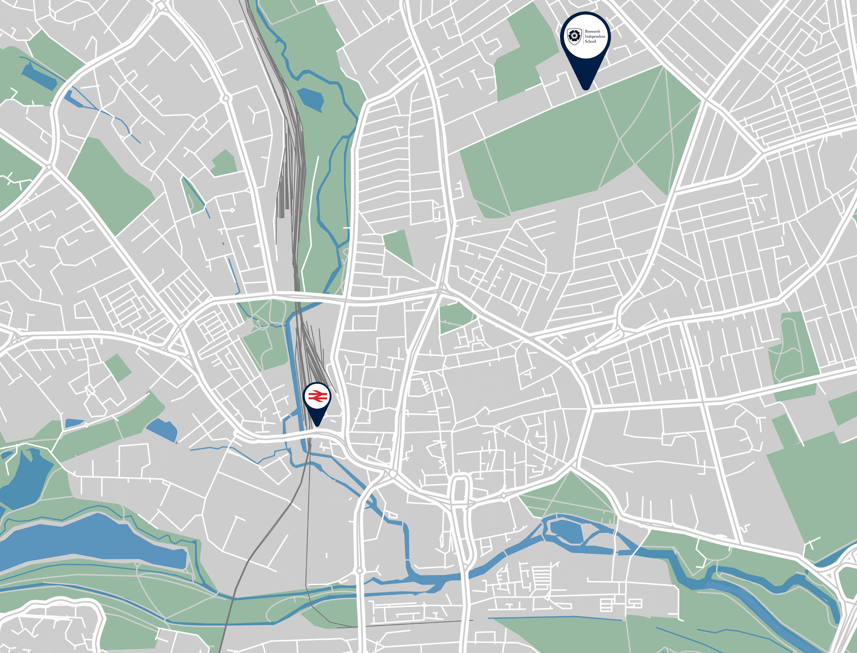

**Our location**

Bosworth Independent School is a stone’s throw away from the vibrant town centre of Northampton. A town

with a rich history dating back to Saxon times, it grew as a strategically important settlement in the medieval era with a castle at its heart which played a key role in English history, including hosting Parliament during the 13th and 14th centuries.

Devastated by a huge fire in the seventeenth century, it was rebuilt and rose to become a centre for the

shoemaking and leather industry during the nineteenth and early twentieth century, features which shaped its industry and economy.

Designated a ‘new town’ in the 1970s, leading to its expansion and growth. Today it is a hub for logistics, business and education (the University of Northampton’s main campus stands on the edge of the town centre), while retaining its historical heritage through features

like Northampton Castle, Delapre Abbey and All Saints’ Church.

The M1 motorway is a couple of miles away from the school. The road network and the school’s location on the edge of the town make it accessible and easy to reach. From Northampton train station, there are

multiple trains per hour that land passengers in central London in under an hour, and there are regular train services that connect with other metropolitan centres and larger cities across the UK. The London airports are close by, with London Luton Airport around a 30-minute drive away and Birmingham International airport around 45 minutes away.

While an urban campus, the school has an open feel with the Racecourse, a vast green space, directly opposite the school. Northamptonshire’s many pretty villages, market towns and countryside are nearby.

The Racecourse

All Saints Church

Northampton Castle



**Benefits of working with us**

All CGS employees have access to a range of benefits, which include:

* Cycle to work Scheme
* Tech Scheme
* Car Scheme
* Free flu vaccine through Healthshield
* Free eye tests
* Financial wellbeing support via WageStream
* Employee Assistance Programme
* Group income protection
* GP24: GP Access for all
* Health Cash Plan
* Death in Service
* Long service awards
* Employee referral scheme
* Enhanced Maternity and Paternity pay

In addition, at Bosworth Independent School all staff can enjoy:

* Free lunches
* Free, secure parking on-site

**Inspection reports**

As an independent school, Bosworth is inspected regularly by the Independent Schools Inspectorate. The most recent inspection reports are available to read on the school’s website.

For another perspective, we really like the review

from ‘Muddy Stilettos’ which captures the school well and can be found [here](https://northantsleicsrutland.muddystilettos.co.uk/kids/school-reviews/bosworth-independent-school-northampton/).

**About CATS Global Schools (CGS)**

Bosworth Independent School is a proud part of CGS, a global community of independent boarding schools, international high schools, an Arts School and English language schools preparing students aged 2 to 18+

for their next destination. More information about our network of schools can be found [here](https://catsglobalschools.com/).

**Safeguarding**

CGS is dedicated to safeguarding and promoting the welfare and well-being of children and young people. As such, appointment is subject to the satisfactory completion of safer recruitment employment checks in line with KCSIE guidelines. This will include satisfactory references, enhanced DBS from the Disclosures and Barring Service and, where applicable, any international

equivalent being obtained. Shortlisted candidates will be

subject to online checks which may include social media.

**Job Overview**

**Assistant Headteacher Academic**

**Full-time, permanent**

**The Team**

The Senior Leadership Team at Bosworth Independent School is a dynamic and experienced group, dedicated to fostering a positive and forward-thinking school culture. Led by newly appointed Headmaster Tony Oulton, the team includes the Deputy Head, Head of Operations, Assistant Head (Pastoral), Head of Boarding, Director of Teaching & Learning, Director of Student Development and Director of Future Pathways & Partnerships.. With a strong presence across the school and an open-door policy, the SLT is approachable, supportive, and strives to work collaboratively with staff and students alike.

At the heart of our leadership approach is a commitment to continuous improvement—not just for the school but for everyone in our community. We actively encourage professional growth, providing a wide range of opportunities, including access to a full suite of National Professional Qualifications (NPQs), to help staff develop their skills and progress in their careers. We believe in looking ahead, keeping an eye on educational trends, and learning from the best practices beyond our own walls to ensure we are always moving forward.

Most importantly, we understand that great education stems from a happy and motivated team. That’s why we place a real emphasis on work-life balance, valuing the well-being of our staff as much as we do their professional development. We know that when people feel supported and fulfilled—both in and out of work—they bring their best selves to the classroom, ultimately benefiting our students. At Bosworth, the SLT is here not just to lead but to inspire, support, and create an environment where everyone can thrive.

**Role Overview**

The Assistant Head (Academic) will play a key strategic role in leading and enhancing the quality of teaching and learning across the school. They will ensure the highest academic standards, drive innovation in pedagogy, and support the professional development of staff. The successful candidate will be instrumental in shaping the future of the curriculum and in ensuring it is dynamic, rigorous and meets the needs of our diverse student community. The successful candidate will have as key strategic priorities the consolidation of existing academic strengths and the continuous improvement and evolution of the school’s educational offer and the philosophy that underpins it.

The role will suit someone who understands the importance of a variety of data sets and can use them to inform their strategy. They will be committed to their own professional development and supportive of others’, and be able to evidence this. They will be creative, forward-thinking, open-minded and understand what excellence in education looks like. They will work collaboratively with the existing members of the Senior Team under the direction of the Headmaster and with his support. They will take the job, but not themselves, seriously. They will be an outstanding teacher and would be expected to teach a reduced timetable in their subject.

They are likely already a school Senior Leader or a current middle leader looking for an exciting opportunity to take the next step in the career. A lot will be asked of them but, in return, they will have the unwavering support of the Headmaster and the rest of the Senior Leadership Team, work alongside brilliant staff and wonderful students in a school that is really going places.

**Key Responsibilities**

**Teaching and Learning**

* Provide strategic leadership in the development and delivery of high-quality teaching and learning across all subject areas.
* Ensure the implementation of evidence-based teaching methodologies and innovative educational practices.
* Monitor and evaluate teaching standards, providing coaching, feedback, and professional development opportunities to staff.
* Promote a culture of continuous improvement, fostering an environment where both staff and students strive for excellence.

**Curriculum Development**

* Lead the design, review, and implementation of a broad, balanced, and ambitious curriculum.
* Ensure the curriculum is inclusive, engaging, and responsive to students' needs, preparing them for success in public examinations, higher education and employment.
* Oversee subject leaders in the development and refinement of schemes of work, ensuring alignment with best practices and regulatory requirements.
* Monitor curriculum innovation and ensure the school remains at the forefront of educational developments.

**Assessment and Data Analysis**

* Develop and oversee effective assessment policies that support student progress and inform teaching strategies.
* Use data analysis to track student performance, identify trends, and implement interventions where necessary.
* Ensure robust reporting and feedback mechanisms are in place to support student development and parental engagement.
* Support teachers in using data to inform lesson planning and adaptation.

**Staff Development and Leadership**

* Lead CPD initiatives focused on teaching excellence, curriculum innovation, and assessment strategies.
* Mentor and support teachers at all stages of their careers, fostering a culture of reflective practice and professional growth, including promoting colleagues’ access to National Professional Qualifications.
* Support the recruitment, induction, and retention of high-quality teaching staff.
* As part of the Senior Leadership Team, develop and implement the school’s strategic vision.

**Essential**

**Qualifications:**

* A Bachelor’s degree in a relevant subject.
* Understanding of the importance of Safeguarding in schools, including familiarity with key policies and procedures.
* Evidence of ongoing professional development and educational research.

**Knowledge and Skills:**

* Proven experience in academic leadership or management.
* A strong track record of improving teaching and learning outcomes.
* Expertise in curriculum design and assessment methodologies.

**Personal Attributes:**

* Excellent leadership and communication skills with the ability to inspire and motivate staff.
* A commitment to continuous school improvement and innovation in education.
* Passion for teaching and working with staff and young people.
* Enthusiasm and creativity.
* Patience and understanding.
* Reliability and punctuality.
* Commitment to safeguarding and promoting the welfare of children.
* Ability to work as part of a team.
* Highest standards of professionalism.

**Person Specification**

**Desirable**

**Qualifications:**

* Postgraduate degrees or equivalent in a relevant subject.

**Experience:**

* Knowledge of national and international curriculum frameworks.
* Experience of mentoring or instructional coaching.
* Experience of teaching in an independent school setting.
* Experience of teaching in a global, multicultural school.
* Experience of successfully supporting students with English as a second language.



[**www.bosworthschool.co.uk**](http://www.bosworthschool.co.uk/)

