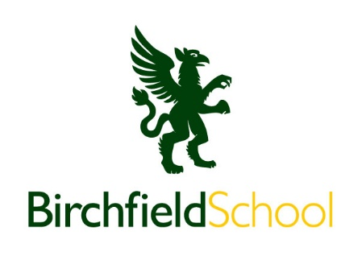
SCHOOL MINIBUS DRIVER
Location: Birchfield School, Harriotts Hayes Lane, Albrighton WV7 3AF
Start Date: As soon as possible
Contract type: Term Time Only
Hours: 20 hours per week
(Monday to Friday 07:00 to 09:00 and 17:00 to 19:00)

Salary: £10.42 per hour.
Additional hours are available for educational trips and sporting matches
Birchfield School is an independent preparatory and senior school for boys and girls aged 4 – 16 in a rural setting. We are seeking to appoint a careful, reliable driver able to relate to children and parents in a professional manner required to join this superb team.
The successful candidate will require a full driving licence.
Applicants must be willing to undergo child protection screening, including checks with past employers and the DBS.
If you are interested in applying or would like more information, please contact the school on office@birchfieldschool.co.uk
Birchfield School is committed to safeguarding and promoting the welfare of children. Applicants must be willing to undergo child protection screening appropriate to the post, including checks with past employers and the Disclosure and Barring Service.

