

**CLOSING DATE: Wednesday 17th April 2019 at 9.00am**

**Interviews will take place week commencing 22nd April 2019**

**Part-time Teacher of Art**

**BURY GRAMMAR SCHOOLS**

**“A positive and uplifting environment”**

**THE GOOD SCHOOLS GUIDE, 2018**

**A JOURNEY OF EDUCATIONAL EXCELLENCE THROUGH OUR FAMILY OF SCHOOLS**

**EMPLOYMENT OPPORTUNITIES**



**WELCOME**

**WHY JOIN BURY GRAMMAR SCHOOL?**

Bury Grammar School is a forward-thinking, vibrant and modern family of schools. We are proud of our rich heritage and the tradition of academic excellence combined with exceptional pastoral care. Our aim is to offer an outstanding and unrivalled education in which pupils are inspired to work hard, aim high and achieve. We have a strong commitment to retaining the long- held traditions, values and ethos of each of the Bury Grammar Schools, while preparing pupils for lives in an ever-changing world. We take enormous pride in our 450 year history, whilst looking to the future with confidence, openness and optimism. We are proud to be a leading academic school with a big heart.

Bury Grammar School is a dynamic and exciting place to work, and employs over 230 staff, across a wide variety of roles. Every member of staff employed by Bury Grammar School has an impact on our pupils and we aim to recruit the highest calibre of staff who are passionate about our school aims: Scholarship, Character, Partnership and Enrichment.

We foster strong Leadership and Management by empowering and involving staff in its strategy and decisions. We have an established CPD programme which provides our staff with every opportunity to continue their own learning journey. We recognise that delivering continuous improvement is key to the success of every individual and to Bury Grammar School as a whole. We value all our staff and believe that attracting and retaining the very best people is fundamental to allowing us to continue to develop.

**BENEFITS OF WORKING AT BGS**

* Opportunities for progression and continued professional development;
* The opportunity for teachers to teach in single-sex boys, single-sex girls and coeducational environments;
* The chance to join a school at an exciting point in its development, with all the opportunities that brings;
* Pay progression based on length of service (teaching staff);
* Pension scheme;
* Fee remission scheme;
* Excellent holiday entitlement for support staff that increases with length of service;
* Term-time lunch allowance in the school canteen;
* Salary sacrifice cycle to work scheme;
* Free After-School Club scheme;
* Free staff swim sessions;
* Free on-site parking;
* Corporate eyecare scheme.

**UNIQUE STRUCTURE**

Bury Grammar School is a ‘diamond model’ school which means that it combines both single-sex and coeducational teaching in the same organisation.  
  
The youngest children are taught in co-educational teaching groups in the purpose-built Kindergarten and Infant School. Pupils are then taught in single-sex teaching groups in separate buildings from Year 3 which continues until the pupils complete their GCSEs, although there is a limited amount of coeducational teaching.  After GCSEs pupils progress into the purpose-built co-educational Sixth Form for their A Level study.  
  
While the school operates as one staff, where colleagues are expected to teach both boys and girls, the school also operates a unique leadership structure where the Principal is also the Headmistress whilst the Vice Principal is the Headmaster.  The Assistant Principal is the Director of Academic Provision and ensures the highest standards are sought whilst maintaining equality of provision for boys and girls.  The Heads have a Deputy Head (Pastoral) who oversees welfare and pastoral care in each school.  School operations are coordinated by the Deputy Head (Administration & Enrichment).  
  
In the Primary Phase the Head of the Girls’ Junior School is also the Head of the Infant School and Kindergarten and is line managed by the Headmistress whilst the Head of the Boys’ Junior School is line managed by the Headmaster.  The primary phase heads are supported by deputy heads.  
  
We believe that our model provides the ‘best of both worlds’ within our family of schools. During the pupils’ formative years (between Years 3-11) they have the focus of single-sex teaching and tutor groups which allow lessons to be specifically tailored to their needs.  
  
Pupils are able to mix socially outside of lessons and extra-curricular activities are almost always mixed.



**DIAMOND STRUCTURE**

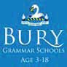

***Sixth Form***

***Girls’ Senior School***

***Boys’ Senior School***

***Girls’ Junior School***

***Boys’ Junior School***

***Infant School***

***Kindergarten***

A **vibrant, high-performing** school with a **rich history** and a warm, friendly community.

**Outstanding examination results**, a focus on **enabling** each individual pupil to **shine** within an **encouraging** and **supportive** environment, **exceptional teaching** and an **extraordinary** range of **extra-curricular** activities are our hallmarks.

**‘ A school leading from the front in its emphasis**

**on gender equality and nurturing mutual respect ‘**

**THE GOOD SCHOOLS GUIDE, 2018**

**FACILITIES**

As a strong and successful school spread over a 45-acre campus, Bury Grammar School provides the ultimate 21st century facilities from the very start of the educational journey.

Each of our family of schools provides modern and state-of-the-art facilities, which do much to promote the high standards of teaching and learning which flourish at BGS.

Our facilities include purpose-built classrooms, leading edge Art Centres, a modern Sixth Form Centre and top quality sports facilities including an 18-metre indoor swimming pool and 3G all-weather pitches.

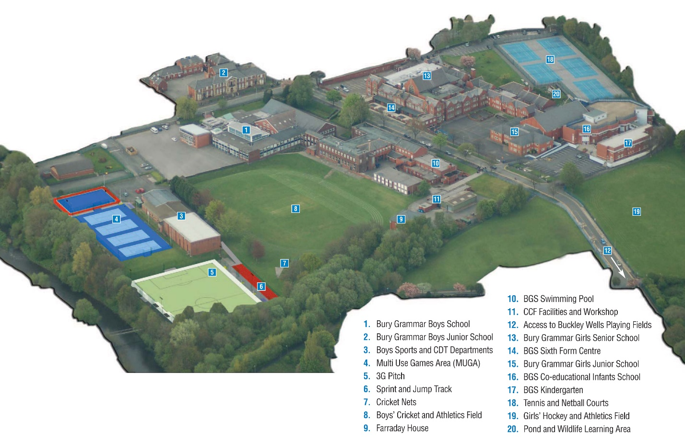

**HOW TO GET TO BGS**

Our Schools are based in the heart of the Lancashire countryside in the centre of Bury and are very easy to reach with the M66, M60 and M62 just minutes away. It is a five-minute walk from the Bury Interchange.

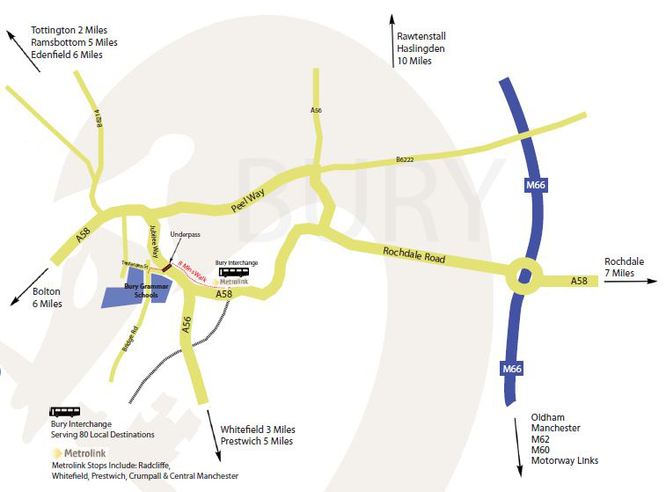

**BURY GRAMMAR SCHOOL IS CURRENTLY SEEKING TO APPOINT A**

**Part-time Teacher of Art (0.75 FTE)**

**Salary – Competitive**

Bury Grammar School aims to be a leading academic institution and the school of first choice for pupils, parents and staff in the area.

We are seeking to appoint, from September 2019, an inspiring, committed and enthusiastic Teacher of Art to join an outward-looking and high achieving Creative and Performing Arts Faculty. The successful candidate will be an outstanding teacher, passionate about their subject, and must be willing to contribute to the wider life of the school.

**The Faculty**

The Creative and Performing Arts Faculty at Bury Grammar School is a thriving team of eleven members of staff. We are committed to enabling our students to benefit from the very best standards of teaching and are proud of our departmental culture of collaboration. The departments in the faculty are Art and Design, Drama, Music, Design and Technology and Food. We provide a wide range of opportunities within the faculty to encourage our students to maximise their potential and thus promoting a sense of challenge, curiosity and risk taking in an inspirational and supportive environment. The Faculty has a strong enrichment programme and contributes an enormous and valuable amount to the wider life of the school with pupils across the schools spending much of their extra-curricular time within these departments. We organise many educational visits to art galleries, the theatre and music recitals, as well as students taking part in external competitions. We host an annual Art Exhibition and the School Production is one of the highlights of the school year attracting sellout performances.

**Applications**

Application is by submission of the School application form and covering letter addressed to the Principal (no more than two sides) in which you refer to the criteria set out in the person specification and outline your vision for the role. The completed application form and letter must be received by Mrs Andrea Jones-Hatcher, Head of Support Staff (vacancies@burygrammar.com), by no later than **9.00am, Wednesday 17th April 2019.** Interviews will be held week commencing 22nd April 2019.

**BURY GRAMMAR SCHOOL**

**Teacher of Art**

**Job Description**

Reporting to: *Head of Art & Design*

**JOB PURPOSE**

To teach Art and Design and ensure outstanding academic outcomes for all students at Bury Grammar School.

**The following duties shall be deemed to be included in the professional responsibilities which you may be required to perform:**

**1. Teaching**

* Planning and preparing courses and lessons;
* Teaching, according to the pupils’ educational needs, the pupils assigned, the setting and marking of work (including examinations) to be carried out by the pupils in School and elsewhere;
* Assessing, recording and reporting on the development, progress and attainment of pupils.
* Providing additional support as may be needed to best meet the educational needs of pupils.

**2. Supporting learning**

* Promoting the general progress and well-being of individual pupils and of any class or group or pupils assigned;
* Providing guidance and advice to pupils on educational and social matters; making relevant records and reports;
* Being a Form Tutor, if required, and carrying out the duties expected to fully meet the requirements of such a role;
* Making records and reports on the personal and social needs of pupils;
* Communicating and consulting with the parents of pupils;
* Communicating and co-operating with persons or bodies outside the School;
* Participating in meetings arranged for any of the purposes described above;
* Accompanying pupils on trips away from the School;
* Contributing to the extra-curricular life of the School;
* Attending School functions;
* Participating in assemblies;
* Contributing to the maintenance of a stimulating working environment in School;
* Upholding the ethos and high standards of the School and abiding by the rules laid down by the School from time to time.

**3. Assessments and Reports**

* Providing or contributing to oral and written assessments, reports and references relating to individual pupils and groups of pupils.

**4. Appraisal**

* Participating in any arrangements that may be made for teacher appraisal.

**5. Review: further training and development**

* Reviewing from time to time methods of teaching and programmes of work;
* Participating in arrangements for professional development.

**6. Contributing to academic provision**

* Advising and co-operating with the Headmaster/mistress, Head of Department and other teachers on the preparation and development of courses of study, schemes of work, teaching materials, teaching programmes, methods of teaching and assessment or pastoral arrangements.

**7. Syllabus**

* Teachers are responsible for ensuring that they teach the correct public examination syllabus offered at BGS in their subject in accordance with School policy. Teachers should be aware of any subject area developments outside the School and where appropriate bring them to the attention of colleagues.

**8. Discipline, health and safety**

* Maintaining good order and discipline among the pupils and safeguarding their health and safety both when they are on the School premises and when they are engaged in authorised school activities elsewhere.

**9. Staff Meetings**

* Participating in meetings at the School which relate to the curriculum for the school or the administration or organisation of the School, including pastoral arrangements.

**10. Public Examinations**

* Participating in arrangements for preparing pupils for public examinations and in assessing pupils for the purposes of such examinations, recording and reporting such assessments; and participating in arrangements for pupils’ presentation for and supervision during such examinations.

**11. Administration**

* Participating in administrative and organisational tasks related to such duties as are described above, including the management or supervision of persons providing support for the teachers in the School and the ordering and allocation of equipment and materials;
* Registering the attendance of pupils and supervising pupils, whether these duties are to be performed before, during or after school session or lunch times, evenings, weekends or cover for absent colleagues.

**12. Duties**

* Undertaking supervisory duties as assigned according to the custom of the School.

**13. Timetable**

* The School may alter the weekly timetable from time to time depending on amongst other things the School roll.

**ALL TEACHING STAFF ARE EXPECTED TO UNDERTAKE THE ROLE OF FORM TUTOR:**

**Accountable to:** Head of Section/Heads of Year/Head of Sixth Form

The Form Tutor is the first point of contact for parents and staff when concerns arise about a pupil and is expected to provide an exceptional level of pastoral care and promote a sense of pride in the school by all pupils.

**The following duties shall be deemed to be included in the professional duties which you may be required to perform:**

**General responsibilities of a Form Tutor**

1. To be committed to the safeguarding and pastoral development of pupils.
2. To implement policies relating to the pastoral welfare of the pupils, in particular the safeguarding and Anti-bullying policies and know the role which the Form Tutor plays in such policies.
3. To welcome, settle and integrate pupils into the form.
4. To ensure that the pupils are aware of the high standards of behaviour, commitment and dress which are expected of them and to motivate and encourage them to achieve those standards.
5. To monitor the welfare, behaviour, dress, punctuality and attendance of each pupil in the form and to respond promptly to poor behaviour and to failures to comply with the school’s dress regulations.
6. To take an active interest in each pupil’s life at BGS – academic work, extra-curricular involvement, social integration and higher education and career aspirations. In addition he/she should be aware of the pupil’s interests and activities outside of school which may make a significant contribution to the pupil’s development.
7. To work closely with subject teachers and careers staff in the guidance of each pupil as required.
8. To support colleagues in dealing with any disciplinary issues which arise and specifically to monitor behavior systems and ensure that follow up actions are recorded.
9. To maintain accurate and up to date records relevant to the responsibilities of the role.
10. To ensure that each pupil is conversant with the school’s Behaviour Policy and with its Fire and Safety procedures.
11. To be available for consultation by parents. Form Tutors are the first port of call for parents wishing to discuss minor welfare or academic issues. More serious issues should be referred to the Head of Section/Head of Year.
12. To liaise with the relevant Head of Section/Head of Year regarding the welfare and academic progress of the pupils.
13. Issues which cannot be resolved by the Form Tutor should be referred to the Head of Section/Heads of Year – whom the Form Tutor should always feel ready to approach for advice and support. In any case the Form Tutor should keep the Head of Section/Head of Year informed of issues relating to the form and of parental contact.
14. To deliver the Pastoral Scheme of Work or a programme of PSHEE
15. To be up to date in the latest developments in pastoral care of pupils.
16. To encourage pupils to participate in extra-curricular activities and opportunities which promote leadership and initiative.

**Academic monitoring**

1. To actively support pupils who may have SEND, be AGT or who have EAL.
2. To monitor each pupil’s academic work in partnership with their Head of Section/Head of Year and the relevant Head of Department, according to the agreed whole school tracking procedures.
3. To discuss interim assessments and reports with each pupil, encouraging challenging but realistic target-setting and promote the values of self-review and reflection in the pursuit of academic excellence and personal development.
4. To ensure that subject teachers are aware of welfare issues which may affect the academic performance of particular pupils.
5. To respond to concerns from colleagues about a pupil’s academic work.
6. To complete tutor reports in accordance with school policy.
7. Where appropriate, to compile UCAS references and other references which may be requested.

**Registration and Attendance**

1. To be punctual at least, and early at best, at Registration each morning and afternoon and to insist on the pupils’ punctuality.
2. To complete the electronic register in accordance with school policy. Pupils must never complete the register.
3. To follow up on all unexplained absences to enable them to be correctly coded and to check patterns of absence.
4. To refer attendance concerns to the Head of Section/Head of Year.
5. To ensure that the pupils arrive punctually at Assemblies and Period 1/Period 7, and to encourage pupils to have packed their bags for the appropriate AM/PM session.

**Form Room**

1. To ensure that the Form Room is kept tidy and in good order and that the pupils treat the furniture and other facilities with care.
2. To encourage a sense of corporate responsibility for the tidiness and good order of the Form Room. The Form Room must always be left in good order with no litter on the floor. Chairs should be tucked under desks at the end of each registration period.
3. To maintain the Form Room noticeboard providing relevant and up to date information and that it is in good order.

**General Duties**

* Work flexibly to meet the Schools requirements including on occasions working in other departments as directed by your manager. This requirement is likely to be particularly relevant where you may be expected to work evenings or weekends.
* Comply with all School policies and procedures. Within these boundaries, staff are expected to use initiative to resolve problems and address issues.
* Ensure the quality standards and performance measures applying to your area of work are met and facilitate continuous improvements in all aspects of the post.
* Maintain a safe environment by working within Health & Safety guidelines and being aware of your responsibilities for health and safety.
* Value diversity and promote equal opportunities
* Participate in appraisal activities as required. Undertake further training as needed to ensure up to date knowledge and implementation of best practice.
* All Bury Grammar Schools’ employees are expected to act as ambassadors for the Schools and promote the Schools and its services positively as well as behave in a manner consistent with the Schools’ Values at all times.
* Undertake any other duties and tasks appropriate to the grade and character of work as may reasonably be required.

*The details contained in this job description reflect the content of the job at the date the job description was prepared. However, over time, the nature of individual jobs inevitably changes; existing duties may be lost and other duties gained without changing the general character of the duties or the level of responsibility entailed. Consequently, the Schools will expect to revise this job description from time to time and will consult with the job holder in so doing.*

**Person Specification: Teacher of Art and Design**

|  |  |  |
| --- | --- | --- |
| **Qualifications** | **Desirable** | **Essential** |
| A good degree in Art or a related subject |  | A |
| PGCE qualified or equivalent. |  | A |
| A commitment to continued professional development. |  | I |
| **Experience** |  |  |
| Experience of teaching GCSE and A-level Art. | A/I |  |
| Participation within the pastoral and broader curriculum programme. |  | A/I |
| Experience of pupil specific tracking and coordination of effective intervention strategies. |  | A/I |
| Portfolio of work |  | I |
| **Knowledge** |  |  |
| Excellent subject knowledge. |  | I |
| To be in alignment with the ethos of Bury Grammar School |  | I/A |
| **Skills** |  |  |
| A passion for innovative student learning and the ability to stretch our brightest students |  | I/A |
| Ability to be self-motivated, and a team player. |  | I/A |
| Confidence in using ICT to enhance learning within the classroom. |  | A/I |
| Interpersonal and communications skills of the highest order. |  | I |
| An understanding of change management | I |  |
| An understanding of how to coach staff | A/I |  |

Application (A)

Interview (I)

**GUIDANCE NOTES FOR APPLICANTS**

**Rehabilitation of Offenders/Disclosure and Barring Service**

A criminal conviction will not necessarily be a bar to your employment. Bury Grammar Schools comply with the Disclosure and Barring Service’s Code of Practice and will consider the suitability of all applicants on merit and ability.

The Rehabilitation of Offenders Act 1974 entitles people who have been convicted of a criminal offence carrying a sentence of up to 30 months’ imprisonment and who have completed the appropriate period of rehabilitation to regard their conviction as “spent”. “Spent convictions” can then be regarded as never having occurred.

The Rehabilitation of Offenders Act 1974 (Exceptions) Order 1975, however, exempts certain types of employment such as working in a school from the provisions of the Act. In addition, the Police Act 1997 required Police checks for all posts that come into contact with under 18s and vulnerable adults on a regular basis. Appointment to this post will require the post-holder to undergo checks by the Disclosure and Barring Service before commencing any duties which could bring them into contact with children.

Any information disclosed will be kept in strict confidence and used only in consideration of your suitability for the job for which you are applying. If you fail to disclose relevant information requested at any stage of the recruitment process, then your employment could be subject to withdrawal of contract, dismissal or disciplinary action in accordance with Bury Grammar Schools’ policies.

**Evidence of permission to work in the UK**

Prior to being permitted to commence employment with Bury Grammar Schools, you will be required to produce documentary evidence of your right to work in the United Kingdom. You could provide, for example, either a British passport or a passport or a National Identity Card from an EEA Country or Switzerland; alternatively, a document showing your permanent UK National Insurance Number and your full UK Birth Certificate.

A full list of acceptable documentary evidence is available on request. Original documents must be provided at interview stage. For further information, please refer to the Home Office website ww.bia.homeoffice.gov.uk.

**Safer Recruitment**

Bury Grammar Schools are committed to safer recruitment and safeguarding pupils. Any appointment will be subject to successful DBS clearance, satisfactory reference and confirmation of medical fitness for the post.

**Bury Grammar Schools welcomes Diversity and is Inclusive of all Cultures,**

**ensuring all are respected and valued for who they are as an individual, and as a group.**

**HOW TO APPLY**

**Completing your application form**

To apply for this position, please complete all sections of our application form. You are also required to complete a covering letter of application, but in Microsoft Word format only. Please do not submit your CV, even to supplement your application as this will not be considered.

**Employment**

Please give us details of your complete work history since leaving school/tertiary education. This should include information on your current and past employers, job title, dates employed and salary. Please explain any breaks in employment when detailing your full work history. You need to demonstrate clearly how your experience, knowledge, skills and abilities match those required in the job, as detailed in the Person Specification.

Where possible you should give examples of when you have used specific skills and abilities or needed to develop competencies in the relevant areas. You can draw on elements from any aspect of your life, such as education, work, home or community life, as long as you focus on its relevance in comparison to the needs of this job. It is important that you fully complete your application as all shortlisting decisions are based on the essential criteria in the person specification and only those candidates who are the closest match to the identified criteria will be invited for interview.

**References**

Please give details of 2 referees who can comment on your suitability to do this job. At least one reference must be from your current or latest employer and your references must cover your last three years of employment. It is BGS policy to request references prior to interview and these are verified as genuine.

BGS reserves the right to contact your current or latest employer following the interview and prior to offering a contract of employment.

In providing the names of referees, you are agreeing that Bury Grammar Schools may ask their opinions on your character in relation to this application. These opinions, given in trust, will remain confidential.

**General**

By signing and returning our application form you consent to Bury Grammar Schools using and keeping information about you, provided by you, or by third parties such as referees, relating to your application or future employment. If you are unsuccessful then your information will be retained for six months from the closing date. If you are successful, then your information will be transferred to your personnel file.

**Keeping your information secure**

Personal and Monitoring information is treated as strictly confidential and will be dealt with in accordance with the General Data Protection Regulation and our Data Protection Policy.

**Assistance with your application**

If you need any assistance in completing your application, please contact Mrs Andrea Jones-Hatcher on email: vacancies@burygrammar.com