Teacher of Maths

Salary Range: Main Pay Scale

St Aidan’s CE Academy is an Academy with a strong shared ethos of ‘success grows success when you are destined for greatness’.

We are looking for an ambitious individual who has extensive expertise in their subject and is fully committed to supporting, developing and further embedding the vision at St Aidan’s CE Academy. The ideal candidate will have a passion for their subject, making a difference and thrive on working as part of a strong, united team of staff.

The ideal candidate will:
- Be an outstanding classroom practitioner and role model, demonstrating high personal and professional standards and expectations in line with the Academy’s vision
- Demonstrate outstanding and extensive pedagogy.
- Fully support the extra-curricular activities of the Academy.
- Be eager to fully engage and take a shared responsibility in the continuation of their own professional development.

What we can offer you:
- A strong family ethos
- Very supportive and incredible staff team
- Career progression
- Outstanding relevant CPD
- Leadership opportunities
- We are an outward facing Academy
- Research opportunities
- Incredible pupils

Our central belief is that exceptional schools / Academies recruit and retain exceptional teachers and leaders. You will be joining an ambitious, energetic and supportive team of staff. You will be working with outstanding colleagues who are incredibly passionate about their subject specialism and pedagogy and who show extraordinary commitment and dedication to our pupils in their care; as well as being hugely supportive of each other.

Should you wish to visit the school which we strongly recommend, please contact Alex Simpson, PA to the Principal, on 01325 373778 to arrange a date/time.

Further details and an application form are available from Alex Simpson, Tel: 01325 373778 or Email: A.Simpson@staidansacademy.org.uk or alternatively downloaded from our website: www.staidansacademy.co.uk.
Applications must be returned to Alex Simpson via email.

Closing Date: Monday 12 April, 12noon
Interview:

The Academy is committed to safeguarding and promoting the welfare of children and expects all staff to share this commitment. The post is subject to a successful DBS clearance and pre-employment checks will be undertaken before an appointment is confirmed.
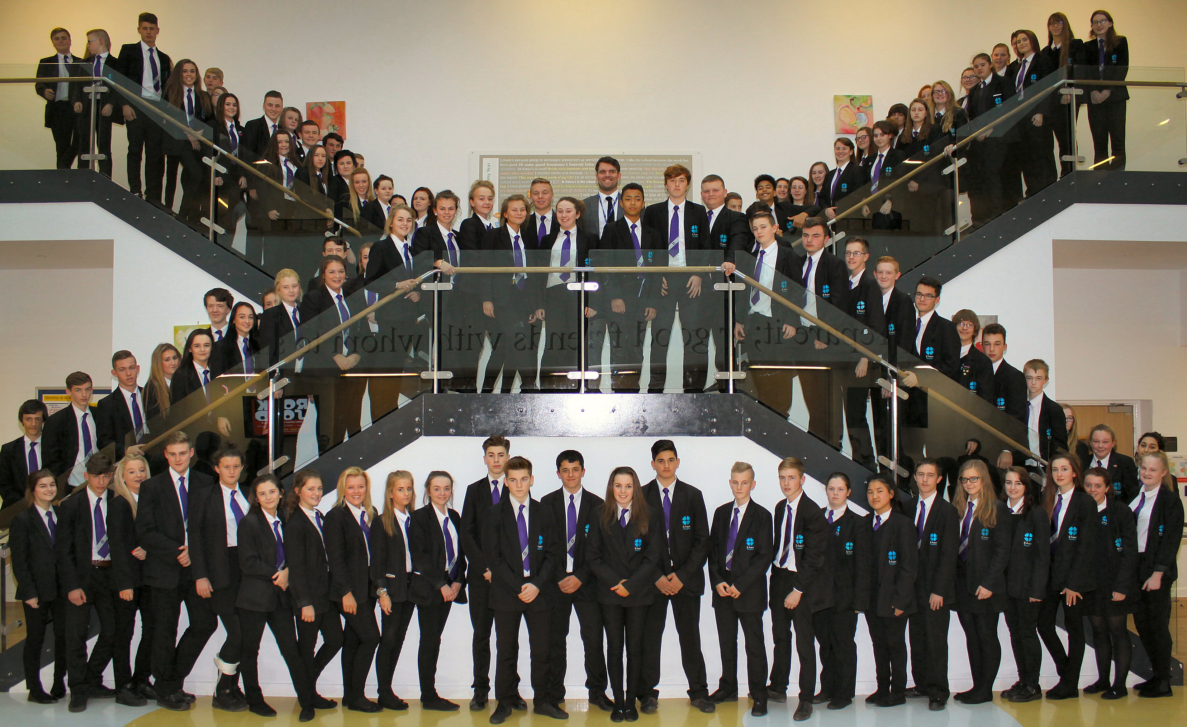 | St Aidan’s Church of England Academy  Hundens Lane, Darlington  DL1 1LL  Phone: (01325) 373770  Principal: Mrs N Gibbon

