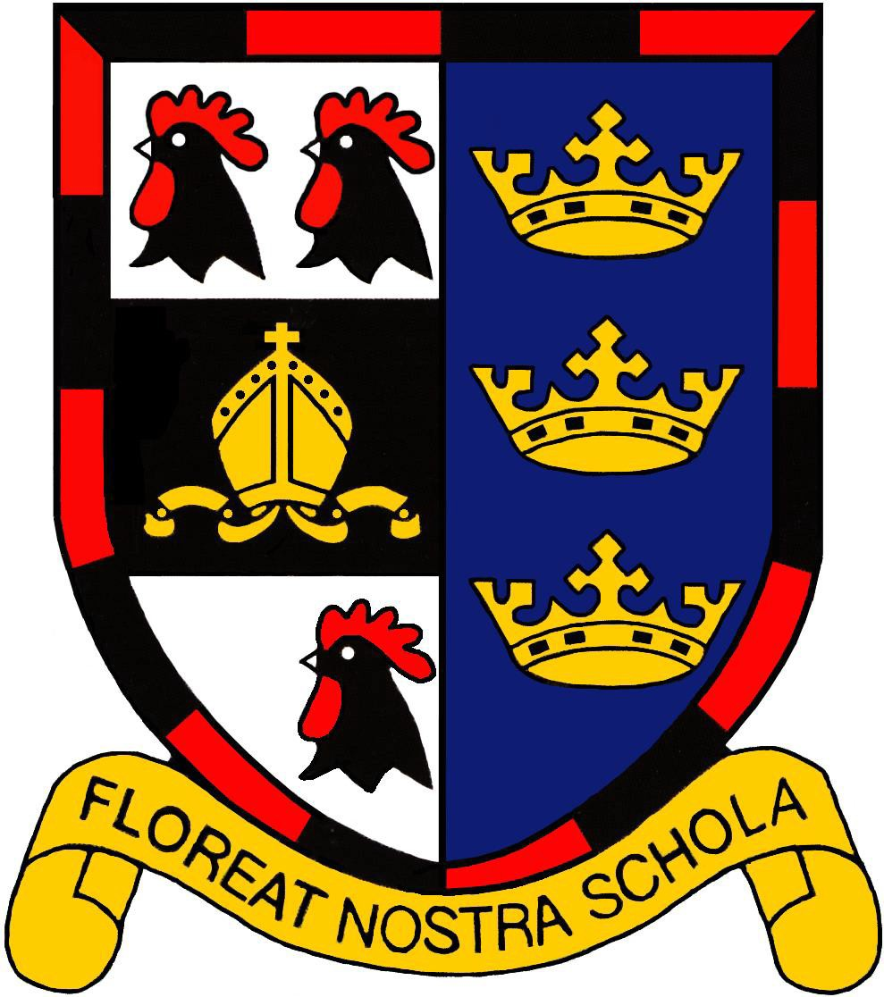
THE BRITISH

201
INTERNATIONAL
S3 CHOOL

A BRIEF INTRODUCTION TO MOSCOW!

Compiled by members of BIS Moscow staff, past and present

Contents
Page 3 Arrival in Moscow and Registration
Page 4 Where will I live. Apartments
Page 6 Clothes
Page 6 Living in Moscow
Page 7 Shopping
Page 7 Health
Page 8 Sports
Page 10 Culture

THE BRITISH INTERNATIONAL SCHOOL INFORMATION ABOUT MOSCOW

Welcome to Moscow! Current and former teachers from the British International School have put together the following information to introduce you to the city and Russia in general. It is intended to offer practical advice and information for anyone moving here. Hopefully it will dispel a lot of the myths and give you a perspective that will enable you to enjoy being in Moscow.

The British International School, Moscow comprises 6 schools, which are situated in the north and south of the city (precise information about the schools and their location can be found on our website, www.bismoscow.com). Although they are far apart geographically the schools work as a whole and hold joint events [both professional and social] during the year. However, the aim of this booklet is not to provide information about BISM, corporately or as individual buildings, it is more to familiarise you with the way of life and customs that you will encounter from the moment you arrive in Moscow.

The Russian Federation remains the largest country in the world, spanning 11 time zones (from Kaliningrad in the west to Petropavlovsk-Kamchatsky in the east). Its population of 142,000,000 sounds like a lot but in truth is very unevenly spread. Roughly ¾ of the population lives in a city. The number varies but there are estimated to be 103 ethnic groups of people living on the territory of Russia, with 97 different languages spoken. And that’s before you get to the ‘foreigners’.
Arrival in Moscow

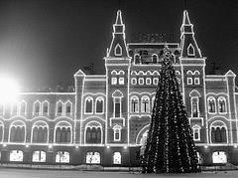
You will be met on your arrival at the airport. There are three airports in Moscow with international terminals Sheremetyevo, Domodedovo and Vnukovo. The School will co-ordinate the date and time of your arrival with you, as there will be a number of international staff to collect and you may be one of 3 or 4 teachers being collected that day.

Registration
All new arrivals to Moscow must have their passport registered within seven days: this is done by your landlord. We have a relationship with those landlords who are willing to do so. Every time you leave Russia or another city within Russia you have to be re-registered by your landlord. This must be actioned to comply with Russian law and enable you to live legally in Moscow and work at the school.

Everyone is very friendly and they remember what it is like to be a 'new face'. There are always people on hand to offer help and advice. You will find that the week you arrive is quite busy as there is an induction programme which aims to give you both a flavour of Moscow and help you become familiar with school. The schools also have a busy informal social calendar. There’s something happening most weekends, whether it is going out for a drink, a get- together in the evening, or a day-out.

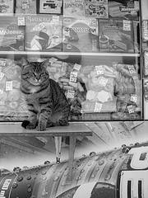
Where will I live? Apartments
In consultation with you, the school will find suitable accommodation for each of our new members of international staff and will find the best options in terms of location, quality and rent cost. The school finds landlords who are willing to register foreigners upon their arrival in Moscow. They need to do this every time you reenter Russia or have visited other areas of the country.

The rent costs may differ for the same quality of apartment, depending on the location, distance from the central part of Moscow or from the Metro station.

There are significant reasons why the school insists upon finding you an apartment:
- We find apartments for a competitive price.
- We know the locations.
- We do our best to find you apartments close to your school.
- We have an excellent relationship with your landlord.
- Most importantly your landlord is willing to register you and hence you are complying with Russian law. Not to do so would put your work visa at risk and you would be in the country illegally.

Rent is paid on a monthly basis, on a given date as determined by your rental agreement. Your school administrator will act as a facilitator to invite your landlord or landlady into school so that the transfer of the rental money may take place, and so that they sign the form confirming the transfer of the money. Some staff that have been here longer have other arrangements but this is down to the long-term relationships that have been established.

After you have paid the rent money, there may be small charges for the following:

•Electricity
•Landline telephone calls. All calls within Moscow are free. Any calls that are within Russia but are outside of Moscow are subject to a charge – look out for the Rostelekom (Ростелеком) bill in your mailbox
•Concierges or caretakers in the buildings may also charge a small fee.

If you wish to have cable television or the Internet, these are separate charges that you pay yourself. They are provided throughout the city by various different companies – speak to your school’s administrator.

Most apartments are in high-rise blocks. It is often a matter of course that in Russia all the apartments have a steel door and many locks, giving a feeling of great security. The entrance areas are variable but we do our best to find apartments that offer comfortable living with up to date facilities. The flat will include basic furniture, all kitchen facilities with plates and cutlery, a bath / shower, a telephone, some bed linen, a T.V., a washing machine and the customary Soviet-era ‘monster’ full-length wall unit in the living room.

Appliances are 220V. Please be aware that Russia, like continental Europe, has two-pin plugs. If you are coming from the UK or another country with different plugs or voltages, you will need to bring appropriate adaptors and/or converters.

If staff are planning to have a visitor in their flat for a long/short stay, or if they decide to share their flat with someone else, they will have to obtain their landlord’s agreement.
Clothes

Teachers are expected to look smart and business like at all times. A suit and tie, or shirt, tie and trousers for men;
smart top, trousers or skirt for women.

There are outside markets where clothing (winter coats etc) can be purchased at reasonable prices.

Basically everything is available in Moscow and at prices similar to the UK. Don’t waste luggage space on items that are obtainable here.

Living in Moscow

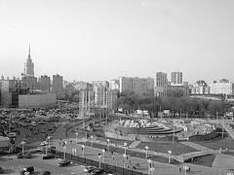
Moscow is a modern, exciting city and like every capital city, it has much to offer. However, preparation for relocation involves recalibrating your mental compass. It is important to learn something about Russia, its peoples and history before embarking on your assignment here.
To recognize their alphabet is certainly an advantage although the Russian and English languages are used in the Metro and signs are generally in both languages.

Living expenses vary depending upon your life style however some things are inexpensive, for example, public transport and theatre tickets. Some things are the same as Western prices, such as bars and restaurants. It is easily possible to live well in Moscow and save money. You will find your own ‘happy medium’ based on the style of living that you like and are accustomed to.

Please ensure that you always have enough money in Moscow to enable you to live comfortably. Don’t get caught out without enough money in your wallet/purse as not all restaurants accept debit cards.

Shopping

The Western-style supermarkets (Stockmann, SPAR, Perekryostok) have most things. ‘Auchan’ and ‘Billa’ are less expensive and also have a wide range of items. More and more Russian shops are adopting a western supermarket approach, and some do a home delivery service. Many famous brand western stores are now in Moscow. There are also several IKEAs around the city.

Health

Bring copies of your latest optical prescription plus a spare pair of glasses and contact lenses for emergencies, although both are easily available in Moscow and reasonably priced.

Your emergency healthcare is covered through a local company. Through this, we have access to excellent medical facilities. Local dentists are good value. Medicines are easy to buy, but can be of doses in excess of those in the UK and should be treated with caution. We also have a doctor or nurse based on all our sites for minor ailments and advice.

Sports

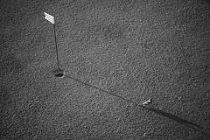
Broomball – For the men or the ladies! The schools are in a local league with the embassies. It is great fun in the winter and there is some obligatory social events attached of course.

Ice-skating - Gorky Park (Park Kultury) in the winter. Most of the other parks also have frozen paths for skating.
Hire skates or buy from shops such as Sportmaster.

Skiing – there are a few training slopes in Moscow and all of them are fairly inexpensive. Cross-country skiing is popular in the winter. For those who fancy skiing in the summer, СНЕЖКОМ at Krasnogorsk (NW Moscow) is an indoor ski-slope.

Horse-riding – there are stables in the North and South where you can ride. “Bitsa” on Balaklavskii prospect (between metro Kaluzhskaya and metro Chertanovskaya) is in Bitsevskii Park in the south of Moscow. It is Europe’s largest equestrian centre within a city’s boundaries and served as the venue for the equestrian events in the 1980 Olympic Games.

Spectator sports – Everything is available on big screen in the bars. The Boar House and Metalitsa are common places when a big game is on. Russia is on a sporting ‘high’ after the Wii n ter Olympics and the World Cup. Russians are big sports fans.

Football – The Russian Premier League runs from March until November. The standard has continued to improve over the last few years, with the emigration of Yuri Zhirkov, Roman Pavlyuchenko and Andrei Arshavin to Chelsea, Spurs and Arsenal respectively a sign of the standard now on view. Best teams to watch – CSKA, Lokomotiv, Zenit, Dynamo. Die- hard fans may want to read English journalist Marc Bennett’s book ‘Football Dynamo’ (2007), which gives an enlightening look at the history and fortunes of each of the major clubs.

Basketball - the standard is very high. CSKA is the best team and play in the European Cup. Tickets to watch all matches are easily available. To book online, go to www.innshopping.ru Delivery is available within Moscow.

Gyms - There are several gyms all over the city. Some can be very expensive. Just ask any of your colleagues who will be able to advise you of one in your locality.

Banya – One of the oldest Russian traditions. Since mediaeval times Russian towns and villages have had a steam house where men and women would sit steaming themselves, beating one another with venniki (branches of birch leaves), and cooling down by rolling around together in the snow. Today it is slightly d ifferent – a person can choose between mixed or single-sex banya, and there are pools of cold water rather than snow – but the birch leaves remain. Worth visiting at least once – for the experience alone (birch leaves optional) Sandunovskiye Banya (m. Kuznetskiy Most) is ornate and plush; whereas Donskoy Banya (m. Leninsky Prospekt/Shabolovskaya) is stark and Soviet -like. Either provides a memorable experience.

Culture
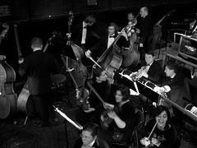
Moscow has a huge amount to offer! There is a tremendous variety of museums, concert halls, theatres, galleries, bowling alleys, cinemas etc..

Theatre and Music – The possibilities are endless. The Bolshoi Theatre is a must though expensive – the name alone carries the gravitas to make you want to go out of curiosity – and it is better than the hype. The Old Stage has reopened after several years of refurbishment. There are many other high quality theatres too. Ballet and opera opportunities abound. The International House of Music and Tchaikovsky Concert Hall attract world class performers from across the musical spectrum. Live popular music, including Jazz and Blues of all varieties, is alive and well in Moscow. Bands that have recently visited Moscow include Blur, Robbie Williams, Garbage, Paul McCartney, Moby, Kylie Minogue, Mark Knopfler, Natalie Imbruglia.

Cinema – cinemas in the centre (e.g. Oktyabr, 35MM, the ‘Dome’ in the Renaissance Hotel) show various films in English but it’s a case of catch as catch can. A great cinematic experience though, if only to appreciate that there are no adverts…… Postings usually appear in the ‘Moscow Times’.

Russian Literature – Russia has a deep and varied literary tradition which the readers among you may wish to explore.

