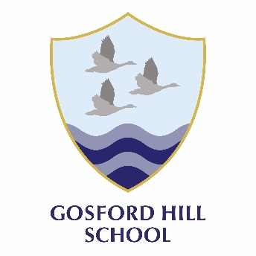
Gosford Hill School

Science Faculty

The Curriculum

In Science we encourage the development of critical analysis, evaluation and use of logical reasoning in our students, all of which are key transferable skills. At the same time we aim to develop curiosity and an understanding of how the scientific method can enable us to answer ‘big’ or ‘challenging’ questions.

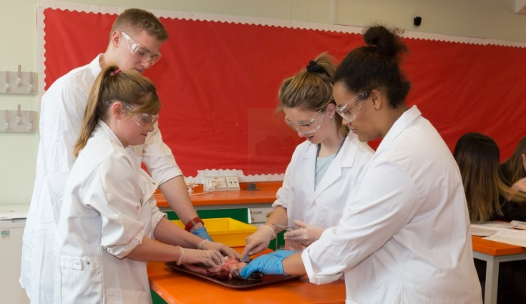
Science students are taught in mixed ability groups in Years 7 and are set in the remaining years. At GCSE we teach AQA separate sciences where students will leave with a grade in each science discipline and we currently have around 30 students taking this option in each KS4 year group. All other students follow AQA Combined Science ‘Trilogy’ which provides students with two GCSE grades that combine the three sciences together. Both Triple and Combined options are extremely rigorous and any student achieving grades 6 and above would be well placed to consider taking A level Sciences post GCSE.

At A Level, we offer Physics and Biology which both follow the AQA specification and Chemistry which follows the Edexcel specification.

Extra-Curricular Provision

Last year we offered a range of trips including taking year 10 to Thorpe Park to learn about the Physics of rides. We also make good use of the amazing local links we have with the University of Oxford, The Museum of Natural History, Begbroke Science Park and Rutherford Appleton Laboratories where we often make trips with groups of students.

We run local and national competitions such as our recent scientific creative writing competition. Last year were very proud to be able to say that two of our students came joint second against 160 other students from a range of state and private schools across the county.

To support students academically we support students with revision and intervention sessions throughout the school year as required for both GCSE and A Level studies to prepare students thoroughly for their exams.

Examination Results

We are delighted to have achieved a significant improvement in our GCSE exam results this in the 2018 results. Whilst in the past examination results have been disappointing, we now have the evidence to prove that as a department we are on an upwards trend and are uncompromising in our determination to both sustain this and improve further.

Examination Results 2018 in Science
GCSE | No. of Students | %9-7 | %9-5 | %9-4
Biology | 32 | 41.0 | 100 | 100
Chemistry | 32 | 50.0 | 94.0 | 97.0
Physics | 32 | 43.1 | 84.0 | 97.0
Combined | 127 | 11.8 | 46.0 | 69.0
A LEVEL | No. of Students | %A*-C | %A*-E
A2 Biology | 15 | 27.0 | 100.0
A2 Chemistry | 14 | 14.2 | 93.0
A2 Physics | 8 | 12.5 | 100.0
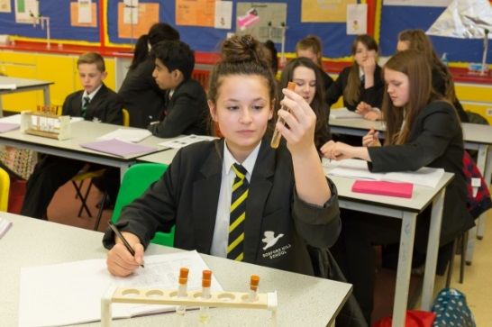

Staffing, Resources and Accommodation

The Science faculty is staffed by 8 Science teachers 3 lab technicians, and an HLTA. All staff teach a variety of year groups and many staff teach a 6th form class. Following our success in the examination results this year the team is focused and energetic in making further developments to ensure continued improvement. We remain dedicated in delivering high quality teaching and learning for all students and we are a team committed to our own professional development. The staff are friendly, supportive and very enthusiastic about developing Science in the school. Science is taught in a self-contained building in 8 dynamic and colourful labs. There is also a large prep room, toilet facilities and a teacher work-room. The teacher work room is equipped with a small kitchen and a photocopier. Members of Science each have their own lab which are spacious, well-furnished and contain a standard set of equipment. All labs are equipped with a projector which connects to a school provided lap top for multi-media based teaching. The faculty is well resourced and we see practical work as a key way to inspire pupils and improve their learning and understanding of the world around them. We also have a number of “pets” including Mollie the tarantula, stick insects and hermit crabs and a small pond and wild life area that pupils can be taken to in lessons.

Informal visits to the school are welcome; please telephone to make an appointment to be shown around.

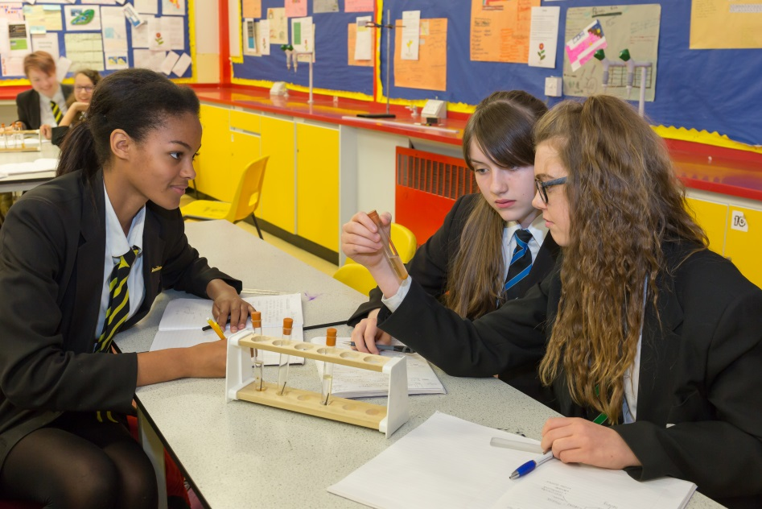

Gosford Hill School is an equal opportunities employer and is committed to safeguarding and promoting the welfare of children and young people. We expect all staff and volunteers to share this commitment. Due to this post having access to children and/or vulnerable adults, candidates will be required to undertake a Disclosure and Barring Service check. The possession of a criminal record will not necessarily prevent an applicant from obtaining this post, as all cases are judged individually according to the nature of the role and information provided.
Gosford Hill School operates a ‘No Smoking Policy’ for all new appointments. September 2016

