The Design and Technology Department

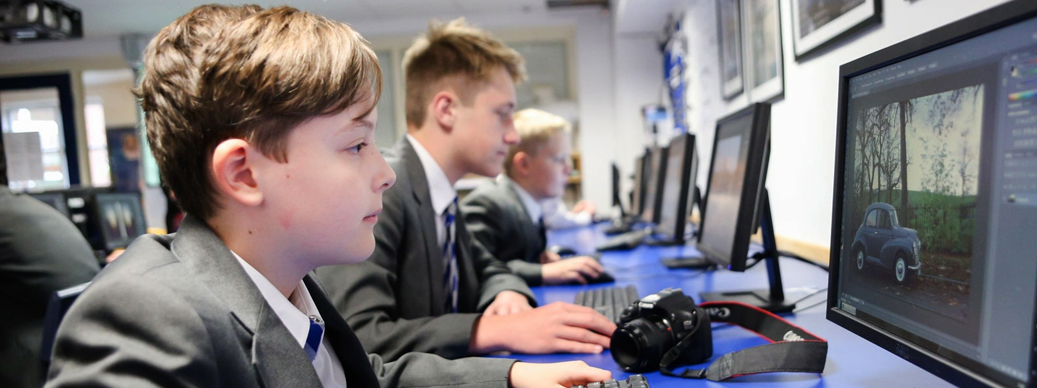

Subject Leader - Mr F Stewart (ststewartf@selstonhigh.org.uk)
The teaching of Design Technology within Selston High School is mainly taught through practical tasks and students learn how to use a workshop and food rooms safely.
Pupils study will study either DT or food for a complete year and rotate between the two subjects as they progress through KS3.
Students cook every week during their time in the Food department.
There are purpose built rooms for the subject, a food area and one materials workshop, plus a computer suite, which contains computer aided design software.
During Key Stage three students design and make a variety of products using a wide breadth of skills, materials and techniques.
Students study design subject areas ranging from packaging and object design, engineering analysis, design communication including sketching graphic design and model making, mechanical design, CAD, design for manufacturing, and ergonomics. This allows students to confidently continue with the subject in further education.
From Sept 2019 the DT department will have benefitted from investment over the summer. This will mean a state of the art food room, purpose built construction area, a newly created computer suite and improvements to the DT room.

