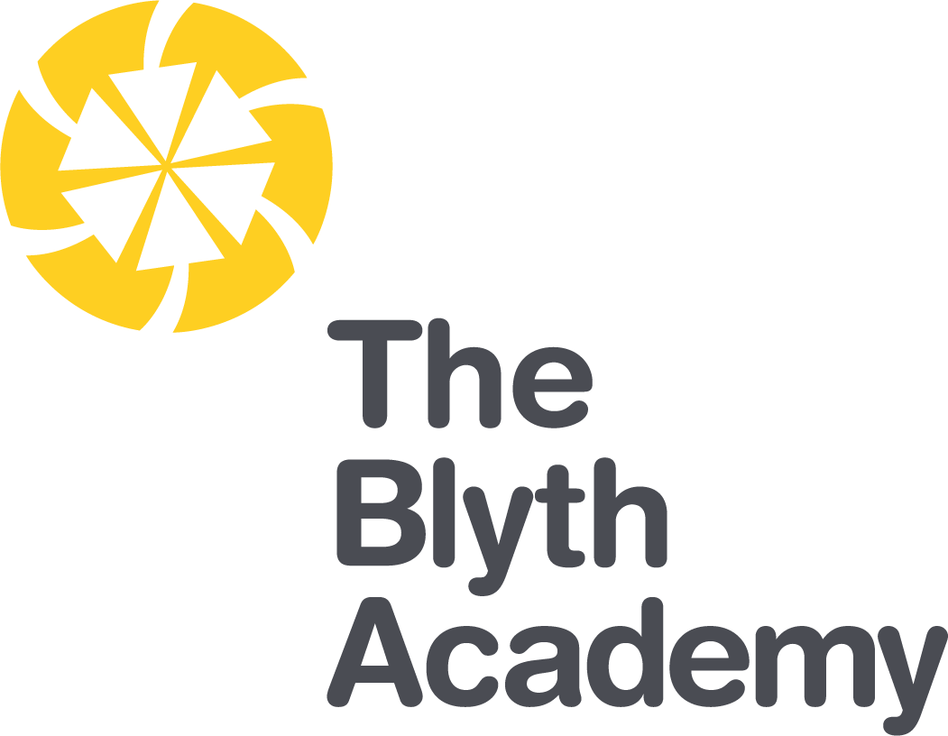

Outcomes Focused, Child Centred

Assistant Principal Recruitment Pack
Contents

Welcome from the Chief Executive | 03
Welcome from the Principal | 04
Introduction to The Blyth Academy | 05
Northern Education Trust | 06
Enrichment | 07
The Application Process | 09
Where to Find Us | 10
Job Advert | 11
Job Description | 13
Person Specification | 16

Welcome from the Chief Executive

On behalf of the Northern Education Trust Board, welcome to the Northern Education Trust.

We are unswerving in our commitment to ensure that the outcomes our young people secure prepare them fully for life beyond school. Our Academies are happy and thriving communities where children both achieve and feel safe and cared for. As an inclusive Trust we strive to help young people overcome any barrier to learning.

We are a caring employer and invest heavily in professional development, allowing our staff opportunities to take the next steps in their career. We hope you find our website holds all the information you need to believe that whether you are a parent or prospective employee, your next steps should be taken with us.
Welcome from the Principal

I am delighted to offer you a warm welcome to Northern Education Trust, The Blyth Academy.
As one of the most improved schools in Northumberland 2019, I am thrilled to say that this is only the start of the regeneration of our Academy; it is a fantastic time to be part of our community. At The Blyth Academy, we place students at the centre of everything we do, we are unashamedly focused on the educational outcomes of our students and deem that our students deserve to achieve the very best grades that they are capable of.

“We constantly focus on standards as we understand outcomes are paramount. Our decision making is driven entirely by what is best for children. By doing this we enhance the life chances of the children and young people in our care.” Northern Education Vision.

English & Mathematics are the cornerstones of our curriculum model as we believe attaining a strong pass in these subjects will open up our students’ life chances, giving them the opportunity to access a variety of post-16 opportunities. However, our curriculum does not stop there, our students will be taught more than just course content; we will ensure students develop the skills needed to become an independent, lifelong learners. We will give them every opportunity to succeed in a huge variety of activities in and out of the classroom, including cultural events, sporting activities and community projects.

It is important to us that our students are happy, confident learners. Our Academy is justly known for the high quality pastoral care that sits at the heart of our pursuit of excellence and guides every aspect of Academy life. This is the result of a stable, dedicated and highly effective team of staff ensuring that pupils have the support they need throughout their school life.

As an outward facing Academy we welcome visitors, please get in touch if you would like to see the Academy in action. I look forward to showing our achievements so far and the future we hold.

Donna Park
Principal

Introduction to The Blyth Academy

The Blyth Academy is a small sized secondary school. It is an 11-16 academy with 769 students currently on roll. The majority of pupils live in areas containing significant pockets of deprivation characterized (10% most deprived areas in the country) by high unemployment, an inadequate employment base, low average income levels, poor physical and mental health and a degraded urban environment.

The proportion of disadvantaged pupils is significantly above the national average (58% v 28%) and is the number currently in receipt of free school meals (44.5% v 14.1%). The Blyth Valley has some of the lowest rates of people in employment in the United Kingdom at 69.6% in comparison to the national average of 75.8%. This coupled with the high numbers of claimants for out of work benefits (7.2% in Blyth compared to 5.1% nationally), suggests that there are low levels of aspiration amongst the families whom send their students the Academy.

Pupils within our Academy are mainly white British, with only 3% of pupils having EAL, compared to 16.9% nationally. SEN support students are lower than national at 9.5%. Those requiring an EHC plan are slightly above the national at 1.1%.

Historically, outcomes at The Blyth Academy have been inadequate; students were failed. At Northern Education Trust we make decisions based upon what is best for the children in our Academies. We have unashamedly focused upon outcomes in English and Maths. By doing this we enhanced the life chances of the children in Blyth and have given them the skills, knowledge and qualifications to access a wide range of opportunities in the future.

As a result, outcomes over the past two years in English and Maths have rapidly increased and are now above that of the national average. 65% of students have now achieved grade 4+ in both English and Maths was 42% achieving grade 5+ in both. The increase in progress 8 to 0.18 demonstrates the evolution of the curriculum, which is ambitious, inclusive broad and balanced and meets the highest of expectations for all of our learners.

We are proud that Ofsted commented on our outcomes focused, child centred approach, ‘Pupils enjoy coming to school and they feel safe. They say staff look after them and want the best for them. Pupils know that they can be themselves and so they accept others for what they are.’ Ofsted October 2019.

Northern Education Trust

Our Vision

We constantly focus on standards as we understand outcomes are paramount. Our decision making is driven entirely by what is best for children. By doing this we enhance the life chances of the children and young people in our care.

The 10 values which underpin our vision:

- We care passionately about the education and welfare of young people

- We believe that all young people, irrespective of background or ability will be successful in our Trust

- We are not and will never be selective. We believe that local schools are for all children

- We are always inclusive. Our mechanisms to support the most vulnerable child to succeed and overcome barriers to learning are a key aspect of our work

- Our approach to education recognises that outcomes are paramount and also allows children to gain experiences and values which prepare them fully for life in modern Britain. This includes workplace skills and appropriate advice for future progression

- We have high expectations of behaviour

- We adopt the local authority admissions protocol and work closely with them

- We would always wish to act in such a way that has a positive effect on a neighbouring school or community. We care passionately about children in all schools, not just our own

- That all employees act with integrity and embrace the value that ‘we are the Trust’

- We work regionally and nationally to develop approaches to MAT improvement that influence the wider school-led system

Enrichment

Below are examples of Enrichment sessions running weekly within our academy
OLC Study Club | A great place to complete homework, research, work collaboratively and use the ICT facilities. This club runs every night with free hot chocolate and biscuits)
School of Rock | There is a space in the school band for anyone and everyone who is interested in learning to play an instrument, performing or learning about the production side of show business.
Mr Taylor’s Flying Circus | If we can make it fly then it is part of our club. Launching rockets, modelling aircraft and flying model planes. This club will start in January.
Basketball | Open to all students. Coached in partnership with the Newcastle Eagles.
Ceramics Club | An art club looking at designing and sculpting ceramics.
The Duke of Edinburgh Award | Open to students in years 9 – 13, following the Bronze, Silver and Gold awards. Be part of an internationally recognised award.
Boys Football | Open to all year groups. Open all year round on the 4G Pitch
Girls Football | Coached in partnership with the NUFC foundation
Dance | Dance club runs on 2 nights. Examination Dance and Core Dance. See the timetable for details
Cooking club | One of our most popular clubs. Come and learn how to cook a range of dishes from around the world.
Creative writing | An opportunity to develop and explore through creative writing.
F24 Car club | We have a F24 electric car! Students have built this car and been involved in a competitive race at croft racing circuit. This year we plan to make the car faster, lighter and more aerodynamic.
Rugby | Coached in partnership with the RFU. Open to boys and girls. See the enrichment timetable for more details.
Trampolining | A very popular club which is open to all students. Come along for bounce of 1 of our 4 trampolines.
Cycling | The Blyth Academy cycle club. Come along to learn how to ride, fix and maintain all bikes. This club offers regular cycle rides and trips.
Zoo Keeper Club | Learn through experience with a range or animals, reptiles and insects. This club offers a trip to Kirkley Hall Zoo at the end of the year.
STEM Club | Bringing all aspects of science, technology, engineering and maths together. Based in a science Lab.
Student Ambassadors | Have your say. Be part of the student Ambassadors. Help to raise money, act as the student voice and work to contribute to the sustainability of our Academy.
Netball | Open to all years. At peak times this club will run on 2 nights per week. Check the enrichment timetable for more details.
Heggerty Maths Club
Computer Coding Club | Learn to code. Using a range of languages code and develop software and games on a number of different hardware platforms.
Rounders club | This club runs through the summer term
Cricket Club | This club runs through the summer term
Athletics club | This club is run by an external athletics coach
Badminton | Open to all year groups. This club is run by Active Northumberland.
Student attendance at Enrichment is tracked to all clubs and work towards prizes (Bronze, Silver, Gold and Platinum)

The Application Process

Thank you for your interest in this role within The Blyth Academy.

The information, job description and person specification have been provided to help you decide whether you wish to apply and, if so make an effective, good quality application.

Please take the time to match your skills, experience and aspirations against these when reaching your decision.

The Application Form

It is important that you complete all sections of the form and you provide full accurate information in each section. CV’s will not be accepted.
After the closing date all applications will be examined and shortlisting will take place. You will be notified at this point if your application has been unsuccessful by email or you will be invited for interview.
Details of interviews and any required tasks that you may need to prepare for will be sent to you. At this point references will be sought if permission has been given
On the day of interview, you will also be asked to bring various forms of identification and original certification as declared on your application.
Post interview
You will be contacted to advise if you have been successful or unsuccessful. If you are the successful candidate you will be made a verbal offer of employment which will be followed up with a conditional job offer. The pre employment checks include:
References
Health check
Proof of the right to work in UK
DBS clearance
Proof of Identity
Qualifications verification

Once all clearances are in place a start date will be a confirmed and followed up with a final offer letter

Where to Find Us
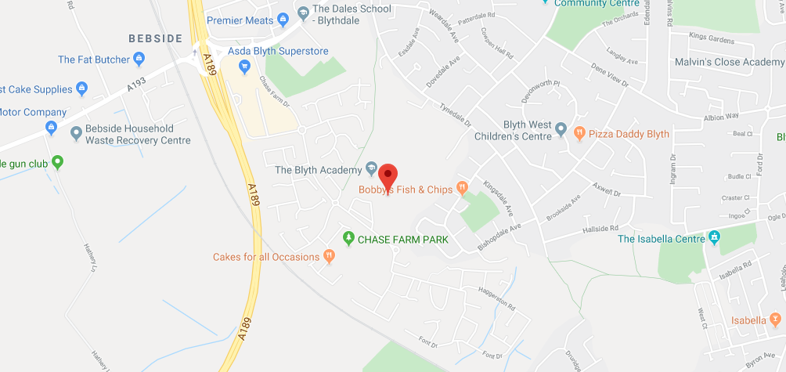

Directions to The Blyth Academy

From the A1 South:
From the A1 join the A19 for 2.3 miles
At the roundabout on the A189 take the second exit onto (A189) for 4.4 miles
Take the exit toward Blyth Riverside and take the third exit on the roundabout onto Cowpen Road 0.1miles
Take third exit onto Chase Farm drive going through two roundabouts and turn left in to the Academy car park

From A19
From Silverlink travel 4.8 miles to the roundabout and take 5th exit onto A189 for 4.4 miles
Take the exit toward Blyth Riverside and take the third exit on the roundabout onto Cowpen Road 0.1miles
Take third exit onto Chase Farm drive going through two roundabouts and turn left in to the Academy car park

From North
From A189 North Seaton Roundabout travel on A189 for 3.0 miles.
Take A193 exit toward Blyth/Blyth Riverside Business Park and the 1st exit at the roundabout 500ft
At the roundabout take third exit onto Chase Farm drive going through two roundabouts and turn left in to the Academy car park

Contact Details

The Blyth Academy
Chase Farm Drive
Blyth
NE24 4JP
Phone: 01670 798100
Email: blyth.enquiries@northerneducationtrust.org
Web: https://tba.northerneducationtrust.org
Job Advert
Assistant Principal
Scale: L8-L12
Salary: £50,150 - £55,337
Closing Date for applications: Monday 24th May 2021 at 12 noon
Interview Date: to be confirmed
Start Date: 1st September 2021
Contract Term: Permanent

Can you contribute to our Outstanding journey?

At The Blyth Academy, we strive to provide an educational experience which focuses upon academic success, enjoyment and participation; engendering a sense of community and belonging. The Blyth Academy has transformed over the past four years, adding +1 to progress 8; 29% increase in the percentage of students achieving English and Mathematics at grade 5 or above and 31% at grade 4 or above. We have been recognised as one of the most improved school in Northumberland.

We are looking for a strong leader with personality, who is resilient, willing and able to learn and with excellent organisational, analytical and communication skills and someone who is committed to supporting students to achieve their potential and can embody our trust vision of ‘Outcomes Focused, Child Centred’

The successful candidate will be able to inspire and motivate colleagues and students alike and will be given, and expected to embrace, opportunities and support for further career and professional development. Northern Education Trust is committed to providing bespoke opportunities for leadership development within the Trust. You will also be part of the Trust family of Academies with a set of values we all share. This is an excellent opportunity for someone with a leadership background in secondary education to make a real difference.

This is a career defining opportunity to join a rapidly expanding academy which is on a journey to ‘Good’ by Ofsted.

Being a part of Northern Education Trust will offer you a fantastic opportunity to develop yourself in an ambitious and thriving team. You will have a strong influence on student outcomes across our family of schools where we actively encourage collaboration and the sharing of best practice. You will be provided with outstanding professional and career development opportunities in an academy where exceptional teaching and learning is an expectation and where CPD is supported by the Northern Education Trust Staff College.

If you are enthusiastic and highly motivated, committed to improving the life chances of young people, and believe that you could contribute to our academy, we would like to hear from you.

For further information, contact the Business Manager, Jill Jackson j.jackson@northerneducationtrust.org

The Blyth Academy is committed to Safer Recruitent. Pre-Employment Checks will be undertaken prior to appointments being confirmed. Positions are subject to Enhanced DBS Checks. We expect all adults who work in our academy to share our commitment to Safeguarding and the Health and Well-Being of our Students.

Please return completed application forms to Jill Jackson - Business Manager
Email: j.jackson@northerneducationtrust.org
Telephone: 01670 798100

Please complete our application and monitoring form and note your letter of application/supporting statement should be no longer than 3 sides of A4.

Job Description

Job Title: | Assistant Principal
Base: | Academy
Reports to: | Vice Principal | Grade: | L8 – L12
Service responsibility: |  | Salary: | £50,150 - £55,337
Additional: | Travel may be required across NET sites. | Term:

JOB PURPOSE
- To support the Senior Leadership Team of the Academy, working to two ‘Deeps’ areas as assigned by the Academy Principal
- To provide proactive support to the Principal/Vice Principals/Academy Councils to ensure that the Leadership and Management of the Academy operates at the most effective level possible

JOB SUMMARY
To contribute to the work of the Senior Leadership Team in accordance with the requirements set out by Principal. In particular, you will be required to play and active part to:
- Ensure the Academy achieves the objectives/targets set out in the Academy Development Plan
- Embed all elements of the ‘Deeps’ within the day-to-day workings of the Academy
- Promote the ‘Every Child Matters’ agenda across the work of the Academy
- Constantly promote the personal development of all staff and participate in the work of the Academy to achieve this
- Participate in development, management activities and research
- Contribute to the initiation and development of innovatory practice
- Promote equal opportunities at all levels of Academy activity

Develop and sustain DEEP LEADERSHIP across the Academy through:
- Be accountable for student progression for allocated classes
- Be responsible for effective classroom management
- Co-ordinate class work with any classroom assistant support
- Develop and sustain knowledge of current educational practices and be responsible for own continuing professional development
- Evaluate lessons, incorporating students’ views and responses in order to reflect and act on strengths and areas for development
- Contribute to the self-evaluation systems in the Academy
- Develop policies for departmental handbooks
- Aide in co-ordinating events and experiences which support the Academy to raise standards

Develop and sustain DEEP LEARNING across the Academy through:
- Work to student targets and ensure that progress is tracked through a range of strategies
- Take account and review Academy contextual factors and prior attainment when planning and teaching lessons
- Reflect on the success of teaching strategies, individual lessons and SoW in meeting the needs of students
- Apply current guidelines on effective learning and teaching
- Take part in coaching and mentoring programmes to support colleagues and develop own practice
- Apply and expand teaching repertoire and feedback to colleagues on effectiveness
- Strive to deliver outstanding lessons
- Deliver interactive lessons with students
- Provide good quality assessment using formative and summative methods in conjunction with the Academy’s AfL policy
- Record test results and ongoing teacher assessments, keep portfolios of evidence

Develop and sustain DEEP EXPERIENCE across the Academy through:
- Have responsibility for developing and implementing SoW
- Be responsible for identifying and reporting issues and developing solutions
- Be responsible for the day to day delivery within subject area, including assessment and reporting process
- Develop communications and training with staff in Department/methodology
- Develop use of ICT within the curriculum
- Provide means of gathering information for Self Evaluation: Student Voice, questionnaires, viewpoints of stakeholders and use opportunities for co-construction of the curriculum
- Take responsibility for planning and execution of Immersion Days
- Adapt lessons and identify next steps in response to evaluation of student progress
- Set effective homework and extension work to encourage and enliven student learning
- Ensure differentiation and personalisation of learning for all students
- Be aware of the KS2 curriculum and the standards of progression and attainment for KS3 students
- Co-ordinate displays with regards to events, opportunities and work which promote the Department/Academy

Develop and sustain DEEP SUPPORT across the Academy through:
- To comply with the Academy’s Child Safeguarding Procedures and to report concerns to the Designated Child Protection Officer
- Take responsibility for upholding standards of behaviour and classroom management within the classroom and the Academy’s environment
- Through the role, develop systems which address the social health of students to raise standards
- Promote the consistent and fair use of the Expectations for Learning system within the classroom and the Academy environment
- Be the first line of contact for parents and carers concerns with regards to their child’s performance and well-being
- Perform the duties of a Vertical Mentor Tutor if required, including the provision of information, advice and guidance for students

GDPR
- To adhere to GDPR and Data Protection Regulations, whilst maintaining confidentiality
General
- To participate in wider Trust meetings and working groups as required

Whilst every effort has been made to explain the main duties and responsibilities of the post, each individual task undertaken may not be identified and the post holder may reasonably be expected to undertake other duties commensurate with the level of responsibility that may be allocated from time to time

NET is committed to safeguarding and promoting the welfare of children and young people. We expect all staff to share this commitment and to undergo appropriate checks, including an enhanced DBS check.

Signed: …………………………………… Date: ……………………………….

Person Specification

Assistant Principal
 |  |  | Assessed by:
No | Categories | Essential / Desirable | App Form | Interview / Task
QUALIFICATIONS
1. | PGCE or Equivalent | E
2. | Degree | E
3. | Leadership/Management Qualification/Course | D
EXPERIENCE
4. | Up to date knowledge of educational theory and practice | E
5. | Strong understanding of government guidelines on safeguarding | E
6. | Understanding of ‘The Deeps’ | D
ABILITIES, SKILLS AND KNOWLEDGE
7. | Experience of Leadership | E
8. | Experience of project management | E
9. | Ability to work to tight deadlines | E
10. | Ability to be innovative and progressive | E
11. | Ability to lead and work constructively with teams | E
12. | Experience of carrying out management investigations | D
PERSONAL QUALITIES
13. | Pleasant and friendly manner | E
14. | Polite and punctual | E
15. | Reliable | E
16. | A commitment to working as part of the whole Academy team and supporting the vision and aims of the Academy | E

NET is committed to safeguarding and promoting the welfare of children and young people. We expect all staff to share this commitment and to undergo appropriate checks, including an enhanced DBS check.

The following methods of assessment will be used:

- Technical Assessment of application against criteria
- Activities designed to provide evidence to assess against Person Specification
- Presentation
- Interview

Additional Requirements

The following criteria must be judged as satisfactory when pre-employment checks are completed:

1 | Enhanced DBS Certificate
2 | Additional criminal record checks if applicant has lived outside the UK
3 | Medical clearance
4 | Qualifications essential to the post
5 | Two references from current and previous employers (or education establishment if applicant not in employment)

Chief Executive: Mr R Tarn
Northern Education Trust
c/o Thorp Academy
Main Road
Ryton
NE40 3AH

Phone: 0191 406 6383
Email: public.enquiries@northerneducationtrust.org
Web: www.northerneducationtrust.org

