The Geography Department
Welcome to the Geography department, here at Wood Green Academy.
Our mission is to make students think:
“Geography is all about the world around you. It will help you make informed decisions about where to live, what to buy, how to live as a global citizen. It will help you develop skills that you will find useful long after you have left school. Geography helps you make sense of an increasingly complex world. It describes, explains, problem solves and explores alternatives.”
“Geography is the subject that holds the key to our future” Michael Palin
We are a very strong and cohesive department of 6 who have a wealth of Human and Physical Geographical experience. Our department is very stable with most teachers having taught for at least 4 years at the school. As a department we are forward thinking and constantly aiming to improve teaching resources and teaching skills. We are a thriving department with increasing numbers of GCSE and A level students.
Post holders:
- Head of Geography (Key Stage 4 manager)
- Key Stage 5 manager
- Key Stage 3 manager
- Year Leader – whole school
- Deputy Head

We firmly believe our students must achieve the very best outcomes and therefore we must provide the very best educational experiences for them. We aim to give them lots of practical fieldwork experiences and involve them in an enquiry based approach to learning.

Resources
The department has a suite of 5 classrooms and numerous stockrooms for organisation and storage. Two of the department classrooms have ICT facilities. The department is situated in the same building, the vast majority of lessons taught within the department.

Each classroom has:
- An interactive whiteboard, which is connected to a staff laptop
- A set of atlases
- Class set of Show- me boards
- Class sets of text books
- Access to a printer.
In terms of practical fieldwork equipment we are a very well stocked department. We also use a number of websites, including: Doddle, VLE.com, and Sam Learning. All A level Geography students have access to their own textbook and their own revision guide. Our current Year 11 GCSE Geography cohort also have access to their own revision guide.
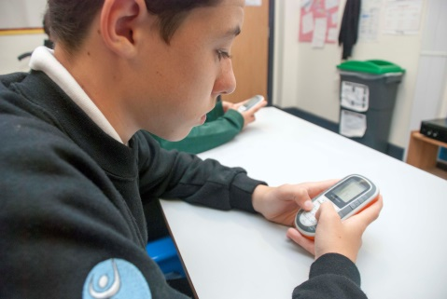
Curriculum and Examination
From September 2017 we have been following a two year KS3 and a three year KS4 course. At present our Year 11 cohort is completing the new Edexcel B 9-1 GCSE Geography specification (as are our Year 10 and Year 9 cohorts). At KS5 the current Year 13 and Year 12 cohorts are following the new AQA A level, studying the two year course option (we are not completing the AS qualification) . We have a high number of GCSE level students and are expanding our numbers at A level.
Successes
Results in 2017:
- GCSE Geography A*-G - 100%
- GCSE Geography A*-C - 70%
- A2 Geography A*-E - 100%
- A2 Geography A*-C - 41%
Many students go on to do Geography related degrees at university.
Support and CPD
The successful candidate will be supported by a departmental coach. This is to make sure that they feel fully supported when joining a new department.
In terms of teaching and learning, we are leading the way. We have excellent Geography staff who deliver subject specific and whole school CPD. We are also developing the department in terms of using IPads to enhance the quality of teaching and learning. Every member of staff has a laptop and an IPad.
We have dedicated time, Wednesday 2:15pm until 4:15pm, each week for professional development. This time will be used for whole staff training, departmental training and individual training. In the department there will be opportunities to shadow roles and take on tasks (for suitable candidates). Both the school and department are dedicated to giving staff opportunities to progress.
We are a department that continually strives to improve and are proud to be part of Wood Green Academy, and we look forward to being joined by likeminded professionals who truly believe in the importance of Geography as a subject that is current, inspiring, relevant and accessible to all.
Thank you for enquiring, and I hope to hear from you.

Mrs Kirstie Buchanan
Head of Geography

