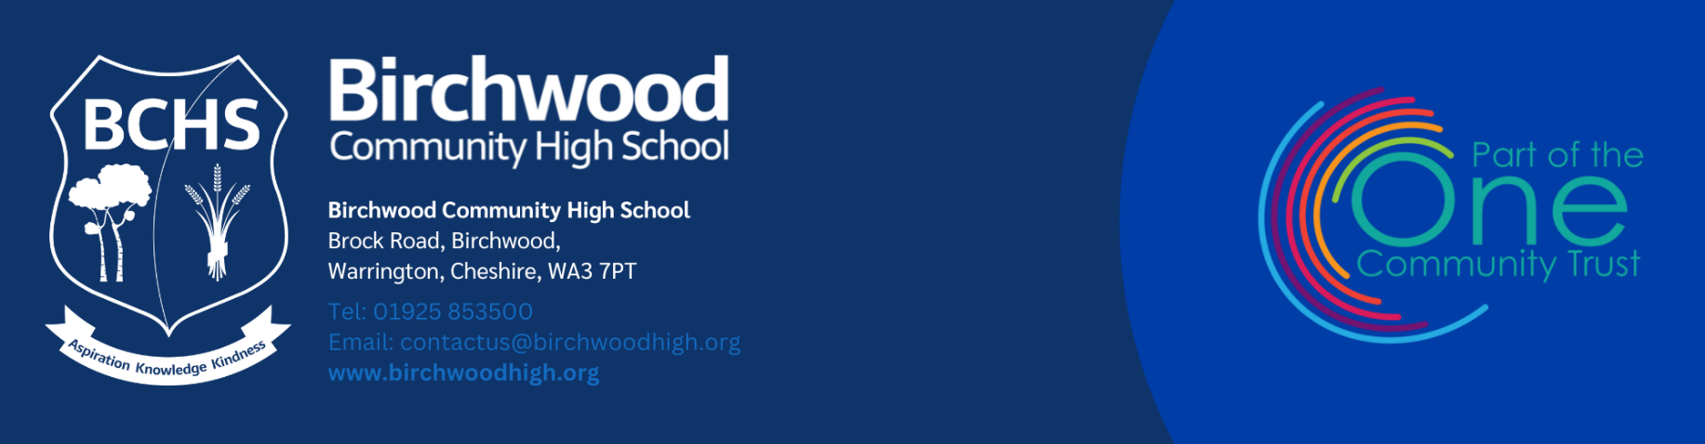

SENDCo
Start Date: September 2026 Contract Type: Full time
Contract Term: Permanent Salary: TPS plus TLR1b

Are you a passionate and experienced SENDCo ready to lead inclusive practice and champion the needs of all learners? Birchwood Community High School is seeking a dynamic SENDCo to join our dedicated team and drive forward our commitment to providing outstanding support for students with Special Educational Needs and Disabilities within a vibrant, inclusive secondary setting.
Based in Warrington and part of the One Community Trust, Birchwood Community High School serves approximately 900 students. We pride ourselves on an inclusive culture where every young person is valued and supported to thrive. With 38% of pupils eligible for Pupil Premium, 14% EAL learners, and specialist SEND provisions including KS3 and KS4 ASD and SEMH centers, we tailor education to meet diverse needs.

As SENDCo, you will be pivotal in shaping and leading our SEND strategy, ensuring high-quality provision and outcomes for all students with additional needs. You will:

- Lead and develop the SEND department, promoting best practice and continuous improvement
- Oversee identification, assessment, and intervention for students with SEND, including those in specialist provisions
- Work collaboratively with teaching staff to embed inclusive teaching strategies across the curriculum
- Build strong partnerships with parents, external agencies, and multi-disciplinary teams to support holistic student development
- Monitor and report on SEND provision outcomes, ensuring compliance with statutory requirements and OFSTED expectations
- Contribute to whole-school improvement planning with a focus on inclusion and student well-being
- Provide training and guidance for staff on SEND legislation, strategies, and personalised support

About You

We are looking for a skilled, compassionate leader who:

- Holds the National Award for SEND Coordination (or equivalent)
- Has proven experience leading SEND provision in a secondary school setting, ideally including SEMH and/or ASD provisions
- Demonstrates a thorough understanding of SEND legislation, assessment frameworks, and best practice
- Is an effective communicator and collaborator, able to build strong relationships across the school and with external partners
- Is proactive, reflective, and committed to driving continuous improvement in outcomes for SEND learners
- Shares our values of aspiration, knowledge, and kindness, fostering a positive, inclusive school culture

This school is committed to safeguarding and promoting the welfare of children and young people/vulnerable adults and expects all staff and volunteers to share this commitment. The successful applicant will be required to apply for a satisfactory enhanced Disclosure and Barring Service Check. Further details can be found at www.homeoffice.gov.uk/dbs. This position is subject to a disclosure check under the Rehabilitation of Offenders Act 1974.

Please see the linked documents or our website for further details. If, prior to submitting an application, you would like to see for yourself why we believe this is such a fabulous school in which to work, then do not hesitate to contact us to arrange a visit.

For further details and an application form please visit: www.birchwoodhigh.org
Closing date for application: 9am Tuesday 28th April 2026. Interview date: Thursday 30th April 2026.

Application forms should be returned to joinus@birchwoodhigh.org.

