March 2021
Ref: SI/DB

Assistant Headteacher Raising Standards Leader

Dear Colleague

Thank you for taking the first step in applying for this exciting role at York High School. We are a mixed 11-16 school serving a genuinely comprehensive intake; we take pride in our commitment to making a difference to the life chances of all of our students through our values of resilience, aspiration and success.

Three years ago our school was judged as a special measures school and three years ago, the Ofsted report was an accurate reflection of the school. Today you will see a school that is unrecognisable from that judgment.

- Behaviour has been through our positive behaviour system which has allowed our students to learn and our teachers to teach.
- Teaching is now good across the school due to a commitment to high quality CPD for all colleagues from NQT to Head of School
- Change has been driven by a commitment to staff voice, not just surveys but meaningful discussion about areas to develop
- Outcomes have improved from a whole school progress 8 score of -0.93 to +0.04

The school prides itself on its honesty and openness and we would strongly encourage any prospective candidate to visit the school where you will see the following:

- A dynamic Leadership team who are leading change through a commitment to high quality teaching and professional development.
- A staff body that is committed to improvement and change through supporting each other.
- An excellent Pastoral Team supporting both students and staff.
- Classes that are well ordered and behaved.
- Students that are happy, cared for and confident.

I would be delighted to discuss the post with you or to arrange for you to see for yourself what York High School is really like then please contact me on 07966403947 or email paula.read@hays.com to arrange a visit to the school.
Please note: Application by CV will not be accepted.

The closing date and time for applications will be 9am on Friday 9th April 2021.
I look forward to receiving your application.

Yours sincerely
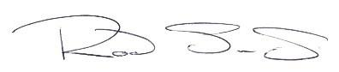
Rod Sims
Head of School

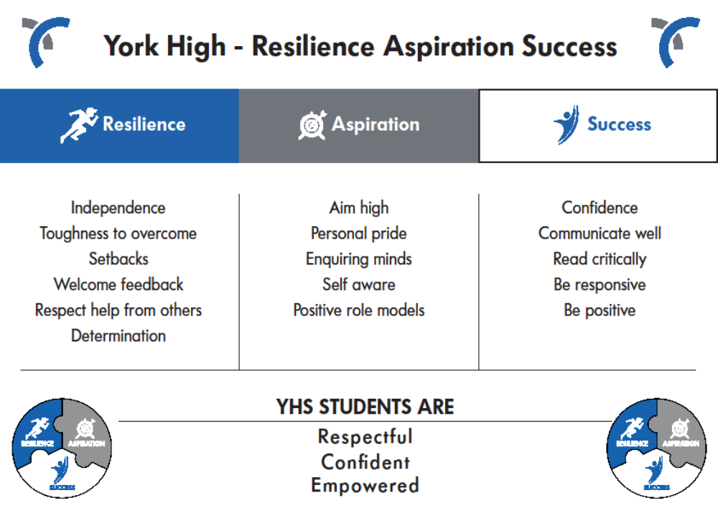

SAFEGUARDING YOUNG PEOPLE

Safeguarding and promoting the welfare of young people is a key priority at York High School.

We have robust Child Protection and Safeguarding Policies and all staff receive training relevant to their role in line with the policy at induction, and throughout their employment at the school.

Declaration of Criminal Records, Convictions and Cautions

The post you are applying for involves regular care for, training, supervision or contact with those under the age of 18 years and is, therefore, exempt from the Rehabilitation of Offenders Act. This means you must disclose information about any spent or unspent convictions when completing the Declaration of Criminal Records, onvictions and Cautions attached to the Job Application included in the pack.
You must also provide information about cautions, no matter how long ago they occurred and regardless of whether the offences were committed as an adult or juvenile.

Failure to complete and sign the Declaration of Criminal Records, Convictions and Cautions declaration attached to the enclosed City of York application, will invalidate your application for this post.

References

In relation to this appointment process you should be aware your referees will be asked, “Are you aware of any Child Protection allegations or issues of a similar nature in relation to this person? If so please provide details.”

Personal Identification

If you are shortlisted for interview, you will be asked to present original documentation which confirms your identity, address and any relevant qualifications for this post, when you attend for interview. The authenticity of these documents will be verified by our HR Manager and photocopied as evidential confirmation of your identity.

DBS Enhanced Clearance

All appointments to York High School are subject to Enhanced Disclosure and Barring Service Clearance (On 1 December 2012, the Criminal Records Bureau merged with the Independent Safeguarding Authority (ISA) to become the Disclosure and Barring Service)

You will be asked to complete a DBS Disclosure Application Form if you are successful in your application; Enhanced clearance is a prerequisite for employment.

York High School, Cornlands Road, York, YO24 3WZ

Assistant Headteacher
Raising Standards Leader

September 2021
Salary scale L11 – L15 (£54,091 to £59,581)
If you joined the teaching profession to challenge inequality then read on.

We want

A leader with enthusiasm, passion and the drive to maximise the potential of all students.
A leader who is not average in thought or effort.
A leader who can inspire and motivate staff, students and parents.
A leader who wants the very best for the students no matter their background.
A leader with a desire to be the very best that they can be.

We can offer

A school which is rapidly improving.
A school totally committed to the development of its staff.
A school where 99% of staff are proud to work for YHS.
A school with a dynamic and supportive leadership team.
A school where the students will make you laugh every day.

York High is a mixed 11–16 school serving a genuinely comprehensive intake. We have an absolute commitment to maximising the potential of all our students. During the last three years there have been substantial improvements based on our commitment to genuine staff voice and high quality professional development.

The school prides itself on its honesty and wishes potential applicants to be aware that three years ago our school was judged as a special measures school and three years ago the Ofsted report was an accurate reflection of the school. Today you will see a school that is unrecognisable from that judgement. With a dynamic Leadership team, a committed staff body and with the support of our students and community, there is a real commitment to implementing change through high quality teaching and professional development. Outcomes have improved from a whole school progress 8 score of -0.93 to + 0.04. We therefore wish to hear from candidates who will be committed to our journey back to good and who will be excited by this challenge.

Don’t just read the advert contact us to arrange a visit or a phone conversation about the role. We welcome visitors to school or we can offer a video chat for those who cannot visit, these can be arranged through Paula Read at Hays.
Further information about working at York High School can be found by clicking through the link https://microsites.hays.co.uk/jobs/york-high-school/index.htm or by contacting Paula Read on telephone 0113 200 3710 or email paula.read@hays.com

Follow the link to hear more about the role from Rod Sims Headteacher
https://youtu.be/6K1JkQpRMtU

The closing date for completed applications is 9am on Friday 9th April
Interviews will take place as soon as possible after this date.

(Please note that we cannot accept CV’s, a school application form must be completed which can be obtained by contacting Paula Read at Hays)

York High School is committed to safeguarding and promoting the welfare of children and young people and expects all staff to share this commitment. This post is subject to a Disclosure and Barring Service (DBS) check.

