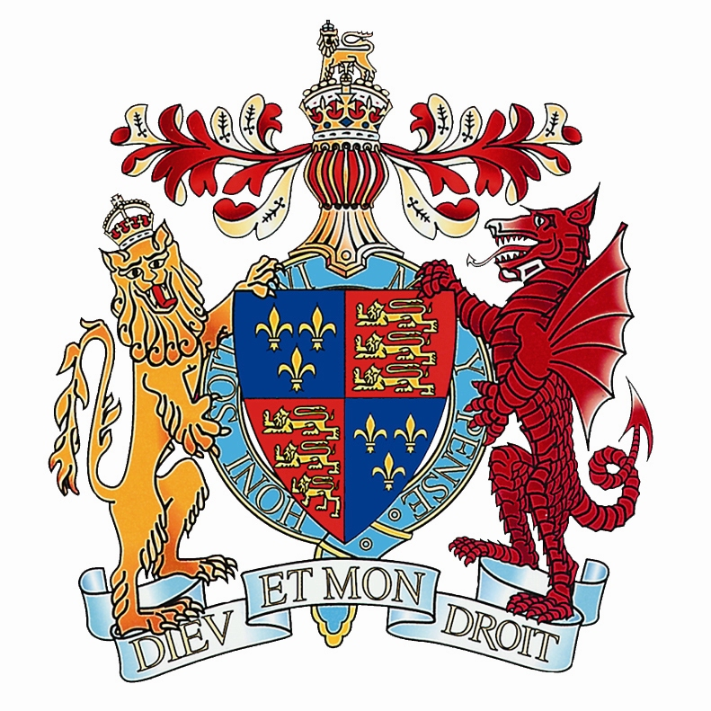 | KING EDWARD VI HANDSWORTH  SCHOOL  History and Politics Department

Staffing
Miss J Smith Head of Department
Mrs L Polke Teacher of History/Politics (also Pastoral Leader for Y13)
Mrs U Cole Teacher of History (also Pastoral Leader for Y8)
Mrs J Nolan Teacher of History (also Sixth Form Careers Coordinator)

History is taught as a discrete subject from Key Stage 3 through to A Level.
Government and Politics is taught at A Level only.

Examinations
Students follow the AQA specifications for A Level History and Politics, also for GCSE History.

Please see details below.

Examination Results
It is compulsory for students to study at least one humanities subject at KS4, with many studying two. History is a very popular option at GCSE with up to three quarters of the year group choosing the subject each year. Results are excellent: 87.4% achieved 7-9 grades in 2018.

History and Politics also have a healthy take-up at Level, with over 80% of girls achieving A*-B grades in 2018. We have a very strong record of Oxbridge success, with at least one girl per year going on to study our subjects at either Oxford or Cambridge in recent years. Many girls apply to read History, Politics or related subjects at other top universities.

Trips and Enrichment
Trips are seen as an essential part of our curriculum.

Key Stage 3
This year all Y7s visited Warwick Castle, to complement their work on medieval England. Year 9 enjoyed a trip to the Black Country Living Museum as part of their local study of Birmingham c1900. We have also run a number of very successful trips to the First World War battlefields of Belgium and Northern France.

Key Stage 4
Trips and enrichment activities vary from year to year. Last year the whole of Y11 went to Hardwick Hall in Derbyshire, the designated site for AQA’s historic environment question. This year we are looking forward to receiving a visiting speaker from Shakespeare’s Globe.

Key Stage 5
Each year we attend the local ‘Democracy Forum’ in central Birmingham, organised by the Rotary Club. Here girls are able to participate in their own Question Time with a panel of local MPs and councillors. Occasional other trips and lectures may take place according to interest. In the autumn Politics students were very pleased to welcome Lord Rooker as part of the House of Lords Speakers in Schools programme. In 2018 History and Politics girls joined the German department in a trip to Berlin. In January 2019 we joined with Maths and Computing to visit Bletchley Park, the World War II code-breaking centre. We also participate in the Lessons from Auschwitz Project each year. In addition, there is a thriving KS4 Historical Film Club who each meet one lunchtime a week. Here girls have the opportunity to explore additional topics from outside of our curriculum, and to enrich their understanding of those they have already studied.

Timetable

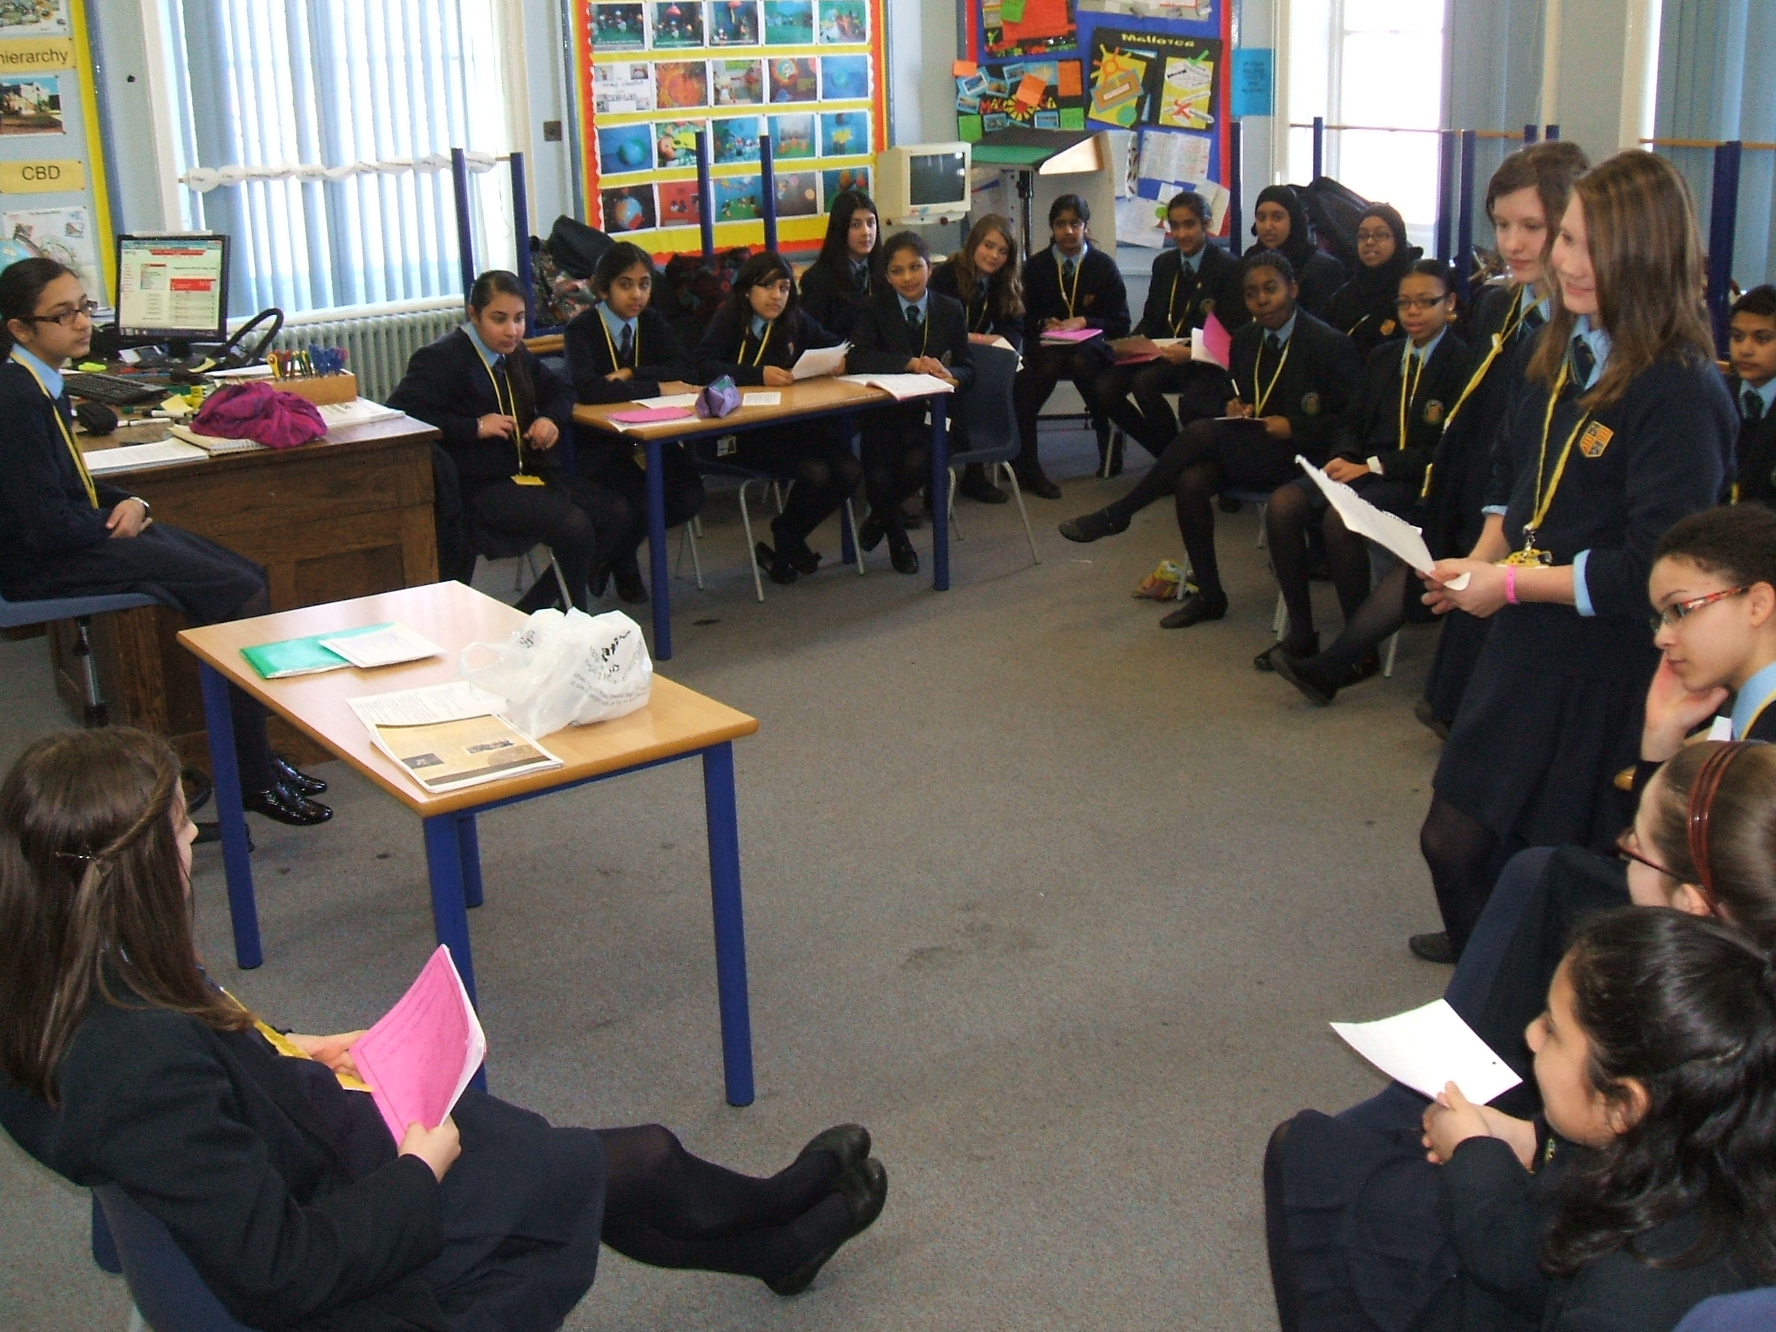

We operate a fortnightly timetable and lessons are 50 minutes long. At KS3 we have three lessons a fortnight, we have five at KS4 and eleven at KS5.

Picture of Y8 girls taking part in a re-enactment of the trial of Guido Fawkes….

Accommodation

Most of the department’s KS3 lessons are taught in a dedicated History Room. KS4 and 5 lessons tend to take place in a smaller classroom in the main building and a room in the sixth form block. We also share a departmental office with Geography. Teaching rooms are well equipped with projectors, interactive whiteboards, VCR/DVD players and visualisers. We have a fantastic range of textbooks for all key stages, including an extensive collection in the library for use by the sixth form. As well as facilities in the History department, we also have access to five bookable ICT suites each with 32 computers.

Courses Taught

KS3

During Key Stage 3, pupils learn about significant individuals and events in the history of Britain, from the Middle Ages to the 21st Century, and aspects of European and world history. Lessons, we hope, are interesting and varied! They may involve group or pair work as well as individual study. Highlights of KS3 include an investigation into why Thomas Becket was murdered (Y7), a re-enactment of the trial of Guido Fawkes (Y8) and a piece of creative writing based on a study of life in Birmingham during the Industrial Revolution (Y9).

Year 7:
Historical Skills
Roman Britain
England 1066-1500, with a depth focus on the Norman Conquest

Year 8:
The Tudors and Stuarts, with a focus on the Reformation and the Civil War
Slavery to Civil Rights

Year 9:
Britain 1750-1900, with a focus on empire, industrial changes and their impact
The 20th Century, with a focus on ‘experiences of war’

GCSE History
Paper 1: Understanding the Modern World
Section A – Germany, 1890-1945
Section B – Conflict and Tension, 1918-1939
Paper 2: Shaping the Nation
Section A - Britain: Health and the people: c1000 to the present day
Section B – British Depth Study: Elizabethan England, c1568–1603

A Level History

Breadth Study. The Tudors: England, 1485-1603

Depth Study. The Cold War, c1945-1991
Historical Investigation: Russia, 1855-1953: From Tsars to Commissars

A Level Government and Politics
Government and Politics of the UK
Government and Politics of the USA and Comparative Politics
Political Ideas

Further Information

As a department, our vision is:

- To foster a genuine interest in and enthusiasm for History/Politics; to bring the past ‘to life’ through consistently interesting and challenging lessons.
- To encourage pupils to pursue this interest beyond the classroom and the specification, through visits, television programmes, wider reading etc. We are not just interested in the exam!
- To provide a firm foundation for the future. Our subjects are academically rigorous and encourage a wide range of skills as well as informed citizenship.

J E Smith
Head of History and Politics
March 2019

