24th January 2024

Dear Applicant
Post of Examination Invigilator

Thank you for your interest in the Examination Invigilator position at St Thomas More RC College. If you would like any further information please contact the Examination Officer (Mrs Mansoor) via email: r.mansoor@stmcollege.org.uk

I look forward to receiving your completed application on or before 3.00pm on Friday 15th March 2024.
Yours sincerely,
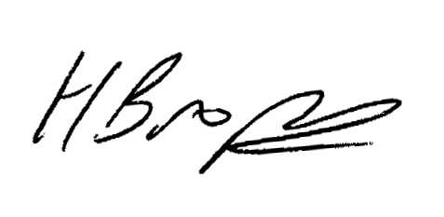
Mr H Brophy
Headteacher

