Denefield School
SUCCESS FOR LIFE

Application Information

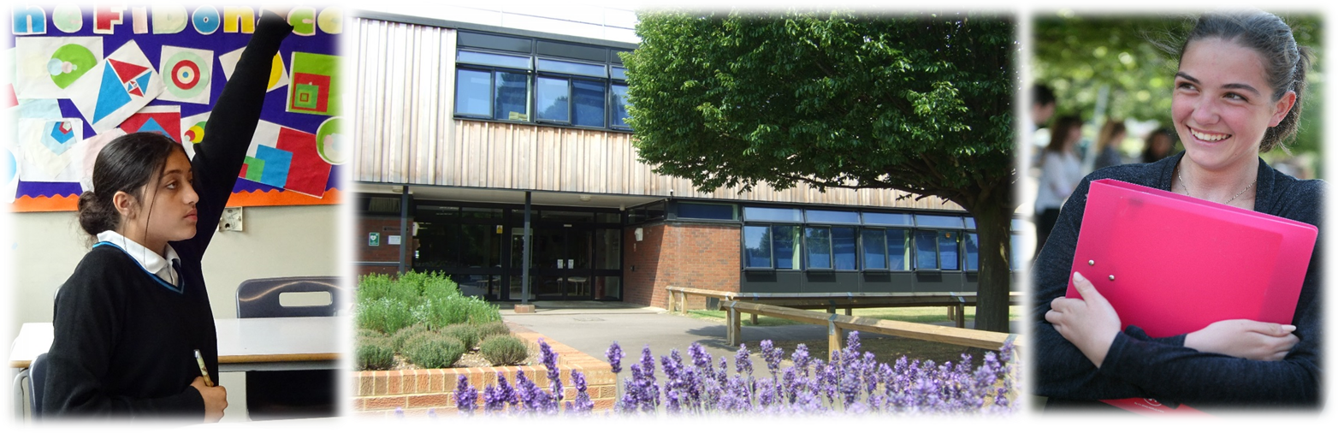

Welcome from the Headteacher

I am delighted to welcome you to Denefield School. Denefield is an ambitious, successful and over-subscribed school located in the western Reading suburb of Tilehurst.

I believe passionately that every young person should gain the qualifications and develop the character skills to have, as we say at Denefield, ‘Success for Life.’ To prepare them for this, Denefield offers a rigorous and engaging curriculum at GCSE and A Level, with creative and practical subjects alongside traditional academic courses. Our current Year 9 students are the last who will be undertaking a three year Key Stage 4; from now on students will take their options in Year 9, and start their GCSE and other Level 2 courses after Easter in Year 9. The school has recently moved to a faculty structure, with three core faculties of English and Literacy, Maths and Computing, and Science and Social Science, as well as four foundation faculties of Humanities, Languages, Business and Travel, Creative and Performing Arts, and Physical Education and Health. The seven Heads of Faculty drive teaching and learning in the school, and staff are supported by full programme of training and professional development, clear schemes of work, and a consistent but flexible approach to pedagogy summarised as our Lesson on a Page. Full details of our curriculum, including our intent statements, curriculum maps and assessment maps, can be found here Curriculum Overview (denefield.org.uk)

The very clear Covid-prevention measures the school has taken has meant that no year groups have been sent home, only two instances of groups of students being asked to self-isolate, both in December 2020. Since January 2021 the school has been running a full programme of five live lessons a day, along with tutor group activities and assemblies. This has proven both extremely successful, and extremely popular. Our recent student voice activities showed great satisfaction with our offer, while of 396 parents and carers who responded to our survey in February 2021, 92% rated the quality of online teaching and learning to be good or outstanding, with 86% rating the support given to students during lockdown as good or outstanding.

In addition, students at Denefield work hard at the school’s nine CHARACTER values – confidence, happiness, articulacy, resilience, ambition, courage, tolerance, empathy and respect. They have the opportunity to develop these during subject lessons, during assemblies and house competitions, as part of our timetabled Success for Life curriculum. Students have an effective voice in the running of the school through our House Councils, Sixth Form Council and School Council, and both the Success for Life curriculum, and the various student councils have continued during lockdown. Further information on our CHARACTER values can be found here.

I am particularly proud of the school’s supportive pastoral system, which except for this Covid-19 year involves vertical tutor groups and houses, where students of different year groups learn alongside each other. I am also very proud of the excellent achievements of Denefield’s many sports clubs and teams. While extra-curricular activities have by necessity been curtailed this year, Denefield students normally benefit from a very wide range of extra-curricular opportunities, including designing and building racing cars, taking part in mock trials or debating competitions, taking the Duke of Edinburgh qualification or joining the Combined Cadet Force, or undertaking residential visits in the UK and abroad. The breadth of these opportunities in many ways sets Denefield apart from other schools, and these activities play a major part in helping students develop the CHARACTER values that contribute so much to a young person achieving success for life. That much said, we are keen to expand our extra-curricular offer still further as soon as circumstances permit.

I am delighted at the achievements of Denefield students and that so many choose to join the school’s Sixth Form. As at GCSE, we offer a rigorous and engaging curriculum in the Sixth Form designed to ensure students can access the most competitive universities, including Russell Group and Oxbridge, and the most sought-after apprenticeships or careers. Our Sixth Form Leadership team play an active role in the school, and students are expected to undertake community service in the school or the wider community. 65% of Year 13 students in 2021 applied to university, and 47% of those applied to Russell Group universities and Oxbridge. I am very impressed with the rapid success of the newly-formed Sports Coaching and Player Development Programme, a combined venture with Reading Football Club, which leads to advanced sporting qualifications and performance in addition to A Level qualifications.

I believe that students at Denefield do enjoy Success for Life. This is partly because of the school’s talented, committed and supportive teaching and support staff and governors (or Trust Board). It is also because of the school’s excellent facilities. Denefield is situated on a generous school site, with many playing fields and plenty of outdoor space. Most recently the school benefited from nearly £10m of investment, creating an expanded canteen area, along with new facilities in the Science and Art, Design & Technology departments, as well as a new display and assembly space – fittingly called the Da Vinci auditorium. We have applied for planning permission for a floodlit 3G pitch, and the process of gaining funding is well under way.

I hope that you will take the time to visit us and to reflect carefully on the potential this post will offer you. If you like what you see and wish to be considered for the role, please complete the relevant application form. You should also write a letter (no more than two sides of A4) which outlines the skills, qualities, attributes and experience you would bring to the role based on the information provided in the job and person specification.

At Denefield we take safeguarding very seriously and consequently the successful candidate will be required to complete a DBS enhanced check for regulated activity. Please do not include CVs with your application as these will be disregarded for safeguarding purposes.

I hope you will consider joining my team and I look forward to receiving your application form and covering letter. Electronic applications are fully acceptable and these should be emailed to recruitment@denefield.org.uk. Please do not hesitate to contact me, or indeed one of my colleagues, should you wish to discuss the role further or arrange a visit.

Mr E Towill MA (Oxon)
Headteacher

Our school

Denefield is a thriving and expanding school on the outskirts of Reading with over 1,100 students on the roll, including approximately 175 in the Sixth Form. The school has been serving the local community for over 40 years since its inception in 1976. It has steadily grown over the last few years reflecting our good reputation and the continued the support from our local community.
The school is a stand-alone academy trust having converted in January 2012. We have an active partnership with our local partner primary schools. Each year, we admit approximately 75% of students from our partner primary schools and the remaining 25% from the wider area. Our standard admission number is 180 students for entry into Year 7, however due to continual demand for places we have admitted, on average, an extra 20 students for the last four years and have also operated a waiting list during this time.
For further information about our school, and for copies of the job description, person specification and application form, please visit our website - www.denefield.org.uk

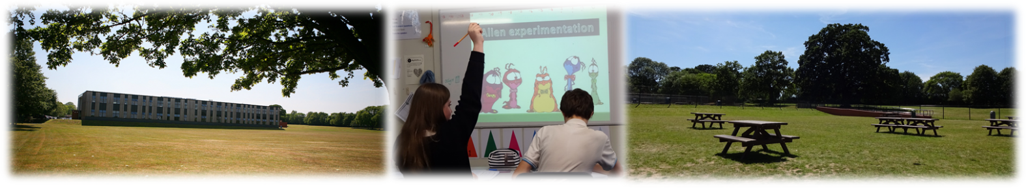

Our distinctive ethos

We are very proud of our distinctive ethos which is based on a set of CHARACTER values and a belief that every student deserves success for life.
Developing CHARACTER values is a key focus of our work and we encourage students to become: confident, happy, articulate, resilient, ambitious, courageous, tolerant, empathetic, and respectful individuals. We host annual CHARACTER Awards to recognise and celebrate students who have displayed CHARACTER values.
We strive to equip our young people with the skills, academic qualifications and personal attributes to thrive in the modern world. We passionately believe that our role is to prepare students for the tests of life and not for a life of tests.

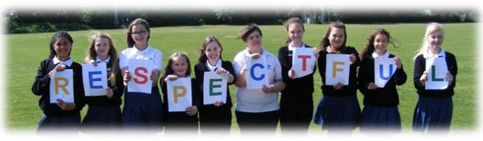

Working at Denefield

We currently employ approximately 75 teaching staff and 70 support staff.

Professional development opportunities for staff in this school are outstanding. We have developed an exceptional in-house annual training programme enabling staff at all levels to follow a personalised programme linked to their performance management needs. Each year staff have the opportunity to review their work, to set targets at an annual appraisal meeting which is followed up with an interim review meeting part way through the year. We have a robust system in place for pay progression for both teaching and support staff.
Senior and middle leaders are supported to take part in recognised senior and middle-leadership qualifications with NPQSL and NPQH providers and the local authority.
Newly qualified staff are effectively supported and are provided with a reduced timetable, a planned induction programme and mentor support. We have welcomed a number of teachers from overseas with a supportive induction programme to help with transition to the UK.
The school is an active strategic partner of the Berkshire Teaching Alliance (BTA) and since 2016 has appointed a number of trainees via School Direct salaried and non-salaried routes.
In order to manage the on-going challenge of finding and retaining high quality teachers, we have implemented a ‘Grow Your Own’ strategy. As the lead secondary school for the Berkshire Teaching Alliance, we recruit and train our own trainee teachers. The school has created a bespoke teacher training programme which is delivered by high quality practitioners within our organisation. Since September 2016, this has resulted in the recruitment of 15% of our teaching staff body, with the vast majority of these new teachers in hard to recruit subjects.
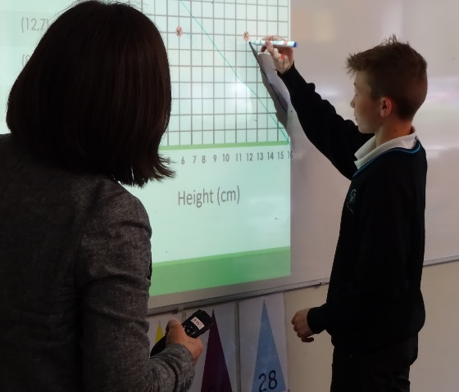

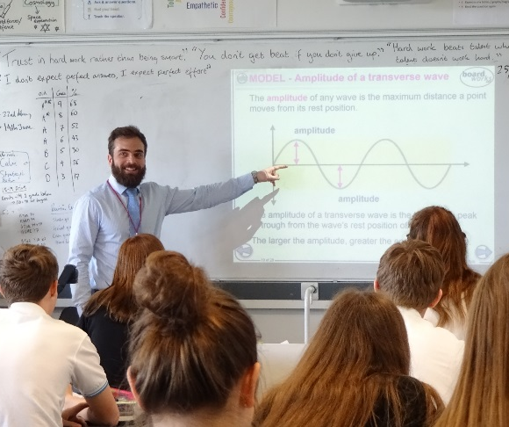
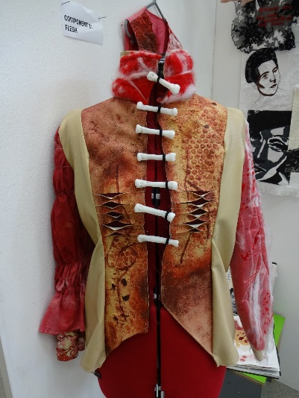
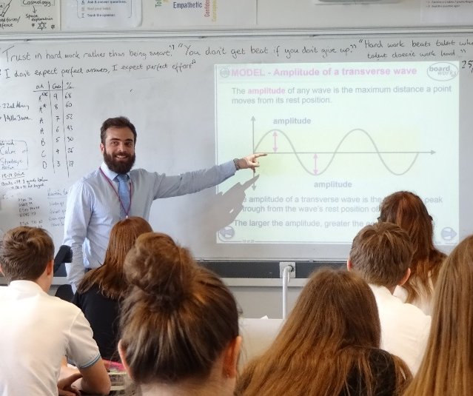
Facilities

The school is located in Tilehurst, a densely populated suburb of Reading, some four miles from the town centre. Our estate backs on to farmland and woods and is generous in size extending to some 23 acres and boasts well maintained buildings and grounds. A few years ago, the school received £9 million of government funding which was used to build a new science block, to provide state of the art design & technology and music classrooms, workshops, a recording studio, an art exhibition space, a community room equipped with a dance floor and a new Sixth Form common room and work areas.

Little Oaks Day Nursery operates on the school site providing care and education for up to 28 children aged 0 to 5 years.

Since academy conversion, we have successfully bid for £2.66 million of Government capital grants to improve the fabric and condition of our buildings. Past projects include: window replacement, new lighting and ceilings, heating controls, and a significant extension to our canteen and outdoor seating area. Our most recent successful project has seen the installation of electronic exit gates and new fencing, external doors and alarms, car park lighting, an extension to the outdoor student supervised area including a ramp for accessible access and classroom doors with viewing panels. Work is already underway to secure a floodlit 3G football pitch, to be used by the school during the day, and the local community in the evenings and at weekends.
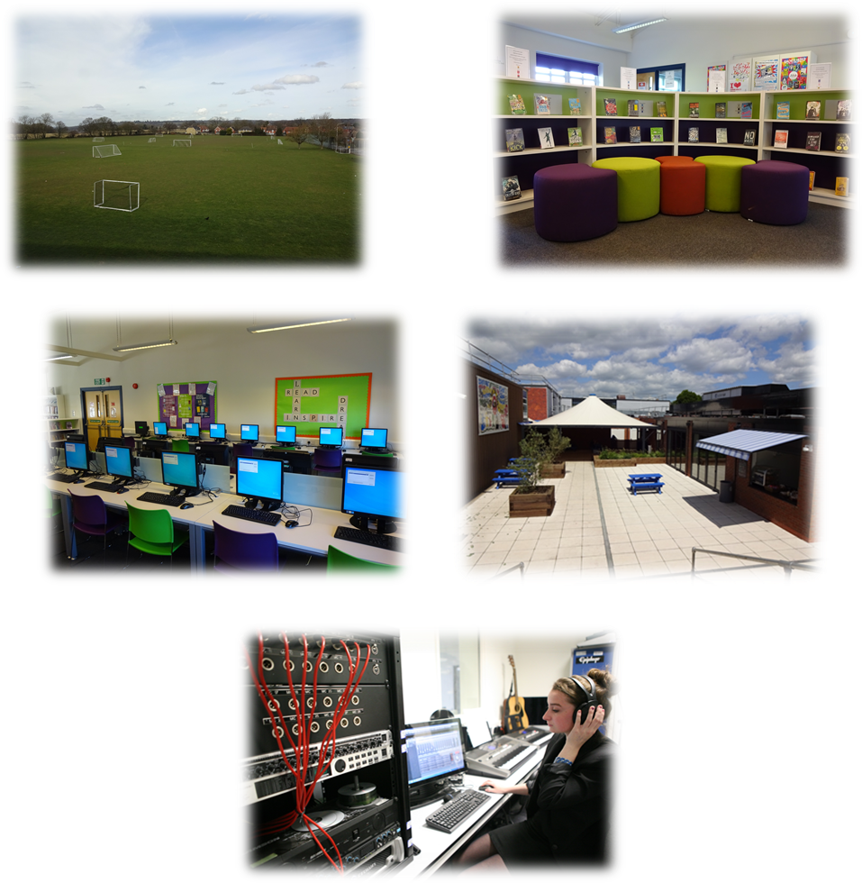

Staff benefits

Salaries and benefits
The school follows the pay and conditions for teaching staff as set out in the current School Teachers’ Pay and Conditions Document, and teaching staff are invited to enrol with the Teachers’ Pension Scheme (TPS). Pay and conditions of service for support staff are governed by the National Joint Council for Local Government Services and support staff are invited to enrol with the Local Government Pension Scheme (LGPS).

Wellbeing
Staff wellbeing is a key priority at Denefield and we are proud to offer a supportive workplace. There is no getting away from the fact that teaching is hard work, but we strive to foster a better work/life balance for our staff through a number of initiatives. After school meetings, including parent consultation evenings, are limited to one a week, and an INSET day is devoted to teacher appraisal, avoiding the need for this to happen after school. Our staffroom has been remodelled to provide a welcoming and stimulating staff area, and there is a weekly staff ‘You’re So Denefield’ shoutout with a termly draw with prizes for the winner. Every INSET day ends with a staff wellbeing event, where staff choose from a range of options from the quiet and passive to the fast and furious. On a recent Friday in February 2021 we trialled finishing our live lessons early, setting wellbeing activities for students, and sending any staff in school home early to engage in their own wellbeing activities. These ranged from fitness to yoga, perfecting steak to French baking, to self head massage, to arts and crafts activities. Those who wished to could simply start their weekend early, spending extra time with their children or partners, or talking themselves off for walks or more vigorous exercise. This was extremely well received by staff, and we are looking to make this a regular feature.

Flu Vaccinations
We offer free flu vaccinations during our October INSET day. In 2020, 90 staff took up this offer.

Cycle to Work Scheme
Denefield partner with the Green Commute Initiative to offer all staff the opportunity to purchase a bike through our cycle to work scheme.

Child Care
A day care nursery operates from the site and provides places for children aged 0 to 5 years. The nursery, open all year around, offers term time only contracts and currently has space to accommodate 28 children.

On-site parking
Free, on-site, parking is available to all staff.

Tea and Coffee
Free tea, and coffee are available to staff, in the staffroom.

Joint Consultative Committee
Following academy conversion, the Trust Board implemented a Joint Consultative Committee (JCC) as a means of consulting with staff on an array of employment, pay and conditions issues. Members of the Trust Board attend meetings to discuss any new developments and work-related issues with staff representatives, trade union representatives and senior leaders.

Working and living in and around Tilehurst
Tilehurst railway station is located approximately a 15 minute walk from Denefield School. It has regular Great Western Railway services between Reading (5 minutes), London Paddington (40 minutes) and Oxford (40 minutes)
The school is served by the number 16 Reading bus which operates up to four times per hour during peak times, providing a 20 minute journey into and out of the centre of Reading.
The vibrant town of Reading sits 5 miles east of Denefield with its thriving shopping centre, constantly evolving restaurant scene, museums and medieval abbey. With its great array of bars, pubs, comedy clubs, live music venues and theatres, there is a nightlife to suit everyone. For those who prefer to spend their free time in a greener, more natural, environment, there is plenty to choose from. Reading has the longest Thames frontage of any borough, most of which is formed by public parks, part of the Thames Path (a long distance walking route) and National Cycle Route 4.

