Dear Colleague

Thank you for your interest in the position of Teacher of Food Preparation and Nutrition and Textiles at Holmes Chapel Comprehensive School & Sixth Form College. The purpose of this letter is to give you some general information about the school and some specifics about the post.

The Post
We require an enthusiastic, inspiring, talented, dedicated and forward-thinking teacher of Design and Technology to join our very successful Teaching School.
The successful candidate:
- will teach both Food and Textiles across KS3 and KS4
- will have the ability to teach Food Technology at KS5
- will be able to demonstrate excellent subject knowledge and to consistently deliver inspirational lessons at KS3 & 4. This is essential in order to continue our success in raising achievement at all levels.
- will have an ability to be flexible in teaching across a range of subjects including KS3 Textiles

The ability to teach Health and Social Care at KS4 would be an advantage.

The Technology Faculty

At present the Faculty of Technology comprise of seven full time and one part time members of staff and benefits from the support of two part time technology technicians and an Education Support Officer.
Our teaching space consists of two recently refurbished Food Technology rooms, one Textiles room, three multipurpose workshops, a Design room, and a dedicated computer room.
At KS3 the students are taught in mixed ability and mixed gender groups and operate a carousel system, which allows them to access all aspects of the subject. At KS4, students are able to choose from: Food Technology and, Design and Technology. At KS5 the faculty currently offers GCE Design and Technology

GCSE 2016 results A* - C
Food Tech - 85%

A Level 2017 Results A* - C
Food - 100%

The School

Holmes Chapel Comprehensive School & Sixth Form College is a dynamic, innovative and ambitious Teaching School, National Support School and Academy with a national reputation for excellence. We work closely with the National College for Teaching and Leadership in modelling, promoting and disseminating best and next practice.

During 2011 Holmes Chapel Comprehensive School & Sixth Form College became both an Academy and a Teaching School. The future challenges and prospects afforded to all, especially by our Teaching School Status and position in a far-reaching alliance is central to our strategic vision.

Academic standards are outstanding, with 80% of last year’s Year 11 gaining 5 or more A*-C
grades including English and maths at GCSE and a pass rate of 100% at Advanced level.

The dashboard.ofsted.gov.uk. for HCCS shows that attainment and progress remain outstanding and it is our mission to make it world class.

As an outstanding school we are not subject to routine inspections. However at each HMI “interim assessment” our academic performance, student progress and attendance have been judged as `Outstanding’.

We, like most successful schools, maintain that success by regularly revisiting our values, vision and guiding principles in order to ensure that they remain apposite and relevant in a world that is changing so rapidly.

The ‘rainbow diagram’ below provides an immediate visual representation of “the basics” that contribute so much to the HCCS family and guide us as we strive for ever higher standards of progress and achievement.

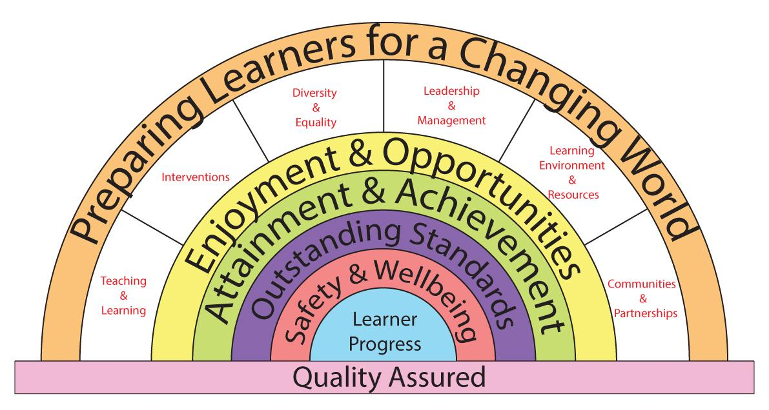

We have expressed our core values as a set of key principles which we use as our touchstones in designing our curriculum and in assessing its success and relevance to the needs of our learners.

Key Principles
The Curriculum at HCCS
1. Is about the development of the whole individual.
2. Ensures equality of opportunity in learning.
3. Provides personalised pathways and ways of learning.
4. Inspires drive, passion and commitment.
5. Promotes high standards, success and achievement.
6. Embodies responsibilities, entitlements, Safety & Wellbeing.
7. Develops respect, tolerance and courtesy.
8. Reflects the learners place in their communities.

The school serves a socially mixed, although generally prosperous rural community centered on the village of Holmes Chapel in Cheshire.
Currently numbers on roll are 1286, including 246 in the Sixth Form. Our intake in September 2016 was 208 students. We have around 82 teaching staff, including myself as Executive Head teacher.
We occupy an attractive site overlooking open countryside but close to modern, private housing estates and with easy access to the M6 at Junction 18. We have just completed building our new Sixth Form and Arts block with purpose built Theatre and our new 3G. AstroTurf pitch.

There are four super faculties within our school including:
iSTEM comprised of ICT, Science, Technology and Mathematics.
Communications comprised of English and Modern Foreign Languages.
Performance Studies comprised of Arts and Physical Education.
World Studies comprised of Humanities and Social Sciences

The Learning Support Team operates across all super faculties and subjects.

Teaching groups change as students’ progress through the school. In Humanities, all students are taught in mixed-ability groupings.

Year 7
Teaching groups are mixed-ability except in Maths, where students are set on entry, and
Modern Foreign Languages, which are set in February of Year 7.

Year 8 & 9
Teaching groups are mixed ability in Science.

Years 10 & 11
Our curriculum consists of a core of Maths, English, Science and PE, together with options which are designed the meet the needs of our learners and which are tailored to provide maximum student satisfaction levels and a range of progression pathways.
In our Sixth Form College we offer a broad set of pathways made up from a choice of 30
Advanced Level subjects.

Learning Support is tailored towards the needs of individuals throughout the school including the sixth form and is very successful in doing so.
The school was awarded the Inclusion Quality Mark and OFSTED commented that at Holmes Chapel Comprehensive “Care, guidance and support are outstanding”. We are very proud of our support framework which everyone in our school community is committed to and lives by. Care and support for our students is provided by the Student Services Team and delivered across the whole school through our highly effective House System.

The successful candidate will be an inspiring teacher who can motivate students across the ability range.

I hope it is clear, from the skills and competencies required, what will be expected from the successful candidate, and what qualities we will be looking for in the application and selection process. In applying for the post please write a separate, succinct (no more than 2 sides of A4), letter of application in which you address the skills and competencies required and also describe your philosophy and style of teaching.

The deadline for the closing date is Thursday, 8th February 2018.

I look forward to reading your application and welcoming a creative, energetic and inspirational teacher to our school community.

Yours sincerely
D Oliver
Executive Headteacher

