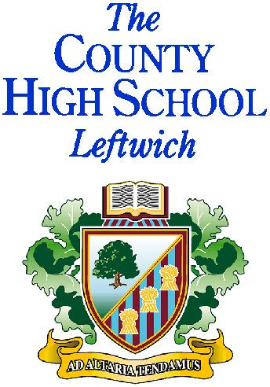

Welcome to The County High School Leftwich.

I thank you for expressing an interest in the post of Teacher of Mathematics (Maternity Leave) and hope that what you read inspires you to make a successful application.

My name is Matthew Snelson and I became Principal of The County High School Leftwich in September 2019, having worked in various roles within the Academy since starting as an NQT in 2006. The Academy is in a new phase of our development, with a new Principal and a new partnership, as along with Sir John Deane’s College, we are now part of the Sir John Brunner Foundation. The opportunities to share best practice and learn from one another are exciting ones.

In 2016, Ofsted judged us to be an “outstanding” school in which “Pupils show a great respect for each other and their teachers and wish to contribute positively to their learning community”, acknowledging their “…strong desire to learn”.

We remain committed to continuous improvement in leadership and management at all levels, in developing and sharing creative learning and teaching approaches and in providing high quality CPD to enable all colleagues to exploit our considerable potential for further growth. As part of this process, I value the chance to recruit the highest quality professionals who will take advantage of these development opportunities.

I hope you find helpful the enclosed information. If you are a team player who believes education enhances life opportunities and is thus committed to making a difference to our students’ learning experiences, I look forward to hearing from you. The closing date for applications for this post is Wednesday 22nd January, 2020, 9am. If you have not heard from us by 31st March unfortunately you have not been successful on this occasion.

Mr M Snelson
Principal

The County High School, Leftwich is part of The Sir John Brunner Foundation, a company limited by guarantee, registered in England and Wales with company number 11227336 and an exempt charity.
Granville Road, Northwich, Cheshire, CW9 8EZ. Tel 01606 333 300 Fax 01606 331 483
Email: admin@leftwichhigh.com www.leftwichhigh.com

Principal Mr M Snelson BSc (Hons), PGCE, MSc

