December 2024

Dear applicant,

Firstly, thank you for expressing an interest in the post of Student Support Officer at The Hollyfield School.

If you are reading this letter you will already have seen that The Hollyfield School is a vibrant and thriving school at the heart of the local community. It is more than a ‘Good’ school, it’s a school ready to take the next step and become a great school; in every way. Our students are fantastic and are drawn from a wide range of backgrounds across Surbiton and Kingston upon Thames. Our school serves the most deprived and most affluent of the local area, we are proud to be the most inclusive and aspirational school of choice.

At last inspection The Hollyfield School was judged by Ofsted to be ‘Good’ and it was commented that ‘The provision for pupils’ personal development and well-being is outstanding.’ Since then we have worked hard to continue to develop and maintain high standards and keep moving forward.

Trustees, governors and myself have a clear and aspirational vision for The Hollyfield School and we hope that you will be the person to drive school improvement and develop the culture to get the school there.

The school is part of the ‘Every Child, Every Day Trust’ and our ethos is clear in our name. We are currently a group of three mixed comprehensive schools with the single aim of providing exceptional experiences and opportunities for the thousands of young people we serve. As a trust we work closely together to support, challenge and develop our schools. We work strategically together on talent management, financial economies of scale, collaboration, school improvement and more.

This is an exciting opportunity for whomever is successful in attaining the role at The Hollyfield School and I hope you too are excited about the possibility.

Should you wish to be considered for this post, please read our school and recruitment brochures and complete the application form by the closing date. If you wish to book a tour of the school then please contact Louise Sutton, PA to the Headteacher at Hollyfield by email at lsutton@hollyfield.kingston.sch.uk or directly by calling the school on 020 8339 4500 ext 102.

Interviewers will include myself, senior staff, trustees, governors and other independent colleagues.

For further information about our school, please refer to the school website and should you have any questions please do not hesitate to contact me.

We look forward to receiving your application.

Yours faithfully,
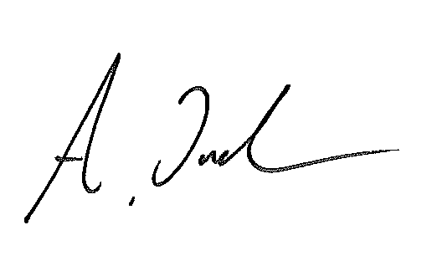
Amy Jackson
Headteacher

