
job description
ICT systems officer
reports to: Senior Director (IT & Estates)
hours: Full time, 35 hours per week
salary: SP 13-16 £27,747 - £30,288
holidays: 23 days plus national bank holidays
start date: As soon as possible
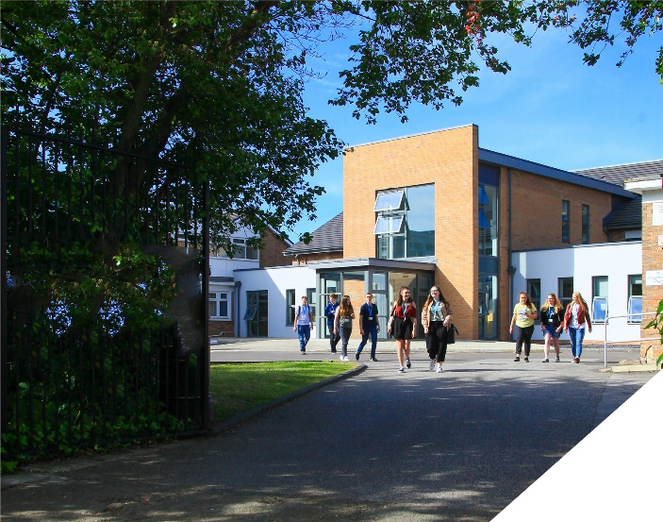
Working as part of the IT Services team at Birkenhead Sixth Form College.

about the College
This is an exciting opportunity to join a highly successful and innovative sixth form College. The College has won multiple national awards, including the College of the Year by Educate North Awards in 2023, and this followed being graded outstanding in all areas by OFSTED. All staff play a vital role in the experience that students have with us and ultimately their success.

The College is committed to its core values of Positivity, Ambition, Resilience and Thoughtfulness, and these values shape everything we do. Our ethos is centred on the scientific evidence that tells us that everyone can achieve success through purposeful hard work as opposed to the talent myth, and as such, the College is in itself an engine for social mobility.

about the role
The ICT Systems Officer is a wide and varied role, taking in ICT systems management, monitoring and support across the Trust. Primarily based at Birkenhead Sixth Form College the role may require support to be provided in a temporary or ongoing capacity at either site depending on their needs.

Below gives a sense of the range of responsibilities involved in the role but is not exhaustive:

- To provide 1st and 2nd line technical support across all sites of the Trust
- Support the Senior Director (IT & Estates) in delivering, developing, maintaining and supporting technology across the trust.
- Support & Development of Microsoft 365 Apps for enterprise (E-Mail, Teams, OneDrive, Forms, Office)
- Support & Development of Microsoft Intune / Endpoint Configuration Manager
- Assist in ensuring all Trust devices are fully functional, including but not limited to, desktops, laptops/tablets, large panel displays, projectors, Multi-Function Print Devices and VOIP Phones.
- Carry out the installation of hardware and software as directed by the Senior Director.
- Liaise with external technical groups, external academic groups and suppliers of hardware and software.
- Undertake research to ensure systems are maintained and operated to latest standards and within applicable legal frameworks.
- Be able to respond flexibly to developments in a rapidly changing environment which may require adjustments to the range of duties described.
- Undertake any other duty the Principal may require from time to time.

The position is ideal for any individual who wants to work in an innovative and supportive work place where no two days are the same and where your day to day work is highly rewarding. Whilst the role has prescribed hours, Monday to Friday, there will be times when flexibility will be required to work outside of these hours when urgent matters arise and at arranged events that occur outside of the College day.

person specification
Qualifications | essential | desirable
Relevant IT qualifications to at least Level 3 or equivalent | 
Experience / Knowledge / Skills / Abilities
Relevant technical experience to match the current systems and equipment in the Trust |  | 
Microsoft Server 2019 / Azure Cloud Technologies |  | 
Microsoft Office365 (E-Mail, Teams, OneDrive, Forms, Office) | 
Professional experience gained in an academic environment |  | 
Microsoft qualifications |  | 
Good organisational and communication skills | 
Ability to form and maintain appropriate working relationships with staff and students | 
Ability to prioritise and meet deadlines | 
Ability to work under pressure and maintain a sense of humour and perspective | 
Ability to demand high standards from oneself | 
Approachable manner and ability to use initiative | 
Ability to work flexibly or as part of team | 
To demonstrate a commitment to:
The Colleges values of Positivity, Ambition, Resilience & Thoughtfulness | 
Personal development and training | 
Safeguarding & promoting the welfare of students | 
Equality & diversity | 

how to apply
If you are ambitious and determined to make a meaningful difference in one of the country’s leading sixth form Colleges then we would be thrilled to have you join our team.

Please complete the Support Staff application form.

Please email this to: hrdept@bsfc.ac.uk

closing date: 12 noon, Wednesday 21st February 2024

