Christ Church Bentinck School
Parish School of St Paul's Rossmore Road
Cosway Street
London, NW1 5NS
Tel: 020 3351 4135
email: office@ccbprimary.co.uk website: www.ccbprimary.co.uk
Headteacher: Mrs Sandra M Tyrrell
Deputy Head: Mrs Louise Williams
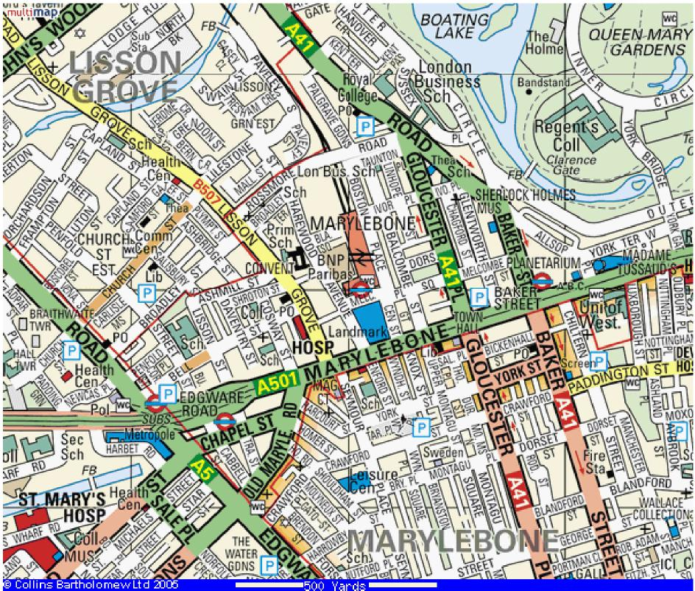
We are here
Christ Church Bentinck C of E School, Cosway Street, London NW1 5NS

Cosway Street is a one-way street from Marylebone Road. There is parking for members of staff at the school and we are situated very close to the following stations.
Underground: Edgware Road - Bakerloo, Hammersmith & City, District, Circle lines
Baker Street - Jubilee, Metropolitan, Bakerloo, Circle, H & C lines
Marylebone - Bakerloo line
Main line: Marylebone Station (2 minutes walk)
Paddington Station (1 0 minutes walk)

