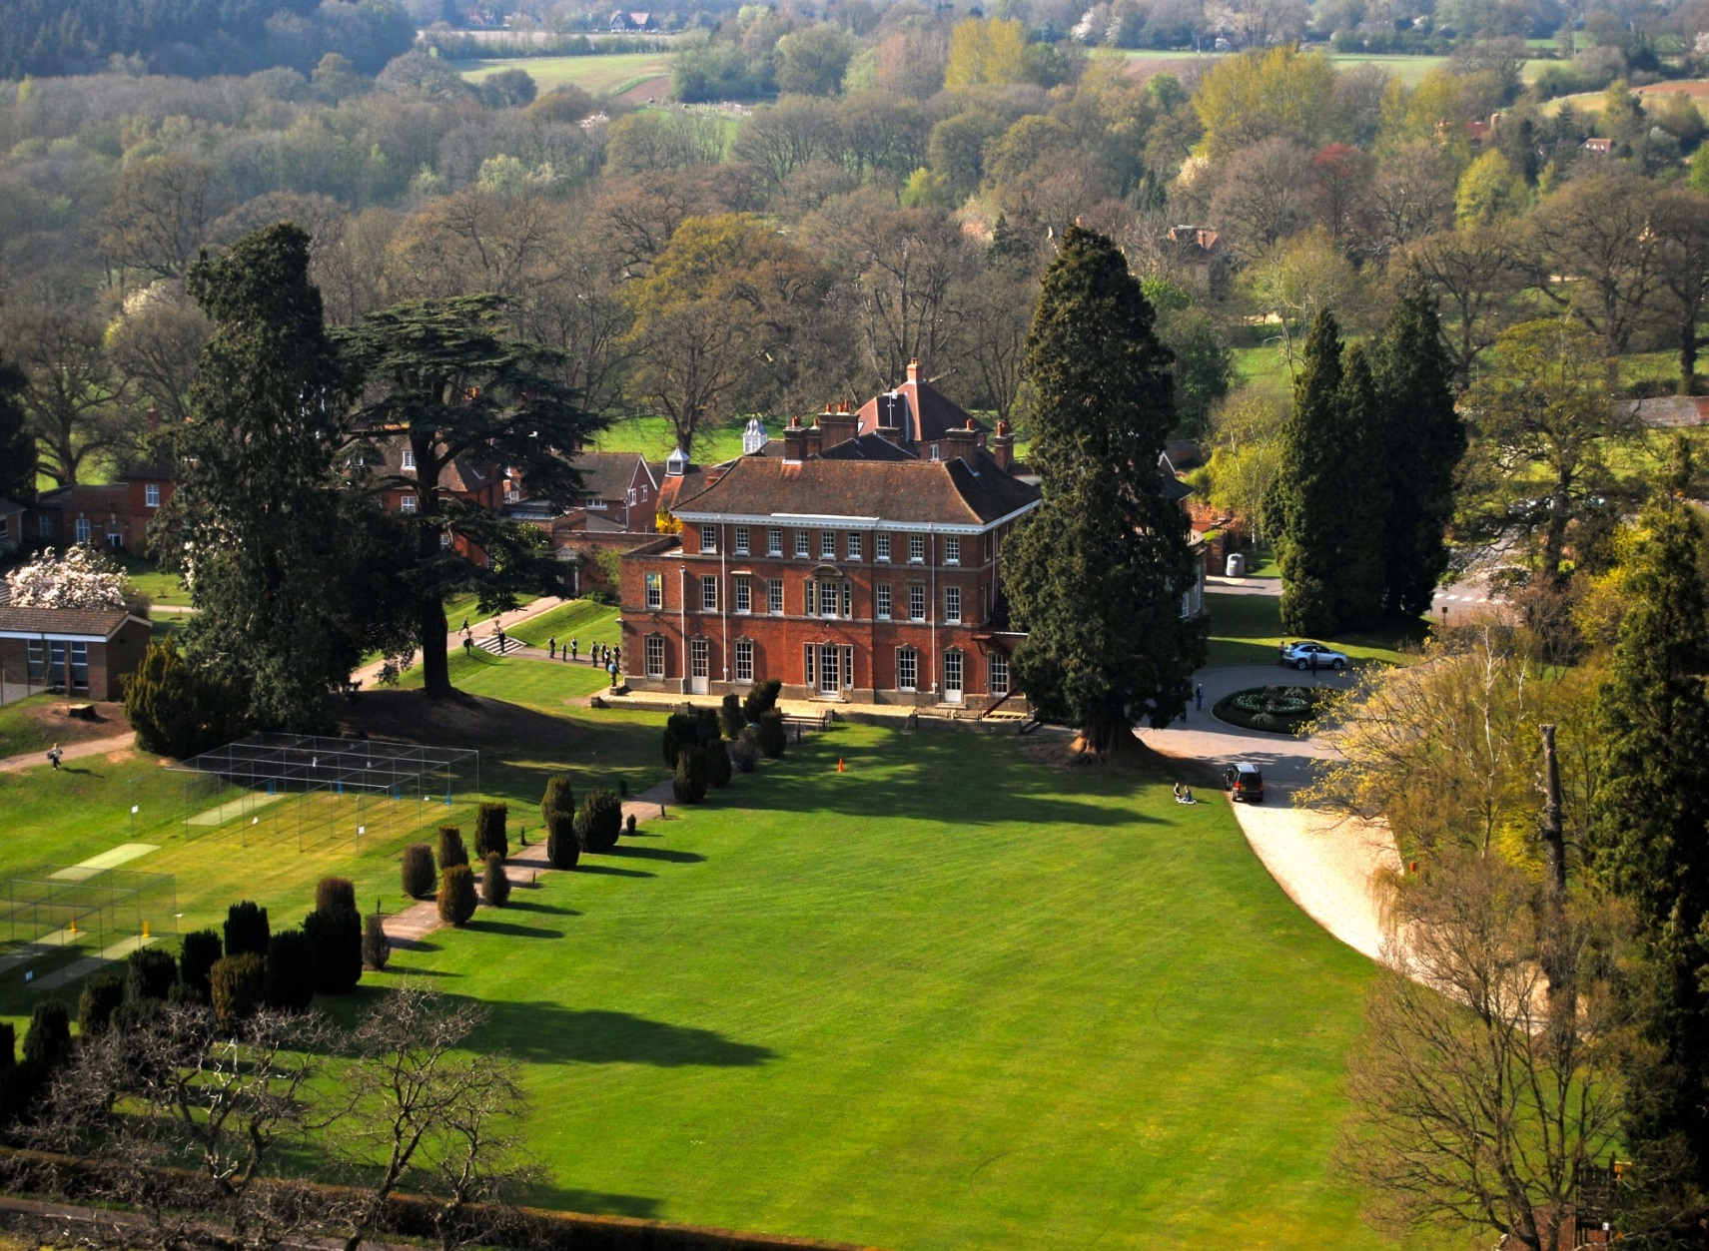
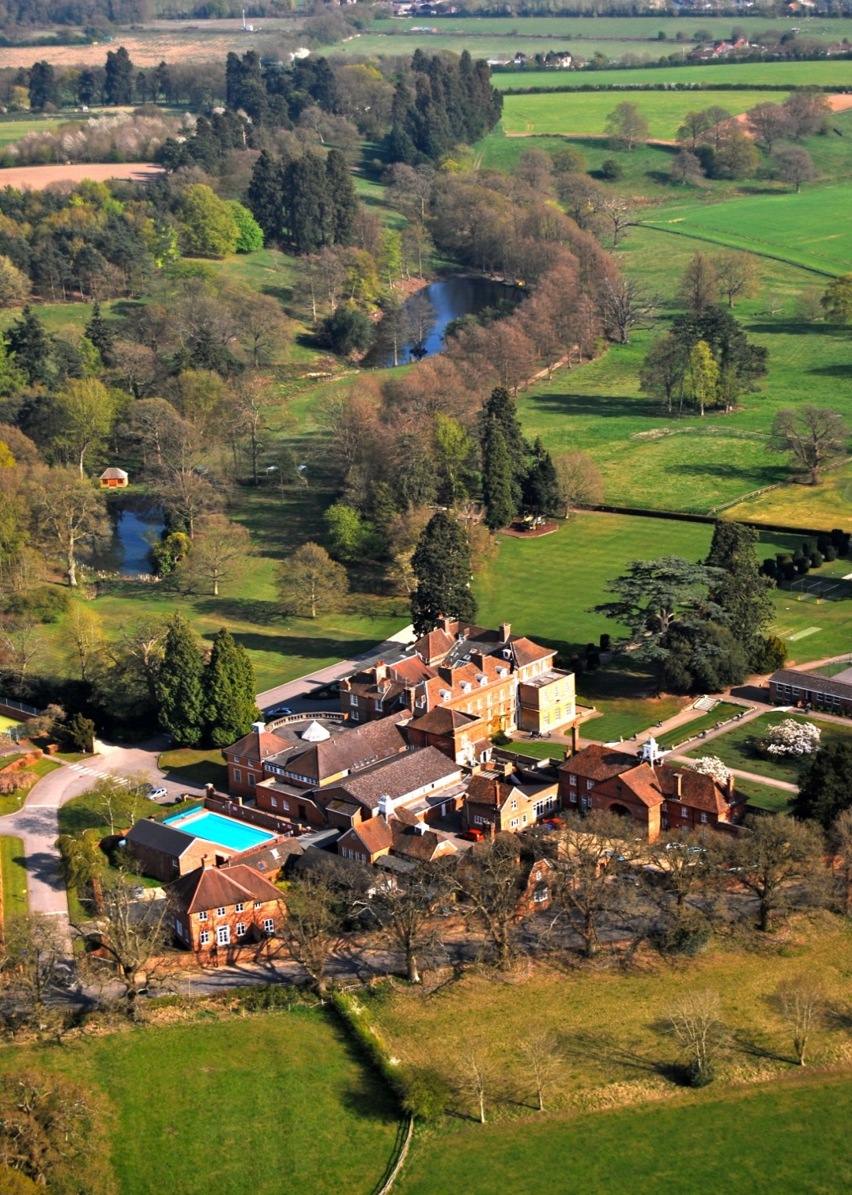 | Contents  The School 3  The Role 6  Remuneration 8  How to apply 8

Pre-Prep
Thank you for your interest in working in our Reception class at Elstree Pre-Preparatory. We hope the following information is useful for you:

Elstree Pre-Prep consists of four classes catering for boys and girls from 3-7 years old. It was founded in 1993 with just eight pupils and now caters for around fifty children. It is located alongside the Prep School allowing us to take full advantage of the wonderful grounds and facilities at Elstree. The children are taught in classes by their class teacher for the majority of the day but have specialist teachers for Music, French, Drama and PE.
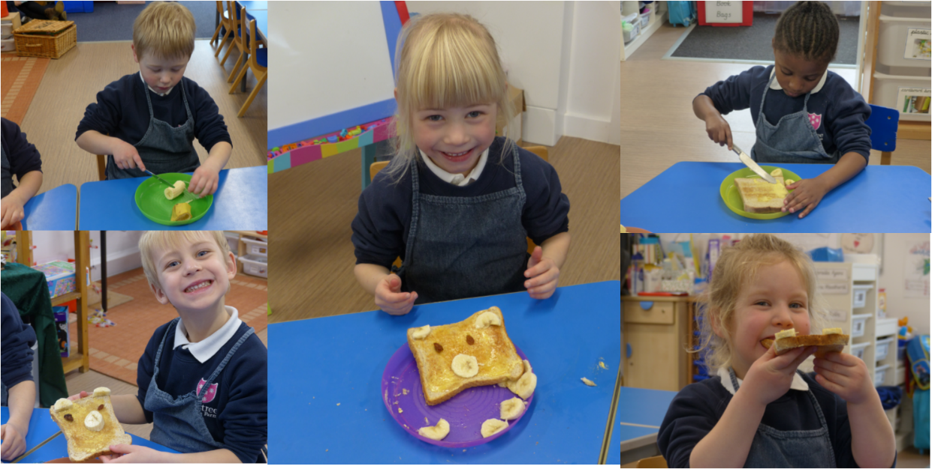

We are a close community and pride ourselves on the very special, warm environment that has evolved since our inception, influenced largely by the family principles of Elstree School. We are often the first experience of school life and understand how important these initial steps on the educational road are. We understand each parent’s desire for their child to feel happy and secure and consider our role in the children’s development and happiness to be a very privileged one. Our committed, energetic and enthusiastic staff look forward to working in partnership with parents throughout their child’s time at the Pre-Prep. All children are valued as individuals and are encouraged to explore and develop their talents to the full.
It is our aim to maintain high academic standards within a strong pastoral community where traditional values and innovative thinking go hand in hand.

Early Years
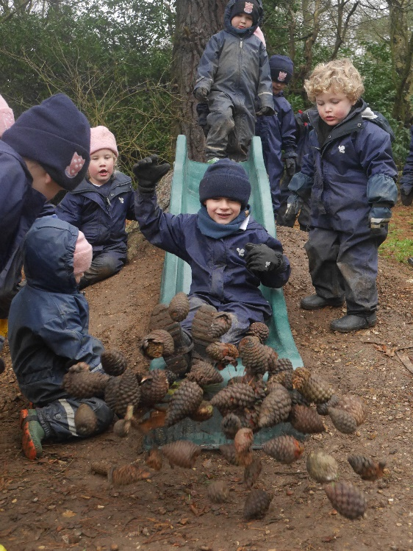
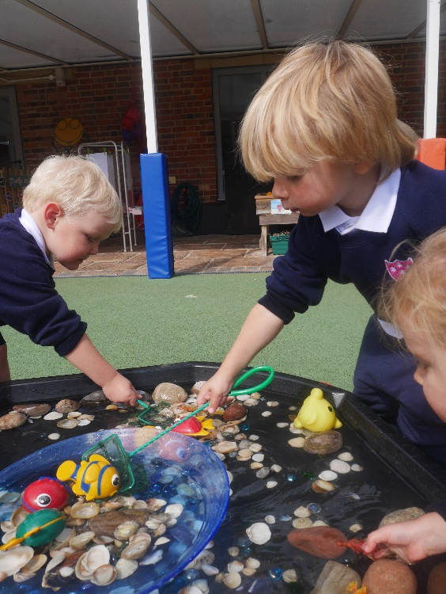
Nursery and Reception classes follow the Foundation Stage Framework, learning through play and practical activities, both in the classroom, in our outdoor play areas as well as in the extensive grounds of Elstree School. Flexible sessions, including lunch if required, are offered to children in the Nursery on days to suit both children and parents.

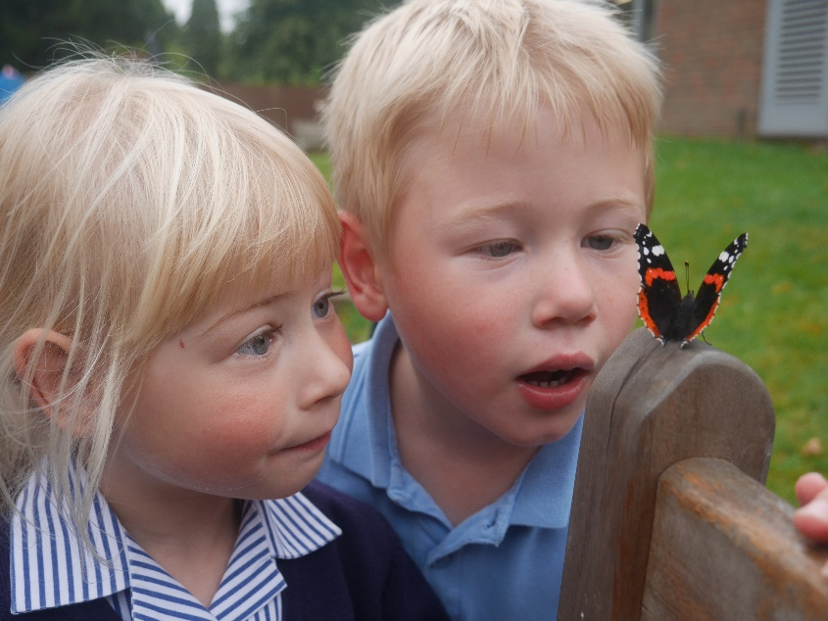
The teachers in Nursery and Reception work closely together, often exploring the same themes or stories with the pupils. In addition, they both have access to the Early Years Garden and take it in turns to plan outdoor activities for the children.

During Reception, teaching follows the Development Matters Document. Lessons and learning experiences are stimulating and fun and the children’s interests are put first. It is our aim for our children to love their time at school and to develop a love of learning.

Years 1 & 2
Year 1 sees children make the transition from the play based learning of the Early Years Foundation Stage curriculum to the more formal lessons of Key Stage 1. The introduction to the year is a gentle one and helps the children become settled into the new routines. There is close liaison with the Reception staff to ensure that the transition is well managed and that staff are aware of each child’s strengths and characteristics of learning.
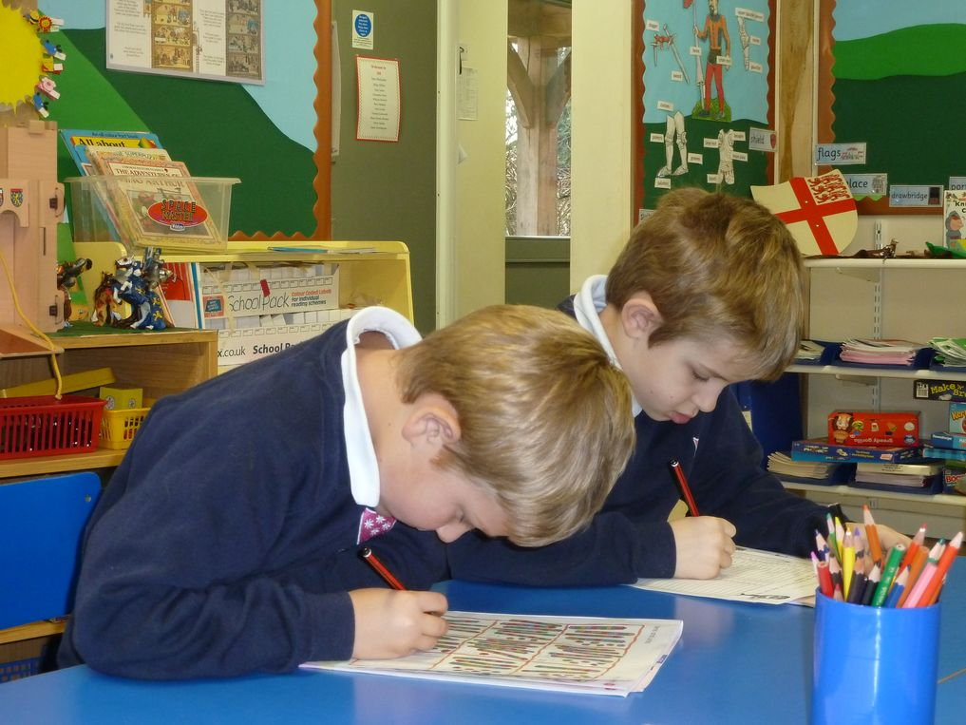

There is a strong emphasis on literacy and numeracy during these two years, whilst still ensuring that the children enjoy a broad and balanced curriculum and have the opportunity to learn by doing and being involved. Our teaching follows the National Curriculum and we aim to maintain the level of excitment and enjoyment in learning that is fostered in the Early Years. There is a balance between individual, group and whole class work.

Reception Class Teacher, Maternity Cover
We are seeking to appoint a passionate and enthusiastic teacher to join our Pre-Prep team from September 2020. The successful candidate will teach in Reception and be a key member of our Early Years team. They will initially take on a maternity position, however, there may be the possibility of extending this for the right candidate.
JOB DESCRIPTION
Appointed by and reporting to: The Head of Pre-Prep
Teaching and Learning:
- To teach a full timetable, delivering the lessons as required by the Head of Pre-Prep.

- To plan and deliver lessons across all seven areas of the Foundation Stage Statutory Framework.

- To have a good working knowledge of the Foundation Stage.

- To have a commitment to deliver the EYFS curriculum through engaging and creative learning experiences, encouraging child based learning where possible.

- To work alongside the other Early Years Staff, discussing learning activities and sharing practice.

- To take a full role in the planning and maintenance of the outdoor learning area.

- To prepare and mark work to facilitate positive pupil development.
- To meet requirements for the assessment and recording of pupils' development.

- To plan next steps for children to meet.
- To manage your classroom in such a way that it is a stimulating and welcoming environment for the children.

Pastoral:
- To develop and foster the appropriate skills and social abilities to enable the optimum development of children, according to age, ability and aptitude.

- To manage behaviours so that a safe and stimulating learning environment can be created.
- Comply with school policies and procedures in areas such as assessment, marking, behaviour management, communication with parents, teaching English as an additional language, cover, induction, planning, staff meetings, parental events.

- Be an integral part of a team that accepts the collective responsibility for the health, education and welfare of the children in the school, and to abide by Health and Safety regulations.
- Support the school’s pastoral system, within the year group, class and with individual pupils.
- Identify any children with particular educational or emotional needs and, where necessary, make provision for them with close liaison with the Learning Development Department.

Wider School Community and Commitments:
- Play a full part in the life of the school community, supporting the ethos of the school, and encouraging staff, parents and pupils to do likewise.

- To keep informed of current teaching and educational developments through documents, meetings and in-service courses.
- Organise and take part in school events, Open Days, outings and activities which may take place at weekends or in the evening.

- Play as full a part as possible in the corporate life of the school, such as undertaking a contribution to the extra-curricular life of the school (as reasonably required by the Head of Pre-Prep).

- Lead assemblies on a timetabled basis and take on a fair share of playground or afterschool duties.

- Attend Parents’ meetings, Common Room and Departmental meetings and major functions when required by the Head of Pre-Prep or Headmaster.

- Cover for absent colleagues and, when absent themselves, set appropriate work wherever possible.

- Take part in the Staff Career Development (Appraisal) scheme.

Person Specification
We are looking for someone who:
- Enjoys working as part of a team
- Is forward thinking, looking for ways to improve or move forward
- Has excellent communication skills
- Is organised
- Manages time effectively
- Has a good sense of humour and a positive outlook
- Can manage pressure

Hours of work
Hours of work are term time only, Monday to Friday, 8.00 – 4.30. You will be expected to stay until 5.00 in order to attend some staff meetings and additional events and until 6.00 once a week to cover an after school club.
In addition, you will be required to work Saturday mornings for Open Mornings, Assessment and Induction mornings.
Holiday
You are entitled to all normal School holidays in accordance with the published dates in the School calendar, you will be required to work three days before the start of a new term in order to attend INSET days and fulfil any duties at the end of term as discussed with the Head of Pre-Prep.
Holidays must not be taken during term time.
Probationary period: 1 term

Salary
According to experience, to be discussed at interview.

How to Apply
If you are interested in applying for this post, please contact Mrs Maria Pouney and she will send you all the required forms for the application. Please ensure this is returned to the School by 5 p.m. on Friday 21st February 2020. We would like to see your curriculum vitae but this will not be accepted in place of the form. Your application may be submitted by email to mpouney@elstreeschool.org.uk or by post to the following address:-

Mrs M Pouney
Elstree School
Woolhampton
Reading
RG7 5TD

You are most welcome to include a short hand-written letter, addressed to the Head of Pre-Prep to develop and expand upon your suitability for the post. Short-listed candidates will be asked to attend an interview at the School, at the School’s expense. If you have any questions please do not hesitate to contact us.

The School is committed to safeguarding and promoting the welfare of children and young people. Applicants must undergo child protection screening, including checks with past employers and Disclosure and Barring Service.

