Person specification  Job title: | Teacher of Modern Languages – Primary
Location: | The Grammar School at Leeds, Alwoodley Gates, junior school
Summary of duties and responsibilities: | To teach French across Key Stage 2  To contribute to pastoral responsibilities and the wider life of the school
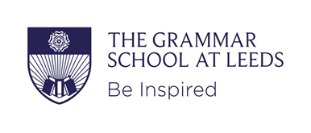
Qualifications & attainments

- Strong educational background
- A teaching qualification at degree or post-graduate level

Experience & knowledge

- Knowledge of current educational practice and issues
- Ability to teach across primary age range
- Awareness of the national curriculum requirements and know how to assess pupils’ progress
- Understands the implications of the Code of Practice for Special Educational Needs for teaching and learning

Skills and qualities

- An excellent practitioner in the classroom
- Ability to communicate effectively orally and in writing to a range of audiences
- High level of organisational and planning skills
- Can work effectively as part of a team, relating well to colleagues, pupils and parents
- Ability to relate to and empathise with pupils and to develop trusting and respectful relationships with them
- Respect for confidentiality of information concerning individual pupils and ability to use discretion in circumstances of disclosure
- Commitment to safeguarding and high levels of pastoral care
- A familiarity with ICT and its application in teaching and learning

Values & ethos

- A willingness to consider and reflect upon one’s teaching methods, with a commitment to learning and continuing professional development
- A commitment to pastoral responsibilities and co-curricular activities
- A willingness to contribute to the corporate life of the school with a supportive understanding of the ethos of independent education

