Specific Role Description

Science (STEM) Teacher

Team:  Area Teaching |  | Supervisor:  Core Subject Lead |  | MoR :  Deputy Head – T&L |  | Band:  Teacher payscale
Requisite Role Authorities:
MoR: |  |  |  | Supervisor: subject learning coach champion plus supervision of the work of learning coaches relevant to in class and remote learning
Program Manager: Subject teaching & curriculum (face to face and remote) |  |  |  | Team Member: Teaching Team, Cross area subject team, school staff team
Purpose: subject curriculum delivery (on site and remote)

The learning and achievement of all children in the subject
Treat pupils with dignity, building relationships rooted in mutual respect.
Work proactively and effectively in the best interests of the children.
Safeguarding the welfare of children within the school.

Authorities:

- Subject curriculum
- Subject budget
- Subject lesson planning
- Remote subject learning curriculum
- Remote learning lesson planning

Person Specification |  |  | 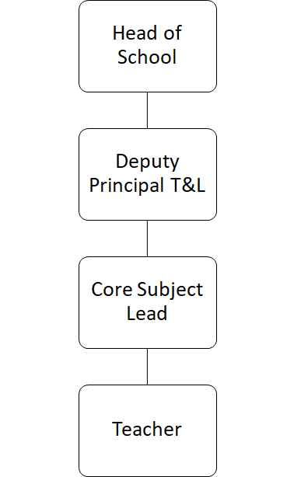
Qualifications and experience:
- QTS in main teaching subject
- Experience in successful subject teaching
- Experience in successful SEND teaching
- Ability to plan for progression across the attainment range, designing effective learning across a series of lessons
- Committed to meeting the needs of all children
- Good knowledge and understanding of the National Curriculum.

Role Relationships:
Professional: Learning Coaches, Learning coach champion, House Leads, SENDCo, Core subject leads, Deputy Heads, Head of School, area subject network

Parents and Community: all parents/carers,

Pupils: all children in the school, children in transition (onboarding/off-boarding), children receiving remote learning support.

Role environment
The role is predominantly based at one of the learning centres and includes on-line/remote learning (Teams) and 1:1 tutoring, at times in the community.

Key result area | Accountability |  |  |  | Performance indicator
Leadership | Model behaviour that represents the CMAS way |  |  |  | 100% of the time
 | Model skills and behaviour that meet the National Teacher Standards |  |  |  | 100% of the time
 | Review revise and plan improvements to your subject area |  |  |  | Pupil progress
 | Review revise and plan remote learning packages (subject) |  |  |  | Pupil progress
 | Monitor access and report on engagement in remote learning. |  |  |  | Reports completed to schedule
 | Lead and report subject data at meetings |  |  |  | Reports completed to schedule
 | Complete statutory and company training |  |  |  | Completed to schedule
 | Personal professional development
 | Subject specific CPD for learning coaches |  |  |  | CPD record
 | Attend moderation meetings
 | Attend staff meetings.
Teaching and Learning | Bespoke curriculum planning – using prior and current knowledge and understanding.
 | Review and update S0W in line with NC and needs of the child
 | Inclusive teaching
 | Integrated experience planning
 | Minimum subject teaching time
 | Lesson planning- systematic curriculum delivery
 | Delivery of the curriculum- Motivational and aspirational teaching
 | Baseline assessment
 | Marking & feedback (as per policy)
 | Attainment, progress and outcomes of all children in the subject
 | Assessment of working at (summative)
 | Assessment of progress (curriculum tracker)
 | Analysis of progress data- identification of high and low performers
 | Gap analysis
 | Design and implementation of ‘catch up’ programmes.
 | planning out-of-class activities to consolidate and extend the knowledge and understanding.
Student Services | Read and implement behaviour support plans.
 | High expectations of behaviour
 | Read and implement learning support strategies (EHCP, pupil passport)
 | Monitor and report lesson attendance (on site and remote)
Community Engagement | Weekly reports
 | Live progress reports to parents (Arbor)
 | Termly reports to parents (narrative)
 | Maintain good relationships with parents/carers
 | Parent subject support sessions
 | Parent evenings
Finances | Lead budget allocations
 | Maintain subject resources and equipment.
 | Monitor budget spend.
Facilities | Establish and maintain a tidy learning environment.
 | Develop and maintain purposeful learning displays.
 | Display a wide range of children's work.
HR | Report any changes that may impact DBS.
 | Participate in appraisal
 | Report other employment
H&S | Implement all H&S policies and procedures
 | Safeguard children in line with company policy and national statutory guidance
 | Safe and clean learning environment
 | Teaching space risk assessment
 | Report faults, risks and hazards
 | ESafety

