Senior School Teaching Assistant
Job Description

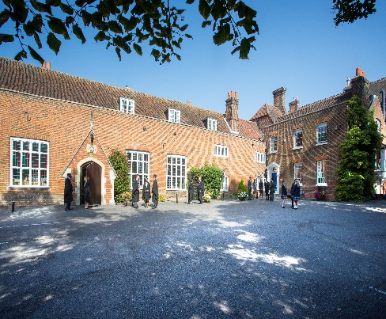

Introduction
Chigwell School, a leading co-educational school just ten miles from central London, seeks to appoint a caring and enthusiastic teaching assistant to work in the Senior School. The role will involve working alongside teaching staff in the English and Mathematics departments on a full time basis during term time. Successful applicants need to be able to work closely as part of a team, be flexible and have excellent communication skills. It is anticipated that the successful candidate will have had experience in a similar role in another maintained or independent school.

Background
Founded in 1629 by Samuel Harsnett, the son of a Colchester baker who went on to become Archbishop of York, Chigwell School stands on it original site with the original school building still in use. However, whilst Chigwell of today is conscious of its long-standing history, it is a forward-looking, ambitious, co-educational independent school of 930 pupils aged four to eighteen. It enjoys excellent facilities, a dedicated staff, bright and hardworking pupils, and a site of 100 acres.

Chigwell School is located in the picturesque village of Chigwell just over ten miles from central London and on the Central Line. The extensive, beautiful grounds are close to the edge of Epping Forest and it is rare for a school to have so much space and yet be so close to the centre of the Capital. Most pupils are day pupils but in the Sixth Form, there is a small community of international boarders, roughly thirty from sixteen countries, and these live in four small boarding houses.

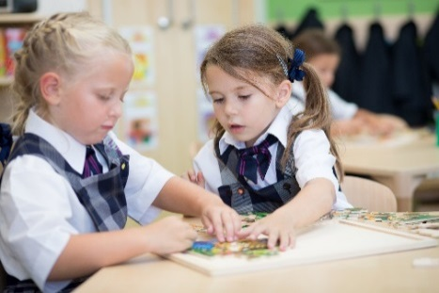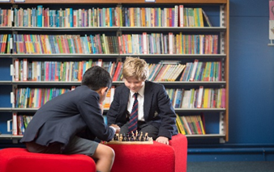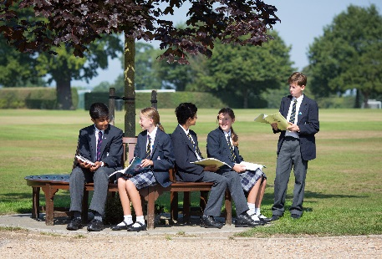

As well as being an academic school, Chigwell has the reputation for providing a rich and full education, with plenty of opportunities for all pupils who are enthusiastic, co-operative and able. Chigwell is a caring and friendly school, with a close sense of community, not least between colleagues. As the 2015 Good Schools Guide reports: Academically, pupils are put through their paces but it all seems to be done in such a civilised and pleasant manner that you are more likely to hear pupils talk about opportunities and prospects than pressure and stress. “Anyone who wants to do well here, will do well” said one student, “and I can’t think of a nicer place to succeed.”

The School Development Programme
Over recent years, the School’s facilities have been extensively developed in order to enhance the educational experience that pupils receive. The development programme has included the following additions:
- 2008 Wilson Building teaching block
- 2008 Floodlit AstroTurf pitch
- 2009 Junior School library extension
- 2010 Complete redevelopment of catering facilities
- 2010 Sixth Form coffee shop
- 2010 Harsnett’s and Church House converted into boys’ boarding houses
- 2012 The Old Chigwellian Club and land was incorporated into the school estate
- 2013 Pre Prep School built and opened
- 2013 Two new science labs created
- 2014 Drama Centre balcony extended to provide additional music and drama rehearsal space
- 2016 The Risham Sarao Sixth Form Centre was completed

At present the extension of the Dining Hall is underway. In the future we plan to:
- Renovate the Chapel
- Develop the Sports Centre
- Expand our music facilities
- Further expand our provision of bursaries

The School
Some pupils join in Reception and there are two classes in each of the three Pre Prep year groups. A small number of other children join the Junior School at 7+ (Year 3) and there are two or three classes in each of the KS2 year groups. At 11+ (Year 7), there is a further entry with four classes making up Years 7 to 11. Again, there is a small entry into the Sixth Form. Entry at each stage is selective and although there are three main sections to the School (Pre Prep, Junior School and Senior School) these sections work closely together and there is a common ethos running throughout.

There are over a hundred teachers and together with the support staff, there is a friendly, mutually-supportive atmosphere. All teaching staff contribute to the extra-curricular programme.

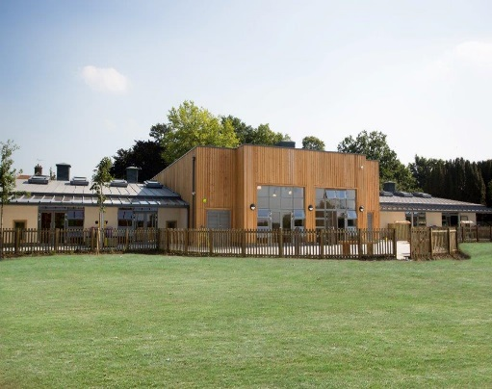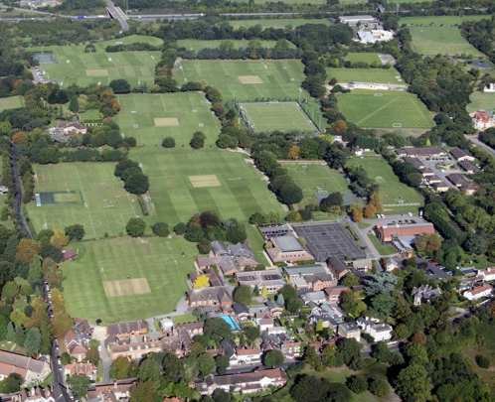

The Role
The purpose of the role is to support pupils’ learning ensuring that they make appropriate progress and support class teachers to raise attainment. The key tasks and responsibilities are:

Teaching and learning

  - Work alongside the teaching staff in the Senior School in the English and mathematics departments
  - Assist in the educational and social development of pupils under the direction and guidance of the Headmaster, Head of Learning Support and class teachers
  - Provide support for individual pupils and groups, under the direction of teachers, as identified by the Learning Support register, inside and outside the classroom, enabling them to attain their full potential
  - Work with small groups of children, as identified by class teachers, inside and outside the classroom, focussing on set learning objectives
  - To be prepared to introduce tasks, monitor pupils work and use a range of strategies to support learning
  - To support the organisation of the learning environment including the production of differentiated materials where appropriate
  - Support students with emotional or behavioural problems and help to develop their social skills
  - Take initiative within lessons to support individual pupils who may appear to be struggling with a concept or task
  - Teach new concepts as agreed with the class teacher
  - Support more able pupils with extension ideas and challenges, as directed by class teachers
  - Liaise closely with class teachers in order to keep informed about planning and learning objectives
  - Report to the class teacher orally about pupil progress or issues
  - Keep a diary of small group or individual support, detailing pupil progress or any problems and share this diary with class teacher and Head of Learning support as required
  - To participate in a programme of support for pupils either at lunchtime, before or after school, as required
  - Keep a diary of small group or individual support, detailing pupil progress or any problems and share this diary with class teacher and Head of Learning support as required

Other duties

- Liaise with the Head of Learning Support, to discuss children’s progress, to plan and review current support and to contribute to records of pupil progress and achievements
- Support class teachers in tasks that support teaching
- Promote the welfare of children and support the school in safeguarding children though relevant policies and procedures.

General

- Set a good example in terms of dress, punctuality and attendance
- Contribute to the overall ethos, work and aims of the school acting as a role model and setting high expectations.
- Participate in training, other learning activities and performance development as required
- Attend and participate in relevant meetings as required
- Take part in the school’s performance management system
- Be aware of and comply with policies and procedures relating to child protection, equal opportunities, health and safety, confidentiality and data protection reporting all concerns to an appropriate person.
- Appreciate and support the roles of other professionals
- Promote equality as an integral part of the role and to treat everyone with fairness and dignity.
- Recognise that health and safety is a responsibility of every employee, to take reasonable care of self and others and to comply with the school’s Health and Safety policy and any school-specific procedures / rules that apply to this role.

This is a description of the main duties and responsibilities of the post at the time of production. The duties make change over time as requirements change. The person in the post may also have to carry out other duties as may be necessary from time to time.

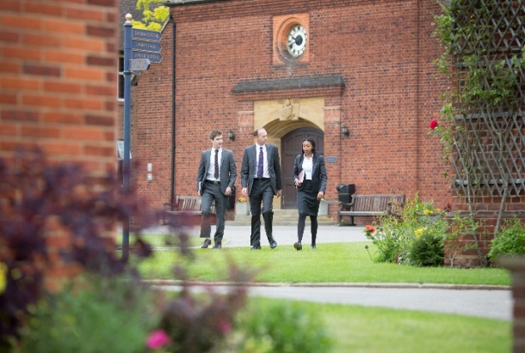

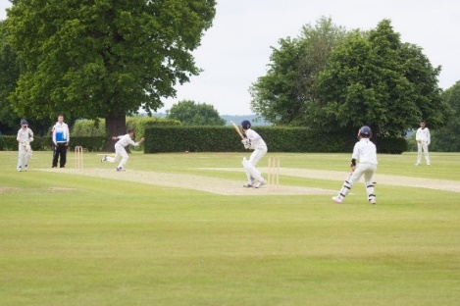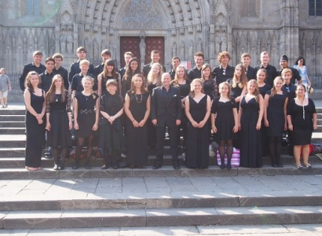

Person specification

The ideal candidate must have strong literacy and numeracy skills and the academic ability to support students effectively within the school curriculum.

The successful candidate will fulfil the following essential requirements, and will also ideally hold the desirable attributes.

Requirement | Essential or Desirable
Qualifications / Education / Training:  - A good GCSE pass in English and Maths is essential  - Appropriate teaching qualifications | Essential  Desirable
Experience:  - Recent experience in a similar role in another maintained or independent school  - Application of a range of learning and teaching strategies  - Experience of monitoring an evaluating impact of teaching sessions  - Effective classroom management | Desirable  Desirable  Desirable  Desirable
Skills and Knowledge  - A good knowledge of the current NC requirements of the subjects  - The ability to adapt to different environments within the school and to the needs of different children  - Awareness of how pupils learn, the factors which affect progress and how to motivate them.  - An understanding of commitment to inclusive education.  - The ability to work with any age group across the school.  - The ability to establish and maintain effective working relationships  - Ability to work constructively as part of a team, understanding classroom roles and responsibilities and your own position within these  - Ability to accept guidance and direction from teachers.  - Ability to relate well to children and adults  - Ability to inspire, motivate and encourage young people  - Ability to adapt sessions appropriately dependent on the needs of young people  - Ability to maintain a high standard of teaching which ensures all students are actively engaged in their learning and make excellent progress  - Ability to use ICT to enhance the quality of learning  - Willingness to undertake training to develop job related skills to support good practice.  - Commitment to the protection and safe-guarding of children and young people  - Awareness of the need to show respect to all children and adults within the school community. | Essential  Essential  Essential  Essential  Essential  Essential  Essential  Essential  Essential  Essential  Essential  Essential  Essential  Essential  Essential  Essential
Personal Attributes:  - Enthusiasm and passion for teaching and learning  - Excellent communication and interpersonal skills: the ability to communicate with people at all levels  - Excellent planning and organizational skills  - Self-motivated and able to use own initiative  - A willing and flexible approach to work  - Team player  - Commitment to equal opportunities  - Interest and ideas of cross- curricular collaboration  - Interest in and willingness to take part in extra-curricular activities  - Commitment to links and partnerships with schools and other organisations  - Commitment to the protection and safe-guarding of children and young people. | Essential  Essential  Essential  Essential  Essential  Essential  Essential  Desirable  Desirable  Desirable  Essential

Salary:

Competitive.

Hours of work:

This is a term time position. The post will be 35 hours per week full-time or negotiated hours part-time.

Benefits of working at Chigwell School include:

- A competitive salary  - Access to the School Pension Scheme  - Free lunch and refreshments during term time  - Childcare Vouchers  - Personal Accident Cover  - Employee Assistance Support Programme  - On site free parking and cycle racks  - Use of School Library | - Medical Centre on site  - Free use of School’s sports facilities outside of the School day  - Commitment to professional development  - A supportive community of highly motivated students and staff  - A beautiful working environment- 100 acres site beautifully landscaped with a number of listed buildings

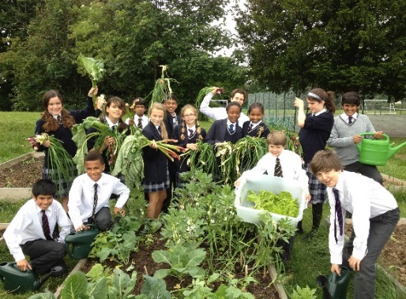

Applications

Applicants should complete the teaching staff application form which can be accessed directly from our website: www.chigwell-school.org (Vacancies) and sent to the Headmaster’s P.A.: hmpa@chigwell-school.org by Monday 5th January 2018.

Chigwell is committed to safeguarding and promoting the welfare of children and young people and expects all staff and volunteers to share this commitment. Applicants must be willing to undergo child protection screening including checks with past employers, prohibition orders and enhanced DBS.

