
Second in Maths Faculty

Information for Applicants












Letter from the headteacher

Dear Applicant,

This is a truly exciting opportunity for someone who is looking to further their career into middle management, and who is ready for the responsibility of such an important part of our school journey. BCHS is an amazing school, with a unique sense of spirit and community – it is warm and welcoming, people-focused and totally dedicated to the community that we serve.

Our staff are passionate about education and believe that all young people should be inspired to be the very best that they can be. Our vision and values articulate the things that we put importance on and encapsulate the school’s spirit: we are a team. The staff know this, our parents/carers know this and, most importantly, our students know this. Our vision at BCHS is to have students who understand the power of aspiration, knowledge and kindness – this role must bring a focus on these areas into the Maths curriculum.

The heart of the job is assisting to lead the Maths team and helping to design the Maths curriculum - ensuring it is knowledge-rich, challenging and full of opportunities to expand our students’ understanding of the world beyond the classroom. We believe in the power of knowledge and the importance of a challenging, word-rich curriculum for all. That being said, we recognise the lessons that can be gained beyond academia, we actively teach social responsibility and direct students in acts of kindness within the school setting but also in our wider community. We view it as our duty to ensure they leave us with high aspirations, secure knowledge and a kind heart.

We pride ourselves on the core ethos of our school being underpinned by the strongest foundations of discipline, respect, tolerance and compassion – we ensure our students are equipped with a strong moral compass. We offer a very strong extra-curricular programme with every member of staff offering a provision, it is an aspect of our school community that we are very proud of, and rightly so.

It is essential that we appoint the right person to this role, and it is important that their values and views align with what we are trying to achieve as well as our philosophy on staff wellbeing and development. I would recommend that your read my personal blog (https://leadership-life.co.uk), our school blog (https://www.birchwoodhigh.org/nexilis/) and our Professional Growth handbook to really give you a more comprehensive insight into how these views and values translate into our day to day processes and habits.

We know that our students are excellent people, and they thrive in a culture of achievement and success; we have high expectations, encouraging them to be aspirational in their learning and to enjoy all aspects of school life. Academic standards at BCHS are good for all students irrespective of their starting point. However, we know that we are all capable of even more. We continue to strive to improve levels of student achievement and move towards being recognised as outstanding in all areas.

Vacancy details:

Salary Scale
Teachers’ Main Pay Scale / Upper Pay Scale + TLR 2b (£5028).

Contract
Permanent

Method of Application
The preferred method of application is electronically via email. All applications must be made using the school’s application form. Applications will be shortlisted for interview and the HR Manager will contact those selected regarding the time and venue. Applicants who have not been contacted within two weeks of the closing date can assume that on this occasion their application was unsuccessful.

Closing Date
Applications received after the closing time of 9am on Thursday 25th May 2023 will not be considered.

Interview Dates
Friday 26th May 2023

Safeguarding
All staff who teach, train or work regularly with children aged up to 18 and vulnerable adults are required to comply fully with legislation and Birchwood Community High School policies and practices to ensure learners are safeguarded and protected.

Please feel welcome to come and have a visit before applying, but be assured that whether you visit or not, it will not affect the short-listing process. If you would like to have a look round, please email our HR Manager, Tina Wiegand (twiegand@birchwoodhigh.org) to arrange.

Thank you for considering our truly amazing school as the next chapter in your career, and hopefully I will be reading your application soon.

Yours sincerely,



Emma Mills
Headteacher



‘There is a ‘buzz’ of energy in classes, reflecting pupil’s positive attitudes to their learning.’


Our Vision

Team Birchwood believe in the power of aspiration, knowledge and kindness. We know that we achieve our best when we work together.

Our Ethos

High aspirations, high expectations and high achievement rely upon a positive working environment based upon respect. For us, respect means consistent positive regard for everyone in our learning community. A strong moral purpose enables students in our school to grow into independent, responsible young adults who can access a happy and healthy future.

At Birchwood we strive to ensure that every lesson counts, for every child, every day. We expect teachers to deliver engaging lessons that ensure students acquire powerful knowledge and develop both essential and desirable skills. For this to happen, behaviour must enable every teacher to teach and every child to learn. We expect students to come ready each day to challenge themselves to be the very best they can be. We have a wide variety of extra-curricular activities to help children develop all their skills and talents and there are many opportunities to develop their leadership skills throughout
their school life.

Our Mission

We are 100% committed to our students. We seek to sustain a community that is rooted in respect and the belief that every student can succeed. We endeavour to equip our young people with the qualities, qualifications and values that will enable them to lead fulfilling lives and become responsible citizens. We want the children in our care to leave us with high aspirations, secure knowledge and a kind heart.

We maintain high standards of ethics and behaviour; one of the ways this is by embracing the British Values: democracy; the rule of law; individual liberty and mutual respect; and tolerance of those with different faiths and beliefs.

Our Aims

We wish for our students to be:

- safe, happy and cared for in a secure and supportive environment.
- supported and challenged to do their best through excellent teaching, a broad and balanced curriculum and a wide variety of experiences.
- recognised, celebrated and rewarded for all their achievements that they develop confidence and independence.
- developed emotionally, intellectually and morally so that they are able to be successful in the rapidly changing, multicultural society in which we live.
- successful, whether through academic qualifications or a more vocational route, so they can move on to the next stage in their life.

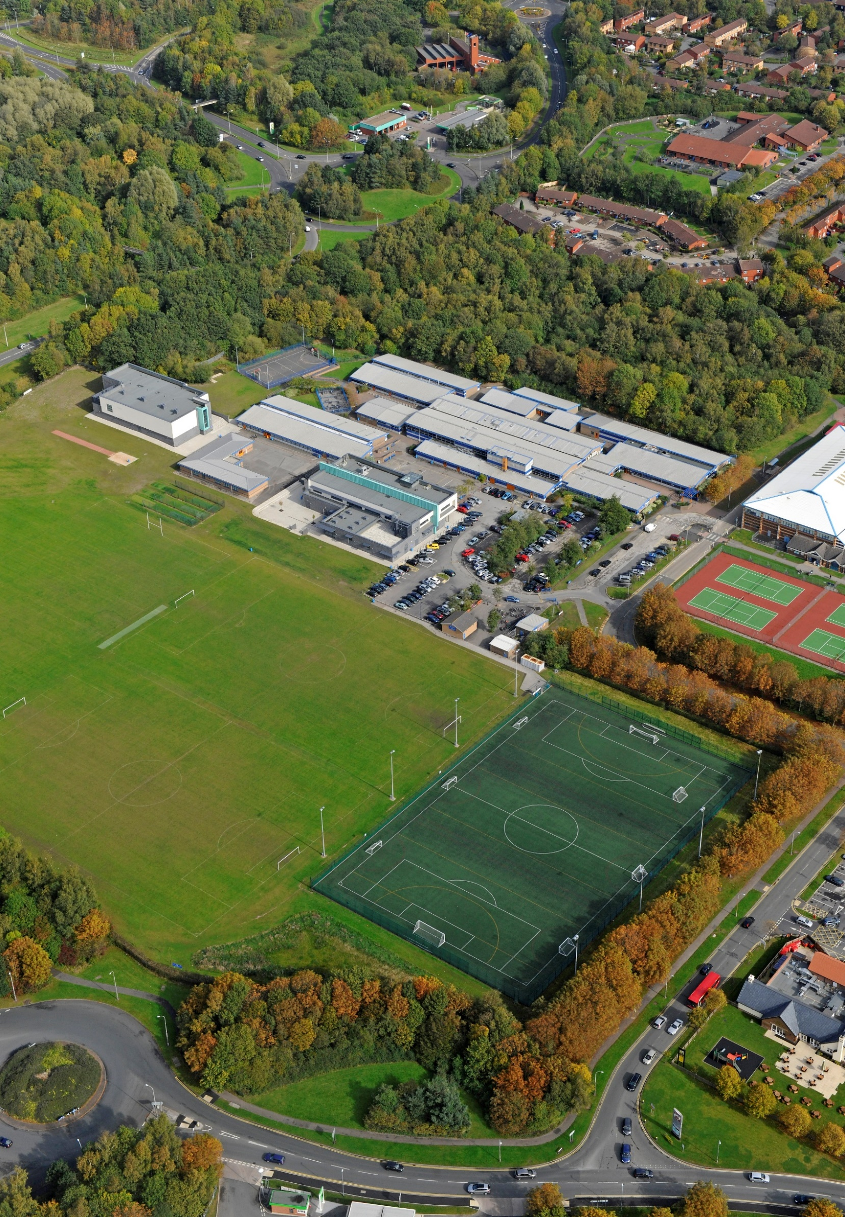

School Profile

JOB DESCRIPTION
- The school became a Single Academy Trust on 1 July 2013.
- The school is of an average size with 916 currently on roll.
- The most recent OFSTED inspection (October 2018) judged the school to be Good in all areas.
- The percentage of students on the Pupil Premium register is 31%, which is above the national average.
- The proportion of students with SEND (ECHP) is in-line with the national average.
- Most students are of white British heritage.
- Students arrive at the school with outcomes broadly in line with national averages.
Job title |  | Second in Maths
Reporting to |  | Head of Faculty
The information contained below is to help staff understand and appreciate the nature of their post and the role they are to play in the organisation. However, it should be noted that, whilst every effort has been made to outline all the duties and responsibilities, a document such as this does not permit every item to be specified in detail. Broad headings may therefore have been used, in which case all the usual associated duties are included in this job description.

- You are required to carry out the duties of a school teacher as set out in the current School Teachers’ Pay and Conditions Document.
- You are required to carry out such particular duties which form part of the current School Teachers’ Pay and Conditions Document as the Headteacher may reasonably direct from time to time.
- In addition, you are required to undertake the following responsibilities for which you are paid your management allowance:
Key Tasks and Accountabilities | Strategic Leadership  - Identify areas for improvement within the faculty and contribute to school self-evaluation and improvement planning.  - Use data and other information to inform strategic planning, to identify improvement targets, and to inform the school’s leadership.  - Develop and implement policies and practices, including performance management, that reflect the school’s commitment to high achievement.  - Analyse current performance of students in the subject throughout the faculty and devise strategies for improving standards further.  - Establish, with the involvement of your line manager, plans for developing and resourcing the faculty to bring about continuous improvement in teaching and learning to promote student achievement.  - Monitor the progress being made towards targets established in subject planning.  - Evaluate the effects of the faculty’s work on standards of learning and teaching.  - Ensure outstanding teaching throughout the faculty.  - Set expectations and targets for staff and students in relation to student achievement and monitor progress towards these targets.  Teaching and Managing Pupil Learning  - Manage resources efficiently so that teaching and learning is effectively supported in the faculty.  - Oversee planning/schemes of work in the faculty.  - Ensure curriculum coverage, continuity and progression for all students through clearly written and regularly reviewed schemes of work.  - Monitor implementation in the classroom through regular monitoring in-line with the whole-school systems.  - Ensure teachers are clear about teaching objectives and provide guidance on methodology.  - Ensure all ability students are well-catered for.  - Develop and sustain students’ communication, literacy and numeracy skills through the subject.  - Keep abreast of new curriculum thinking, teaching methods and examination syllabuses.  - Be aware of developments not only at KS3 and 4 but also at KS2.  Assessment and Evaluation  - Establish and implement clear practices for assessing, recording and reporting on student achievement in-line with school policy.  - Monitor pupil standards and achievement against annual targets and track progress across the faculty.  - Lead the implementation of intervention strategies to ensure outstanding pupil progress.  Development  - Role model outstanding classroom practice.  - Achieve constructive working relationships with students and staff.  - Sustain motivation; promote enthusiasm, openness to new ideas, commitment and a happy and homogenous team.  - Promote links and co-operation with other departments/faculties. Encourage department involvement in school-wide initiatives and in the development of the whole school policy.  Relationship with Parents and the Wider Community  - Establish excellent and effective communication with parents.  - Help develop links with the local community to extend and enhance the work of the department.

All employees have the responsibility to:
- Ensure any documentation produced is to a high standard.
- Be aware and comply with policies and procedures relating to safeguarding, child protection, health, safety and security, confidentiality and data protection, reporting all concerns to the appropriate person.
- Participate in training and other learning activities as required.
- Provide appropriate guidance and supervision and assist in the training and development of staff as appropriate.
- To promote the area of responsibility within the school and beyond.
- To represent Birchwood Community High School at events as appropriate.
- To support and promote Birchwood Community High School’s ethos.
- To undertake any other duties and responsibilities as required that are covered by the general scope of the post.

REVIEW ARRANGEMENTS
The details contained in this job description reflect the content of the job at the date it was prepared. However, it is inevitable that over time, the nature of the jobs may change. Existing duties may no longer be required and other duties may be gained without changing the general nature of the post or the level of responsibility entailed. Consequently, the Headteacher will expect to revise this job description from time to time and will consult with the post holder at the appropriate time.

PERSON SPECIFICATION

JOB TITLE | GRADE
Second in Maths | MPS/UPS + TLR 2b

NOTE TO APPLICANTS: Whilst all points on the specification are important, those marked ‘E’ are the key requirements. You should pay particular attention to these points and provide evidence of meeting them. Failure to do so may mean that you will not be invited to interview.

 | Necessary requirements | Essential / Desirable
Qualifications and experience | A degree or equivalent in Maths | E
Qualifications and experience | PGCE/QTS or equivalent | E
Qualifications and experience | Masters degree or similar in a relevant subject | D
Qualifications and experience | Demonstrable track record of delivering excellent student outcomes | E
Qualifications and experience | Experience of a middle leadership role within a Maths department | D
Qualifications and experience | Experience of carrying out monitoring and evaluation of departmental colleagues, including appraisal | D
Qualifications and experience | Experience of leading CPD activities for colleagues | D
Qualifications and experience | Evidence of successfully developing the practice of other colleagues | D
Skills and Abilities | To be able to teach consistently good or outstanding lessons | E
Skills and Abilities | To use a variety of techniques to engage students and ensure good standards of behaviour | E
Skills and Abilities | A passion for developing effective pedagogical practice across all key stages, and the ability to consistently demonstrate this to others | E
Skills and Abilities | To work well in a team, contributing ideas and assisting with faculty procedures | E
Skills and Abilities | To demonstrate a professional manner | E
Skills and Abilities | To use own initiative, make decisions and respond to problems | E
Skills and Abilities | To contribute to the wider life of the faculty and school, supporting extra-curricular and intervention initiatives | E
Skills and Abilities | To become involved in curriculum development and increase the profile of the faculty within the school | E
Skills and Abilities | To demonstrate competence and interest in using ICT in the classroom | E
Professional knowledge and understanding | Secure understanding of how to raise achievement at faculty level, including effective use of data | E
Professional knowledge and understanding | Knowledge and understanding of the statutory requirements of legislation concerning equal opportunities, disability, child protection health and safety and safeguarding | E
Professional knowledge and understanding | Understanding of how to use data to analyse past and current performance in order to improve outcomes | E
Professional knowledge and understanding | Up-to- date knowledge of latest specifications and curriculum developments in all key stages, including KS2 | E
Professional knowledge and understanding | Understanding of the latest evidence and thinking regarding effective practice in Science teaching and assessment and what this looks like in the classroom | E
Professional knowledge and understanding | Experience of using other data packages (e.g. FFT, SISRA) at the departmental level of analysis | D
Personal qualities | A genuine respect for, and motivation for working with, young people, a commitment to inclusive education and a willingness to respond to the needs of all | E
Personal qualities | To be totally committed to continually improving the education of our students | E
Personal qualities | The capacity for sustained hard work and resilience | E
Personal qualities | A strong commitment to improving outcomes for all students and the drive and determination to make this happen | E
Personal qualities | The ability to lead, motivate and inspire and to build warm and effective professional relationships with staff, students and parents | E
Personal qualities | Commitment to extra-curricular activities and revision opportunities outside the classroom, within the faculty | E
Personal qualities | Ability to show initiative and work independently, as well as part of a team | E
Personal qualities | Excellent organisational skills | E
Personal qualities | Reliability, professionalism and integrity | E
Other requirements | Enhanced DBS Disclosure | E








