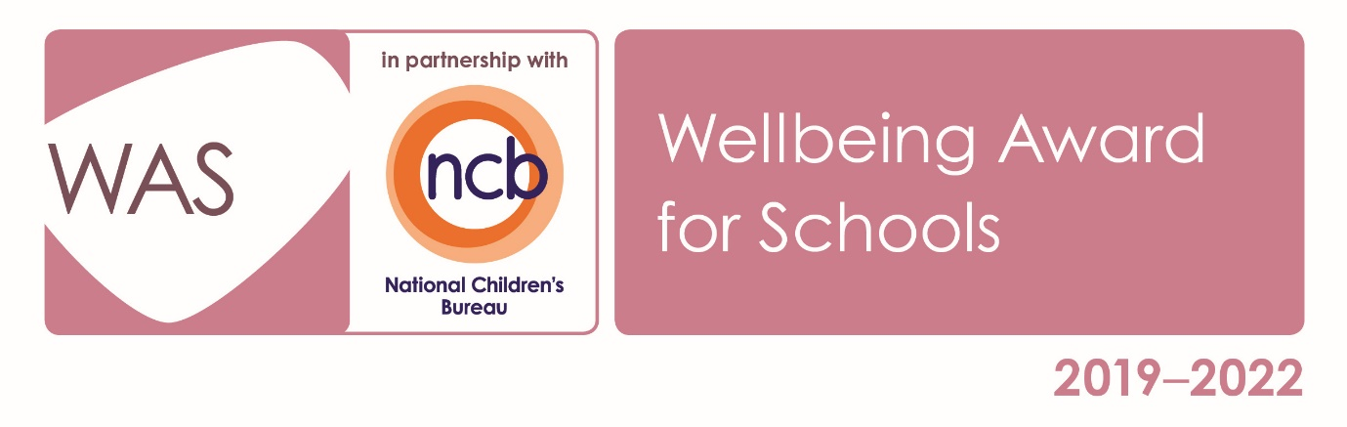

Person Specification
Specialist SEN Class Teacher

CATEGORY | CRITERIA | Essential | Desirable | MEASURED BY
Qualifications | - PGCE or equivalent  - QTS status  - Commitment to completing Bladon induction programme including specific Safeguarding and Child Protection modules  - Right to work in UK  - Additional specialist qualification in SEN | X  X  X  X | X | - Application  - Certificates  - Interview
Experience | - Leading and managing adults in the classroom  - Teaching children and/or young people with SEN  - Previous role in SEN /LD setting  - Supporting or willing to support young people with challenging behaviour  - Specific experience with either MLD or SLD pupils | X | X  X  X  X | - Application  - Interview
Knowledge | - Up to date knowledge and understanding of KCSIE  - Knowledge of the role and an understanding of its rewards and challenges  - Understanding of children with SEN (Autism and attachment)  - Strategies to support managing challenging behaviour  - Understanding of the National Curriculum framework, AIM awards and EQUALS curriculum  - Up to date knowledge of 2019 Ofsted framework  - Practical understanding of the SEND Code of Practice including EHCP format and structure | X  X  X  X  X  X | X | - Application  - Interview  - References
Skills | - Good literacy and numeracy skills  - Positive and effective communication skills  - Ability to work as a team member  - Able to use own initiative  - Ability to plan and deliver learning programmes around specific needs of young people  - Use of data to inform planning  - Able to work in challenging circumstances  - Knowledge of augmentative communication and alternative communication tools  - Organising and planning off site and residential trips  - Attention to detail in report writing | X  X  X  X  X  X  X  X | X  X | - Application  - Interview  - References  - Interview tasks
Personal Qualities | - Demonstrates a commitment to upholding British Values and promoting these in the workplace  - Tolerance, patience and resilience  - Resilient and able to work with challenging behaviours  - A natural respect of the individuality and dignity of vulnerable young people  - An ability to engage with and enthuse pupils  - Show commitment to equality of opportunity at all times and have due respect for the diverse make up of colleagues and pupils  - Willing to develop extra-curricular interests  - Confident and positive | X  X  X  X  X  X  X | X | - Application  - Interview  - References  - Interview tasks

