Letter from Chair of Trustees

Dear Applicant,
Thank you for your interest in the role of Headteacher at West Hill School. Following the retirement of the current Headteacher, the Trustees are looking to appoint an inspirational, forward-thinking individual with a proven track record of success to join us on the next stage of our journey.
West Hill School is a popular and oversubscribed boys’ 11-16 school. We are a single academy trust located in Stalybridge, Tameside. We have a strong ethos that has been developed over generations, leading to an excellent reputation in the local community.
The school has a strong identity based on traditions and the core values of being ready, respectful and responsible; it also has a clear vision for the future. Progress over recent years has led to rapid improvements in all facets of school life. The latest Ofsted Report and external examination results reflect this. The school is committed to removing barriers for every boy, to ensure they can achieve their full potential. Recent successful funding bids have secured over £1m of investments in our facilities, and further bids are in progress.
At West Hill School we are proud of our high standards. The school motto of Aim High underpins our aspirations for every boy. It is the back bone in creating a positive learning environment, where pupils and staff can feel safe and thrive.
We have a committed Board of Trustees and a well-established senior leadership team, all ready to support the successful candidate.
Applicants are warmly welcome to visit the school, to see our community for themselves.
We look forward to receiving your application.

Kind Regards
Dr Martha Davies.
Chair of Trustees.

About West Hill School

West Hill School first opened its doors to educate boys in 1927. Throughout our long history, we have established an ethos and set of values that are secure and have been shared through West Hill generations past, present and still to come. Our reputation in the community is one we value and strive to enhance.

We aim to develop confident and ambitious young men, equipped with the skills and qualifications to thrive in a changing world.

We have the highest expectations, where every boy, no matter his starting point, is expected to follow the school motto and Aim High, work as hard as he can, and behave as well as he can.

Alongside academic excellence, we are a school in which boys are exposed to, and encouraged to partake in, a wealth of extra-curricular activities – that not only broaden the mind, but support and protect it.

These opportunities will empower our young men to become fully engaged citizens in their community, becoming part of our West Hill family, and moving forward, will enrich their own lives as well as the lives of others.

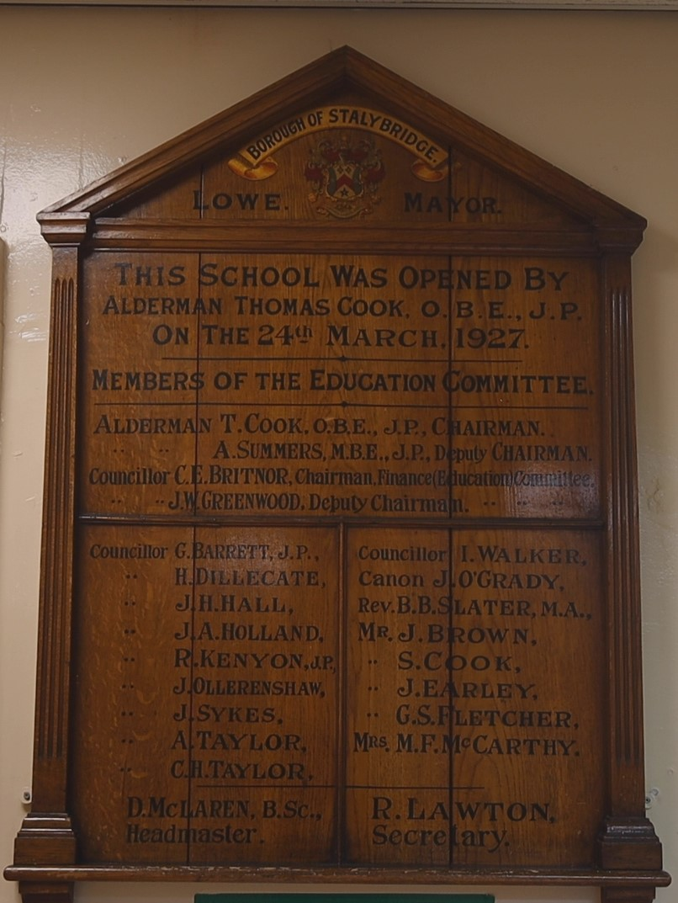

Our mission

- West Hill School aims to develop confident and ambitious young men, equipped with the skills and qualifications to thrive in a changing world.

Our values

- West Hill is a school where we have a core set of values that we live by: an ethos in which our values of Respect, Responsibility and Readiness constantly influence positive actions and behaviour.

- West Hill is a school where both pupils and staff have the highest expectations of themselves and each other. It is a place where every young man, no matter his own individual and unique starting point, is expected to 'Aim High' and work as hard as he can at all times.

- West Hill is an inclusive school in which all of its pupil’s access challenging and engaging lessons, delivered by a passionate and committed team of specialist teachers. It is a school that promotes a positive mind-set in which our young men develop into independent, lifelong learners, underpinned by a community in which pupils show the desire and resilience to learn and flourish.

- Our school prides itself on its “opportunity-based curriculum.” Our curriculum is specifically tailored to empower our young men, giving them the knowledge, skills, confidence and set of behaviours to become fully engaged citizens within the community.

- West Hill is a school which recognises that what we offer outside of the classroom is as important as what takes place within it. It is a school in which boys are exposed to, and encouraged to partake in, a wealth of extra-curricular activities to not only broaden the mind, but support and protect it.

- Our school prides itself in having the highest reputation in our community, exemplified at all times, by the conduct of the West Hill Boy.

- West Hill is a school where we promote the physical and emotional well-being of its staff by creating a working environment in which they feel valued, supported, and encouraged to thrive.

Our vision

- Every boy will be an independent, committed and engaged learner.

  - Every boy will embody the characteristics of the West Hill Boy and uphold our values of Respect, Responsibility and Readiness for Learning.

- Every boy will participate in a range of extra-curricular activities.

- Every barrier to accessing the full curriculum will be removed for all boys.

  - Every boy who leaves West Hill will make an informed and ambitious transition to the next stage of his learning.

  - Every member of staff will engage in professional development opportunities to be the best practitioner they can.

- Every stakeholder will feel valued and connected to our community.

  - Every stakeholder will benefit from a continual focus on improving facilities for all.


Job Description
Purpose: | To provide outstanding leadership and management of the school ensuring the safety of all pupils and conducting the affairs of the school for the benefit of the pupils, and the community it serves.  To ensure all pupils make excellent progress and achieve their true potential.
Responsible to: | The Trustee Board.
Responsible for | All staff via delegated line management responsibility.

Ethics and Professional Conduct
Headteachers uphold and demonstrate the Seven Principles of Public Life at all times. Known as the Nolan principles, these form the basis of the ethical standards expected of public office holders.
School Culture and Behaviour
- Establish and sustain the school’s ethos and strategic direction in partnership with those responsible for governance and through consultation with the school community.
- Create a culture where pupils experience a positive and enriching school life.
- Uphold ambitious educational standards which prepare pupils from all backgrounds for their next phase of education and life.
- Promote positive and respectful relationships across the school community and a safe, orderly and inclusive environment.
- Ensure a culture of high staff professionalism.
Teaching
- Establish and sustain high-quality, expert teaching across all subjects and phases, built on an evidence-informed understanding of effective teaching and how pupils learn.
- Ensure teaching is underpinned by high levels of subject expertise and approaches which respect the distinct nature of subject disciplines or specialist domains.
- Ensure effective use is made of formative assessment.
Curriculum and Assessment
- Ensure a broad, structured and coherent curriculum entitlement which sets out the knowledge, skills and values that will be taught.
- Establish effective curricular leadership, developing subject leaders with high levels of relevant expertise and access to professional networks and communities.
- Ensure that all pupils are taught to read through the provision of evidence informed approaches to reading, particularly the use of systematic synthetic phonics in schools that teach early reading.
- Ensure valid, reliable and proportionate approaches are used when assessing pupils’ knowledge and understanding of the curriculum.

Behaviour
- Establish and sustain high expectations of behaviour for all pupils, built upon relationships, rules and routines, which are understood clearly by all staff and pupils.
- Ensure high standards of pupil behaviour and courteous conduct in accordance with the school’s behaviour policy.
- Implement consistent, fair and respectful approaches to managing behaviour.
- Ensure that adults within the school model and teach the behaviour of a good citizen.

Additional and Special Educational Needs and Disabilities
- Ensure the school holds ambitious expectations for all pupils with additional and special educational needs and disabilities.
- Establish and sustain culture and practices that enable pupils to access the curriculum and learn effectively.
- Ensure the school works effectively in partnership with parents, carers and professionals, to identify the additional needs and special educational needs and disabilities of pupils, providing support and adaptation where appropriate.
- Ensure the school fulfils its statutory duties with regard to the SEND code of practice.

Professional Development
- Ensure staff have access to high-quality, sustained professional development opportunities, aligned to balance the priorities of whole-school improvement, team and individual needs.
- Prioritise the professional development of staff, ensuring effective planning, delivery and evaluation which is consistent with the approaches laid out in the standard for teachers’ professional development.
- Ensure that professional development opportunities draw on expert provision from beyond the school, as well as within it, including nationally recognised career and professional frameworks and programmes to build capacity and support succession planning.

Organisational Management
- Ensure the protection and safety of pupils and staff through effective approaches to safeguarding including Prevent, as part of the duty of care.
- Prioritise and allocate financial resources appropriately, ensuring efficiency, effectiveness and probity in the use of public funds.
- Ensure staff are deployed and managed well with due attention paid to workload.
- Establish and oversee systems, processes and policies that enable the school to operate effectively and efficiently.
- Ensure rigorous approaches to identifying, managing and mitigating risk.

Continuous School Improvement
- Make use of effective and proportional processes of evaluation to identify and analyse complex or persistent problems and barriers which limit school effectiveness, and identify priority areas for improvement.
- Develop appropriate evidence-informed strategies for improvement as part of well-targeted plans which are realistic, timely, appropriately sequenced and suited to the school’s context.
- Ensure careful and effective implementation of improvement strategies, which lead to sustained school improvement over time.
Working in partnership
- Forge constructive relationships beyond the school, working in partnership with parents, carers and the local community.
- Commit their school to work successfully with other schools and organisations in a climate of mutual challenge and support.
- Establish and maintain working relationships with fellow professionals and colleagues across other public services to improve educational outcomes for all pupils.
Governance and Accountability
- Understand and welcome the role of effective governance, upholding their obligation to give account and accept responsibility.
- Establish and sustain professional working relationship with those responsible for governance.
- Ensure that staff know and understand their professional responsibilities and are held to account.
- Ensure the school effectively and efficiently operates within the required regulatory frameworks and meets all statutory duties.

Person Specification

Post: Headteacher
 | Essential | Desirable | Method of Assessment
Qualifications

Qualified teacher status. |  |  | Application
Degree or equivalent. |  |  | Application
Evidence of appropriate professional development for the role of headteacher. |  |  | Application
National Professional Qualification for Headship NPQH or higher degree. |  |  | Application
Experience
Experience of successful senior leadership within secondary school settings. |  |  | Application  Interview  Reference
Experience of strategic financial planning and budget management in relation to school improvement. |  |  | Application  Interview  Reference
Experience of implementing strategies for improving the quality of teaching and learning, including promoting excellence and challenging under performance. |  |  | Application  Interview  Reference
Experience of initiating and managing significant change with a track record of achieving planned outcomes. |  |  | Application  Interview  Reference
Evidence of leading systemic and rigorous school self-evaluation and improvement. |  |  | Application  Interview  Reference
Experience of challenging and improving areas of underperformance. |  |  | Application  Interview  Reference
Experience of working well in partnership with Trustees, parents, carers and the wider community. |  |  | Application  Interview  Reference
Professional Knowledge and Understanding
Knowledge of statutory education frameworks, governance, national policy and wider educational thinking. |  |  | Application  Interview  Reference
A good understanding of the requirements of the Academy Trust Handbook and the responsibilities of the Accounting Officer role including accounting records, budgets and accounts. |  |  | Application  Interview  Reference
An understanding and commitment to safeguarding and promoting the physical and emotional health and well-being of pupils. |  |  | Application  Interview  Reference
Personal Qualities
Able to create, communicate and implement a clear vision for school improvement that builds upon existing strengths in our school. |  |  | Application  Interview  Reference
A belief in the right of pupils to a high-quality education, raising standards of achievement by recognising the value and worth of each individual, providing teaching, learning and enrichment which stretches each student and supports them to become fulfilled, confident adults. |  |  | Application  Interview  Reference
Ability to prioritise and be adept in managing work load. |  |  | Application  Interview  Reference
Able to inspire, challenge, motivate and empower teams and individuals to achieve high goals. |  |  | Application  Interview  Reference
Able to employ the appropriate leadership style(s) and approach to develop staff and secure an ethos of wellbeing and mutual respect. |  |  | Application  Interview  Reference
Able to build and maintain quality relationships through outstanding interpersonal skills. |  |  | Application  Interview  Reference
To be an excellent role model for pupils, parent and staff. |  |  | Application  Interview  Reference
An ability to work under pressure, determine priorities, delegate appropriately and meet deadlines whilst maintaining effective communications with all stakeholders. |  |  | Application  Interview  Reference
Philosophy |  |  | Application  Interview  Reference
Commitment to the vision and aims of West Hill School. |  |  | Application  Interview  Reference
Commitment to continuous improvement and sharing of good practice. |  |  | Application  Interview  Reference

For information:
Category (E) – ESSENTIAL - without which the candidate would be unable to carry out the duties of the post
Category (D) – DESIRABLE FEATURES which would normally enable the successful candidate to perform the duties and tasks better and more efficiently than one who did not have the qualifications, training, experience etc.

The school is committed to safeguarding and promoting the welfare of children and young people and expects all staff and volunteers to share this commitment. This post is subject to an enhanced DBS check.

