July 2019

Dear applicant

Thank you for your interest in the post of Progress Manager. I am extremely proud to be the Headteacher of such a successful and rapidly improving school with an innovative and personalised curriculum which provides a stimulating education within a friendly and supportive community.
Worden is a comprehensive Converter Academy that has a proven track record of sustained improvement. Since 2009 Worden has 'raised the bar’ and achieved successive impressive results year on year.
The successful candidate will work closely with the Assistant Headteacher, the Behaviour and Attendance Administrator and the other Progress Manager(s). If you are a committed professional, enjoy a challenge and are passionate about raising standards and making a difference, you are the person we want working with us.
Please take time to read through all the documentation and familiarise yourself with the ethos and aims of Worden and I look forward to receiving your application shortly.

Yours sincerely
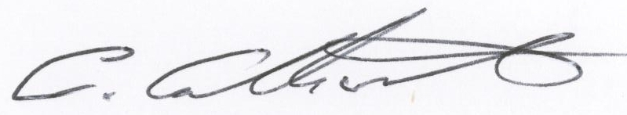

Mr C Catherall
Headteacher

