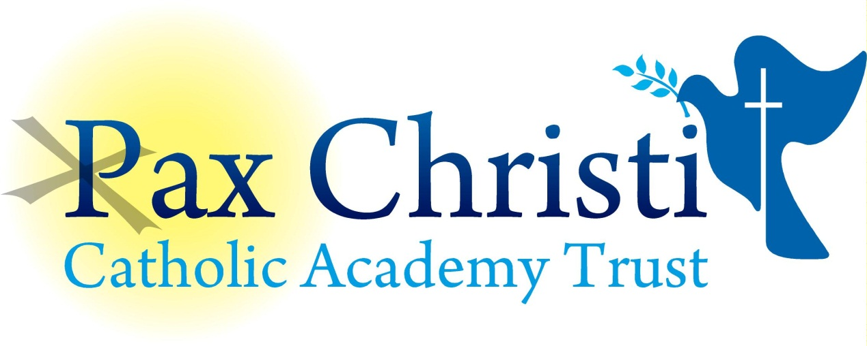

CHRIST THE KING CATHOLIC VOLUNTARY ACADEMY

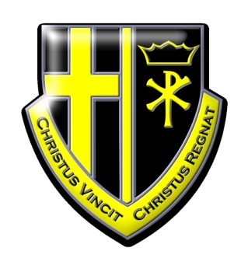

JOB DESCRIPTION

HR Administrator (P/T 30 hours per week over 5 days)
NJE Grade 3
(Fixed Term until July 2018)

Current Post holder:

Job Description Review Date:  Signed…………………………………………………………… | July 2018  Date………………………………………..
Job Purpose
This post holder will provide a wide and varied range of administrative support to the academy as directed.

Line Management
Responsible to: Principal, Support Services Manager and HR Manager
Responsible for: No staff

Specific Responsibilities
The post holder will:

- Perform a wide and variety of administrative tasks and demonstrate a due regard to confidentiality and safeguarding.
- Create, manage and manipulate information relating to HR, student or staffing information and any other service requirement which will include producing bespoke and complex reports.
- Develop basic systems and processes to meet operational needs and to ensure the high quality of information held.
- Prepare interview documentation and process employment offers, rejection and contractual paperwork.
- To support the HR Manager and Support Services Manager as required.

Skills and Abilities
The post holder will be expected to demonstrate the following skills and abilities at all times during the discharge of their duties:

- Work on own initiative and to demonstrate the ability to solve unexpected or new problems in a methodical, efficient manner.
- Work with a variety of IT Systems including SIMS, Microsoft Word and Excel.
- Learn new skills and expand current skill set and to be able to pass on knowledge and techniques to others.
- Demonstrate good general interpersonal and communication skills.
- Deal with conflicting demands and work flexibly.

Whole Academy Responsibilities
- Be a positive influence on the climate and culture of the Academy and show a positive example at all times.
- Support the catholic ethos of the Academy.
- Be aware of and comply with policies and procedures relating to child protection, health, safety and security, confidentiality and data protection, copyright etc reporting all concerns to line manager.
- Be aware of and support difference and ensure equal opportunities for all.
- Contribute to the overall aims of the Academy.
- Appreciate and support the role of other professionals.
- Attend and participate in relevant meetings as required.
- Participate in training and other learning activities and performance development as required.
- Recognise own strengths and areas of expertise and use these to advise and support others.

General

To work in collaboration with other Pax Christi Academies, sharing good practice and supporting during time of absence and/or heavy workload.
- This job description contains the main accountabilities relating to this post and does not describe in detail all the tasks required to carry them out. All staff are expected to be flexible to ensure the most effective organisation and delivery of services.

- The duties and responsibilities of the post will evolve with the natural development of the Academy and/or Trust. Such changes are, therefore, a normal part of the post and the post holder must be prepared to undertake any other duties commensurate with the general level of responsibility of the post which may be determined from time to time subject to the proviso that any permanent, substantial changes shall be incorporated into the job description and evaluated as such.

