

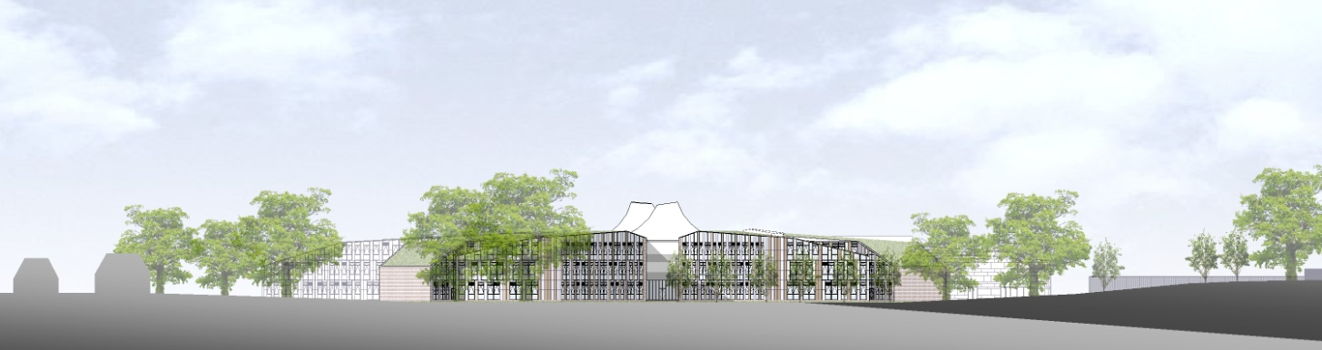

# ST. BARTHOLOMEW'S SCHOOL

# TEACHER OF MATHEMATICS

Full-time, fixed term

# Required for 1 January 2019 for 1 or 2 terms

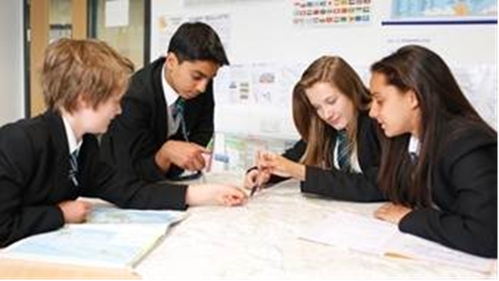

**Andover Road**

**Newbury RG14 6JP**

**Tel: 01635 521255**

**Fax: 01635 576320**

**Email:** [**recruitment@stbarts.co.uk**](mailto:recruitment@stbarts.co.uk)

[**www.stbarts.co.uk**](http://www.stbarts.co.uk)

Dear Colleague,

Thank you for your interest in the position of Teacher of Mathematics at St Bartholomew’s School. I hope that the details contained in this pack will provide you with a clear picture of this post and give you a flavour of the school and its values. This post really is an exciting opportunity for the successful candidate who will be joining a highly achieving faculty in the school with outstanding facilities.

St Bartholomew’s prides itself on its academic success. For the last 3 years St Bart’s has secured the best GCSE and A level results in West Berkshire state schools. This year 84% of our students achieved both English and Mathematics at level 4 or better and 40% of all grades were 9 – 7 (A*/A). Our Progress 8 score is 0.66 which puts St Bartholomew’s in the top 8% of schools nationally which we are very proud of. A level results were strong with 33% of all grades A*/A and 82% of all grades A* – C.

This is an important appointment for the school at an exciting time when we are working towards becoming outstanding as recognised in our recent short Ofsted Inspection. At St Bartholomew’s we all work together as a team to share good practice, and really develop outstanding teaching and learning to ensure every student makes expected or greater than expected progress. Every member of staff is part of an Action Research Group and you will also contribute to whole school development in this way. The staff at St Bartholomew’s care very much about the community and are ambitious for the school in terms of learning and enrichment opportunities for all the students.

Teaching at St Bartholomew’s School is a rewarding experience. Our students are eager to learn, well behaved and proud of their school, and this was reflected in our last Ofsted inspection which judged students’ behaviour and safety as outstanding. As a school we are committed to ensuring that all the students and staff realise their full potential. Students leave the school as good citizens and this is underpinned by an exceptional house system and a vast range of extra curricular activities.

The professional development of staff is a significant factor in ensuring that we achieve our aim of improving on our previous best and there are rich professional development opportunities at St Bartholomew’s (see CPD offer on our website under Job Opportunities) at all levels. Our induction and NQT programme for new staff is supportive and thorough and coaching is available for all staff across the school upon request.

All staff are issued with their own laptop and the Governors currently kindly offer a subsidised meal at Activity time. All faculties have their own workrooms.

I know that anyone applying for this post will find working at St Bartholomew’s very rewarding, and the Governors and I look forward to hearing from you if you feel you have the qualities and experience we are looking for.

If you would like to have a discussion with me or the Head of Mathematics about this post or require any further information please contact Human Resources, on the above number or recruitment@stbarts.co.uk.

Yours faithfully,

Julia Mortimore

Headteacher

**THE FACULTY**

The Mathematics Faculty aims to enable all students to reach their maximum potential by employing a variety of teaching methods on a range of courses. Imaginative use of practical and open-ended activities is encouraged, and the faculty aims to use ICT effectively to enhance learning.

The Mathematics Faculty has a strong ethos of teamwork.

At present the Faculty consists of 11 full-time and 4 part-time members of teaching staff, including an AST, plus a part-time Lead Teaching Assistant and a full-time Teaching Assistant. The Mathematics Faculty has eleven teaching rooms and an ICT suite, all on one floor, together with two Faculty office/storage areas. The department is well resourced with books, practical equipment and 30 Netbooks. All rooms have an interactive whiteboard.

At Key Stage 3, 135 students are set into five groups by ability. Students across the curriculum are in two bands according to which House they are in, giving ten groups in each year. We annually hold a Happy Puzzle Day in year 7 and a Crystal Maze Activity Day with year 8. Students in all years participate in the National Maths Challenge and there are opportunities to participate in a range of other extra-curricular activities, including chess, speed cubing, and a board games club.

At Key Stage 4, 130 students are set into six ability groups, with the class sizes benefitting from the addition of the extra group. We are currently following AQA GCSE Specification. Most Year 11 students in the highest sets will also be entered for the AQA Level 2 Certificate in Further Mathematics.

In the Sixth Form we offer A level courses based on the Edexcel specifications. We currently have 4 A Level Maths and one separate Further Maths group in each of years 12 and 13. Each year a substantial proportion of Further Mathematics group gain double A/A* grades.

Students in Year 12 are able to study a one-year GCSE course.

**THE POST**

* We are seeking to appoint a suitably qualified inspiring Teacher of Mathematics to join the Mathematics Faculty with effect from 1 January 2019 on a fixed term basis until 31 March or 31 August 2019.
* The position is full-time.
* Applications are welcome from newly qualified and experienced teachers.

###### THE SALARY

* The successful candidate will be appointed to the main or upper pay scale in accordance with her/his experience and qualifications.

**HOW TO APPLY**

Full post details, an application form and instructions on how to upload your completed application are available via the Jobs & Training / Job Opportunities section on the School’s website:

[**www.stbarts.co.uk**](http://www.stbarts.co.uk)

(Please note that curriculum vitae and covering letters cannot be accepted)

Successful candidates will be subject to a DBS enhanced check along with other relevant employment checks.

## Closing date: Sunday 18 November 2018

Thank you for considering St Bartholomew’s School.

Julia Mortimore

Headteacher