Class Teacher
Application Pack

Contents

Welcome from the Head Teacher | 1
About Our School | 2
Job Description | 4
Person Specification | 7
How to Apply | 10
Location | 11
Southwark -The place to live and work | 12
Additional Information | 13

Welcome fromthe Headteacher
Dear applicant,

Thank you for your interest in the recently advertised Class Teacher posts and Brunswick Park Primary School. We need great teachers, whatever your career stage and experience. I hope that
by reading this pack you gain a valuable insight into life at the school and into the lives of those who teach, work and learn here. If you have any questions about the posts or the school, please do not hesitate to contact me. I think visits are very helpful if you are trying to make up your mind about whether or not to apply to a school, so please feel welcome to come and look around.

Our children believe that where you start should not affect where you finish. They are our most valuable resource and keep us focused and driven to provide the very best in all circumstances. The school is facing the challenges of moving swiftly from RI to Good with optimism and commitment and has already made great strides. We understand fully all we have to do and we need teachers who share our commitment to make this happen. This could be you.

Brunswick Park holds the Inclusion Quality Mark and has a Resource Base for children with autistic spectrum condition (ASC). Staff are committed to inclusive education and value the school’s
diversity. We have a dedicated school staff and we are growing our leadership capacity. If you join our team we will ensure that you are supported with ongoing professional development to equip you well for your future and that of Brunswick Park.

Our school is located in an Edwardian building in Camberwell with excellent transport links – 20 minutes by bus from Waterloo and 15 from the Elephant and Castle. We have a purpose built
Sports Hall and Dining Hall and parking is available on site. Classes are small, with a maximum size
of 25 pupils. We have access to a newly built community garden and are a very short walk from Burgess Park. The immediate area is
undergoing regeneration and many new homes are being built and refurbished, enabling Brunswick to continue to grow and develop.

Our teachers receive comprehensive induction, an iPad, access to the WorkLife Support Wellbeing Programme and a variety of retention incentives. We recognise the demanding nature of teaching today, but the successful candidates will enjoy
a supportive and welcoming staff team and an energetic and committed governing body. To understand the ethos and vibrancy of our school, a visit is warmly recommended. Please make an appointment by contacting the School on
Tel: 020 7525 9033
email: vdavidson6.210@lgflmail.org

to experience at first hand what makes our school so special to us.
Best wishes

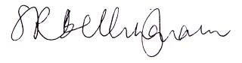
Susannah Bellingham
Headteacher

About Our School

Brunswick Park is a two and a half form entry school, run as a three-form entry school in Camberwell, Southwark. Each September, the school is able to admit 75 children into three reception classes. We also have a purpose built nursery offering up to 60 part time places.

Brunswick Park is an inclusive school. We welcome children with special educational needs (SEND) as part of our community and aim to ensure that all children have an equal opportunity to engage in the curriculum. The needs of children are identified andassessed as earlyaspossible. We are committed to a multi-disciplinary approach to meeting the needs of pupils with SEND. We work
closely withparentsandcarers, valuing their views and contributions, keeping them fully involved in their children’seducation.
Resource Base
The Resource Base is a resource for children with autistic spectrum disorders and has been open since 2005. It offers specialist provision in a variety of settings in school. Pupils work within their classrooms as much as possible and are well supported by adults who are trained to understand and respond to their needs. To continue to
enhance its provision, Brunswick Park is developing links with Tollgate Primary School in Newham.

The Aims and Vision of Our School
At Brunswick Park Primary Schoolthestaffand governors are fully committed to providing the best educational opportunities for all of the children.

We aim to:
- Raise each child’s level of achievement by providing a high quality education based on the Foundation Stage and the National Curriculum
- Provide a positive and enjoyable environment in which a broad and balanced curriculum will develop eachchild’spotential
- Encourage children to work co-operatively and respect each other’s values, beliefs and cultures to prepare them for the next stage of their education and for their future lives
- Liaise and work in partnership with the children, parents/carers/guardians, governors, staff, outside agencies and the wider community to ensure equality of opportunity for all pupils and staff.
Children, staffand governors haveworked together to explore our core values and beliefs about the role of primary school in the development of young children into young people, ready and prepared
for the demands of living well and successfully in society.

Good relationships throughout the school are fundamental to a positive ethos. School is more than lessons; it fosters and encourages challenge, ambition and drive and teaches values such as respect, tolerance, honesty, trust and friendship. At Brunswick Park these values, including hard work, behaving considerately, valuing citizenship and being a good citizen, are at its heart. These values and beliefs inform our school’s vision statement:

“Learning for living through respect, support and challenge.
To create an optimistic, forward-thinking learning environment based on effective teamwork to give the children the best life chances possible.”
We believe that every child can do amazing things and that it is our job to help make this potential
a reality. With an outstanding education, children have the freedom to choose their own futures At Brunswick Park we offer a relevant, exciting, broad and balanced curriculum through which children are encouraged to be independent thinkers and to make informed, responsible choices about their learning. Learning is supported and enriched through a wide range of experiences including visitors to the school, residential trips, historical, scientific and geographical visits, music, sport and the performing arts. We consider the skills
of communication, mathematics and English to be fundamental to our learning and we work hard to continue improving our standards and achievements.

Pupil Profile
Our diversity is a real strength and we use it for the positive. We were the first school in Southwark to obtain the National Inclusion Quality Mark, which was renewed in 2012 and staff work hard to develop the whole child in a safe and friendly environment.
Total number of pupils on roll (all ages) | 526
Percentage of boys on roll | 52.9%
Percentage of girls on roll | 47.1%
Percentage of pupils with SEN statement/ EHCP or on School Action Plus | 29.4%
Percentage of pupils with English not as first language | 59.8%
Percentage of pupils eligible for free school meals | 26.6%
Percentage of pupils eligible for FSM at any time during the past 6 years | 30.5%

Job Description
The role: | Class Teacher
Accountable to: Head Teacher
Salary: | MPS/UPS (area of responsibility to be negotiated where applicable)

The appointment of a Pre-UPR Teacher is subject to QTS status and the current conditions of employment for teachers contained in the School Teachers’Pay and Conditions Document (STCPD) and other current legislation.

This job description may be amended at any time following discussion between the Head Teacher and the member of staff, and will be reviewed annually as part of the appraisal process.

This job description includes references to:
  - The School Development Plan
  - Professional Standards for Teachers
  - Teacher Appraisal
  - Ofsted’s School Inspection Framework
Part 1: Recruitment General description of the post
The holder of this post is expected to carry out the professional duties of a pre-UPR teacher as described below, as circumstances may require
and in accordance with the school’s policies under the direction of the Head Teacher. The post-holder is required to fully support the vision, ethos and policies of the school.

Values and behaviour
Teachers make the education of their pupils their first concern, and are accountable for achieving the highest possible standards in work and conduct.
Teachers act with honesty and integrity; have

strong subject knowledge, keep their knowledge and skills as teachers up-to-date and are self-critical; forge positive professional relationships; and work with parents in the best interests of their pupils.

School Improvement Plan Priorities
- Improve attainment and achievement through ensuring every child makes at least expected progress.
- Improve the quality of teaching and learning across the school with the aim that 100 % of teaching is good or better, and develop whole school integrated curriculum provision from EYFS to KS2 in line with the expectations of the National Curriculum 2014.
- Improve attendance, punctuality and behaviour through development and application of consistent systems.
- Improve and develop the expertise and capacity of leadership at all levels.

Personal and professional conduct
A teacher is expected to demonstrate consistently high standards of personal and professional conduct. The following statements define the behaviour and attitudes which set the required standard for conduct throughout a teacher’s career.

Teachers uphold public trust in the profession and maintain high standards of ethics and behaviour, within and outside school, by:

- treating pupils with dignity, building relationships rooted in mutual respect, and at all times observing proper boundaries appropriate to a teacher’s professional position;
- having regard for the need to safeguard pupils’ well-being, in accordance with statutory provisions;

- showing tolerance of and respect for the rights of others and not undermining fundamental British values, including:
  - democracy , the rule of law, individual liberty and mutual respect, and
  - tolerance of those with different faiths and beliefs;
- ensuring that personal beliefs are not expressed in ways which exploit pupils’ vulnerability or might lead them to break the law.
Teachers must have proper and professional regard for the ethos, policies and practices of the school in which they teach, and maintain high standards in their own attendance and punctuality.

Teachers must have an understanding of, and always act within, the statutory frameworks which set out their professional duties and responsibilities.

Responsibilities
The post-holder is accountable to their line manager in all matters.

The appraisal process is the vehicle for determining the performance of a teacher and this assessment will directly relate to pay determination (in accordance with the school pay policy), CPD provision and career advancement (in accordance with the school CPD policy).

All appointments made, are conditional on the most recent appraisal assessment.

Duties
- Making a distinctive contribution to raising standards across the school.
- Supporting and helping colleagues to improve effectiveness.
- Setting clear and challenging targets that build on prior attainment for each pupil.
- Establishing clear targets for achievement and evaluate progress through the use of appropriate assessments and records and regular termly analysis of this data.
- Ensuring that every child has the opportunity to reach their potential and meet their highest expectations.
- Setting, tracking, evaluating and reporting on progress towards individual pupil targets.
- Devising and implementing targeted interventions that enable students to reach and exceed their targets.
- Acting as a role model for staff for high quality teaching and learning.
- Using own class and practice as an example of outstanding teaching and learning.
- Ensuring continuity and progression by supporting colleagues in choosing the appropriate sequence of teaching and teaching methods and setting clear learning objectives through an agreed scheme of work, developed in line with the school development plan.
- Developing plans that identify clear targets, times-scales and success criteria for its development and/or maintenance in line with the School Improvement Plan.
- Helping colleagues to create a stimulating learning environment for teaching and learning.
- Ensuring that teachers are aware of the implications of equality of opportunity.
- Providing regular coaching and mentoring for less experienced teachers.
- Promoting team commitment with colleagues through collaborative planning.

- Enabling all teachers to achieve expertise in planning for and teaching through
example, support and by leading or providing high quality professional development opportunities.
- Ensuring that the Head Teacher, SLT and governors are well informed about policies, plans, priorities and targets that these are properly incorporated into the School Improvement Plan.
- Taking responsibility for drafting appraisal objectives and ensuring agreed evidence is available for review against agreed criteria.
- Securing and maintaining good working relationships with colleagues.
- Contributing to the corporate life of the school through effective participation inmeetingsand managementsystems
necessary to coordinate the management of the School.
- Collecting, analysing and reporting on pupils’ views of their subject area.
- Developing effective links with the local communityincluding parents, business and industry.
Par t 2 : Assessment of Per for mance

Assessment and Performance of this Job Description is available to download from our website:
www.brunswickparkprimary.co.uk
This job description may be amended at any time following discussion between the Head Teacher and member of staff, and will be reviewed annually as part of the teacher appraisal process.

Person specification
This person specification is related to the requirements of the post as determined by the job description. Shortlisting is carried out on the basis of how well you meet the requirements of the person specification. You should refer to these requirements when completing your application.

Measured by:

A | Application | I | Interview | R | Reference

 |  | A | I | R
Qualifications
1 | Qualified teacher status | ✓
2 | Commitment to and evidence of ongoing professional development | ✓
Experience
3 | Suitable for teachers with experience across the primary age range | ✓
4 | Suitable for teachers with experience of successfully leading a subject area | ✓ | ✓ | ✓
Skills, Knowledge and Abilities
6 | Successful teaching or teaching practice at primary level, with a commitment to high quality teaching and a willingness to share good practice | ✓ | ✓ | ✓
7 | An understanding of the different ways in which children learn and the appropriateness of a variety of teaching styles to meet the individual learning needs of each child | ✓ | ✓ | ✓
8 | An ability to successfully organise the curriculum for a class of mixed abilities, aptitudes and educational needs, through planning, preparation, monitoring and assessment | ✓ | ✓ | ✓
9 | An ability to undertake monitoring and evaluation and use the outcomes to plan for improvement | ✓ | ✓ | ✓
10 | A good general knowledge of the requirements of the National Curriculum and learning strategies for children of all abilities | ✓ | ✓ | ✓
11 | A commitment to excellence and the maximising of academic and personal achievement for all pupils |  | ✓

12 | Good organisational skills to create and maintain a stimulating and attractive learning environment | ✓ | ✓ | ✓
13 | Knowledge and understanding of effective record keeping and its use to promote the educational and personal development of all children within the school | ✓ | ✓
14 | Excellent ICT skills in order to support the learning of pupils | ✓ | ✓ | ✓
15 | The ability to deal with children with warmth, care and understanding and yet set clear andappropriate boundaries forbehaviour | ✓ | ✓ | ✓
16 | Excellent interpersonal skills, with the ability to work as member of a team and develop and maintain good relationships with all members of the school community | ✓ | ✓ | ✓
17 | The ability to communicate clearly both orally and in writing with pupils, parents and colleagues | ✓ | ✓ | ✓
18 | Respect for the views of parents and a commitment to the importance of the involvement of parents in the learning process | ✓ | ✓
19 | A commitment to safeguarding and promoting the welfare of children, with an ability to ensure that each child’s identity is respected, maintained and enhanced and that stereotypes are challenged in a sensitive way | ✓ | ✓
20 | An understanding of the responsibility of the class teacher with regard to the health and safety of pupils in your care |  | ✓

We are committed to safeguarding and promoting the welfare of children and young people and expect all staff and volunteers to share this commitment. These posts are subject to an enhanced DBS check.

How to apply

If you decide to make an application, please look carefully at the Job Description and Person Specification.

Your supporting statement should be no longer than 3 sides of A4 and should be tailored to demonstrate your suitability for this post.

CVs will not be accepted and interviews will be offered to those applicants best demonstrating how their skills, abilities and experience match the person specification and can demonstrate and evidence their commitment to our school.

Key Dates
Closing date: 13/10/2017

Interviews:
17/10/2017
Visits to the school:
By arrangement, please contact Fay Murray as below

Any Questions?
If you would like an informal discussion about any aspects of this job opportunity, please contact Dena Dada, School Business Manager in the first instance, on

Tel: 020 7525 9033

Email: vdavidson6.210@lgflmail.org

Applying
If you decide to apply for this post please return your completed application form to: vdavidson6.210@lgflmail.org

Location

Brunswick Park Primary School
Picton Street Camberwell London SE5 7QH
Tel: 020 7525 9033
By bus:
The school is served by many bus routes. From Elephant and Castle Station: 35, 40, 45, 68, 148, 171,
176, 468

By train:
The school is a short bus journey from Elephant and Castle, Kennington or Oval stations.

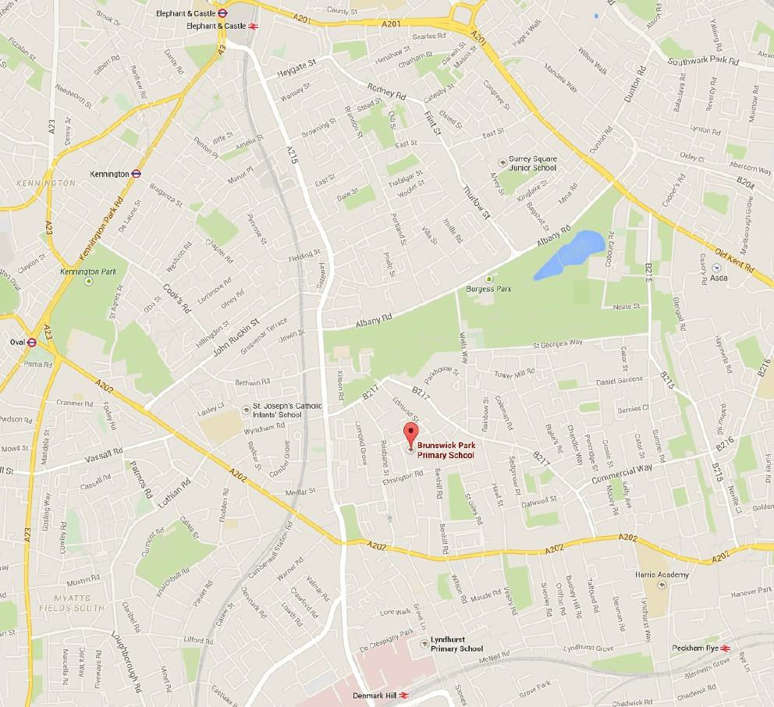

Southwark - The place to live and work

Is Southwark what you think it is? Probably not. While we have some things in common with other London boroughs, such as a culturally diverse population, there’s a lot more to a place which people from Charlie Chaplin to Rio Ferdinand have called home.

Just a walk along the South Bank or over the Millennium Bridge to the Tate Modern will show you this is an area worth investing in. Around 40% of it is being redeveloped and regenerated, to the tune of £4 billion.

Southwark dates back to Roman times, so we’re a living history lesson. During the Anglo Saxon
period it was the greatest traffic and trading centre in the country. Thanks to the fact that we were outside the City of London’s jurisdiction, playhouses like the Globe and the Rose began to make up our popular theatre district. And today, the Elephant and Castle is the location of one of the UK’s biggest regeneration initiatives.
Around London Bridge there’s a thriving business district full of financial institutions, service companies and a growing arts and media sector. Stunning residential districts along the river embody high quality design and lifestyle. For a 2,000 year old area, we’re good at looking ahead.

Life in Southwark can spoil you for choice. Foodie? Borough Market. Shakespeare buff?The Globe.
Outdoor type? Burgess or Dulwich Park. Kids feeling bored? The City farm.

There’s a great deal for you and your family and friends to do. Getting to and from those various places and events won’t be a problem either, as we’ve got great transport links. Most teachers live around a half-hour’s walk or bike ride away from work, and enjoy access to good rental properties, shared ownership schemes and interest-free loans for home purchase on the open markets as part of the Keyworker Living scheme. So living and travelling couldn’t be much easier.

Millennium Bridge

Fromfrequent carnivals to the afro-caribbean food market, Southwark pretty muchhasitcovered.
Thriving, established markets, restaurants that cover almost every cuisine in the world, riverside walks, beautiful green spaces, sport, dance and music.
There’ssomethingforeveryone, whetheryou’re after stimulation or peace of mind.

The children of Southwark are our future business leaders, hairdressers, politicians, taxi drivers, mechanics, nurses, plumbers, artists, footballers, engineers, music moguls, journalists, chefs and even teachers. We owe it to them to give them the best start to their lives and careers.

Some of our schools weren’t always as good as they are now, and some others still have a way to go.
But the important part is that they’re getting better year on year and making children ready for the opportunities coming their way.

That’s because we’ve made a concerted effort to support teachers and school leaders in bringing the curriculum alive. Whether they’re at an Academy, Specialist, Church, Foundation or Community School, they’re not left to go it alone. There’s a structure and good funding in place to help them. Our determination plus their talent and experience is already beginning to bear fruit.

As one of our school leaders or teachers, you’ll have children’s futures in your hands. Because of that, you deserve all the support we can provide. In fact, all our teachers enjoy the best we can offer, from our renowned Induction Programme for NQTsthrough to Leadership and Management Programmes that will help you develop your knowledge and skills, no matter what your level of experience.

Borough Market Shakespeare’s Globe Theatre

We don’t forget our invaluable support staff either: they’ve got access to development and training
in order to raise pupils’ achievement levels, and they have real career paths. For you, it means you’ll have a motivated, well-trained team of people around you. And you’ll benefit from all the other support systems we’ve implemented, from the Arts team and EAL advisors to borough advisory staff who focus on Hearing, Visual, Speech & Language, Specific Learning and Physical Difficulties, and a Behaviour Improvement Programme.

For teachers with children, there are many nursery classes and crèches, good childcare, and after- school clubs and play centres. We’ll also be happy to talk to you about flexible and part-time working.

Just as importantly, you’ll have borough-wide opportunities for Continuing Professional Development, including conferences, action research and overseas trips. You’ll also have the chance to take part in local authority advisory work, contributing your ideas and expertise to borough- wide development. So your students won’t be the only ones improving their prospects.

(extracted from the Inspiration Brochure - www.southwark.gov.uk/downloads/download/1046/ inspiration_brochure)

Additional information
Please click on the links below for additional information.

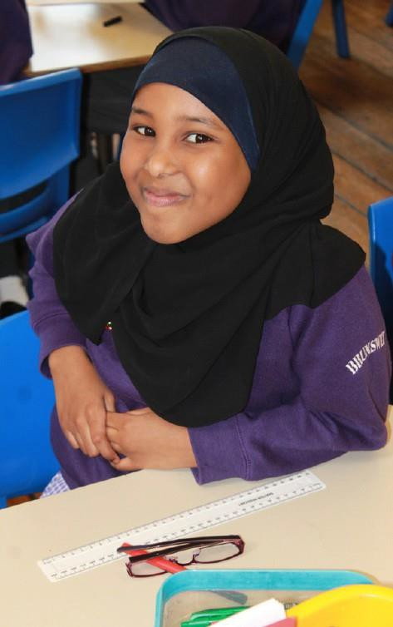
Brunswick Park School Performance:
Please click here.

Brunswick Park School Data Dashboard
Please click here.

Brunswick Park School Ofsted Reports
Please click here.

Teaching in Southwark
Please click here.

All In London – Guide to Southwark
Please click here.

First Steps – Mayor of London’s shared ownership scheme
Please click here.

Properties to rent within a 1 mile radius of the school
Please click here.

Properties for sale within a 1 mile radius of the school
Please click here.

w w w . b r u n s w i c k p a r k p r i m a r y . c o . u k

