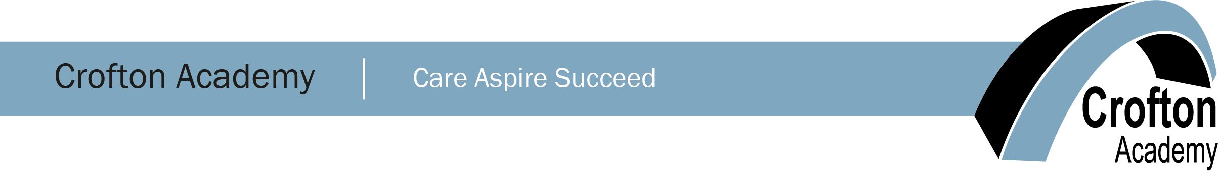

Cover Supervisor/PE Department Support
28.75 hours per week - Term time only
Grade 6 FTE £22,183 - £24,982 (Actual Starting Salary £14,544)

Crofton Academy are seeking to recruit an enthusiastic Cover Supervisor/Department Support role to provide both classroom supervision for pupils where teachers are absent from duty as well as departmental support across the Academy.

We require a confident person who can relate well to students and is committed to supporting teaching and learning. Previous classroom experience is not essential, however some experience of working with young people in a supportive capacity is preferred.

The successful candidate will have:
- Good literacy and numeracy skills.
- Motivation and flexibility to work across the Academy and have a real passion for working with young adults at secondary school age.
- Effective analytical, organisation and communication skills.
- Will have the ability to work on their own initiative, but also be able to work flexibly as part of a team.
- Passion for physical education and sports programmes.

The post holder will be responsible to the Cover Manager.
This is a fantastic opportunity for an individual who is motivated and passionate about the education of young people. Leading lessons in the absence of a classroom teacher, and assisting with the PE Department will enable the candidate to get a real feel for what it is like being a positive educator and enable them to gain valuable experience in working with young adults.
We are able to offer staff a secure, supportive environment with continuous professional development. If you have the vision and drive for excellence and want to join a partnership where relationships for learning are fundamental to their continued success we would be delighted to hear from you.

The school is committed to safeguarding and promoting the welfare of children and young people and expects all staff to share this commitment. You will be required to undertake an enhanced DBS disclosure.

Headteacher : Mr Peter Walker

All relevant information and application forms can be downloaded from the school website at www.croftonacademy.org.uk. For further enquiries or to discuss the role, please contact Kim Hinchcliffe at recruitment@croftonacademy.org.uk. The closing date for fully completed applications is 12 noon on Wednesday 14th April 2021.

The Academy reserves the right to interview any suitable candidates prior to the closing date.

