
Bourne Grammar School

Atmosphere

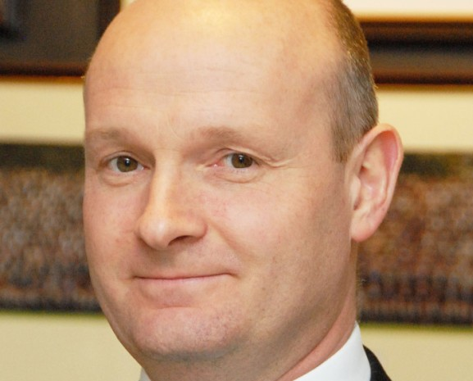
The best schools do everything well - academic, pastoral, sport, music, drama, Duke of Edinburgh’s Award, trips and visits. By virtue of a committed staff working with willing students and an appreciative Leadership Team, we have all these in abundance and to a high standard.

Support

We have no ‘mission statement’ - merely a very short purpose statement: Best Atmosphere, Best Support, Best Results. The order is deliberate; we believe that if we get the first two right then, given our able students and a committed staff, good results will follow. The atmosphere is special and is cherished by us all.

I write as a fellow teacher. It is important to me that I am a teacher for a significant part of my time. I do not run other schools. I am not always out at meetings and conferences.

I am entirely committed to ensuring that Bourne Grammar offers the best experience to its students and, importantly for those who read this, a pleasant and rewarding
experience to its teaching staff.

Jonathan Maddox
Headteacher

Results

We are a large and busy school, educating the top 25% by academic ability. That means that we do have a range of ability here. Some do very well indeed; practically all achieve at least pass grades in all their GCSE subjects.

The students want to be here and their parents/carers want them to be here. Most of the students, most of the time, want to learn and enjoy lessons which are well- planned, well-taught and are engaging.

We have expanded considerably because of demand for our places. A full, expanded school means that our income allows us to run a financial surplus. There have been no redundancies and departments are well funded. We pay salary increments. Our estate and IT systems are in good order. A new, £4m Science Block enhances an estate which is modern and well maintained. We are adding not losing subjects in our large and expanding Sixth Form which will soon have 27 A-level subjects; there is no minimum set-size.

I didn’t go to a grammar school

Neither did I. There are only 164 selective schools in the country so it is not surprising that only a handful of our staff were educated at grammar schools. We recruit teachers who were educated and may now work in comprehensive, selective or independent schools.

I don’t have a degree from a top-class university

We don’t demand that. Colleagues here come from across the entire range of higher education. What matters to me is that you want to teach here.

Behaviour?

Behaviour will be a revelation if you have not worked in a school such as ours. Students want to be here, they want to learn, they do not want to make your life a misery. If you engage well with the students and keep them interested, you can expect calm lessons, which leave you feeling positive, fulfilled and worthwhile. You will not drive home feeling shattered.

Please get in touch

We always welcome visits by prospective applicants, although I understand that it isn’t always easy or possible to come here before you apply. In any event, Stella Chamberlain is at the end of the phone, and she responds quickly to email. Please do contact her. She can put you through if you wish to discuss the role.

The best atmosphere, the best support, the best results

The English Department

English is a successful and forward-looking curriculum area, which was highly commended in a recent review by the director of NATE, Paul Clayton. The staff are dedicated and highly-qualified professionals, committed to raising standards and improving still further the quality of teaching and learning. There are 11 full time, fully qualified members of the department with a range of specialisms including: linguistics, literature, creative writing, media and drama.

At KS3, Year 7 students are taught in mixed-ability form groups for the first term, with setting introduced from Term 2. Year 8 and Year 9 students are set from the start of the academic year. At the end of each KS3 Year, sets are reviewed.

Recent examination results in Literature and Language at GCSE and A level have consistently been very good. All GCSE students follow the Edexcel Language and Literature specifications, sitting exams at the end of Year 11. Uptake for A Level English Literature and A Level English Language is very good and there are two classes for each subject in Year 12 and Year 13 and students follow the AQA syllabus for Language and AQA A syllabus for Literature.

Students benefit from a wide range of co-curricular and extra-curricular activities, including theatre trips, live theatre screenings, writing competitions and study days. We have recently established a Literary Society within the school for senior students. This offers short lunchtime lectures and workshops which allow students to gain a wider experience of literature, this encourages students to take English at university and also allows staff to deliver on their personal interests.

The Post

We seek to appoint a dynamic and passionate teacher to join this highly successful, cohesive and supportive department. The post is for a September 2018 start.

Application process

Arrangements can be made by telephoning Stella Chamberlain on 01778 391648 or emailing recruitment@bourne-grammar.lincs.sch.uk

Go to our website for more information about the School: www.bourne-grammar.lincs.sch.uk

Informal visits are welcome

We are happy to accept a CV or an application form.

Closing date for applications is Friday 2 February 2018

