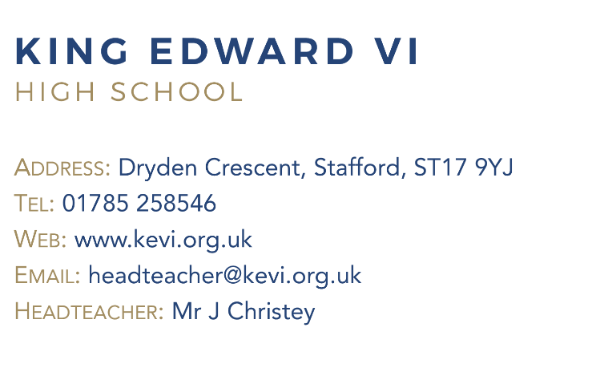
Teacher Job Description

Post Title: | Teacher
Purpose: | - To raise standards of student attainment and achievement within the curriculum area(s) and to monitor and support student progress.  - To be accountable for student progress and development within classes.  - To ensure the provision of an appropriately broad, balanced, relevant and differentiated curriculum for students studying in classes taught, in accordance with the aims of the school and the curricular policies determined by the Governing Body and Headteacher of the school.  - To effectively manage and deploy support staff, and physical resources within the classroom to support teaching and learning.
Reporting to: | Leader of Subject
Responsible for: | Teaching and learning within the classroom.
Liaising with: | Headteacher/Leadership Team, Subject Leader, Student Support Services and relevant staff with cross-school responsibilities, relevant non-teaching support staff, LA staff and parents.
Working Time: | 195 days per year. Full time.
Salary/Grade: | MPS / UPS
MAIN (CORE) DUTIES
Operational/ Strategic Planning | - To develop appropriate syllabuses, resources, schemes of work, and teaching and learning strategies in the classroom.  - To actively monitor and follow up student progress.  - To implement School Policies and Procedures, e.g. Equal Opportunities, Health and Safety, COSHH, etc.  - To work with colleagues to formulate aims, objectives and strategic plans for the department which have coherence and relevance to the needs of students and to the aims, objectives and strategic plans of the school.  - To link with the Subject Leader to ensure that the work in the curriculum area fully reflects the school’s distinctive ethos and mission.
Curriculum Provision: | - To liaise with the Subject Leader to ensure the delivery of an appropriate, comprehensive, high quality and cost-effective curriculum programme which complements the School Improvement Plan/School Evaluation.  - To be accountable for the development and delivery of lessons.  - To make appropriate arrangements for classes when absent.
Curriculum Development: | - To keep up to date with national developments in the subject area and teaching practice and methodology.  - To liaise with the Subject Leader to maintain accreditation with the relevant examination and validating bodies.
Quality Assurance: | - To use common standards of practice within the department and develop the effectiveness of teaching and learning styles in all subject areas within the department.  - To contribute to the school procedures for lesson observation.  - To implement school quality procedures and to ensure adherence to those within the Department.  - To ensure that the Department’s quality procedures are adhered to.
Management Information: | - To make use of analysis and evaluate performance data provided.  - To identify and take appropriate action on issues arising from data, systems and reports; setting deadlines where necessary and reviewing progress on the action taken.
Communications: | - To ensure effective communication/consultation as appropriate with the parents of students.
Marketing and Liaison: | - To contribute to the school liaison and marketing activities, e.g. the collection of material for press releases.  - To contribute to effective subject links with partner schools and the community, attendance where necessary at liaison events in partner schools and the effective promotion of subjects at Open Days/Evenings and other events.  - To actively promote the development of effective subject links with external agencies.
Pastoral System: | - To monitor and support the overall progress and development of students within the department.  - To monitor student attendance together with students’ progress and performance in relation to targets set for each individual; ensuring that follow-up procedures are adhered to and that appropriate action is taken where necessary.  - To act as Form Tutor and to carry out the duties associated with that role as outlined in the generic job description.  - To contribute to PSHEE, Citizenship and enterprise according to school policy.  - To ensure that the Behaviour Management system is implemented in the classroom and around the school so that effective learning can take place.
Teaching: | - To undertake an appropriate programme of teaching in accordance with the duties of a main scale / UPS teacher.
Additional Duties: | - To play a full part in the life of the school community, to support its distinctive mission and ethos and to encourage and ensure staff and students follow this example.
Other Specific Duties:
To continue personal development as agreed.
To engage actively in the performance review process.
To undertake any other duty as specified by STPCB not mentioned in the above.
Whilst every effort has been made to explain the main duties and responsibilities of the post, each individual task undertaken may not be identified.
Employees will be expected to comply with any reasonable request from a manager to undertake work of a similar level that is not specified in this job description.
Employees are expected to be courteous to colleagues and provide a welcoming environment to visitors and telephone callers.
The school will endeavour to make any necessary reasonable adjustments to the job and the working environment to enable access to employment opportunities for disabled job applicants or continued employment for any employee who develops a disabling condition.
This job description is current to date, but in consultation with you, may be changed by the Headteacher to reflect or anticipate changes in the job commensurate with the grade and job title.

