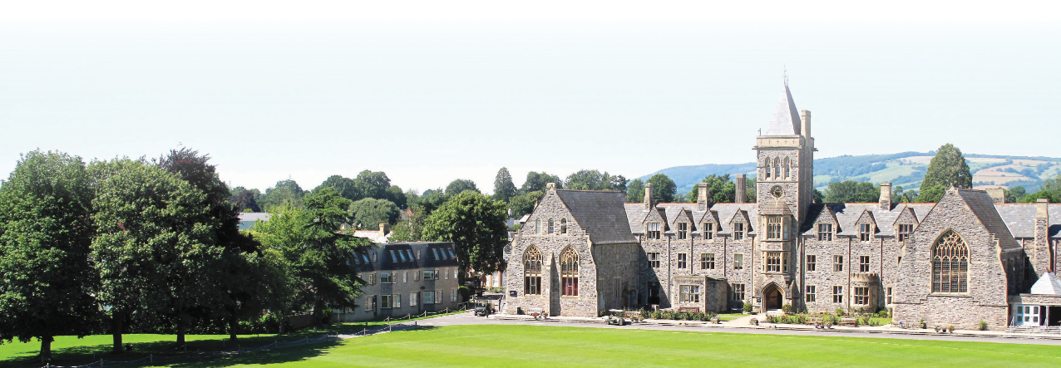
Job Description & Person Specification
Job Title
Graduate Resident Assistant

Responsible to
Head of TSIMS

Contract
Fixed term contract to June 2022

Hours
Full time

Salary
£12,000 + accommodation

Purpose of the role
GRAs are responsible to the Principal through the Head of TSIMS. It is a key part of the GRA role to live in and sleep on site and to take most meals with students and other staff. GRAs provide invaluable assistance with boarding house duties and also play a full role during the school day and participate in sports, trips and activities.

Key Duties and Responsibilities

- Support the house staff in creating a warm and friendly atmosphere and fostering a happy community spirit, especially for students newly arrived at the School.
- Help students learn the routines of the boarding house and assist with any problems. Any concerns about the well-being of students must be brought to the attention of the Head of Pastoral.
- Uphold the rules of the House and pass on breaches of the rules to the Head of Pastoral.
- Participate in the evening and overnight duty rota under the direction of the senior member of staff on duty. Duties will include supervising prep, helping with bedtimes and providing overnight staff cover in the boarding house.
- Participate in the weekend duty rota, under the direction of the house staff. Duties will include organizing and actively engaging in games and activities.
- Accompany staff on excursions and activities as required.
- Assisting with classwork on a 1:1 or small group basis and to provide lesson cover, when required
- Working with pupils during prep (homework) sessions to ensure they are working on task and supporting their needs.
- Assist the PE / Games staff in the weekly programme of sports. This may include assisting with one of the School’s sports teams.
- Help to organise travel arrangements, liaising between students and administration staff.
- Attend staff meetings as required.
- Assist the administration staff with office tasks as required.
- GRAs are also given the opportunity to participate as required in Taunton School International’s summer school for which separate remuneration is paid.
In relation to the pupils, GRAs are expected to:

- Promote the general progress and wellbeing of all individual pupils under your supervision and care.
- Provide guidance and advice to pupils on educational and social matters or assist them in speaking to an appropriate member of staff about any such matters.
- Be sensitive to social relationships between children.
- Promote good behaviour and be on the lookout for any signs of physical and emotional bullying. Any concerns, however small, must be reported to the Head of TSIMS.
- Be responsible for the pastoral care of each child within any activity, session or in carrying out any of your duties around the School.
- Be familiar with the following School documents:
  - Rewards and Sanctions, Code of Practice, Anti-Bullying Procedure.
  - Complaints Procedure.
  - Principles and Guidelines.
  - Child Protection Policy.
  - Keeping Children Safe in Education (KCSIE) Document.
  - Code of Conduct for staff
  - ICT policies and procedures
In relation to staff, GRAs are expected to:

- Liaise with their line manager on at least a weekly basis.
- Participate in INSET days at the beginning of each term, or as otherwise arranged.
- Actively seek help or guidance from other experienced staff in case of any uncertainty.
- Feed all relevant information –from concerns to congratulations- about children or activities back to the senior staff member responsible for that individual or session.
The duties and responsibilities shown above are not intended to be exhaustive and the post holder will be expected to be flexible and to take on new responsibilities as necessary to meet the changing needs of the School.

Person Specification

 | ESSENTIAL | DESIRABLE
QUALIFICATIONS | - An undergraduate degree | - Full UK driving licence
EXPERIENCE | - No experience required but must be enthusiastic about education and young people | - Experience of working with children  - Experience of EAL/SEND/Marketing
SKILLS | - Excellent communication skills  - Leadership skills  - Good organisation skills  - ICT literate  - Attention to detail  - Ability to drive a 7-seater people carrier | - Ability to drive a minibus
ATTITUDES & APPROACH | - Professional manner  - Collaborative approach  - Shared responsibility approach  - Caring and sensitive to the needs of students  - Positive “can do” attitude  - Resilient  - Personable and approachable  - Team player  - Follow instructions reliably and efficiently  - A willingness to enter into the spirit of the school, and contribute to the wider life and work of the school  - Committed to safeguarding

