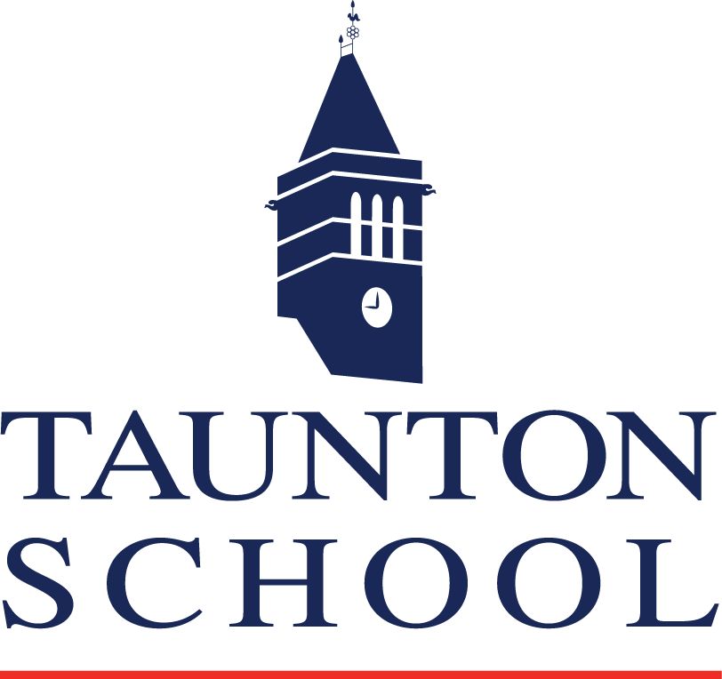
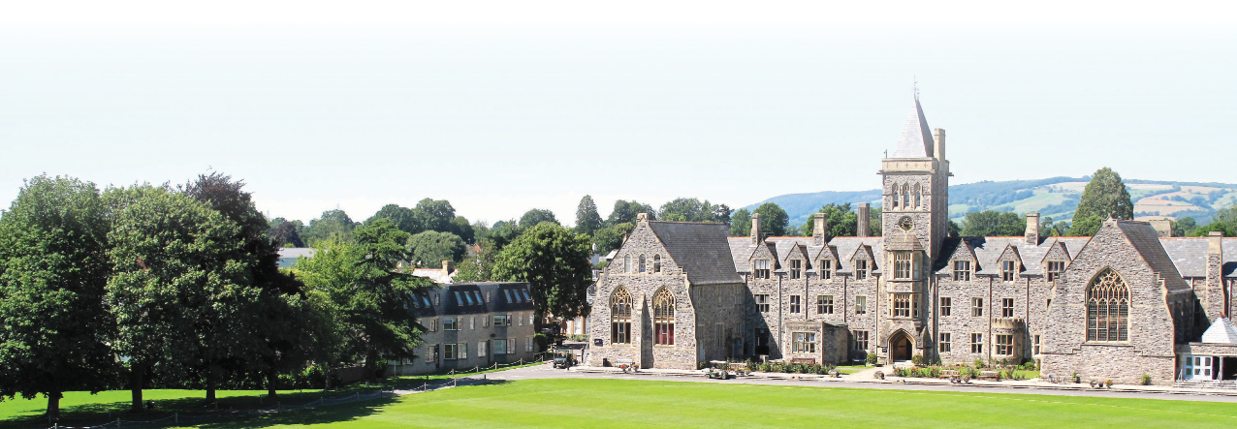
Additional Information: GRA (TSIMS)

Taunton School was founded in 1847. It is an independent day and boarding school for approximately 1,150 boys and girls, aged from 0 - 18 years, with approximately 400 boarders. We are a large, exciting and diverse school, which aims to challenge, nurture and inspire young people to succeed in a global community.

Taunton School International (TSI) was set up by Taunton School in 1996 to provide a first step for international students wishing to complete their education in a British school. It is located on the school campus, is fully residential and has places for 84 boys and girls aged 15 to 18 year olds.
In September 2012, TSI expanded by opening Taunton School International Middle School (TSIMS) for children aged 9 to 14 years. TSIMS is located three miles off campus at The Grange, Kingston St Mary and aims to encourage gifted international students into the School at a younger age to gain the all-round skills, before transferring to the Prep and Senior Schools.
GRAs occupy a very important position in the girls’ and boys’ Houses. When appropriate they may also be students’ confidantes. However, they are first and foremost members of staff and must always ensure that their behaviour reflects that prime professional responsibility.
Hours of work in term time are demanding, however it is always found with such appointments that the more one puts into the life of the school, the more rewarding it becomes.
We offer our GRA’s the following:

- Salary of £12,000
- A memorable year working with lively and interesting students within a flourishing co-educational environment
- Full board accommodation in a boarding house, or school accommodation
- A range of benefits including staff discounts, access to our onsite gym and swimming pool etc.
- First Aid, Fire, and Child Protection training
- Opportunities for continuing professional development and training.

You will be assigned a mentor for the year who will provide you advice on professional development and working with students both in the classroom and in the boarding house.

This fantastic experience provides a platform for various career progressions paths; many of our GRAs are accepted on to Teacher Training courses, and we have an excellent record in universities such as Exeter and Durham.

