Teacher
Application Pack 2019

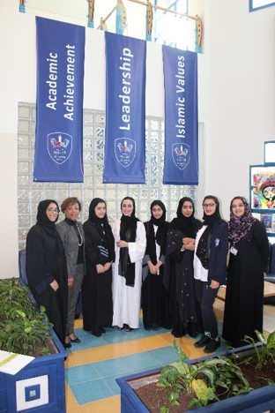
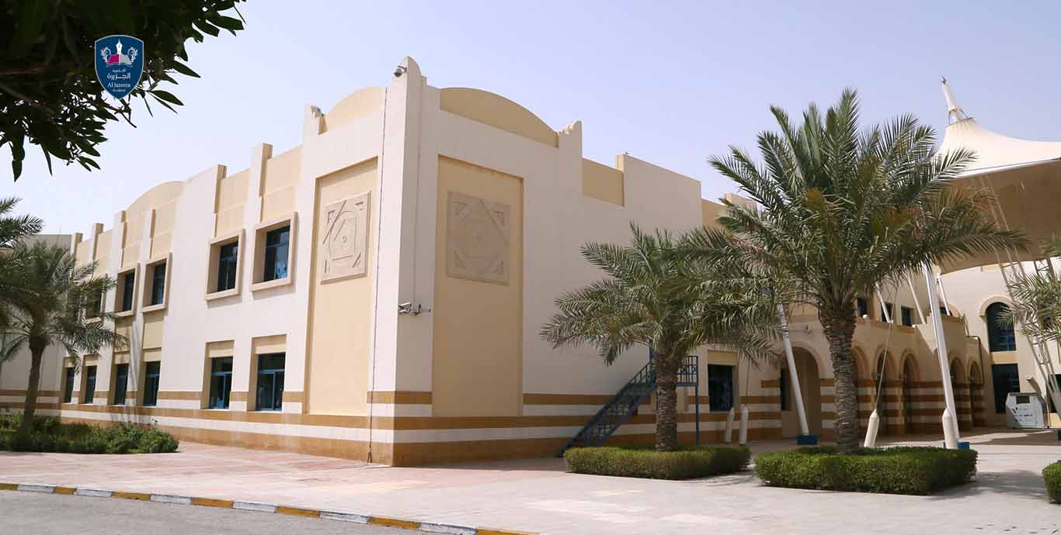
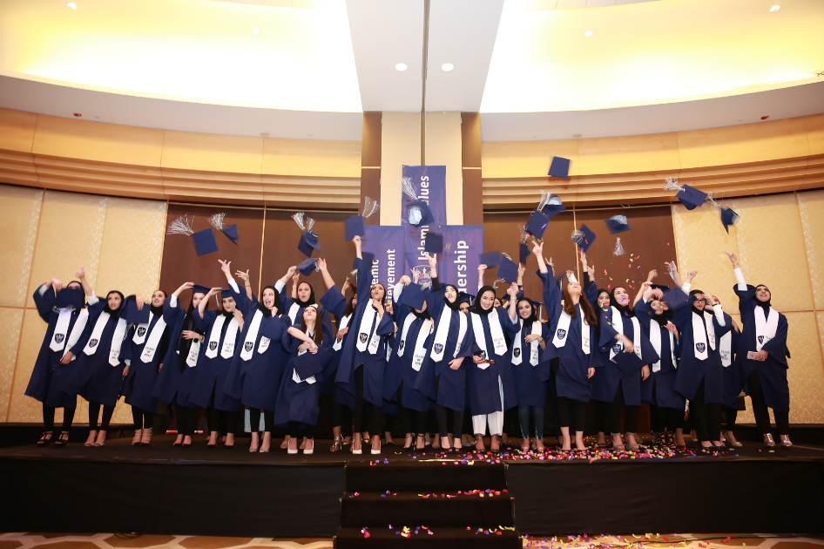

Application Pack

Letter to Applicants
Selection Arrangements
Ta’allum Education Profile - Our Vision
Job Description and Person Specification
Recruitment Statement

March 2019
Dear Applicant
Thank you for your interest in the post of Teacher with Ta’allum Education at Al Jazeera Academy.

Our aim is to develop the potential of all students, both in the classroom and outside by aiming for excellence in all that we do and encouraging students and staff to do the same. Our school is unique in providing for the needs of our mainly Qatari pupil population with our mission to develop ‘Academic leaders with Islamic values.’ Our most valuable asset is our talented and dedicated team of highly qualified teaching and support staff. They provide care, guidance, support and inspiration to all students in a learning environment characterised by high standards of behaviour and mutual respect.

We are proud to be a part of the Ta’allum Group of Schools and take the professional development of all our staff very seriously. We offer a range of development opportunities for our staff both within our school but also within the wider Ta’allum Group.

You will find a job description, along with further details about the post, the Academy and the wider Ta’allum Group of schools from the information provided.

To apply please use the TES online application form including a brief supporting statement, outlining your skills, experience and motivation for joining the team in Doha.

Please visit our websites – www.taalumgroup.com and http://aja.edu.qa/ to find out more about our Academy and the Ta’allum Group of schools. Candidates are very welcome to arrange an informal discussion with Peter Kubicki, Ta’allum Secondary School Improvement Consultant, about the post prior to application. Tel: 00 974 50373045 pkubicki@taalumgroup.com

Interviews will be conducted by Skype for candidates abroad or in person for candidates already in Doha.

We look forward to receiving your application.

Yours faithfully,
James Batts (Head of Secondary)

About the Ta’allum Group - Education Profile

The Ta’allum Group of Schools comprises Al Jazeera Academy, Al Maha Academy for Boys and Al Maha Academy for Girls.

Introduction to Ta’allum - Excellence in Education
The Ta’allum Group is dedicated to excellence in education. We are a successful and forward thinking organisation epitomised by our distinctive educational vision as ‘a progressive institution of learning experiences offering quality education based on an Islamic ethos that aims to serve humanity.’ We aspire to the highest international educational standards, aiming to secure the best learning outcomes for our students in academic excellence, leadership skills and Islamic values.

With over 13 years of commitment to our unique brand of holistic education, Ta’allum has carved a popular and respected niche for itself within the State of Qatar, creating a brilliant future for its students by preparing them to be successful leaders and active members of society. Ta’allum Academies provide an extraordinary community for children to grow and learn.

Ta’allum Group was formed under the auspices of the Emiri Decree, aligning itself with recognised international educational standards. It emerged as a result of the beneficence of the Ghanem Bin Saad Al Saad & Sons Group (GSSG) and is currently responsible for three academies in Doha, Qatar; Al Maha Academy for Boys, Al Maha Academy for Girls and Al Jazeera Academy with ‘all through’ educational provision at KG, Primary and Secondary level.

Ta’allum Schools were established in the firm belief that Qatar must provide a world-class education system for its citizens with the highest standards of academic excellence and cultural integrity. We are fully committed to contributing towards Qatar’s potential for international prominence.

Rising Levels of Success
In the recent past Ta’allum Academies have made significant strides forward, evidenced in the upward trajectory of our external exam results, successful Qatar National Schools Accreditation and positive ethos. Ta’allum’s unique blend of modern, global education alongside respect for Arabic heritage and culture, is increasingly appreciated by our parent and stakeholder groups. As a direct result of parental oversubscription Ta’allum will soon expand to a 4th Academy with ‘state of the art’ buildings currently under construction. Further plans are also at an advanced stage for new Ta’allum schools in Al Wakra and Malaysia.
Partnership and collaborative work are growing across the organisation and key to our success at every level in developing the very best standardised education practice. This ensures consistency and high standards across Ta’allum Academies.
Almost 100% of Ta’allum students successfully complete their Thanawia and the vast majority of Ta’allum students will move on to University, whether locally in Doha or abroad to universities in the UK and US. They are the leaders of tomorrow.

3 Ta’allum’s Distinctive Vision and Mission
Our goal is to help every child to learn and acquire Islamic knowledge alongside building a solid foundation in all academic subjects. This will help them develop and gain true Islamic values and thereby make a valuable, correct moral and social contribution to the community in which they live.

‘’Creative learners today, our future leaders tomorrow”

Ta’allum Schools - Learner Outcomes
Academic Achievement and Leadership with Islamic Values are the characteristic hallmarks of our students. This is what distinguishes our students from others.
Learner Outcome 1 | Our students are Academic
Strand 1:1 | They are lifelong learners
Strand 1:2 | They are creative thinkers
Strand 1:3 | They are bilingual
Strand 1:4 | They are confident
Strand 1:5 | They are innovative
Strand 1:6 | They are independent
Learner Outcome 2 | Our students are Leaders
Strand 2:1 | They have strength of character
Strand 2:2 | They are organised
Strand 2:3 | They are confident
Strand 2:4 | They are responsible
Strand 2:5 | They are future leaders
Learner Outcome 3 | Our students practise and exemplify Islamic values
Strand 3:1 | They adhere to the Five Pillars of Islam
Strand 3:2 | They have good morals
Strand 3:3 | They are polite
Strand 3:4 | They are considerate

The Ta’allum Curriculum - An Unrivalled Learning Experience
Ta’allum’s broad, vibrant curriculum provides a firm foundation for future success with a balance of exciting, engaging, pupil centred learning experiences to nurture enquiring minds, encourage self-motivation and develop a love of learning. Our curriculum promotes education based on thinking skills in a safe and encouraging environment, built upon strong human relations and the positive values of compassion, tolerance and perseverance.
Pupils follow a curriculum for a majority of the time based on the English National Curriculum and conducted in English with Upper School pupils taking mainly Edexcel iGCSE and AS qualifications. The ethos of the Academies and the curriculum are underpinned by positive Islamic values. These values are planned for and integrated across the curriculum (also promoted by the active Tarbeya organisation.) Arabic, Islamic Studies and Qatar History are studied for up to one third of curriculum time.

Language learning is a central feature for Qatar in its development. Ta’allum’s curriculum programmes preserve culture and Arabic language alongside English language learning in order to give students a competitive edge in international employment. Our students are dual linguists and there is a rich array of programmes and competitions such as the Qatar Debates public speaking competitions and Arabic Story writing to engage students in language development. High proficiency and confidence in First Language Arabic is an important and required credential for the future of our students as Qatari leaders. Our curriculum is designed to educate the whole learner.

Ta’allum – High Quality Teaching, Learning and Assessment
Excellent relationships and a focus on high quality teaching and learning lead to high academic standards during the 13 years that the majority of students are part of our Academy family. Teaching and Learning is at the heart of the Ta’allum educational process and its purpose is explicit within all our plans. The quality of the classroom interaction is of fundamental importance in raising standards of achievement. The active participation of students is essential if the process is to be successful and this requires teaching staff to use a varied range of teaching methods, different teaching styles, differentiation, excellent learning resources and strategies which focus on learning as well as on teaching.

Our culture of care provides students with the confidence and independence they need to succeed. We believe that order and respect are at the heart of creating a climate for success. To this end we insist on smart uniform, good behaviour and politeness. In turn this underpins our aim to enable students of all abilities to discover and develop, not only their academic potential, but also their creative and sporting talents. In an ever changing world of employment, where we are preparing our students for jobs that have not even been conceived yet, we are committed to ensuring that our students are positive leaders, strong problem-solvers and develop the life-skills required to prepare them for life after school.

Well defined Assessment is also central to the Ta’allum educational process. It is the process by which we identify whether our students’ learning has been successful and whether teaching has been effective. Recording and reporting of assessments are important. Students need to be aware of how well they are doing in school and to know how well they are performing in relation to their potential; what level they are working at and what they need to do in order to improve and move on to the next level. Parents are regularly informed of how well their child is progressing and developing. Ta’allum is currently pioneering increasing degrees e Assessment through use of the OWLTS software system.

Islamic Values and Leadership - A Culture of Care
We seek to develop an ethos in Ta’allum Academies based on the very best universal Islamic values. This is conducive to the highest standards of pupil learning and achievement and we foster an environment where all participants respect and care for each other. Everything we do, and importantly, the way in which we do it, is focused on these purposes. Our community values knowledge, truth, beauty, wisdom, honour, compassion and service. At our schools, we have embarked on this 21st century journey with a spirit of adventure and a sense of fun!

Through the inspiration of Mr. Ghanim Bin Saad Al Saad, Ta’allum’s Group Chairman, our Academies are integral partners in the nationally endorsed Tarbeya programme, promoting Islamic values to underpin all we seek to achieve with our students. Ta’allum Academies share this commitment to positive Islamic and universal values. We value people, learning, partnerships, relationships, sustainability, and stewardship. Our values are not merely words to us. They offer direction and a sense of moral purpose as we strive to fulfil the complex yet rewarding mission of transforming and enriching the lives of our students. Promoting, encouraging and instilling values in young people are among the cornerstones of every society. Beyond academic teaching, Ta’allum schools recognise the strong impact on our young people’s character, imparting in them values such as curiosity, achievement, and citizenship.

The Head of Tarbeya coordinates a broad range of opportunities project including a tutorial programme, scout camps, cultural competitions and sports international enrichment trips and a sense of how the values can be incorporated into all lessons. There is a wide range of programmes, including Qada (Leadership), Holy Qur’an and Hadith memorisation competitions, Makarem and Rahul.
Ta’allum is proud of its commitment to implement vision into practice. This includes the adoption and implementation of the interactive educational Al Hidaya’ programme, based on the principle of partnership between teacher, student and parent with the goal of deepening the skills of understanding the Holy Qur’an, promoting concepts to be applied in practice. In addition, there are opportunities for students to participate in Holy Qur’an competitions as well as the allocation of extra sessions in the school timetable for Holy Qur’an memorization.
Our courses in interpersonal learning incorporate reference to the importance of developing strong emotional intelligence and empathy. The academic and interpersonal strands are complemented by our enquiry based learning approach that also develops our students’ internationalism and global awareness.

Digital Transformation
Digitalisation is a key component in our vision for success and Ta’allum and is at the cutting edge of our development. The rapidly evolving digital technologies which continue to shape our world present our students with vital learning opportunities. It is a salutary reminder that all our present students will work with technologies which have not been invented yet! Thus we see technology as crucial to accessing learning. Every Ta’allum student has an electronic tablet for use in class and at home, strengthening parental involvement and effectively encouraging learning 24/7. The school is a Microsoft partner with all 3 Academies designated as ‘Microsoft Expert’ schools – the first schools in Qatar to be accredited with this prestigious designation. Staff have benefitted through worldwide training opportunities. Online assessment is becoming firmly established for students. Strong data analysis using the PowerBI and the SIMS systems provides insights for staff to personalise and target teaching according to individual student needs.

Extra Curricular Activities - A Wealth of Enriching Opportunities
We provide an extensive programme of extra-curricular activities through which students extend their learning, build teamwork skills and develop friendships. We want students to aspire to be the best in every aspect of school life, tackling fresh challenges and taking pride in their achievements. Students participate in a broad range of after-school and breaktime activities as well as homework and revision clubs. Our students participate in an extensive programme of inter-school competitions, with our sports teams enjoying considerable success at local and national levels. In school, they enjoy enrichment days – when the timetable is suspended to allow them to participate in a variety of activities – and they are inspired by visiting speakers from business, the arts and voluntary organisations. Students raise considerable sums for a range of charities, particularly Qatar Cancer charities.
Extra-curricular activities also play an important role in helping to accomplish balance in students’ academic journeys. We are committed to broadening students’ horizons through an enriching and holistic experience for all students. The commitment of the staff team has been instrumental in fashioning a rich array of extra -curricular opportunities, including the Model United Nations and Qatar Debates to promote public speaking and engagement with critical world issues. Our students gain confidence, understanding and empathy.
A plethora of Leadership opportunities are available to students whether in school through School Councils or including the Qatar Leadership Conference, ‘Reach Out to Asia’ programme and charity fundraising. Interpersonal learning stresses the importance of developing strong emotional intelligence and empathy

A Bright Future for Ta’allum Group
These are exciting times for Ta’allum Education. We are extremely optimistic about the next stages of our development. In the year ahead our Academies have candidacy for prestigious international accreditation with the Western Association of Schools and Colleges. The new Academy buildings edge closer to completion and we seek to develop increased 2 year Advanced level courses to enhance our existing curriculum offer. As an organisation we will never stop learning or become complacent. We have a heightened awareness of the constant process of change in education which emphasises our need to play to the strengths and skills of our team.
We are determined to continue our positive progress, committed to the Emir’s 2030 Educational vision and fulfilling our goal of offering the highest quality education to all our students.

Dr Mohammed Saefan

Director of Education, Ta’allum Group

Job Description – Teacher

Organizational Relationships: (reports to whom, and supervises whom. Job titles and not names)

Reports to: Coordinator, Year Leader, Head/Deputy Head Teacher of the Academy (Or as per latest Organization Chart of the School)

Correspond to: Staff, Students, Parents

Supervises: Assigned Teacher Assistant (where applicable)

Teaching Load
As per the Academy Timetable
Overall Functions
- To plan, organize and implement an appropriate instructional programme in a learning environment that guides and encourages students to develop and fulfill their academic potential.
- To teach and educate students according to guidelines provided by the UK National Curriculum Framework under the overall guidance of the Ta’allum Group and Ministry of Education of State of Qatar.
- To teach and educate students according to the educational needs, abilities and attainment potential of individual students, and in keeping with Taállum school policies and procedures.

Main Duties and Responsibilities
- Plan, prepare and deliver lesson plans and instructional materials that facilitate student centred and active learning, in a culture of high aspirations.
- Teach according to the educational needs, abilities and achievement of the individual students and groups of students.
- Plan and implement effective classroom management practices, design and implement effective strategies to develop self-responsible / independent learners.
- Prepare classroom for class activities & conduct assigned classes at the scheduled times.
- Maintain a teacher file to include lesson planning, student attainment outcomes and other information as required by line manager/ Taállum policies and procedures.
- Develop plans for learning (long, medium and short) including lesson plans and tests that are in accordance with Ta’allum policy and procedures.
- Instruct and monitor students in the use of a range of learning materials and equipment.
- Create and maintain a safe learning environment, with strict compliance to the Ta’allum’s Child Protection and Safeguarding Policies and procedures.
- Manage student behaviour in the classroom, by establishing and enforcing rules and procedures in accordance with relevant Ta’allum policies.
- Maintain good order and discipline amongst students under one’s care and safeguard their health and safety at all times.
- Promote students’ intrinsic motivation by providing meaningful and progressively challenging learning experiences which include, but are not limited to: self-exploration, questioning, making choices, setting goals, planning and organizing, implementing, self-evaluating and demonstrating initiative in tasks.
- Provide appropriate and timely feedback on student work, following the Ta’allum Feedback and Marking policy.
- Apply appropriate multiple assessment tools and strategies to evaluate and promote the continuous intellectual development of the students, ensuring full compliance with Ta’allum’s Assessment policy and procedures.
- Encourage and monitor the progress of individual students and use information to adjust teaching strategies.
- Register and monitor the attendance of students under one’s care.
- Ensure that records of student outcomes for all subjects are maintained in an organised way in student books, or where necessary, in soft copy format.
- Provide these for monitoring and moderation purposes as and when required.
- Maintain accurate and complete records of students' attainment and progress in all subjects and in relation to behaviour.
- Update all necessary records accurately and completely as required by laws of Ministry of Education and the Taa’llum School Policies/Procedures.
- Prepare required reports on students’ activities.
- Provide or contribute to oral and written assessments, reports and references relating to individual students or groups of students.
- Promote the general progress and well-being of individual students, groups of students or class entrusted to him/her.
- Provide guidance and advice to students on educational and social matters and on their further education and future careers; providing information on sources of more expert advice.
- Participate actively in department, school, community and parent meetings.
- Work collaboratively, communicating, consulting and co-operating with other professionals/staff members, and parents/guardians to ensure the best interest of students.
- Communicate necessary information regularly to students, line manager and parents regarding curriculum coverage, student progress and student needs.
- Establish and communicate clear objectives and differentiated success criteria for all learning activities.
- Observe and evaluate students’ performance and development during lessons.
- Adopt and work towards the implementation of the School Development Plan and School Accreditation from National and or International Bodies.
- Review and evaluate one’s own teaching and learning strategies, methodologies and programmes in line with the UK National Curriculum Framework guidelines and feedback provided by line manager and Ta’allum Educational Consultant.
- Advise and co-operate with the Head of School, Deputy Head, Heads of Department, Education Consultants and other teachers in the preparation and development of courses of study, teaching materials, teaching programmes, methods of teaching and assessment and pastoral care arrangements.
- Ensure high standards of professional practice and quality of teaching and learning of the subject/s. Through effective dialogue, participate in reciprocal peer review and observation of class teaching practice as directed by relevant line manager.
- Participate in training courses (internal and external) as well as in continuing professional development (CPD) opportunities, and take part in action research exercises, to improve job-related skills.
- Participate in staff, group or other meetings related to the school curriculum or pastoral care arrangements, for the better organization and administration of the school.
- Contribute to the professional development of new teachers and student teachers, according to arrangements agreed with the line manager/ Head of School.
- Provide the necessary information and advice to the designated personnel in the school and to provide all the necessary information regarding requisitions and arrangements in connection with the teaching of the subject/s assigned to him/her.
- Ensure the safe custody and optimum use of equipment normally used by oneself during lessons and keep informed relevant personnel regarding its regular servicing and maintenance.
- Participate in school assemblies.
- Nurtures a culture where teachers view themselves essentially as facilitators of learning and reflective practitioners.
- Ensure that schemes and forecast of work carried out in class are handed to the Learning Support Assistants (where assigned) on a timely basis so that the necessary adaptations and resources are made for use with students with individual educational needs in class.
- Regularly discuss and monitor the work being carried out by the Learning Support Assistants (where assigned) in class
- Liaise and collaborate with specialist teachers/resource persons and other professionals working with Learning Support students.
- Make use of relevant technology (E-Learning tools, projectors etc.) in an appropriate way to support teaching and learning and make other adaptations during the delivery of lessons.
- Attend and participate in faculty meetings and serve on staff committees as required.
- Take all necessary and reasonable precautions to protect students, equipment, materials and facilities.
- Assist in the selection of books, equipment, and other instructional materials.
- Be a positive role model for students and support the mission of the School and Taállum.
Qualifications:

Educational Qualification: BA Degree in Education or BA Degree with PGCE in Education (for specialist subjects, degree is a must in the subject area that the teacher will teach)
Number of years of experience: Minimum of 3 years teaching experience at an International School(s)

Certification: Valid Teaching License required for all Teachers

Specialized trainings required (if any): Single subject teaching credential or certification if teaching a specialized subject

Area of experience required:

- Meet professional teacher education requirements of Ta’allum Group and or Ministry of Education of State of Qatar
- Experience teaching the National Curriculum for England in the UK or an international setting
- Previous experience working with students for whom English is not their first language
- Passion for teaching and commitment to educating the whole child
- A high level of professionalism and consideration of the well-being of children
- Recent and consistent involvement in extra-curricular activities
- Respect for Islamic religion, Arabic and Qatari traditions, all members of school community, irrespective of position, gender, age and ethnic background
Competency requirements: (State the competencies required for this job)

- Key competencies include:-
- Self-motivation
- High energy level
- Attention to detail
- High work standards
- Problem solving
- Decision making
- Organizing and planning
- Learning orientation
- Critical thinking
- Flexibility and adaptability
- Positive and solution-focused attitude to working life

- Demonstrate the character qualities of enthusiasm, courtesy, flexibility, integrity, gratitude, kindness, self-control, perseverance, and punctuality.

- Demonstrate competence in classroom instruction

- Demonstrate timeliness and attendance for assigned responsibilities

- Demonstrate preparation and skill in working with students from diverse cultural and ability backgrounds.

- Meet everyday stress with emotional stability, objectivity, and optimism.

- Maintain a personal appearance that is a role model of cleanliness, modesty, good taste, and in agreement with school policy.

- Demonstrate skill when managing student behaviour, intervening and resolving discipline problems as per Policies & Procedures of the School.

- Actively participate responsibly in School improvement initiatives

- Good verbal, oral and written communication skills in English. Speak with clear articulation.

- Refuse to use or circulate confidential information inappropriately. Avoid off-the-cuff comments and inappropriate communication of administrative, staff, parent, or student information.
Children Safeguarding and Welfare

Ta’allum Group is committed to safeguarding and promoting the welfare of children and has zero tolerance to any divergence from Children Safeguarding and Welfare. All applicants must be willing to undergo child protection screening, including checks with past employers, prohibition from teaching and the Disclosure & Barring Service.

All Successful applicants will be required to provide criminal records check from the Disclosure and Barring Service (DBS) before employment is confirmed. Candidates from outside the authority of the DBS will be required to provide an approved Certificate from the similar authority in the Country in which he/she is currently residing.

Working Conditions:

Mental Demands/Physical Demands/Environmental Factors:
Maintain emotional control under stress. Frequent standing, stooping, bending, pulling and pushing. Move small stacks of textbooks, media equipment, desks, and other classroom equipment.
Additional Information

Education is an ever-changing service and all staff are expected to participate constructively in schools’ activities and to adopt a flexible approach to their work.

The duties and responsibilities listed above are provisional. Further details may be supplied when the person is appointed. The post holder is expected to accept any reasonable alterations that may from time to time be necessary.

It is understood that areas of responsibility of the job description are not necessarily a comprehensive definition of the post or an exhaustive list of all duties performed. The main duties and responsibilities are indicated above. Other duties of an appropriate level and nature may also be required, as directed by the Line Manager.

This job description might be reviewed from time to time and where possible, and will be varied in the light of the business needs of Ta’allum Group. The job description sets out the main duties of the post at the date when it was drawn up. Such duties may vary from time to time without changing the general character of the post or the level of responsibility entailed. Such variations are a common occurrence and cannot of themselves justify a reconsideration of the grading of the post.

The job description allocates duties and responsibilities but does not direct the amount of time to be spent on carrying them out and no part of it may be so construed.

This job description shall be discussed with the relevant employee and he/she should be made aware of his authorities, responsibilities and roles in support of company’s objectives and the competency requirements. An uncontrolled copy of relevant job descriptions can be distributed to employee and modifications made should be communicated to him. This Job Description is made in 2 Copies. 1 copy should be kept in employee file in HR Dept. and 1 copy to be handed over to the employee.

Teacher – Person Specification

 | Essential Criteria | Desirable Criteria | Measured By
Education and Qualifications | Must have QTS (Qualified Teacher Status  First degree or Certificate of Education | Experience of working in 11-18 schools  Masters degree  Ability to teach AS Level | Application form  Certificates
Skills and  Abilities | Able to follow the school’s safeguarding procedures and recognise when to report any concerns.  Excellent written and verbal communication skills  Adaptable to changing circumstances and new ideas  Self-motivated with good organisational skills and the ability to prioritise workload effectively | Safeguarding training/ formal qualification | Application form  Interview
Experience | Principles and practices of effective teaching and learning  Preparation of schemes of work and lessons, knowledge and understanding of subject area(s)  Principles and practices of monitoring/assessment/evaluation  The application of information and communications technology (ICT) learning and teaching in subject area(s) |  | Application form  Interview  Assessment
Knowledge and Understanding | Excellent teacher  Accesses, analyses and interprets information  Committed to:  Raising standards for all in the pursuit of excellence  Continuous learning for the entire school community  Entitlement of all pupils to effective learning and teaching  Choice and flexibility to meet the personal learning needs of every child |  | Interview  Assessment
Other Requirements | A professional role model who is committed to their own continuous professional development and to  developing others  Committed to and able to promote the aims of the school and the values of the Ta’allum Group: ‘AJA Students are Academic Leaders with Islamic Values.’  Values diversity and the unique contribution that every individual makes to the learning community  Able to work calmly under pressure and withstand stress  Demonstrates professionalism, loyalty and integrity  Able to work flexibly, and to attend meetings and INSET days as required | Organisation of and participation in Extra Curricular Activities. | Interview  Assessment

Recruitment and Selection Statement

1. The safe recruitment of staff in schools is the first step to safeguarding and promoting the welfare of children in education. Ta’allum is committed to safeguarding and promoting the welfare of children and young people and expects all staff, volunteers and other workers in the Academy to share this commitment. It is recognised that this can only be achieved through sound procedures, good co-operation and the recruitment and retention of competent, motivated employees who are suited to, and fulfilled in the roles they undertake.

2. Ta’allum is committed to ensuring that the recruitment and selection of all who work within the Academies is conducted in a manner that is systematic, efficient, effective and promotes equality of opportunity. Selection will be on the basis of merit and ability, assessed against the qualifications, skills and competencies required to do the job.

3. Ta’allum will implement robust recruitment procedures and checks for appointing staff and volunteers to ensure that reasonable steps are taken not to appoint a person who is unsuitable to work with children, or who is disqualified from working with children, or does not have the suitable skills and experience for the intended role.

4. Ta’allum will ensure that the terms of any contract with a contractor or agency requires them to adopt and implement measures described in this procedure. The school will monitor the compliance with these measures and require evidence that relevant checks have been undertaken for all workers deployed to the school.

5. The following pre-employment checks will be required:

Receipt of at least two satisfactory references*
Verification of the candidate’s identity
Satisfactory Disclosure and Barring Service (DBS) disclosure
Verification of the candidate’s medical fitness
Verification of qualifications
Verification of professional status where required e.g. QTS status (unless properly exempted)
the production of evidence of the right to work in the UK.

NB It is illegal for anyone who is barred from working with children to apply for, or work in a school in any voluntary or paid capacity.

*In exceptional circumstances, where you have good reason not to want your referees to be contacted prior to interview, you should set out your reasons with your application form. Ta’allum HR will liaise with you and where they agree to defer in such cases, referees will be contacted immediately after interview and before an offer of employment is made.

6. Ta’allum will keep and maintain a single central record of recruitment and vetting checks.

7. Ta’allum requires all staff and volunteers who are convicted or cautioned for any offence during their employment to notify the school in writing of the offence and penalty. All applicants will be required to declare spent and unspent convictions, cautions and bind-overs, including those regarded as spent and have an Enhanced Criminal Records Disclosure. A previously issued Disclosure and Barring Service Disclosure Certificate will only be accepted in certain restricted circumstances.

The Disclosure and Barring Service has published a Code of Practice and accompanying explanatory guide. This School is committed to ensuring that it meets the requirements of the Disclosure and Barring Service in relation to the processing, handling and security of Disclosure information.

Referees

In order to comply with the guidance on safer recruitment, you are requested to provide referees in line with the following guidance:

    - One reference from your current employer
    - One reference from your previous employer if employed by them within the last 5 years, otherwise one from another suitable professional.

Salary and Benefits Package:

• Competitive Tax free salary, depending upon qualifications & experience
• Two Bedroom Fully Furnished Apartment with paid utilities
• Joining/repatriation ticket, Yearly annual return ticket, medical insurance, visa and residency for self and one nominated dependent
• Private medical insurance for self and one nominated dependents
• Free Schooling at Ta’allum Group Schools - 100% discount on tuition, registration and exam fees
• End of Service Benefit Gratuity of 21 days of basic salary as per Qatar Labor law

Paperwork Requirements: Notarized and Attested academic degrees, teaching certificates, transcripts, marriage and dependent birth certificates. You will be advised of school requirements.

The selected applicant will be required to provide criminal records check from the Disclosure and Barring Service (DBS) before employment is confirmed. Candidates from outside the authority of the DBS will be required to provide an approved Certificate from the similar authority in the Country in which he/she is currently residing.

Interviews by Skype

To apply for this post please submit the completed application form including a supporting statement outlining your skills, experience and motivation for joining the Ta’allum Group team in Doha. Completed applications should be submitted using the online application form.

Enquiries can be made to recruitment@taalumgroup.com. Please visit our websites – www.taalumgroup.com and http://aja.edu.qa/ to find out more about Al Jazeera Academy and the Ta’allum Group of schools.

You can also find us on social media portals such as Instagram @ taallumgroup or aja.qatar

